INSTRUCTIONS AND WARRANTY

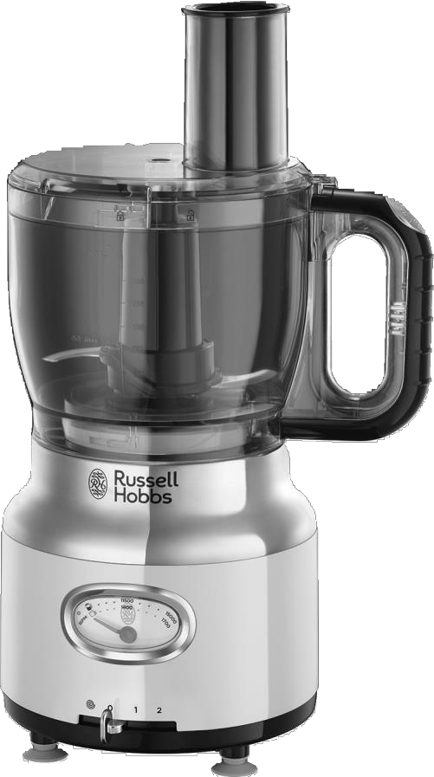

MODEL NO. 25180-56, 25182-56, 25184-56, 25186-56 RUSSELL HOBBS RETRO FOOD PROCESSOR

2

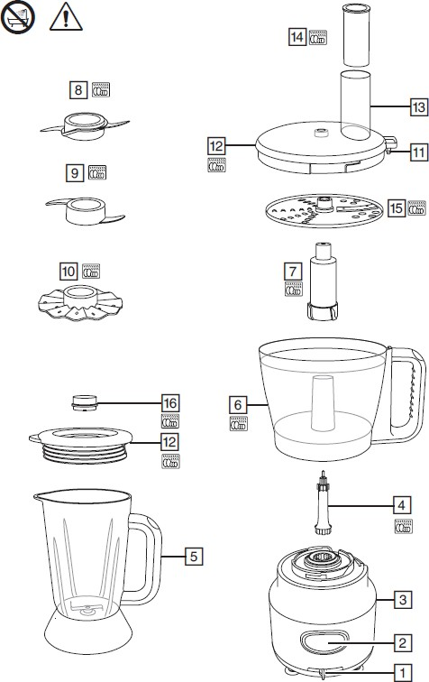

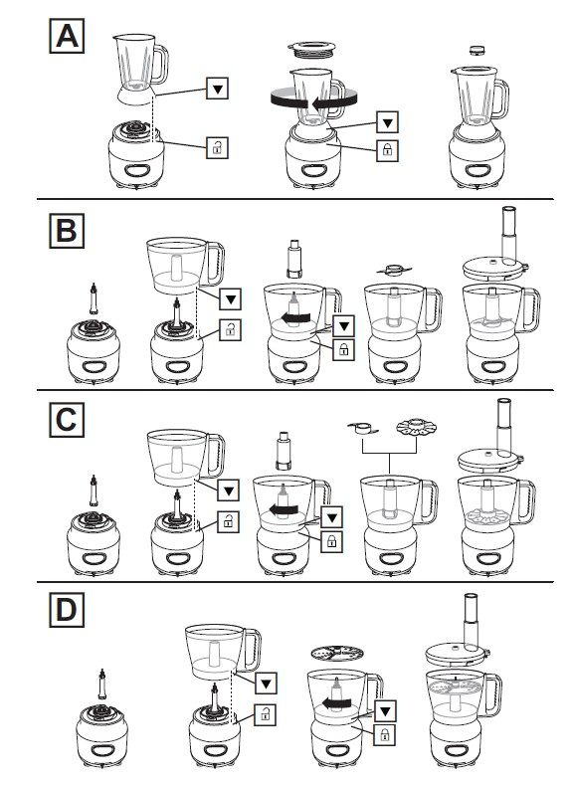
3

Read the instructions, keep them safe, pass them on if you pass the appliance on. Remove all packaging before use.

IMPORTANT SAFEGUARDS
Follow basic safety precautions, including:
This appliance can be used by persons with reduced physical, sensory or mental capabilities or lack of experience and knowledge if they have been supervised/instructed and understand the hazards involved. Children must not use or play with the appliance. Keep the appliance and cable out of reach of children.
To avoid injury, take care handling the blades, emptying the jug, and cleaning. Do not add hot liquids into the jug. Misuse of the appliance may cause injury.
Unplug the appliance before assembly, disassembly, or cleaning. Do not leave the appliance unattended while plugged in.
If the cable is damaged, it must be replaced by the manufacturer, its service agent, or someone similarly qualified, to avoid hazard.
- Don’t put the motor unit in liquid.
- Switch off (0) before fitting the jug to the motor unit.
- Switch off(0),and wait till the blades come to a stop before removing the lid from the jug, or removing the jug from the motor unit.
- Don’t put utensils into the jug while the appliance is plugged in.
- Don’t use accessories or attachments other than those we supply.
- Don’t use the appliance for any purpose other than those described in these instructions.
- Don’t operate the appliance if it’s damaged or malfunctions.
- Don’t run the motor continuously for more than one minute, it may overheat. After one minute switch off for at least two minutes, to recover.

HOUSEHOLD USE ONLY

PARTS
- Speed control
- Gauge
- Motor unit
- Spindle
- Blender jug
- Bowl

- Drive shaft
- Chopping blade
- Mixer attachment
- Creamer attachment
- Tab
- Lid

- Tube
- Pusher
- Disc
- Cap
Dishwasher safe accessories

BEFORE FIRST USE
Turn to “CARE AND MAINTENANCE” and ensure the appliance is cleaned before first use to remove manufacturing dust, etc.

GAUGE
The gauge shows the speed of the blade in rpm (revolutions per minute). The top row of figures show the speed when the jug is fitted.
The bottom row of figures show the speed when the bowl is fitted.

GENERAL OPERATION
  - Sit the motor unit on a dry, firm, level surface.
  - Route the cable so it doesn’t overhang and won’t trip.
  - Assemble the unit, and fit any accessories required according to how you want to use it.

  - Check that the speed control is set to O.
GB
  - Put the plug into the power socket (switch it on, if it’s switchable).
  - Move the speed control to the 1 or 2 position to operate your food processor.
  - Switch the appliance off by moving the speed control to the 0 position and unplug it.
  - Hold the speed control in the pulse position to operate your food processor in short, controlled bursts.
  - Release the control to stop.

USING THE BLENDER
The general assembly steps are shown in figure A.
- Lower the blender jug on to the motor unit, then turn the jug clockwise, to lock it in place.
- Remove the lid.
- Put the ingredients into the blender jug.
- Replace the lid.
- Align the pips on the cap with the slots in the hole in the lid, fit the cap, and turn it clockwise to lock it.
- Don’t run the appliance without fitting the cap.
- To add ingredients while the blender is working, remove the cap, pour the new ingredients through the hole, then replace the cap.
- Once finished, switch the appliance off (0) and unplug it.
- Turn the blender jug anti-clockwise, and lift it off the motor unit.

CRUSHING ICE
- For best results, fill the jug with between 150ml and 500ml of ice cubes.
- Put the lid on the blender, then:
- Turn the speed control to pulse for a second or two, then release it.
- Check the results, and adjust.

USING THE PROCESSOR
The general assembly steps are shown in figure B.
- Fit the spindle to the top of the motor unit.
- Lower the bowl on to the motor unit, then turn it clockwise to lock it in place.
- Fit the drive shaft.
- Fit the chopping blade.
- Put the ingredients into the bowl.
- Hold the lid with the tube slightly behind the bowl handle, set it on the bowl, then turn it clockwise to lock the tab into the top of the handle.
- Once finished, switch the appliance off (0) and unplug it.
- Turn the jug anti-clockwise, and lift it off the motor unit.

USING THE MIXER/CREAMER ATTACHMENT
The general assembly steps are shown in figure C. Use the mixer to mix ingredients together.
Use the creamer to thicken cream, to beat eggs, and to cream eggs and sugar together.
- Fit the spindle to the top of the motor unit.
- Lower the bowl on to the motor unit, then turn it clockwise to lock it in place.
- Fit the drive shaft.
- Fit the mixer or creamer attachment.
- Put the ingredients into the bowl.
- Hold the lid with the tube slightly behind the bowl handle, set it on the bowl, then turn it clockwise to lock the tab into the top of the handle.
- To add ingredients while the motor is running, lift the pusher out of the tube, add the ingredients through the tube then replace the pusher.
- To remove the lid, turn it anti-clockwise to unlock it, then lift it off.

SLICING/GRATING
The general assembly steps are shown in figure D.
  - Fit the spindle to the top of the motor unit.
  - Lower the bowl on to the motor unit, then turn it clockwise to lock it in place.
  - Lower the disc over the top of the spindle with the slicing or grating side facing upwards depending to whether you want to slice or grate the ingredients.
  - Hold the lid with the tube slightly behind the bowl handle, set it on the bowl, then turn it clockwise to lock the tab into the top of the handle.
  - Remove the pusher, and drop the ingredients down the tube.
  - Replace the pusher, and use it to push the ingredients gently down the tube.
- Don’t use fingers or cutlery to push food down the tube – only the pusher.
- Don’t let the bowl get more than about half full – stop and empty it.
- To remove the lid, turn it anti-clockwise to unlock it, then lift it off.

CARE AND MAINTENANCE
- Switch the appliance off (0) and unplug it.
- Wipe the outside of the motor unit with a clean damp cloth.
- Hand wash the removable parts.
- You may wash the removable parts in a dishwasher.

STORING THE APPLIANCE
  - Unplug the unit from the wall outlet and clean all the parts as instructed above. Ensure that all parts are dry before storing.
  - Store the appliance in its box or in a clean, dry place.
  - Never store the appliance while it is still dirty.
  - Never wrap the power cord around the appliance.

SERVICING THE APPLIANCE
There are no user serviceable parts in this appliance. If the unit is not operating correctly, please check the following:
    - You have followed the instructions correctly
    - That the unit has been wired correctly and that the wall socket is switched on.
    - That the mains power supply is ON.
    - That the plug is firmly in the mains socket.

If the appliance still does not work after checking the above:
- Consult the retailer for possible repair or replacement. If the retailer fails to resolve the problem and you need to return the appliance, make sure that:
  - The unit is packed carefully back into its original packaging.
  - Proof of purchase is attached.
  - A reason is provided for why it is being returned.
If the supply cord is damaged, it must be replaced by the manufacturer or an authorised service agent, in order to avoid any hazard. If service becomes necessary within the warranty period, the appliance should be returned to an approved Home of Living Brands (Pty) Ltd service centre. Servicing outside the warranty period is still available, but will, however, be chargeable.

CHANGING THE PLUG
Should the need arise to change the fitted plug, follow the instructions below.

This unit is designed to operate on the stated current only. Connecting to other power sources may damage the appliance.
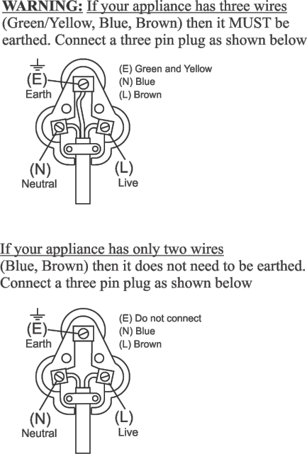

RECYCLING
To avoid environmental and health problems due to hazardous substances, appliances and rechargeable and non-rechargeable batteries marked with one of these symbols must not be disposed of with unsorted municipal waste. Always dispose of electrical and electronic products and, where
applicable, rechargeable and non-rechargeable batteries, at an appropriate official recycling/collection point.

For recipes, please visit http://eu.russellhobbs.com/recipes/

PLEASE AFFIX YOUR PROOF OF PURCHASE/RECEIPT HERE
IN THE EVENT OF A CLAIM UNDER WARRANTY THIS RECEIPT MUST BE PRODUCED.

2 YEAR WARRANTY
1 year retail ⵏ 1 year extended warranty upon registration*
visit www.russellhobbs.co.za

W A R R A N T Y AND EXTENDED WARRANTY

- Home of Living Brands (Pty) Limited ("Home of Living Brands") warrants to the original purchaser of this product ("the customer") that this product will be free of defects in quality and workmanship which under normal personal, family or household use and purpose may manifest within a period of 1 (one) year from the date of purchase ("warranty period").
- Home of Living Brands shall extend the warranty period for a further period of 1(one) year (“extended warranty period*”), on condition that the purchaser registers the product on the website, within 12 months from the date of purchase of the product. The website address for registration is as follows: http://russellhobbs.co.za/info- pages/warranty-info.aspx. The extended warranty period only applies to products purchased on or after 1 October 2017.
- Where the customer has purchased a product and it breaks, is defective or does not work properly for the intended purpose, the customer must notify the supplier from whom the customer bought the product ("the supplier") thereof within the warranty period or if applicable, the extended warranty period. Any claim in terms of this warranty must be supported by a proof of purchase. If proof of purchase is not available, then repair, and/or service charges may be payable by the customer to the supplier.
- The faulty product must be taken to the supplier's service centre to exercise the warranty.
- The supplier will refund, repair or exchange the product in terms of this warranty subject to legislative requirements. This warranty shall be valid only where (a) the customer is not the cause of the product breaking, and (b) the product has been used for the intended purpose stipulated in the product manual. The warranty does not include and will not be construed to cover products damaged as a result of disaster, misuse, tamper, abuse or any unauthorised modification or repair of the product.
- This warranty will extend only to the product provided at the date of the purchase and not to any expendables attached or installed by the customer. In this regard any accessories supplied with the product by the supplier, may be excluded in this warranty or extended warranty (see Exclusions to Warranty and Extended Warranty document).
- If the customer requests that the supplier repairs the product and the product breaks or fails to work properly within 3 (three) months of the repair and not as a result of misuse, tampering or modification by or on behalf of the customer, then the supplier may replace the product or pay a refund to the customer, subject to the supplier’s discretion.
- The customer may be responsible for certain costs where products returned are not in the original packaging, or if the packaging is damaged. This will be deducted from any refund paid to the customer.

HOME OF LIVING BRANDS (PTY) LTD (JOHANNESBURG)

JOHANNESBURG TEL NO. (011) 490-9600
CAPE TOWN TEL NO. (021) 552-5161
DURBAN TEL NO. (031) 303-1163
www.homeoflivingbrands.com www.russellhobbs.co.za www.facebook.com/RussellHobbsSA

EXCLUSIONS TO W A R R A N T Y AND EXTENDED WARRANTY

- Any accessories supplied with the product, including but not limited to, bowls, jugs, mills or carafes made either of glass or plastic and supplied with this appliance (hereinafter referred to as “the accessory or accessories”), is warranted to be free from material and workmanship defects for the duration of the appliance warranty.
- The accessories should give trouble free service when used in accordance with the directions described in the instruction manual. However, the accessories will be damaged if subjected to impact, and this damage is not covered by the warranty. Such impact damage can occur either from the outside (if for example it is dropped or knocked against a hard surface), or from within (if for example foreign objects are placed within the accessories and the power is switched on).
- Should you need to replace an accessory during the warranty period; a claim for a free replacement will only be considered if the item (including all shards and broken parts) is returned to the nearest HOLB service centre for examination.
- The remains of the accessory will be carefully examined by the relevant professionals and if it is determined (at the sole discretion of HOLB) that the damage was caused by impact, then the claim will be refused and will not be covered by the warranty or any extended warranty.
- Any replacement part provided in terms of clause 4 above will become a chargeable item payable by the customer.

Lisez les instructions, conservez-les et transférez-les si vous transférez l’appareil. Retirez tous les emballages avant utilisation.

PRÉCAUTIONS IMPORTANTES
Suivez les précautions essentielles de sécurité, à savoir: Cetappareilpeutêtreutilisépardespersonnesauxaptitudesphysiques, sensorielles ou mentales réduites ou ne possédant pas l’expérience et les connaissances suffisantes, pour autant que ces personnes soient supervisées/ aient reçu des instructions et soient conscientes des risques encourus. Les enfantsnedoiventpasutilisernijoueravecl’appareil.Tenezl’appareiletlecâble hors de portée des enfants.
FR
c Pourévitertouteblessure,faitespreuvedeprudencelorsdela manipulation deslames,delavidange duboletdunettoyagedel’appareil.
h Veillezà ne pasajouterdeliquidechaud(àunetempératuresupérieureà 40°C),carilpourraitêtre expulséparuncoupdevapeurbrusque.
Une utilisation inappropriée de l’appareil peut causer des blessures. Débranchez l’appareil avant le montage, le démontage ou le nettoyage. Ne laissez pas l’appareil sans surveillance lorsqu’il est branché.
Silecâbleestabîmé,vousdevezlefaireremplacerparlefabricant,undeses techniciens agréés ou une personne également qualifiée, pour éviter tout danger.
  - Veillez à ne pas plonger le bloc moteur dans du liquide.
  - Eteignez (0) avant de mettre le bol en place sur le bloc moteur.
  - Eteignez (0)et attendezjusqu’à ce queleslames s’arrêtentavant d’enlever le couvercle dubolou avant d’enlever le bol du bloc moteur.
  - Ne placez aucun ustensile dans le bol lorsque l’appareil est branché.
  - N’adaptez pas d’accessoires autres que ceux fournis.
  - N’utilisez pas l’appareil à d’autres fins que celles décrites dans ce mode d’emploi.
  - N’utilisez pas l’appareil s’il est endommagé ou ne fonctionne pas correctement.
• Ne pas faire fonctionner l’appareil en continu au-delà de 1 minute afin d’éviter une surchauffe. Si nécessaire, laisser reposer l’appareil pendant au moins 2 minutes pour laisser refroidir le moteur.

POUR UN USAGE DOMESTIQUE UNIQUEMENT

SCHÉMAS
- Contrôledevitesse
- Jauge
- Bloc moteur
- Tige
- Récipient mélangeur
- Bol

- Arbre d’entraînement
- Hachoir
- Accessoire mélangeur
- Accessoire batteur
- Onglet
- Couvercle

- Tube
- Élément pousseur
- Disque
- Plug
` Résistant au lave-vaisselle

AVANT LA PREMIÈRE UTILISATION
Veuillez consulter la section «SOINS ET ENTRETIEN» et nettoyer l’appareil pour éliminer la poussière de fabrication, etc.

JAUGE
La jauge indique la vitesse de la lame en tr/min (tours par minute).
Larangéesupérieure deschiffresindiquelavitesseaveclerécipientmisenplace. Larangéeinférieuredeschiffresindiquelavitesse aveclebol misen place.

UTILISATION GÉNÉRALE
  - Placez l'appareil sur une surface horizontale stable.
  - Placez le bol sur le bloc-moteur, puis faites pivoter le bol dans le sens des aiguilles d’une montre pour leverrouiller.
  - Montez l'appareil et fixez les accessoires nécessaires au mode d’utilisation souhaité.
  - Assurez-vous que le contrôle de vitesse est réglé sur 0.
  - Mettez la fiche dans la prise de courant.
  - Placez le contrôle de vitesse surlaposition 1 ou 2 pour faire fonctionner votre robot decuisine.
  - Éteignez l'appareil en plaçant le contrôle de vitesse sur la position 0 et débranchez-le.
  - Maintenez le contrôle de vitesse dans la position Y pour faire fonctionner votre robot de cuisine pendant de courts intervalles contrôlés.
  - Lâchez le contrôle pour arrêter.

UTILISATION DU BLENDER
Les étapes de l’assemblage général sont illustrées dans la figure A.
- Placez le récipient mélangeur sur le bloc-moteur, puis faites pivoter le récipient mélangeur dans le sens des aiguilles d’une montre pour le verrouiller.
- Retirez lecouverlce.
- Mettez les ingrédients dans le récipient mélangeur.
- Placez le couvercle sur le récipient mélangeur.
- Alignezlesergotssurle couvercle aveclesfentesdansletrousituédanslecouvercle,insérezle
bouchon et faites-le tourner dans le sens horaire pour le verrouiller.
- Ne mettez pas en marche l’appareil sans placer le bouchon dans le trou.
- Pour ajouter desingrédients lorsquele mixeur est en fonctionnement, retirez le bouchon, versezles nouveaux ingrédients par le trou et replacez ensuite le bouchon.
- Une fois le traitement effectué, éteignez l’appareil (0) et débranchez-le.
- Faitespivoterlerécipient mélangeurdansle sensinverse desaiguilles d’une montreet retirez-ledu bloc-moteur.

GLACE PILÉE
- Pour des résultats optimaux, remplir le bol de 150 ml à 500 ml de glaçons.
- Placez le couvercle sur le mixeur, puis:
- Faites pivoter lecontrôle de vitesse sur Ypendantune ou deuxsecondes, puis relâchez-le.
- Vérifiez les résultats et ajustez au besoin.

UTILISATION DU ROBOT
Les étapes de l’assemblage général sont illustrées dans la figure B.
- Fixezla tige àla partiesupérieure du bloc-moteur.
- Abaissezle bol sur le bloc moteur, puis faites-le pivoter dans le sens horaire pour le verrouiller à sa place.
- Fixez l'arbred'entraînement.
- Fixez le hachoir.
- Mettez les ingrédients dans le bol.
- Tenez le couvercle avec le tube légèrement derrière la poignée du bol, placez-le sur le bol, puis faites- lepivoter dans lesenshoraire pourverrouillerl’onglet danslapartiesupérieure delapoignée.
- Une fois le traitement effectué, éteignez l'appareil (0) et débranchez-le.
- Faites pivoter le boldanslesensinverse desaiguillesd’unemontre et retirez-le dubloc-moteur.

UTILISATION DES ACCESSOIRES : MIXEUR/BATTEUR
Les étapes de l’assemblage général sont illustrées dans la figure C. Utilisez le mixeur pour mélanger les ingrédients.
Utilisez le batteur pour épaissir la crème, battre les œufs et pour battre les œufs et le sucre ensemble.
- Fixez la tige à la partie supérieure du bloc-moteur.
FR
- Abaissezle bol sur le bloc moteur, puis faites-le pivoter dans le sens horaire pour le verrouiller à sa place.
- Fixez l'arbred'entraînement.
- Fixez l'accessoire mélangeur ou batteur.
- Mettez les ingrédients dans le bol.
- Tenez le couvercle avec le tube légèrement derrière la poignée du bol, placez-le surle bol, puis faites- lepivoter dans lesenshoraire pourverrouillerl’onglet dansla partie supérieuredela poignée.
  - Pour ajouter des ingrédients lorsque le moteur tourne, extrayez l’élément pousseur du tube, ajoutez les ingrédients dans le tube et replacez ensuite l’élément pousseur.
  - Pour retirerlecouvercle, faites-lepivoter dansle sens contraire des aiguilles d’une montre pourle débloquer, puis soulevez-le.

TRANCHAGE/RÂPAGE
Les étapes de l’assemblage général sont illustrées dans la figure D.
- Fixez la tige à la partie supérieure du bloc-moteur.
- Abaissezle bol sur le bloc moteur, puis faites-le pivoter dans le sens horaire pour le verrouiller à sa place.
- Abaissez le disque sur la partie supérieure de la tige avec le côté de tranchage ou de râpage orienté vers le haut suivant que vous souhaitez trancher ou râper les ingrédients.
- Tenez le couvercle avec le tube légèrement derrière la poignée du bol, placez-le surle bol, puis faites- lepivoter dans lesenshoraire pourverrouillerl’onglet dansla partie supérieuredela poignée.
5. Retirez l’élément pousseur et versez les ingrédients dans le tube.
6. Replacez l’élément pousseur etutilisez-le pourpousserles ingrédients dans le tube.
  - N’utilisez pas vos doigts ni des couverts pour pousser les ingrédients dans le tube – utilisez uniquement l’élémentpousseur.
  - Veillezà ce que le bol ne se remplisse pas à plus de la moitié environ de sa contenance. Arrêtez l'appareil et videz-le.
  - Pour retirerlecouvercle, faites-lepivoter dansle sens contraire des aiguilles d’une montre pourle débloquer, puis soulevez-le.

SOINS ET ENTRETIEN
- Éteignez l’appareil (0) et débranchez-le.
- Essuyez l’extérieur du bloc moteur à l’aide d’un chiffon humide propre.
- Lavez à la main les pièces amovibles.
- Toutefois, les conditions delavage du lave-vaisselle affecteront la finition de la surface de l'appareil.
- Cela affecte l’apparence de l’appareil, non pas son fonctionnement.
` Vous pouvez laver ces pièces dans un lave-vaisselle.

RECYCLAGE
Afin d’éviter les problèmes occasionnés à l’environnement et à la santé par des substances dangereuses,lesappareilsetlesbatteriesrechargeablesetnon rechargeables présentant l’un de ces symboles ne doivent pas être éliminés avec les déchets municipaux non triés. Éliminez dans tous les cas les produits électriques et électroniques et,lecaséchéant,lesbatteries rechargeables etnon rechargeables, dans un centre officiel et approprié de collecte/recyclage.

Rezepte finden Sie auf unserer Website: http://eu.russellhobbs.com/recipes/

Leia as instruções e guarde em lugar seguro. Forneça-as também caso venha a fornecer o aparelho a alguém. Retire todo o material de embalar antes da utilização.

MEDIDAS DE PRECAUÇÃO IMPORTANTES
Siga as precauções básicas de segurança, incluindo as seguintes:
Esteaparelho pode ser utilizado por pessoas comcapacidades físicas,sensoriais oumentaisreduzidasou comfaltadeexperiência econhecimentodesde que supervisionadas/instruídas e que compreendam os riscos envolvidos. As crianças nãodevemusarnembrincarcomoaparelho.Mantenhaoaparelhoeocabofora do alcance das crianças.
c Paraevitarferimentos,tenhacuidadoaomanusearaslâminas,aoesvaziaro jarro e ao limpar. h Nãoacrescentelíquidosquentes(commaisde40ºC),poispodemser expelidosdevidoa vaporização repentina.
PT
Utilizar o aparelho incorretamente poderá resultar em ferimentos.
Desligue o aparelho da corrente elétrica antes da montagem, desmontagem ou limpeza. Não deixe o aparelho desacompanhado enquanto estiver ligado.
Se o cabo estiver danificado, o fabricante, o seu agente de assistência técnica ou qualquer profissional devidamente qualificado deverá substituí-lo para se evitarem riscos.
  - Não coloque a unidade motora em líquidos.
  - Antes de instalar o jarro na unidade motora desligue o aparelho (0).
  - Desligue (0) e aguarde atéaslâminas pararem completamente antesderetirar a tampadojarro ou
de retirar o jarro da unidade motora.
  - Não coloque utensílios no jarro com a ficha do aparelho na tomada.
  - Não utilize acessórios ou peças que não sejam fornecidos pela nossa empresa.
  - Não utilize o aparelho para quaisquer outras finalidades senão as descritas nestas instruções.
  - Não utilize oaparelho se estiver danificado ouse oseu funcionamento for defeituoso.
  - Nãoponhao motor afuncionar continuamenteporumperíodo superiora 1 minuto, poispode causar o seusobreaquecimento. Após1 minuto, desligue-o pelo menosdurante 2 minutos para ele
recuperar.

APENAS PARA USO DOMÉSTICO

ESQUEMAS

- Controlo de velocidade
- Indicador
- Unidade motora
- Eixo
- Jarro
- Recipiente
- Suporte
- Lâmina de picar
- Misturador
- Acessório para natas
- Patilha
- Tampa
- Cano
- Empurrador
- Disco
- Tampa pequena
` Lavável na máquina

ANTES DE UTILIZAR PELA PRIMEIRA VEZ
Consulte a secção «CUIDADO E MANUTENÇÃO» para limpar o aparelho, para remover poeiras de fabrico, etc.

INDICADOR
O indicador mostra a velocidade da lâmina em rpm (rotações por minuto).
A linha superior de números mostra a velocidade quando o jarro está encaixado.
A linha inferior de números mostra a velocidade quando o recipiente está encaixado.

FUNCIONAMENTO GERAL
  - Coloque a unidade motora numa superfície estável e plana.
  - Oriente do cabo de modo que não fique pendurado, não possa ser puxado nem se prenda.
  - Monte a unidade e encaixe os acessórios necessários consoante aforma como pretender usá-los.
  - Verifique se o controlo da velocidade está regulado para o 0.
  - Ligue a ficha à tomada elétrica.
  - Coloque o controlo de velocidade na posição 1 ou 2 para operar o processador de alimentos.
  - Desligue o aparelho colocando o controlo de velocidade na posição 0 e retire a ficha da tomada elétrica.
  - Mantenha o controlo de velocidade na posição Y para operar o processador de alimentos em pressões curtas e controladas.
  - Para parar, liberte ocontrolo.

UTILIZAR O JARRO MISTURADOR
Os passos de montagem gerais foram ilustrados na figura A.
- Baixe ojarro até àunidademotora, rode ojarro no sentido dosponteiros do relógio parao fixar.
- Retire atampa.
- Coloque os ingredientes no jarro.
- Coloque a tampa no jarro.
- Alinhe as pontasna tampa pequena com as ranhuras do orifício na tampa, encaixe a tampa pequena e gire-a para a direita para a bloquear.
6. Não coloque o aparelho em funcionamento sem encaixar a tampa pequena.
- Para adicionar ingredientescom aliquidificadora em movimento,remova a tampa pequena,deite os
novos ingredientes através doorifício, depois recoloque a tampa pequena.
- Quando terminar, desligue o aparelho (0) e retire-o da tomada elétrica.
- Rode o jarro no sentido contrário ao dos ponteiros dorelógio e levante aunidade motora.

TRITURAÇÃO DE GELO
- Para melhores resultados, encha o jarro com entre 150 ml e 500 ml de cubos de gelo.
- Coloque a tampa no liquidificador e seguidamente:
- Rode ocontrolo de velocidade para Ydurante um ou dois segundos edepois liberte-o.
- Verifique o resultado e ajuste.

UTILIZAR A O PROCESSADOR DE ALIMENTOS
Os passos de montagem gerais foram ilustrados na figura B.
- Encaixe o eixo na parte superior da unidade motora.
- Coloque o recipiente sobre a unidade motora e, em seguida, rode-o para a direita de forma a bloqueá-lo no sítio.
- Encaixe osuporte.
- Encaixe a lâmina de picar.
- Coloque os ingredientes no recipiente.
- Segure a tampa com o cano ligeiramente atrás da pega do recipiente, coloque-a sobre o recipiente e, emseguida, rodeparaadireitade formaabloquearapatilhanapartesuperiordapega.
- Quando terminar, desligue o aparelho (0) e retire-o da tomada elétrica.
- Rode o recipiente nosentidocontrário aodosponteiros do relógio elevanteaunidademotora.

USAR O MISTURADOR/ACESSÓRIO PARA NATAS
Os passos de montagem gerais foram ilustrados na figura C. Utilize o misturador para misturar ingredientes.
Utilize o acessório para natas para engrossar natas, bater ovos e bater ovos e açúcar.
- Encaixe o eixo na parte superior da unidade motora.
- Coloque o recipiente sobre a unidade motora e, em seguida, rode-o para a direita de forma a bloqueá-lo no sítio.
- Encaixe osuporte.
- Encaixe o misturador ou acessório para natas.
- Coloque os ingredientes no recipiente.
- Segure a tampa com o cano ligeiramente atrás da pega do recipiente, coloque-a sobre o recipiente e, emseguida,rodeparaadireitade formaabloquearapatilhanapartesuperiordapega.
  - Paraacrescentaringredientes enquantoomotorestiveremfuncionamento,levanteoempurrador retirando-o do cano. Adicione os ingredientes através do cano e volte a colocar o empurrador.
  - Para retirar a tampa, rode-a no sentido contrário ao dos ponteiros do relógio e levante-a. PT

FATIAR/RALAR
Os passos de montagem gerais foram ilustrados na figura D.
- Encaixe o eixo na parte superior da unidade motora.
- Coloque o recipiente sobre a unidade motora e, em seguida, rode-o para a direita de forma a bloqueá-lo no sítio.
- Coloque o disco sobre a parte superior do eixo com o lado de fatiar ou ralar virado para cima, consoante se pretender fatiar ou ralar os ingredientes.
- Segure a tampa com o cano ligeiramente atrás da pega do recipiente, coloque-a sobre o recipiente e, emseguida,rodeparaadireitade formaabloquearapatilhanapartesuperiordapega.
- Retire o empurrador e deite os ingredientes pelo cano.
6. Volte a colocar o empurrador e utilize-o para empurrar os ingredientes cuidadosamente pelo cano.
  - Não utilize os dedos ou talheres para empurrar os alimentos pelo cano – apenas o empurrador.
  - Nãopermita que o recipiente fique cheio em mais de metade, caso aconteça, pare aoperação e esvazie-o.
  - Para retirar a tampa, rode-a no sentido contrário ao dos ponteiros do relógio e levante-a.

CUIDADO E MANUTENÇÃO
- Desligue o aparelho (0) e desligue-o da corrente.
- Limpe a superfície externa da unidade motora com um pano limpo e seco.
- Lave à mão as peças removíveis.
- Se utilizar uma máquina delavarloiça, oambiente agressivo no seuinterior afetará o acabamento da superfície.
- Os danosdeveriam serapenascosméticosenãodeveriamafetaro funcionamento doaparelho.
` Poderá lavar estas peças na máquina de lavar loiça.

RECICLAGEM
Para evitar problemas ambientais e de saúde devido a substâncias perigosas, os aparelhos e baterias recarregáveis e não recarregáveis com um destes símbolos não deverão ser eliminados com o lixo doméstico normal. Elimine sempre os produtos elétricos eeletrónicos e, quando aplicável, as baterias recarregáveis enão recarregáveis, no ponto de reciclagem/recolha oficial apropriado.

Receitas disponíveis no nosso website: http://eu.russellhobbs.com/recipes/

