INSTRUCTIONS AND WARRANTY

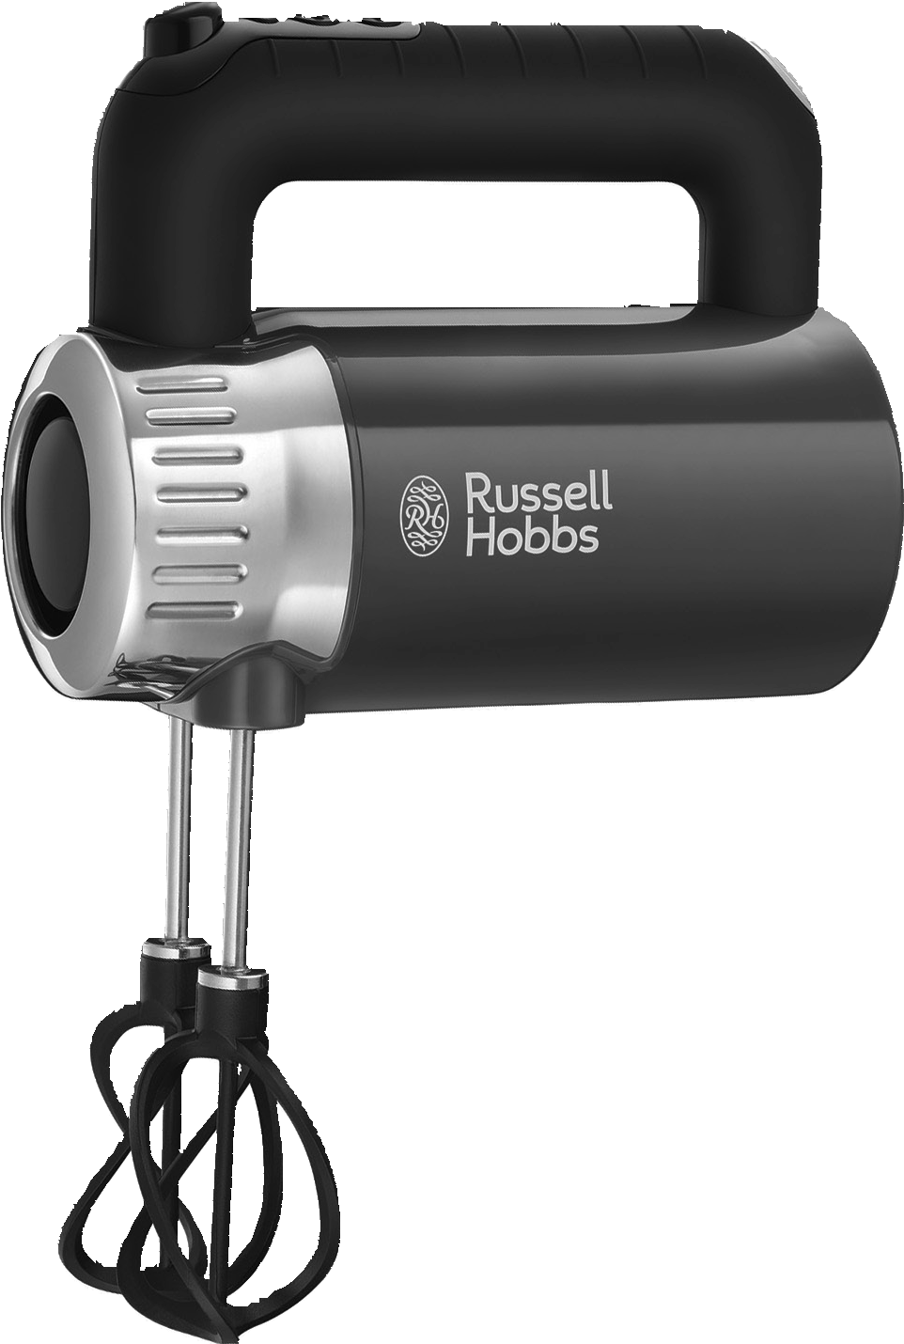

MODEL NO. 25200-56, 25202-56, 25204-56, 25206-56

RUSSELL HOBBS RETRO HAND MIXER

1

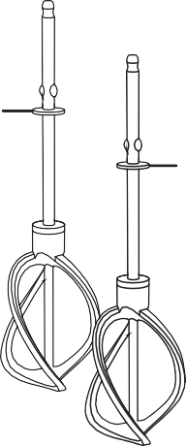
4
3

2
2
2

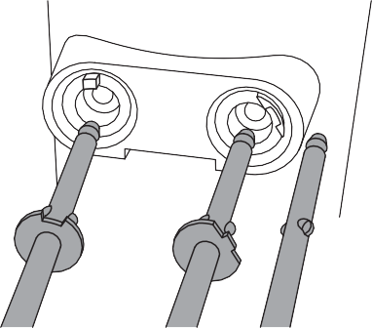
Fig. A
L
R
Read the instructions, keep them safe, pass them on if you pass the appliance on. Remove all packaging before use.
GB

IMPORTANT SAFEGUARDS
Follow basic safety precautions, including:

This appliance can be used by persons with reduced physical, sensory or mental capabilities or lack of experience and knowledge if they have been supervised/instructed and understand the hazards involved.
Children must not use or play with the appliance. Keep the appliance and cable out of reach of children. Misuse of the appliance may cause injury.
Unplug the appliance before assembly, disassembly, or cleaning. Do not leave the appliance unattended while plugged in.
If the cable is damaged, it must be replaced by the manufacturer, its service agent, or someone similarly qualified, to avoid hazard.
- Do not use this appliance near bathtubs, showers, basins or other vessels containing water.
- Don’t use accessories or attachments other than those we supply.
- Don’t use the appliance for any purpose other than those described in these instructions.
- Don’t use the appliance if it’s damaged or malfunctions.
- Don’t run the motor continuously for more than 5 minutes, it will overheat. After five minutes switch off for at least five minutes, to recover. Your mixer will automatically switch off after five minutes of continuous use.

PARTS
- On/off button
- Flange
- Whisks

HOUSEHOLD USE ONLY

- Hooks
Dishwasher safe

FITTING THE WHISKS/ HOOKS
- Switch off (0) and unplug the mixer before fitting or removing the whisks/hooks.
- Turn each whisk or hook to align the pips on the shaft with the slots in the drive head, then push it into the drive head till it clicks into place.
- Each whisk/hook must be fitted into a specific drive head (fig. A).
- Use both whisks or both hooks, don’t mix them.

REMOVING THE WHISKS/HOOKS
- Switch off (0) and unplug the mixer, then shake any excess mixture into the mixing bowl.
- Hold both whisks/hooks, to prevent them jumping out, and press the button. This will eject them from the drive heads.

USING THE MIXER
- Put the plug into the power socket.
- Press and release the button. The button light will flash.

- Press the + button to start your mixer and increase the speed, press the - button to decrease the speed. During operation the button light will stay on. Repeatedly pressing the - button will reduce the speed to zero and stop your mixer. The button light will then flash.
- To stop your mixer immediately, press the button.

TURBO MODE
If you press and hold the + button while your mixer is running, after two seconds, it will run at its highest speed and continue to do so as long as you hold the button. Release the button and your mixer will revert to the previously set speed.

HINTS AND TIPS
- Generally, large quantities, thick mixes, and a high ratio of solids to liquids suggest longer timings and slower speeds.
- Smaller quantities, thinner mixes, and more liquids than solids suggest shorter timings and higher speeds.
- Use the whisks for beating/aerating light dough and batter.
- Use the hooks for mixing heavier dough (e.g. bread, fruit-cake).
- When making dough, use the mixer only for mixing the ingredients. Don’t use it for kneading. You’ll overload it and damage the motor.

CARE AND MAINTENANCE
- Switch the appliance off and unplug it.
- Clean the outside surfaces of the appliance with a damp cloth.
- Wash the whisks and hooks in hot soapy water, or in the cutlery basket of your dishwasher.

STORING THE HAND MIXER
- Unplug the unit from the wall outlet and clean all the parts as instructed above. Ensure that all parts are dry before storing.
- Store the hand mixer is in its box or in a clean, dry place.
- Never store the hand mixer while it is still wet or dirty.
- Never wrap the power cord around the hand mixer.

SERVICING THE APPLIANCE
There are no user serviceable parts in this hand mixer. If the unit is not operating correctly, please check the following:
- You have followed the instructions correctly
- That the unit has been wired correctly and that the wall socket is switched on.
- That the mains power supply is ON.
- That the plug is firmly in the mains socket.

If the hand mixer still does not work after checking the above:
- Consult the retailer for possible repair or replacement. If the retailer fails to resolve the problem and you need to return the hand mixer and make sure that:
- The unit is packed carefully back into its original packaging.
- Proof of purchase is attached.
- A reason is provided for why it is being returned.
If the supply cord is damaged, the manufacturer or an authorised service agent must replace it, in order to avoid any hazard. If service becomes necessary within the warranty period, the hand mixer should be returned to an approved Home Of Living Brands (Pty) Limited service centre. Servicing outside the warranty period is still available, but will, however, be chargeable.

CHANGING THE PLUG
Should the need arise to change the fitted plug, follow the instructions below.
This unit is designed to operate on the stated current only. Connecting to other power sources may damage the appliance.

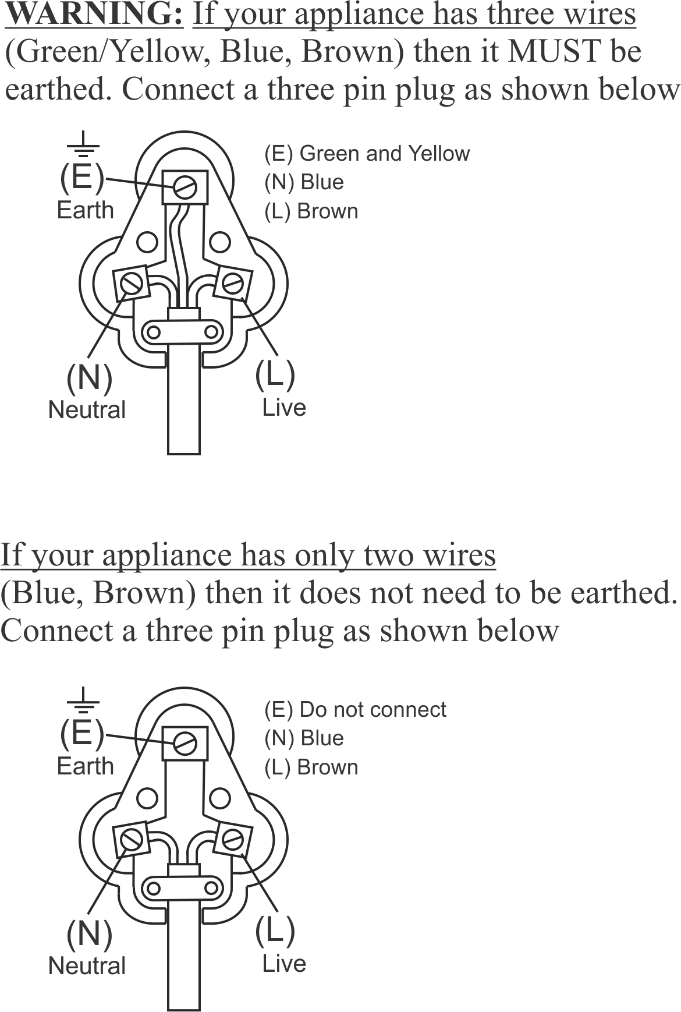
RECYCLING
To avoid environmental and health problems due to hazardous substances, appliances and rechargeable and non-rechargeable batteries marked with one of these symbols must not be disposed of with unsorted municipal waste. Always dispose of electrical and electronic products and, where applicable, rechargeable and non-rechargeable batteries, at an appropriate official recycling/collection point.

PLEASE AFFIX YOUR PROOF OF PURCHASE/RECEIPT HERE
IN THE EVENT OF A CLAIM UNDER WARRANTY THIS RECEIPT MUST BE PRODUCED.

2 YEAR WARRANTY
1 year retail ⵏ 1 year extended warranty upon registration*
Visit www.russellhobbs.co.za

W A R R A N T Y AND EXTENDED WARRANTY

- Home of Living Brands (Pty) Limited ("Home of Living Brands") warrants to the original purchaser of this product ("the customer") that this product will be free of defects in quality and workmanship which under normal personal, family or household use and purpose may manifest within a period of 1 (one) year from the date of purchase ("warranty period").
- Home of Living Brands shall extend the warranty period for a further period of 1(one) year (“extended warranty period*”), on condition that the purchaser registers the product on the website, within 12 months from the date of purchase of the product. The website address for registration is as follows: http://russellhobbs.co.za/info-pages/warranty-info.aspx. The extended warranty period only applies to products purchased on or after 1 October 2017.
- Where the customer has purchased a product and it breaks, is defective or does not work properly for the intended purpose, the customer must notify the supplier from whom the customer bought the product ("the supplier") thereof within the warranty period or if applicable, the extended warranty period. Any claim in terms of this warranty must be supported by a proof of purchase. If proof of purchase is not available, then repair, and/or service charges may be payable by the customer to the supplier.
- The faulty product must be taken to the supplier's service centre to exercise the warranty.
- The supplier will refund, repair or exchange the product in terms of this warranty subject to legislative requirements. This warranty shall be valid only where (a) the customer is not the cause of the product breaking, and (b) the product has been used for the intended purpose stipulated in the product manual. The warranty does not include and will not be construed to cover products damaged as a result of disaster, misuse, tamper, abuse or any unauthorised modification or repair of the product.
- This warranty will extend only to the product provided at the date of the purchase and not to any expendables attached or installed by the customer. In this regard any accessories supplied with the product by the supplier, may be excluded in this warranty or extended warranty (see Exclusions to Warranty and Extended Warranty document).
- If the customer requests that the supplier repairs the product and the product breaks or fails to work properly within 3 (three) months of the repair and not as a result of misuse, tampering or modification by or on behalf of the customer, then the supplier may replace the product or pay a refund to the customer, subject to the supplier’s discretion.
- The customer may be responsible for certain costs where products returned are not in the original packaging, or if the packaging is damaged. This will be deducted from any refund paid to the customer.

HOME OF LIVING BRANDS (PTY) LTD (JOHANNESBURG)

JOHANNESBURG TEL NO. (011) 490-9600
CAPE TOWN TEL NO. (021) 552-5161
DURBAN TEL NO. (031) 303-1163
www.homeoflivingbrands.com
www.russellhobbs.co.za
www.facebook.com/RussellHobbsSA

EXCLUSIONS TO W A R R A N T Y AND EXTENDED WARRANTY

- Any accessories supplied with the product, including but not limited to, bowls, jugs, mills or carafes made either of glass or plastic and supplied with this appliance (hereinafter referred to as “the accessory or accessories”), is warranted to be free from material and workmanship defects for the duration of the appliance warranty.
- The accessories should give trouble free service when used in accordance with the directions described in the instruction manual. However, the accessories will be damaged if subjected to impact, and this damage is not covered by the warranty. Such impact damage can occur either from the outside (if for example it is dropped or knocked against a hard surface), or from within (if for example foreign objects are placed within the accessories and the power is switched on).
- Should you need to replace an accessory during the warranty period; a claim for a free replacement will only be considered if the item (including all shards and broken parts) is returned to the nearest HOLB service centre for examination.
- The remains of the accessory will be carefully examined by the relevant professionals and if it is determined (at the sole discretion of HOLB) that the damage was caused by impact, then the claim will be refused and will not be covered by the warranty or any extended warranty.
- Any replacement part provided in terms of clause 4 above will become a chargeable item payable by the customer.

*
Lisez les instructions, conservez-les et transférez-les si vous transférez l’appareil. Retirez tous les emballages avant utilisation.

PRÉCAUTIONS IMPORTANTES
Suivez les précautions essentielles de sécurité, à savoir:
FR

Cet appareil peut être utilisé par des personnes aux aptitudes physiques, sensorielles ou mentales réduites ou ne possédant pas l'expérience et les connaissances suffisantes, pour autant que ces personnes soient supervisées/aient reçu des instructions et soient conscientes des risques encourus.
Les enfants ne doivent pas utiliser ni jouer avec l'appareil. Tenez l'appareil et le câble hors de portée des enfants.
Une utilisation inappropriée de l'appareil peut causer des blessures. Débranchez l'appareil avant le montage, le démontage ou le nettoyage. Ne laissez pas l’appareil sans surveillance lorsqu’il est branché.
Si le câble est abîmé, vous devez le faire remplacer par le fabricant, un de ses techniciens agréés ou une personne également qualifiée, pour éviter tout danger.
- Veillez à ne pas utiliser cet appareil à proximité de baignoires, douches, lavabos ou autres récipients
contenant de l’eau.
- N’adaptez pas d’accessoires autres que ceux fournis.
- N’utilisez pas l’appareil à d’autres fins que celles décrites dans ce mode d’emploi.
- N’utilisez pas l’appareil s’il est endommagé ou s’il ne fonctionne pas correctement.
- Ne pas faire fonctionner l’appareil en continu au-delà de 5 minutes afin d’éviter une surchauffe. Si nécessaire, laisser reposer l’appareil pendant au moins 5 minutes pour laisser refroidir le moteur. Votre mixeur va automatiquement s’éteindre après une utilisation continue pendant 5 minutes.

POUR UN USAGE DOMESTIQUE UNIQUEMENT

SCHÉMAS
- Bouton marche/arrêt
- Bride
- Fouets

- Crochets malaxeurs
` Résistant au lave-vaisselle

FIXATION DU FOUET/DES CROCHETS MALAXEURS
- Eteignez (0) et débranchez le mixeur avant de fixer ou de retirer les fouet/crochets malaxeurs.
- Tournez chaque fouet ou crochet malaxeur pour aligner les repères de centrage de l’axe avec les fentes des têtes motrices, puis poussez-le dans la tête motrice pour le clipper à sa place.
- Chaque fouet/crochet malaxeur doit être inséré dans une tête motrice spécifique (Figure A).
- Utiliser ensemble les deux fouets ou les deux crochets malaxeurs; ne pas mélanger les deux types d’accessoires.

RETRAIT DES FOUETS/DES CROCHETS MALAXEURS
  - Eteignez (0) et débranchez le mixeur, puis secouez pour enlever l’excès de mixture dans le bol mélangeur.
  - Maintenez les fouets/crochets malaxeurs, pour éviter qu’ils ne sortent et appuyez sur le bouton 5. Ils seront éjectés des têtes motrices.

UTILISATION DU MIXEUR
- Mettez la fiche dans la prise de courant.
- Appuyez sur le bouton C et lâchez-le. Le voyant du bouton C va clignoter.
- Appuyez sur le bouton + pour démarrer votre mixeur et augmenter la vitesse. Appuyez sur le bouton - pour réduire la vitesse. Quand l’appareil fonctionne, le voyant du bouton (C) reste allumé. En appuyant à plusieurs reprises sur le bouton - , vous pouvez réduire la vitesse à zéro et arrêter votre mixeur. Le voyant du bouton C va clignoter.
- Pour arrêter rapidement votre mixeur, appuyez sur le bouton C.

MODE TURBO
Si vous appuyez sur le bouton + et que vous le maintenez enfoncé pendant que le mélangeur est en marche, après deux secondes, il fonctionnera à la vitesse maximale et maintiendra cette vitesse tant que vous appuyez sur le bouton. Lâchez le bouton et votre mélangeur reviendra à la vitesse réglée précédemment.

ASTUCES ET CONSEILS
- En général, de grandes quantités, des mélanges épais et un plus grand nombre d’aliments solides que de liquides sous-entendent des temps de mixage plus longs et des vitesses plus réduites.
- De petites quantités, des mélanges plus fins et plus d’aliments liquides que de solides sous- entendent des temps de mixage plus courts et des vitesses plus élevées.
- Utilisez les fouets pour battre/aérer une pâte légère ou une pâte à frire.
- Utilisez les crochets pour mixer une pâte plus lourde (par exemple, pain, gâteau aux fruits).
- Lorsque vous faites de la pâte, utilisez le mixeur uniquement pour mélanger les ingrédients. Ne l’utilisez pas pour pétrir. Vous risquez de le surcharger et d’endommager le moteur.
- Si le moteur commence à fatiguer, ajoutez du liquide au mélange, si possible, ou éteignez-le et continuez à la main.

SOINS ET ENTRETIEN
- Éteignez l’appareil (0) et débranchez-le.
- Nettoyez l’extérieur de l’appareil avec un chiffon humide.
` Lavez les fouets et les crochets à l’eau chaude et savonneuse, ou dans le panier à couverts de votre lave-vaisselle.

RECYCLAGE
Afin d’éviter les problèmes occasionnés à l’environnement et à la santé par des substances dangereuses, les appareils et les batteries rechargeables et non rechargeables présentant l’un de ces symboles ne doivent pas être éliminés avec les déchets municipaux non triés. Éliminez dans tous les cas les produits électriques et électroniques et, le cas échéant, les batteries rechargeables et non rechargeables, dans un centre officiel et approprié de collecte/recyclage.

Leia as instruções e guarde em lugar seguro. Forneça-as também caso venha a fornecer o aparelho a alguém. Retire todo o material de embalar antes da utilização.

MEDIDAS DE PRECAUÇÃO IMPORTANTES
Siga as seguintes instruções básicas de segurança:

Este aparelho pode ser utilizado por pessoas com capacidades físicas, sensoriais ou mentais reduzidas ou com falta de experiência e conhecimento desde que supervisionadas/instruídas e que compreendam os riscos envolvidos.
As crianças não devem usar nem brincar com o aparelho. Mantenha o aparelho e o cabo fora do alcance das crianças. Utilizar o aparelho incorrectamente poderá resultar em ferimentos. Desligue o aparelho da corrente elétrica antes da montagem, desmontagem ou limpeza.
PT
Não deixe o aparelho desacompanhado enquanto estiver ligado.
Se o cabo estiver danificado, o fabricante, o seu agente de assistência técnica ou alguém igualmente qualificado deverá substituí-lo a fim de evitar acidentes.
b Não utilize o aparelho perto de casas de banho, duches, bacias ou outros recipientes que contêm
água.
- Não utilize acessórios ou peças que não sejam fornecidos pela nossa empresa.
- Não utilize o aparelho para quaisquer outras finalidades senão as descritas nestas instruções.
- Não utilize o aparelho se estiver danificado ou defeituoso.
- Não ponha o motor a funcionar continuamente por um período superior a 5 minutos, pois pode causar o seu sobreaquecimento. Após 5 minutos, desligue-o pelo menos durante 5 minutos para ele recuperar. A sua batedeira irá desligar-se automaticamente após 5 minutos de utilização contínua.

APENAS PARA USO DOMÉSTICO

ESQUEMAS
- Botão ligar/desligar
- Flange
- Batedores de claras

- Batedores em espiral
` Lavável na máquina

INSTALAR OS BATEDORES/BATEDORES EM ESPIRAL
- Antes da instalação ou remoção dos batedores, desligue (0) a batedeira e retire a ficha da tomada eléctrica.
- Rode cada um dos batedores de forma a alinhar as saliências dos veios com as ranhuras da cabeça de accionamento e empurre-os para dentro desta até encaixarem em posição.
- Introduza o batedor com flange na cabeça de acionamento da esquerda (visto de baixo para cima do aparelho (fig. A).
- Utilize ambos os batedores de claras ou ambos os batedores em espiral, não misture os dois tipos de batedores.

RETIRAR OS BATEDORES/BATEDORES EM ESPIRAL
  - Desligue (0) a batedeira e retire a ficha da tomada, em seguida sacuda a eventual mistura em excesso para dentro da tigela misturadora.
  - Segure ambos os batedores de modo a impedi-los de saltar, e prima 5. Estes serão assim ejectados das cabeças de accionamento.

UTILIZAÇÃO DA BATEDEIRA
- Ligue a ficha à tomada eléctrica.
- Prima e liberte o botão C. A luz do botão C irá piscar.
- Prima o botão + para colocar a batedeira a funcionar e aumentar a velocidade e prima o botão
- para reduzir a velocidade. Quando se encontrar a funcionar, a luz do botão (C) permanecerá ligada. Se premir repetidamente o botão - irá reduzir a velocidade para zero e parar a batedeira. A luz do botão C irá piscar.
- Para parar a batedeira rapidamente, prima o botão C.

MODO TURBO
Se mantiver premido o botão + enquanto o misturador estiver a funcionar, após dois segundos, começará a operar à velocidade mais alta enquanto mantiver premido o botão. Liberte o botão e o misturador regressará à velocidade definida anteriormente.

DICAS E SUGESTÕES
- Geralmente as grandes quantidades, misturas espessas e uma grande percentagem de sólidos em relação aos líquidos sugerem tempos mais prolongados e velocidades mais lentas.
- As quantidades menores, as misturas menos espessas e a maior quantidade de líquidos sugerem tempos mais curtos e velocidades superiores.
- Use os batedores de claras para bater massa densa e massa cremosa.
- Utilize os batedores em espiral para bater massas mais consistentes (por exemplo, pão, bolos de frutas).
- Ao fazer massa de pão, utilize a batedeira apenas para misturar os ingredientes. Não a utilize para amassar. Se o fizer, sobrecarregá-la-á e danificará o motor.
- Se o motor começar a esforçar-se, adicione mais líquido à mistura se for possível, senão desligue a batedeira e continue a bater à mão.

CUIDADOS E MANUTENÇÃO
- Desligue o aparelho (0) e desligue-o da corrente.
- Limpe as superfícies exteriores do aparelho com um pano húmido.
` Lave os batedores e os batedores em espiral em água quente com sabão, ou no cesto dos talheres da máquina de lavar louça.

RECICLAGEM
Para evitar problemas ambientais e de saúde devido a substâncias perigosas, os aparelhos e baterias recarregáveis e não recarregáveis com um destes símbolos não deverão ser eliminados com o lixo doméstico normal. Elimine sempre os produtos elétricos e eletrónicos e, quando aplicável, as baterias recarregáveis e não recarregáveis, no ponto de reciclagem/recolha oficial apropriado.

