INSTRUCTIONS AND WARRANTY

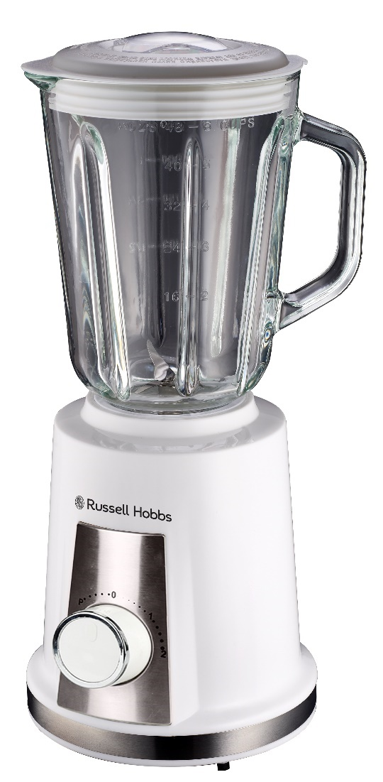

MODEL NO. RHB048

RUSSELL HOBBS INFINITY JUG BLENDER

Thank you for purchasing the Russell Hobbs Infinity Jug Blender. Each unit has been manufactured to ensure safety, reliability and ease of use. Before use, please read the instructions carefully and keep it for future reference. Should you pass the unit on, please ensure that you also pass the instruction manual.

FEATURES OF THE RUSSELL HOBBS INFINITY JUG BLENDER

- Bringing versatility, efficiency and effortless food preparation to your kitchen
- 500W motor
- 1.5L glass jug
- 2 speeds with pulse function
- Pulse function for increased control when blending ingredients
- Safety lock mechanism
- Grinder/mill attachment
- Ideal for crushing ice, smoothies, cocktails, sauces and much more
- Blends ingredients quicker and smoother to achieve desired consistency
- Non-slip feet for added stability
- For domestic use only
- 2-year warranty (1 year retail • 1 year extended upon online registration of product • visit www.russellhobbs.co.za)

IMPORTANT SAFEGUARDS
- Please read the instructions carefully before using the appliance.
- Always ensure that the voltage on the rating label corresponds to the mains voltage in your home.
- Incorrect operation and improper use can damage the appliance and cause injury to the user.
- The appliance is intended for household use only. Commercial use invalidates the warranty and the supplier cannot be held responsible for injury or damage caused when using the appliance for any other purpose than its intended use.
- Always disconnect the appliance from the power supply if it is left unattended and before assembling, disassembling or cleaning.
- The blender is fitted with a safety switch to prevent the motor operating unless the jug is in place. Do not use this to switch the blender on and off.
- Turn the switch to standby “0” before fitting/ removing the jug or mill to/ from the motor/ base unit.
- Turn the switch to standby “0” and wait until the blades come to a complete stop before removing the jug cover from the jug, and before removing the jug or mill from the motor/ base unit.
- This appliance is not intended for use by persons (including children) with reduced physical, sensory or mental capabilities, or lack of experience and knowledge, unless they are under supervision or instruction concerning use of the appliance by a person responsible for their safety. Children should be supervised to ensure that they do not play with the appliance.
- Do not use the blender without first locking the jug cover in place.
- Do not fill the jug with boiling liquids. Allow liquids to cool to a lukewarm temperature before you put them in the jug. This type of temperature would be suitable for any individual to touch/consume.
- Do not put your hands into the jug, even when it has been removed for cleaning – the blades are very sharp.
- Do not come into contact with moving parts.
- Do not put any other object (spoon, spatula, etc.) into the jug while the blender is plugged in.
- Do not leave the blender unattended when plugged in.
- Misuse of this appliance can result in injury.
- Position the motor unit on a dry, firm, level surface, close to a power socket and out of reach for children.
- Route the mains lead so that it cannot be caught accidentally or tripped over.
- Keep the blender and the mains lead away from hotplates, hobs and burners.
- Store the blender away from direct sunlight and fluorescent light where possible.
- Do not let the jug overflow. If liquid gets under the motor unit, it may be sucked into the motor and thereby damage it.
- The blender is equipped with a powerful motor and therefore processes very quickly.
- Do not run the motor for more than 1 minute, either continuously, or using the pulse setting, otherwise it may overheat. After 1-minute use (one cycle), switch it off for at least 1 minute allowing it to cool to room temperature thereby allowing it to recover.
- Do not use the blender for any purpose other than those described in these instructions.
- Do not run the blender empty, as it may overheat.
- Do not operate the blender after it malfunctions. If the mains lead or plug is damaged, return the blender to the manufacturer to avoid any hazard.
- Children should be supervised to ensure that they do not play with the appliance.
- A short cord is provided to reduce the hazards that result from being entangled in or tripping over a longer cord.
- Do not let the cord hang over the edge of a table or counter. Ensure that the cord is not in a position where it can be pulled on accidentally.
- Always turn the power off at the power outlet before you remove the plug. Remove by grasping the plug. Do not pull on the electrical cord.
- This appliance is designed for processing household quantities; it is not suitable for commercial purposes. Use the appliance only for the purpose it was designed for.
- Do not use this appliance if it or parts of it show visible damage or if the appliance has been dropped.
- Do not attempt to make any modifications to this appliance.
- To avoid any risk and to remain within warranty, repairs to this appliance must be carried out by an authorised service agent only.

PARTS DIAGRAM

- Removeable cap
- Jug cover
- Jug
- Stainless steel blender blades
- Lockable blade assembly
- Motor unit
- Mill
- Milling blade
- Lockable blade assembly

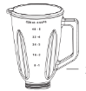

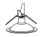

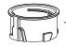

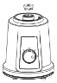

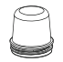

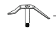

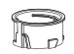

BEFORE FIRST USE
Before using your appliance for the first time take it out of the box and take off any protective wrapping. REMEMBER: DO NOT LEAVE PROTECTIVE PACKAGING LAYING AROUND, AS IT COULD BE DANGEROUS AROUND INFANTS.
Wash the jug, jug cover and mill in warm soapy water, rinse well and dry.
NOTE: The blades are sharp, handle with care.

OPERATING INSTRUCTIONS

- Place the motor base on a clean, dry, level surface such as a counter or table top.

- Ensure the unit is off before adding the ingredients

- Put ingredients into the jug. The jug has a maximum capacity of 1500 ml, to avoid possible foaming or spilling when blending the ingredients, do not fill the jug over the 1250ml mark.
- Secure the jug cover onto the jug and place the jug onto the motor base, ensuring it’s locked in properly.

- Plug the power cord into the electrical outlet and select the speed to start the machine.

- Don’t remove the jug cover from the jug while the blender is ON.

- Do not operate on the preferred speed setting for longer than 1 minute.

- Let the product and mixture cool down for 1 minute to room temperature before next cycle.

- After using the blender, always move the switch to the ‘0’ setting and remove the mains plug from the power outlet.

- To remove the jug just turn it in an anti-clockwise direction and then lift it up.

Pulse Function

The pulse function will give you a short burst at maximum speed, regardless of the current speed of the blades. The button is spring-loaded. When you stop pressing, it will return to the speed the switch is pointing at.

Crushing Ice

Before using the blender to crush ice, make sure it is clean and rinse it out thoroughly. Any remaining trace of detergent may affect the taste of the crushed ice and will flatten any drink to which it has been added.

Ice cubes come in many shapes and sizes. You will have to experiment with the ice from your ice cube tray. Insert a maximum of 12 ice cubes and add 60ml (4 tablespoons) of cold water. Put the jug cover on the blender and turn the control knob to “P”. While the unit is blending, hold for 2 seconds and release for 2 seconds. Note that too much blending will reduce the ice to liquid, too little will merely chip the edges/corners off the ice. Do not try to crush ice without adding water into the jug.

Do not be tempted simply to increase the amount of ice and blend for longer – this will not work. Too much ice will never give you satisfactory results.

Adding Ingredients

If you need to add ingredients while the blender is working, lift the removeable cap off, pour the new ingredients then re-place the removeable cap. Make sure that the added ingredients do not push the volume in the jug past the MAX. mark.

Tips for Using Your Blender

- Do not blend dry, thick or heavy mixtures for more than 60 seconds continuously. Let the appliance cool down before you continue operating the appliance again.
- Do not place the jug cover into boiling water as it may deform.
- To achieve the best results when pureeing solid ingredients, place small portions into the jug one by one instead of placing a large quantity all at once.
- If you are blending solid ingredients, cut them into small pieces first (2-3cm).
- When blending solid ingredients start off first with a small amount of liquid. Gradually add more and more liquid.
- For blending solid or very thick liquid ingredients we recommend that you use the blender in pulse mode to prevent the blades from becoming stuck.
- Always place your hand on top of the blender when you are operating the device.

CAUTION: Do not use the jug blender when it is empty.

Mill attachment:

- Fill the glass mill with ingredients you wish to grind. Do not fill the cup more than ¾ of it’s capacity.
- Securely lock in the glass mill onto the motor unit by turning it in a clockwise direction.
- Ensure that it is properly locked in and that there is no gap between the glass rim on the mill and the base of the mill.
- With one hand push the grinding mill down and with the other select the desired speed. Ensure the grinding mill is pushed down throughout the entire grinding process.
- Turn the glass mill counter clockwise to loosen it from the motor unit.

Note: Do not grind nutmeg in this grinding mill.

CLEANING AND MAINTENANCE
- This appliance is for household use only and is not user-serviceable.
- Always remember to unplug the unit from the electrical outlet when not in use and before cleaning.
- Do not use bleach or other abrasive substances or solvents to clean your appliance as it can be damaging to the finish.
- Do not immerse the whole unit in water or any other liquid or hold it under a running tap to clean.
- Clean after use to prevent residues from settling inside the jug.
- Remove the jug from the motor unit. Wash the jug, jug cover and mill in warm soapy water, rinse well, then turn the jug upside down to dry.
- Keep hands out of the jug – BLADES ARE VERY SHARP.
- If the jug is left for too long without cleaning and bits have glued themselves onto the inside of the jug, use a nylon brush to remove.
- Wipe the outside of the motor unit with a clean damp cloth.
- Do not put the motor unit in water or any other liquid.

Quick glass jug cleaning tip -

Empty the glass jug and fill it with water. Place the glass jug on the motor and turn the switch several times to the ‘P’ function. Empty the glass jug and rinse until clean.

Thorough cleaning of the dismantled glass jug -

Ensure that the glass jug is completely empty before you unscrew the blade assembly. Be careful when handling the blade. All removable parts are suitable for the dishwasher. Note that the dishwasher can affect the surface finishes. Do not use harsh or abrasive cleaning agents or solvents.

STORING THE APPLIANCE
- Unplug the unit from the wall outlet and clean all the parts as instructed above. Ensure that all parts are dry before storing.
- Store the appliance in its box or in a clean, dry place.
- Never store the appliance while it is still wet or dirty.
- Never wrap the power cord around the appliance.

SERVICING THE APPLIANCE
There are no user serviceable parts in this appliance. If the unit is not operating correctly, please check the following:
- You have followed the instructions correctly
- That the unit has been wired correctly and that the wall socket is switched on.
- That the mains power supply is ON.
- That the plug is firmly in the mains socket.

If the appliance still does not work after checking the above:
- Consult the retailer for possible repair or replacement. If the retailer fails to resolve the problem and you need to return the appliance, make sure that:
- The unit is packed carefully back into its original packaging.
- Proof of purchase is attached.
- A reason is provided for why it is being returned.

If the supply cord is damaged, it must be replaced by the manufacturer or an authorised service agent, in order to avoid any hazard. If service becomes necessary within the warranty period, the appliance should be returned to an approved Home Of Living Brands (Pty) Limited service centre. Servicing outside the warranty period is still available, but will, however, be chargeable.

CHANGING THE PLUG

Should the need arise to change the fitted plug, follow the instructions below.
This unit is designed to operate on the stated current only. Connecting to other power sources may damage the appliance.

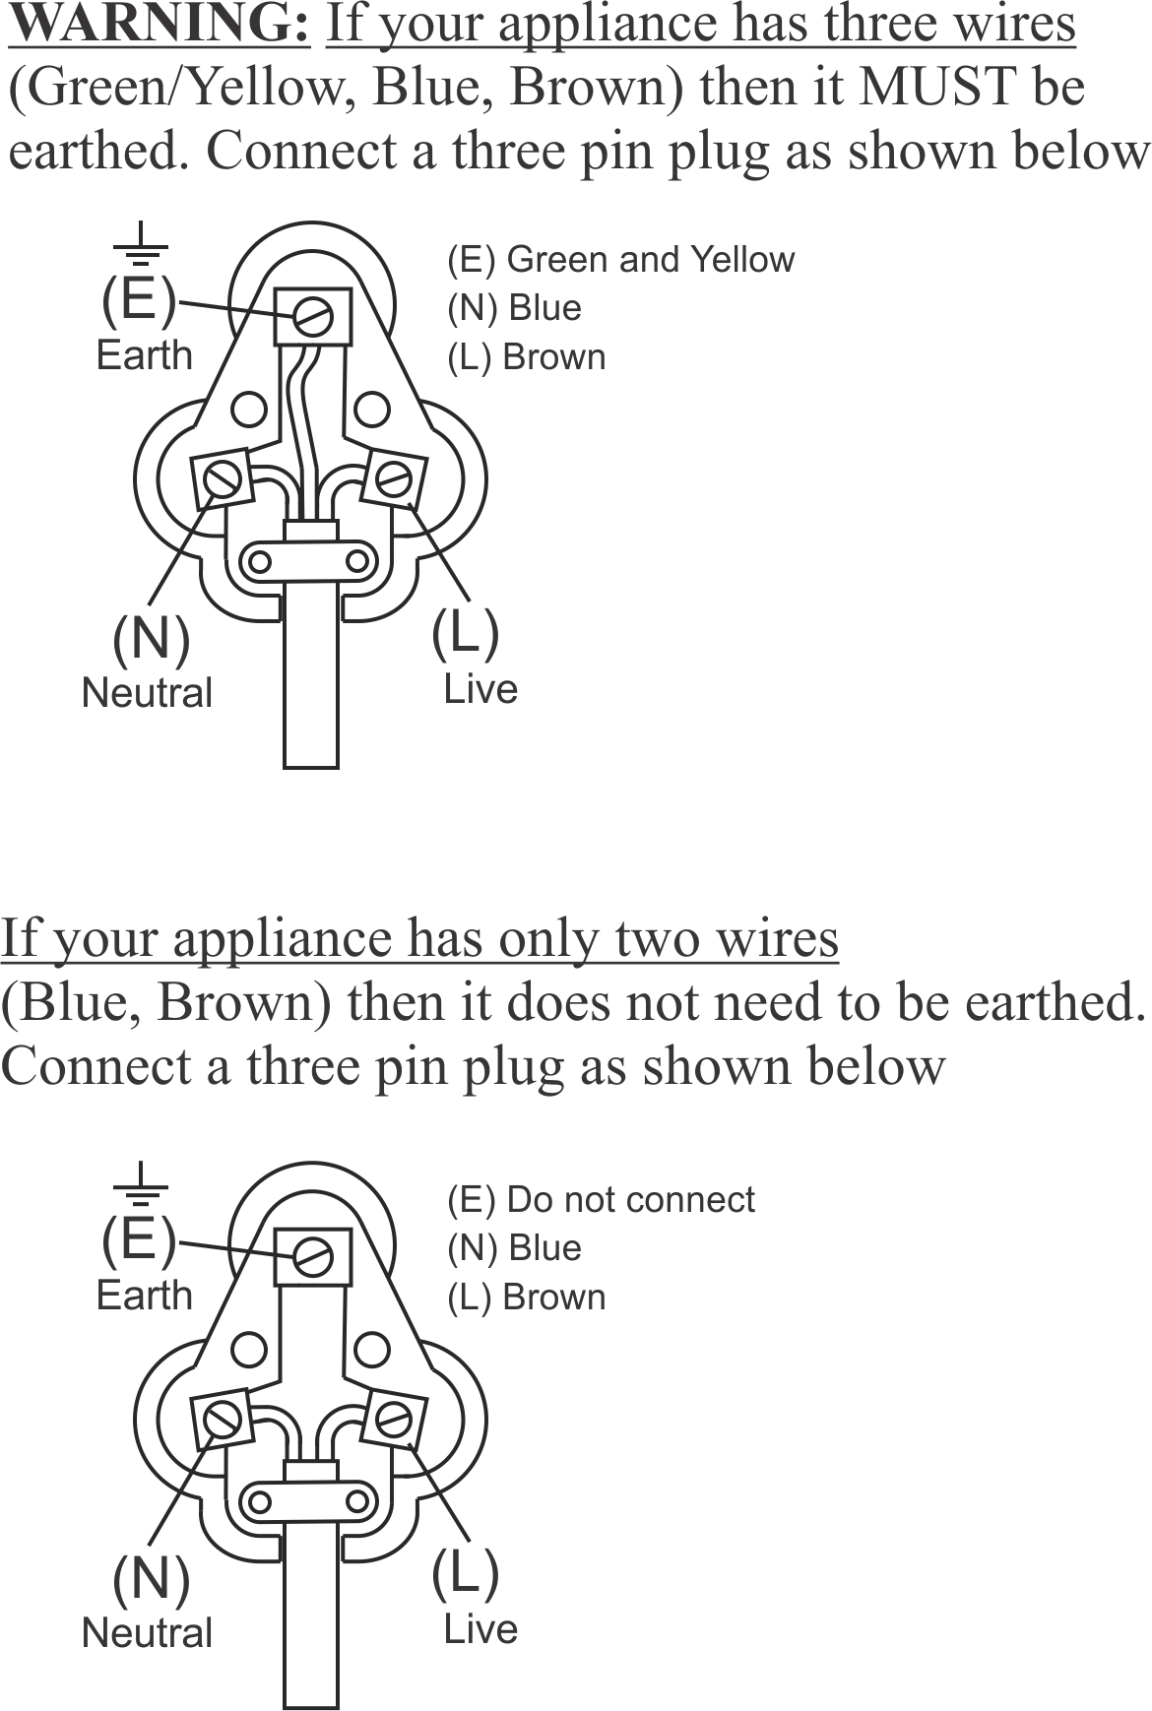

PLEASE AFFIX YOUR PROOF OF PURCHASE/RECEIPT HERE
IN THE EVENT OF A CLAIM UNDER WARRANTY THIS RECEIPT MUST BE PRODUCED.

2 YEAR WARRANTY
1 year retail ⵏ 1 year extended warranty upon registration*
visit www.russellhobbs.co.za

W A R R A N T Y AND EXTENDED WARRANTY

- Home of Living Brands (Pty) Limited ("Home of Living Brands") warrants to the original purchaser of this product ("the customer") that this product will be free of defects in quality and workmanship which under normal personal, family or household use and purpose may manifest within a period of 1 (one) year from the date of purchase ("warranty period").
- Home of Living Brands shall extend the warranty period for a further period of 1(one) year (“extended warranty period*”), on condition that the purchaser registers the product on the website, within 12 months from the date of purchase of the product. The website address for registration is as follows: http://russellhobbs.co.za/info-pages/warranty-info.aspx. The extended warranty period only applies to products purchased on or after 1 October 2017.
- Where the customer has purchased a product and it breaks, is defective or does not work properly for the intended purpose, the customer must notify the supplier from whom the customer bought the product ("the supplier") thereof within the warranty period or if applicable, the extended warranty period. Any claim in terms of this warranty must be supported by a proof of purchase. If proof of purchase is not available, then repair, and/or service charges may be payable by the customer to the supplier.
- The faulty product must be taken to the supplier's service centre to exercise the warranty.
- The supplier will refund, repair or exchange the product in terms of this warranty subject to legislative requirements. This warranty shall be valid only where (a) the customer is not the cause of the product breaking, and (b) the product has been used for the intended purpose stipulated in the product manual. The warranty does not include and will not be construed to cover products damaged as a result of disaster, misuse, tamper, abuse or any unauthorised modification or repair of the product.
- This warranty will extend only to the product provided at the date of the purchase and not to any expendables attached or installed by the customer. In this regard any accessories supplied with the product by the supplier, may be excluded in this warranty or extended warranty (see Exclusions to Warranty and Extended Warranty document).
- If the customer requests that the supplier repairs the product and the product breaks or fails to work properly within 3 (three) months of the repair and not as a result of misuse, tampering or modification by or on behalf of the customer, then the supplier may replace the product or pay a refund to the customer, subject to the supplier’s discretion.
- The customer may be responsible for certain costs where products returned are not in the original packaging, or if the packaging is damaged. This will be deducted from any refund paid to the customer.

HOME OF LIVING BRANDS (PTY) LTD (JOHANNESBURG)

JOHANNESBURG TEL NO. (011) 490-9600
CAPE TOWN TEL NO. (021) 552-5161
DURBAN TEL NO. (031) 303-1163
www.homeoflivingbrands.com
www.russellhobbs.co.za
www.facebook.com/RussellHobbsSA

EXCLUSIONS TO W A R R A N T Y AND EXTENDED WARRANTY

- Any accessories supplied with the product, including but not limited to, bowls, jugs, mills or carafes made either of glass or plastic and supplied with this appliance (hereinafter referred to as “the accessory or accessories”), is warranted to be free from material and workmanship defects for the duration of the appliance warranty.
- The accessories should give trouble free service when used in accordance with the directions described in the instruction manual. However, the accessories will be damaged if subjected to impact, and this damage is not covered by the warranty. Such impact damage can occur either from the outside (if for example it is dropped or knocked against a hard surface), or from within (if for example foreign objects are placed within the accessories and the power is switched on).
- Should you need to replace an accessory during the warranty period; a claim for a free replacement will only be considered if the item (including all shards and broken parts) is returned to the nearest HOLB service centre for examination.
- The remains of the accessory will be carefully examined by the relevant professionals and if it is determined (at the sole discretion of HOLB) that the damage was caused by impact, then the claim will be refused and will not be covered by the warranty or any extended warranty.
- Any replacement part provided in terms of clause 4 above will become a chargeable item payable by the customer.

