INSTRUCTIONS AND WARRANTY

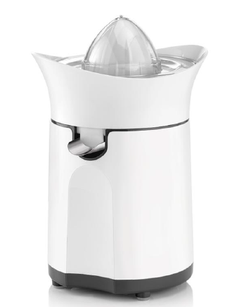

MODEL NO. RHCJ11

RUSSELL HOBBS INFINITY 60W CITRUS PRESS

Thank you for purchasing the Russell Hobbs Infinity 60W Citrus Press. Each unit has been manufactured to ensure safety, reliability and ease of use. Before use, please read the instructions carefully and keep it for future reference. Should you pass the unit on, please ensure that you also pass the instruction manual.

FEATURES OF THE RUSSELL HOBBS INFINITY 60W CITRUS PRESS

Bringing versatility, efficiency and effortless cleaning to your kitchen

Designed to extract maximum amounts of juice out of any citrus fruit

2 x interchangeable juicing cones

1 x small one for lemons and limes and 1 x larger one for oranges and grapefruits

60W

Anti-drip spout

Classic white finish

Automatic 2-way juicing

Disassembles easily for quick and easy cleaning

For domestic use only

2 year warranty (1 year retail • 1 year extended upon online registration of product • visit www.russellhobbs.co.za)

IMPORTANT SAFEGUARDS

- Please read the instructions carefully before using the appliance.
- Always ensure that the voltage on the rating label corresponds to the mains voltage in your home.
- Incorrect operation and improper use can damage the appliance and cause injury to the user.
- The appliance is intended for household use only. Commercial use invalidates the warranty and the supplier cannot be held responsible for injury or damage caused when using the appliance for any other purpose than its intended use.
- Always disconnect the appliance from the power supply if it is left unattended and before assembling, disassembling or cleaning.
- Do not operate the appliance for longer than two minutes. Allow the appliance to cool down to room temperature to avoid overheating.
- Do not store any materials other than the manufacturer’s recommended accessories in this unit when not in use.
- Do not place any of the following materials inside the unit: paper, cardboard, plastic or anything of this nature.
- Close supervision is required when any appliance is used near or by children.
- When using an electrical appliance, basic precautions should always be followed.
- Check the power cord and plug regularly for any damage. If the cord or the plug is damaged, it must be replaced by the manufacturer or a qualified person in order to avoid any electrical hazard.
- Do not use the appliance if it has been dropped or damaged in any way. In case of damage, take the unit in for examination and/or repair by an authorised service agent.
- To reduce the risk of electric shock, do not immerse the unit plug or the power cord into water or any other liquid. Do not use the appliance with wet hands.
- Do not use if supply cord is damaged. If the supply cord is damaged, it must be replaced by the manufacturer, its service agent or a similarly qualified person in order to avoid hazard.
- Remove the plug from the socket by gripping the plug. Do not pull on the cord to disconnect the appliance from the mains. Always unplug the unit when not in use, before cleaning or when adding or removing parts.
- This appliance is not intended for use by persons (including children) with reduced physical, sensory or mental capabilities, or lack of experience and knowledge, unless they are under supervision or instruction concerning use of the appliance by a person responsible for their safety. Children should be supervised to ensure that they do not play with the appliance.
- A short cord is provided to reduce the hazards resulting from becoming entangled in or tripping over a longer cord.
- Do not let the cord hang over the edge of a table or counter. Ensure that the cord is not in a position where it can be pulled on accidentally.
- Do not allow the cord to touch hot surfaces and do not place it on or near a hot gas, electric burner or in a heated oven.
- Do not use the appliance on a gas or electric cooking top, over or near an open flame.
- Keep the appliance and cord away from direct radiant heat from the sun, damp areas, sharp edges and other dangers.
- Use of an extension cord with this appliance is not recommended. However, if it is necessary to use an extension cord, ensure that the cord is suited to the power consumption of the appliance to avoid overheating of the extension cord, appliance or plug point. Do not place the extension cord in a position where it can be pulled on by children or animals or tripped over.
- The manufacturer does not accept responsibility for any damage or injury caused by improper or incorrect use, or for repairs carried out by unauthorised personnel.
- Never pull the cord to disconnect it from the outlet. Grasp the plug and pull it from the outlet.
- Never lift or carry the citrus press by the cord.
- Keep the cord away from heated surfaces.
- This citrus press is for household use only. Any other use will void the warranty.
- Do not plug the unit into the power socket before set up is complete.
- Caution: Please keep this product away from the fire or similar hazardous substances.
- DISPOSAL: Do not dispose this product as unsorted municipal waste. Collection of such waste separately for special treatment is necessary.
- Do not store explosive substances such as aerosol cans with a flammable propellant in this appliance.

PARTS DIAGRAM

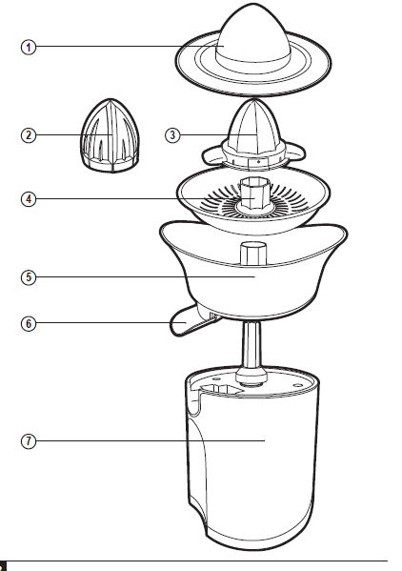

- Lid
- Small juicing cone
- Large juicing cone
- Pulp strainer
- Filter basket
- Spout
- Motor unit

BEFORE FIRST USE
Before using your appliance for the first time remove the appliance from the box and take off any protective wrappings.
Note: Do not leave protective packaging lying around, as it could be dangerous around infants.

OPERATING INSTRUCTIONS

- Before using the appliance for the first time, wash all the removable parts. Do not wash the base containing the motor.
- Remove the all packaging and covers and unwind the cable.
- Plug the citrus press into the mains.
- Cut the fruit (oranges, lemons, grapefruits etc.) in half.
- Use the cone in relation to the size of the citrus fruit. Gently press the side of the fruits where the flesh is exposed against the cone to automatically start the motor and extract the juice from the fruit.
- Do not put excessive pressure on the cone; otherwise the motor will begin to lose power and speed.
- Too much pressure on the cone may cause the motor to block.
- The motor stops automatically as soon as you cease to press the fruit against the cone.
- Please make sure the juice doesn’t pour out as you are juicing. To ensure this does not occur, the juice can be poured directly into a glass. To do so, place a glass under the dispenser spout and press the spout down gently into its serving position.
- Do not operate the citrus press for more than two minutes consecutively.
- Wait five minutes between operation cycles and allow the motor to cool down to room temperature.
- After you have processed all ingredients and the juice flow has stopped, switch off the appliance and wait until the filter has stopped rotating.

Note: After use, the spout must always be in the raised position.

Tips
- Use fresh fruit as they contain more juice.
- Remove the white pith of citrus fruits because it has a bitter taste.
- Drink the juice immediately after you have extracted it. If it is exposed to air for some time, the juice will lose its taste and nutritional value.
- To extract the maximum amount of juice, press the citrus fruit onto the cone several times instead of keeping it continually pressed.
- This type of citrus press is not suitable for processing very hard and/or rubbery/starchy fruits or vegetables such as sugar cane.

CLEANING AND MAINTENANCE

- Always remember to unplug the unit from the electrical outlet when not in use and before cleaning.
- Wash the cone, filter and juice container every time you use the appliance. Wash it with normal detergent and lukewarm water. Rinse and dry well.
- The body of the appliance containing the motor cannot be immersed in water. It can be cleaned with a moist cloth. Do not let water enter the appliance.
- Do not use bleach or other abrasive substance or solvents to clean your appliance as it can be damaging to the finish.
- Do not immerse the appliance in water or any other liquid or hold it under a running tap to clean.
- To remove stubborn spots/marks, wipe the surfaces with a cloth slightly dampened in soapy water or mild non-abrasive cleaner. Rinse and dry with a clean, dry, soft cloth.

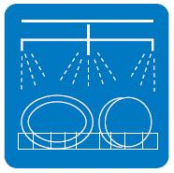
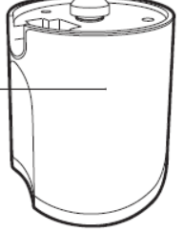
Plastic Filter
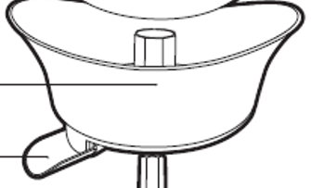
STORING THE APPLIANCE
- Unplug the unit from the wall outlet and clean all the parts as instructed above. Ensure that all parts are dry before storing.
- Store the appliance in its box or in a clean, dry place.
- Never store the appliance while it is still wet or dirty.

SERVICING THE APPLIANCE
There are no user serviceable parts in this appliance. If the unit is not operating correctly, please check the following:
- You have followed the instructions correctly
- That the unit has been wired correctly and that the wall socket is switched on.
- That the mains power supply is ON.
- That the plug is firmly in the mains socket.

If the appliance still does not work after checking the above:
- Consult the retailer for possible repair or replacement. If the retailer fails to resolve the problem and you need to return the appliance, make sure that:
- The unit is packed carefully back into its original packaging.
- Proof of purchase is attached.
- A reason is provided for why it is being returned.

If the supply cord is damaged, it must be replaced by the manufacturer or an authorised service agent, in order to avoid any hazard. If service becomes necessary within the warranty period, the appliance should be returned to an approved Home Of Living Brands (Pty) Limited service centre. Servicing outside the warranty period is still available, but will, however, be chargeable

CHANGING THE PLUG
Should the need arise to change the fitted plug, follow the instructions below.
This unit is designed to operate on the stated current only. Connecting to other power sources may damage the appliance.

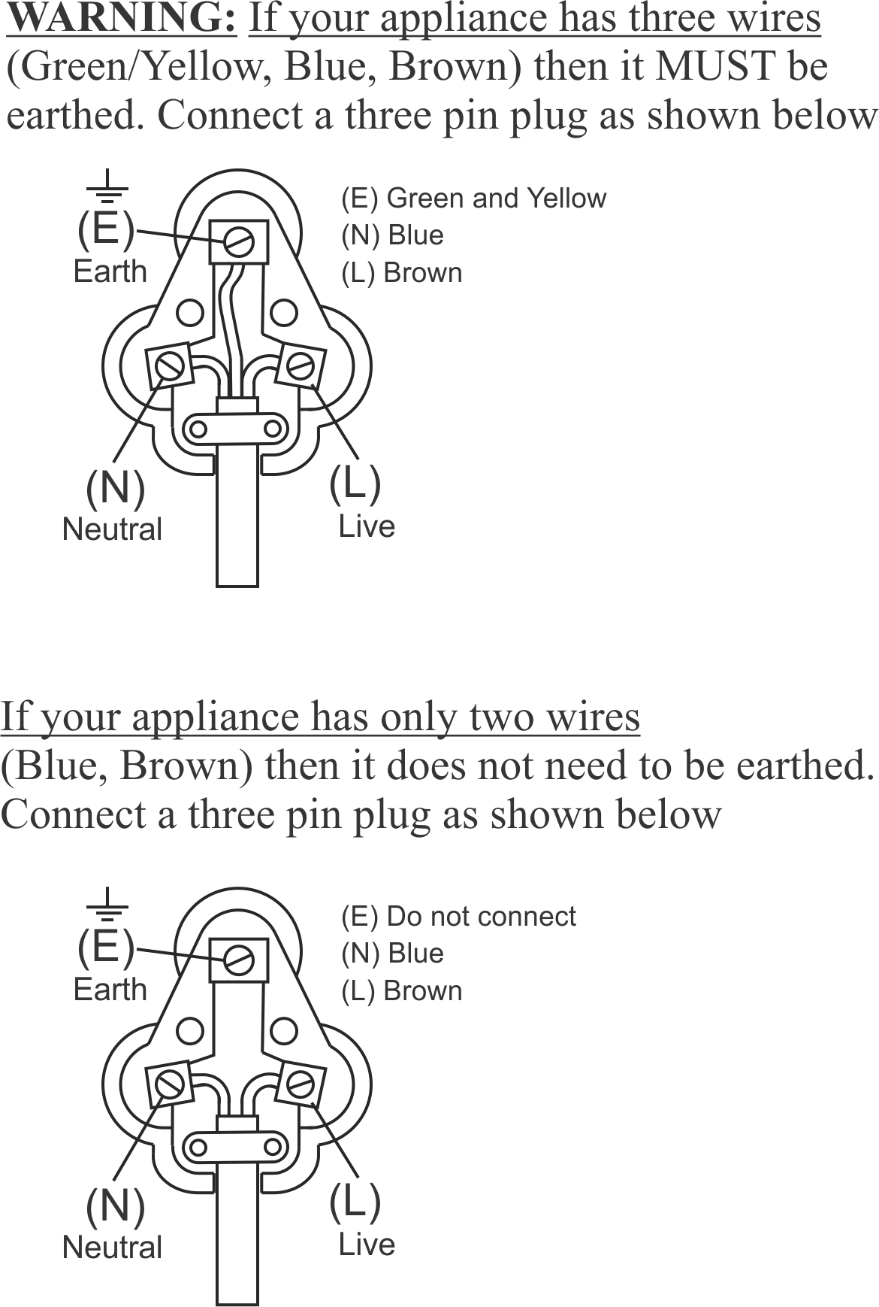

PLEASE AFFIX YOUR PROOF OF PURCHASE/RECEIPT HERE
IN THE EVENT OF A CLAIM UNDER WARRANTY THIS RECEIPT MUST BE PRODUCED.

2 YEAR WARRANTY
1 year retail ⵏ 1 year extended warranty upon registration*
visit www.russellhobbs.co.za

W A R R A N T Y AND EXTENDED WARRANTY

- Home of Living Brands (Pty) Limited ("Home of Living Brands") warrants to the original purchaser of this product ("the customer") that this product will be free of defects in quality and workmanship which under normal personal, family or household use and purpose may manifest within a period of 1 (one) year from the date of purchase ("warranty period").
- Home of Living Brands shall extend the warranty period for a further period of 1(one) year (“extended warranty period*”), on condition that the purchaser registers the product on the website, within 12 months from the date of purchase of the product. The website address for registration is as follows: http://russellhobbs.co.za/info-pages/warranty-info.aspx. The extended warranty period only applies to products purchased on or after 1 October 2017.
- Where the customer has purchased a product and it breaks, is defective or does not work properly for the intended purpose, the customer must notify the supplier from whom the customer bought the product ("the supplier") thereof within the warranty period or if applicable, the extended warranty period. Any claim in terms of this warranty must be supported by a proof of purchase. If proof of purchase is not available, then repair, and/or service charges may be payable by the customer to the supplier.
- The faulty product must be taken to the supplier's service centre to exercise the warranty.
- The supplier will refund, repair or exchange the product in terms of this warranty subject to legislative requirements. This warranty shall be valid only where (a) the customer is not the cause of the product breaking, and (b) the product has been used for the intended purpose stipulated in the product manual. The warranty does not include and will not be construed to cover products damaged as a result of disaster, misuse, tamper, abuse or any unauthorised modification or repair of the product.
- This warranty will extend only to the product provided at the date of the purchase and not to any expendables attached or installed by the customer. In this regard any accessories supplied with the product by the supplier, may be excluded in this warranty or extended warranty (see Exclusions to Warranty and Extended Warranty document).
- If the customer requests that the supplier repairs the product and the product breaks or fails to work properly within 3 (three) months of the repair and not as a result of misuse, tampering or modification by or on behalf of the customer, then the supplier may replace the product or pay a refund to the customer, subject to the supplier’s discretion.
- The customer may be responsible for certain costs where products returned are not in the original packaging, or if the packaging is damaged. This will be deducted from any refund paid to the customer.

HOME OF LIVING BRANDS (PTY) LTD (JOHANNESBURG)

JOHANNESBURG TEL NO. (011) 490-9600
CAPE TOWN TEL NO. (021) 552-5161
DURBAN TEL NO. (031) 303-1163

www.homeoflivingbrands.com
www.russellhobbs.co.za
www.facebook.com/RussellHobbsSA

EXCLUSIONS TO W A R R A N T Y AND EXTENDED WARRANTY

- Any accessories supplied with the product, including but not limited to, bowls, jugs, mills or carafes made either of glass or plastic and supplied with this appliance (hereinafter referred to as “the accessory or accessories”), is warranted to be free from material and workmanship defects for the duration of the appliance warranty.
- The accessories should give trouble free service when used in accordance with the directions described in the instruction manual. However, the accessories will be damaged if subjected to impact, and this damage is not covered by the warranty. Such impact damage can occur either from the outside (if for example it is dropped or knocked against a hard surface), or from within (if for example foreign objects are placed within the accessories and the power is switched on).
- Should you need to replace an accessory during the warranty period; a claim for a free replacement will only be considered if the item (including all shards and broken parts) is returned to the nearest HOLB service centre for examination.
- The remains of the accessory will be carefully examined by the relevant professionals and if it is determined (at the sole discretion of HOLB) that the damage was caused by impact, then the claim will be refused and will not be covered by the warranty or any extended warranty.
- Any replacement part provided in terms of clause 4 above will become a chargeable item payable by the customer.

