
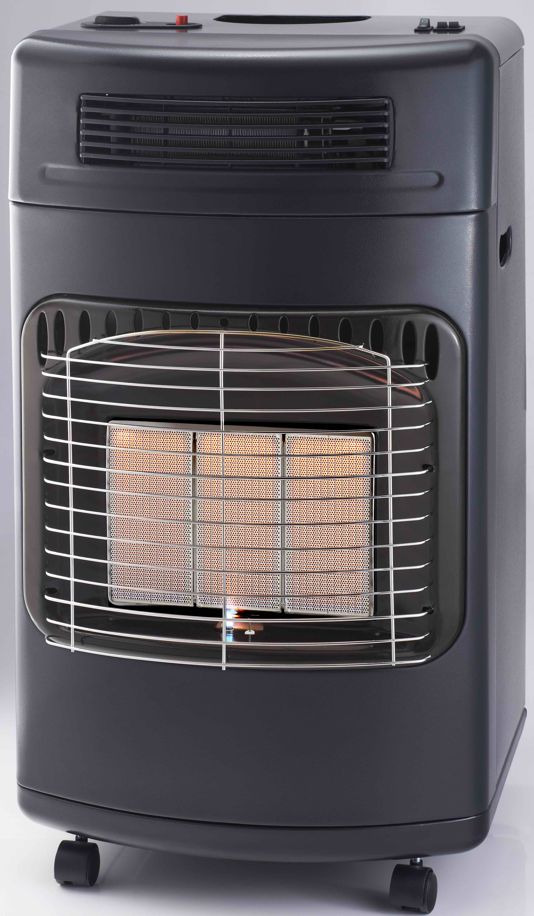
INSTRUCTIONS AND WARRANTY

MODEL: RHG03

RUSSELL HOBBS GAS HEATER

IMPORTANT: PLEASE READ BEFORE USE!
Congratulations on purchasing your Russell Hobbs gas/electric fan heater. Each unit is manufactured to ensure safety and reliability. Before using this appliance for the first time, please read the instruction manual carefully and keep it for future reference.

IMPORTANT SAFEGUARDS
When using any electrical appliance, basic safety precautions should always be followed including the following:

- Please read the instructions carefully before using any appliance.
- Always ensure that the voltage on the rating label corresponds to the mains voltage at home.
- Incorrect operation and improper use can damage the appliance and cause injury to the user.
- Use LPG (Liquid Petroleum Gas) only with this heater.
- The heater must always be turned OFF at the gas cylinder.
- Always ensure adequate ventilation for the safe and effective performance of the appliance.
- Children should be supervised to ensure that they do not play with the appliance.
- Never attempt to open any part of the heater or dismantle the controls. The supplier cannot accept responsibility for any possible unit failure should this instruction be ignored.
- The appliance is intended for household use only. Commercial use invalids the warranty and the supplier cannot be held responsible for injury or damage caused when using the appliance for any other purpose than that intended.
- Close supervision is required when any appliance is used near or by children or invalids.
- Do not use the appliance if it has been dropped or damaged in any way. In case of damage, take the unit in for examination and/or repair by an authorised service agent
- Never immerse the unit in water or any other liquid for cleaning purposes.
- The use of accessory attachments that are not recommended or supplied by the manufacturer may result in injuries, fire or electric shock.
- Do not use the appliance on a gas or electric cooking top or over or near an open flame.
- Always operate the appliance on a smooth, even, stable surface.
- Ensure that the switch is in the “Off” position after each use.
- The manufacturer does not accept responsibility for any damage or injury caused by improper or incorrect use, or for repairs carried out by unauthorised personnel.
- In case of technical problems, switch off the appliance and do not attempt to repair it yourself. Return the appliance to an authorised service facility for examination, adjustment or repair. Always insist on the use of original spare parts. Failure to comply with the above mentioned pre-cautions and instructions, could affect the safe operation of this machine.
- If the hose needs to be replaced, ensure that the replacement hose is suitable for LPG. Hoses should only be bought from certified gas dealers.
- Do not use the heater to cook or to heat food or fats.
- Always use the heater in an upright position.
- Always face the heater to the centre of the room.
- Do not leave the heater ON overnight.
- Do not cover the heater with any type of cloth, clothing, or foreign object or block the airflow in any way.
- The gas cylinder must always be in an upright position. Do not turn the cylinder upside down in order to empty it completely.
- Never use a naked flame (matches, lighter, candle) to test for gas leaks.
- Be aware that the appliance will remain hot for some time after use.
- Household use only.
- DO NOT COVER THE APPLIANCE.

PARTS DIAGRAM
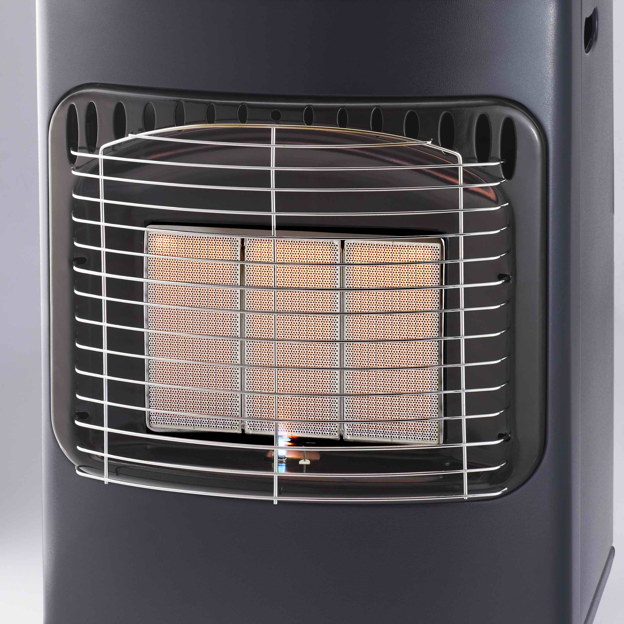
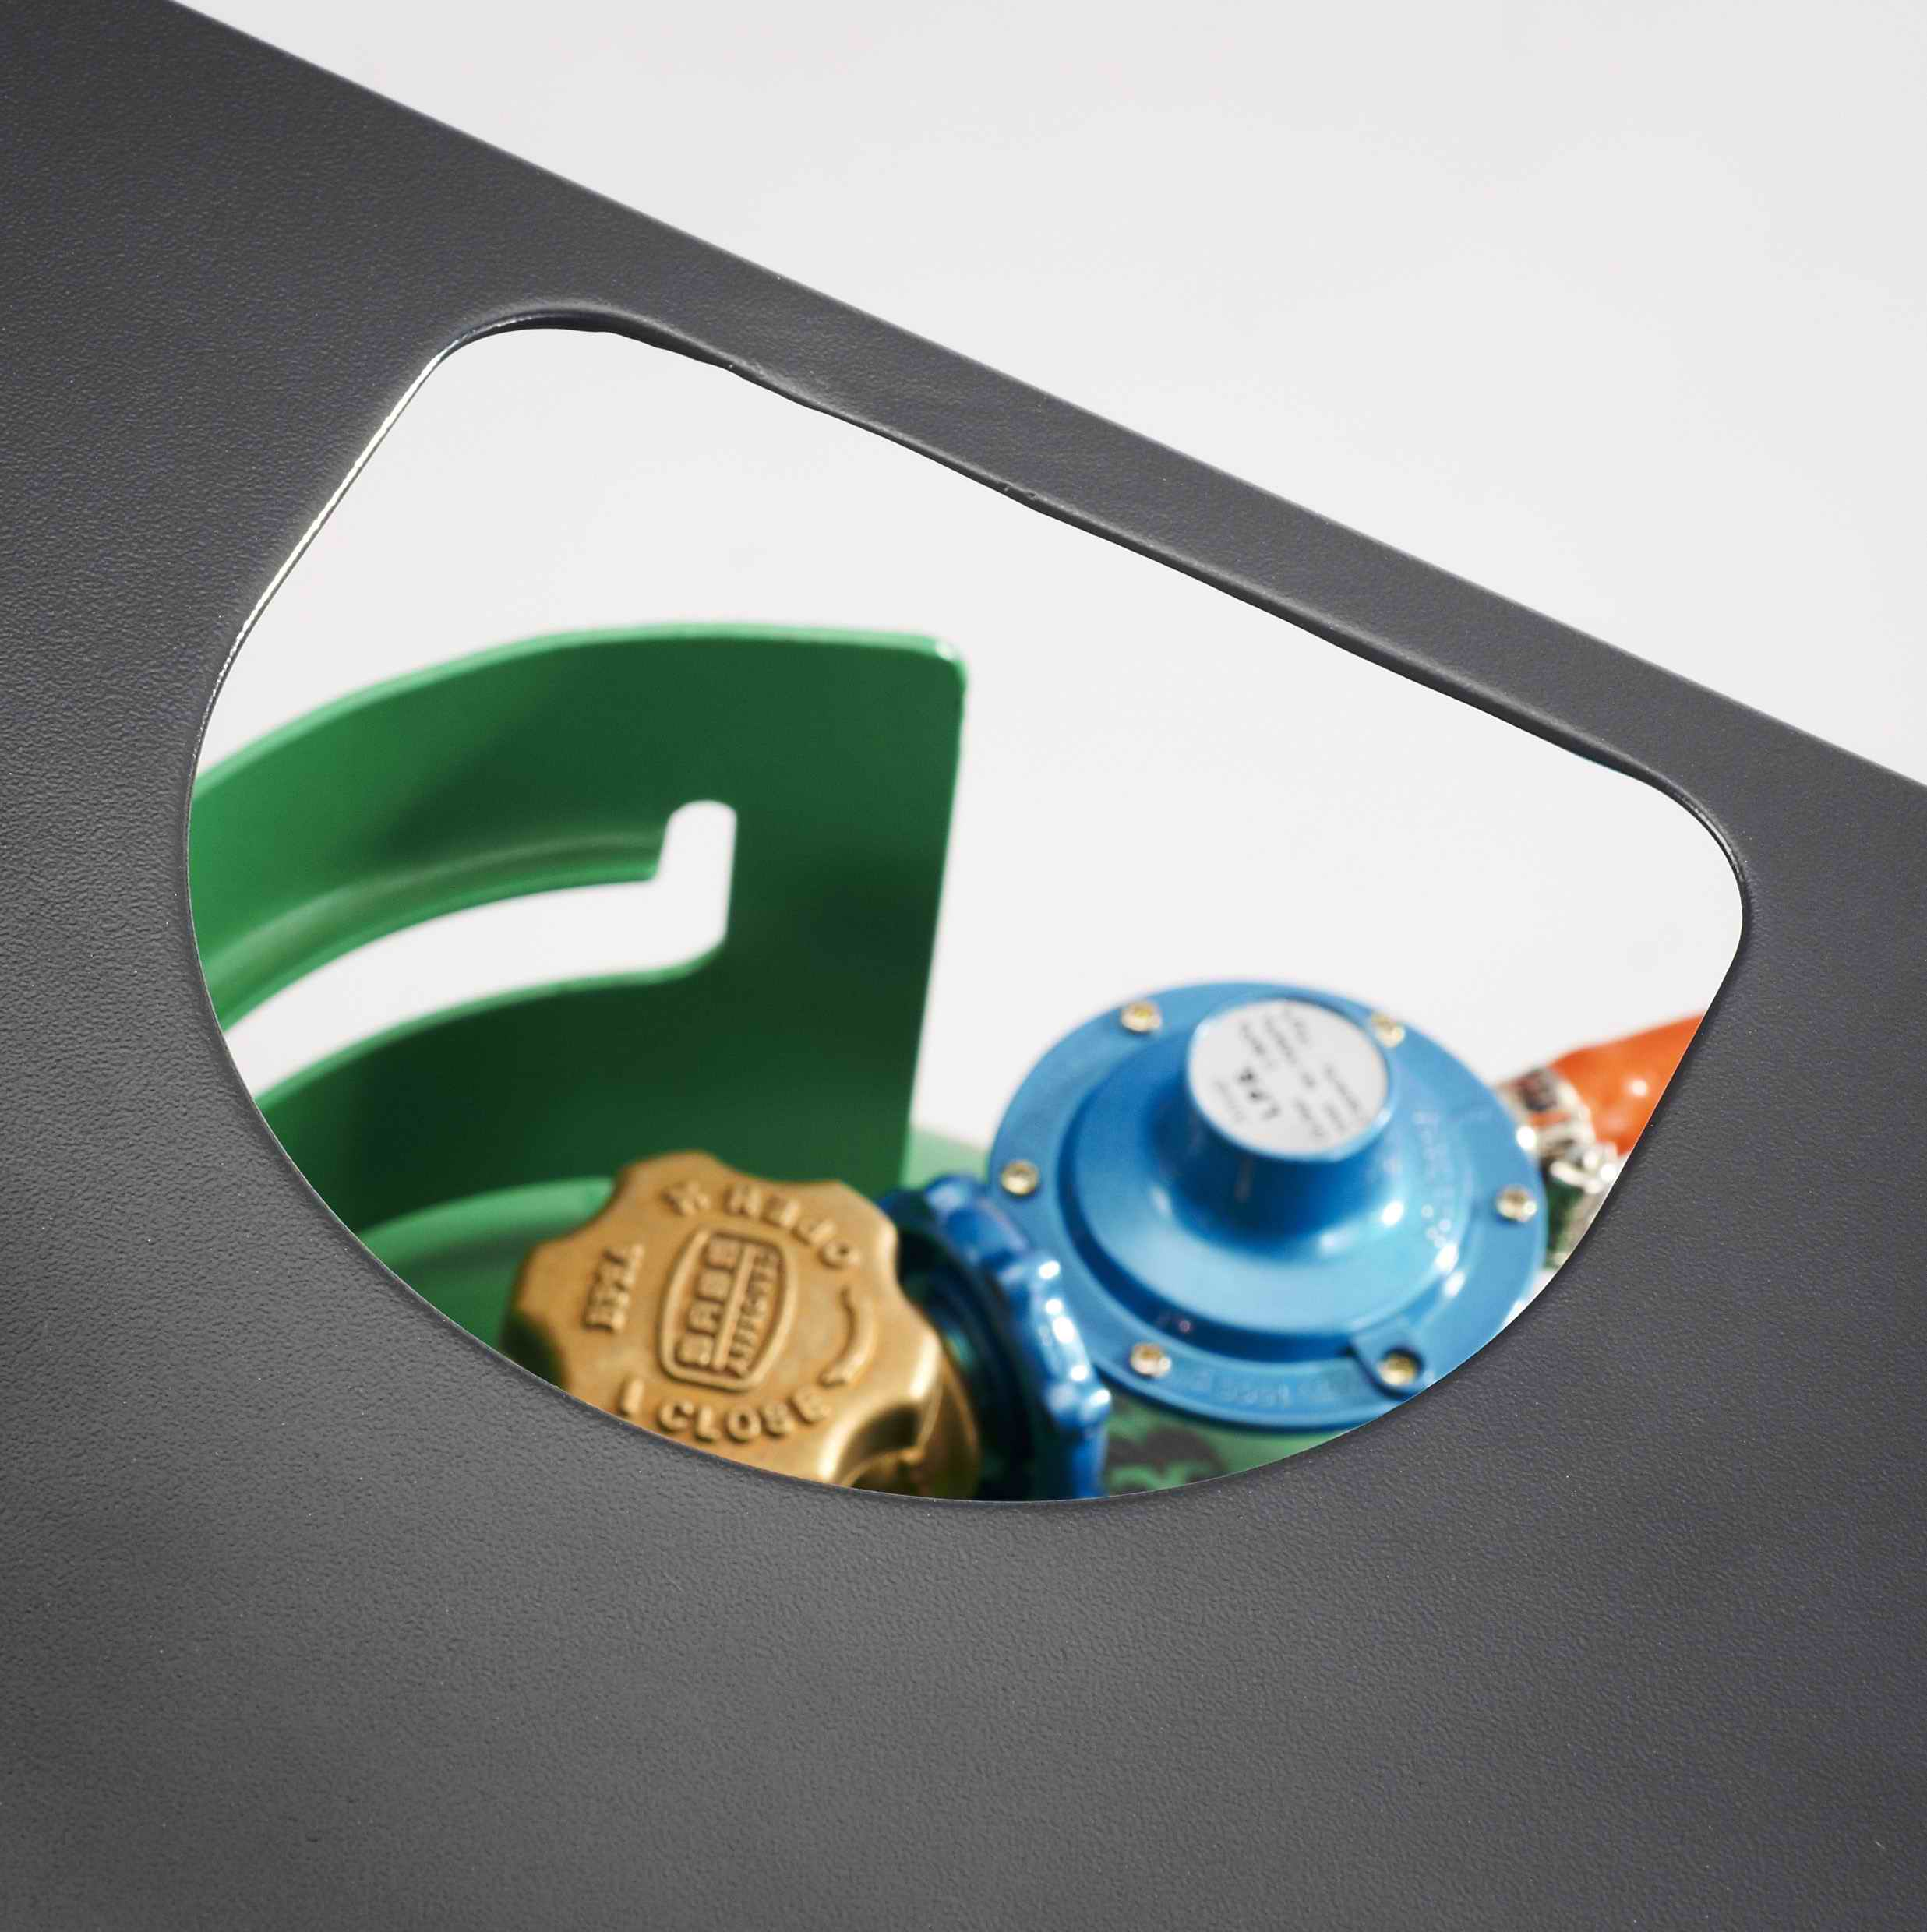
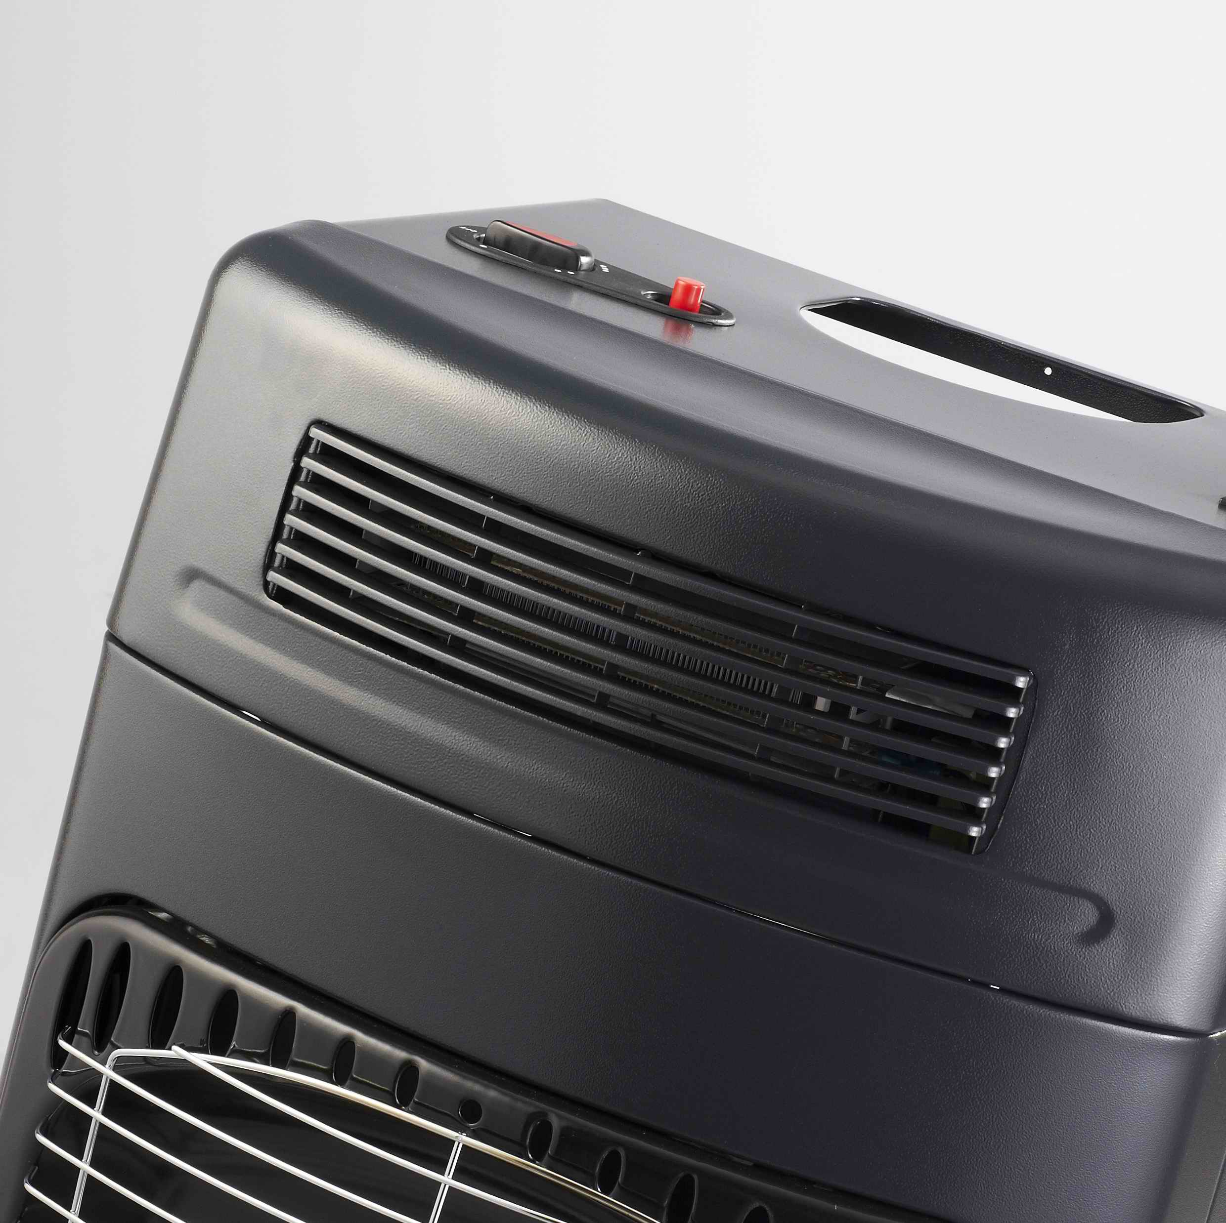
Fan Heater Grill
Safety Guard
Gas Bottle Access Opening
Heating Panel
Pilot Flame

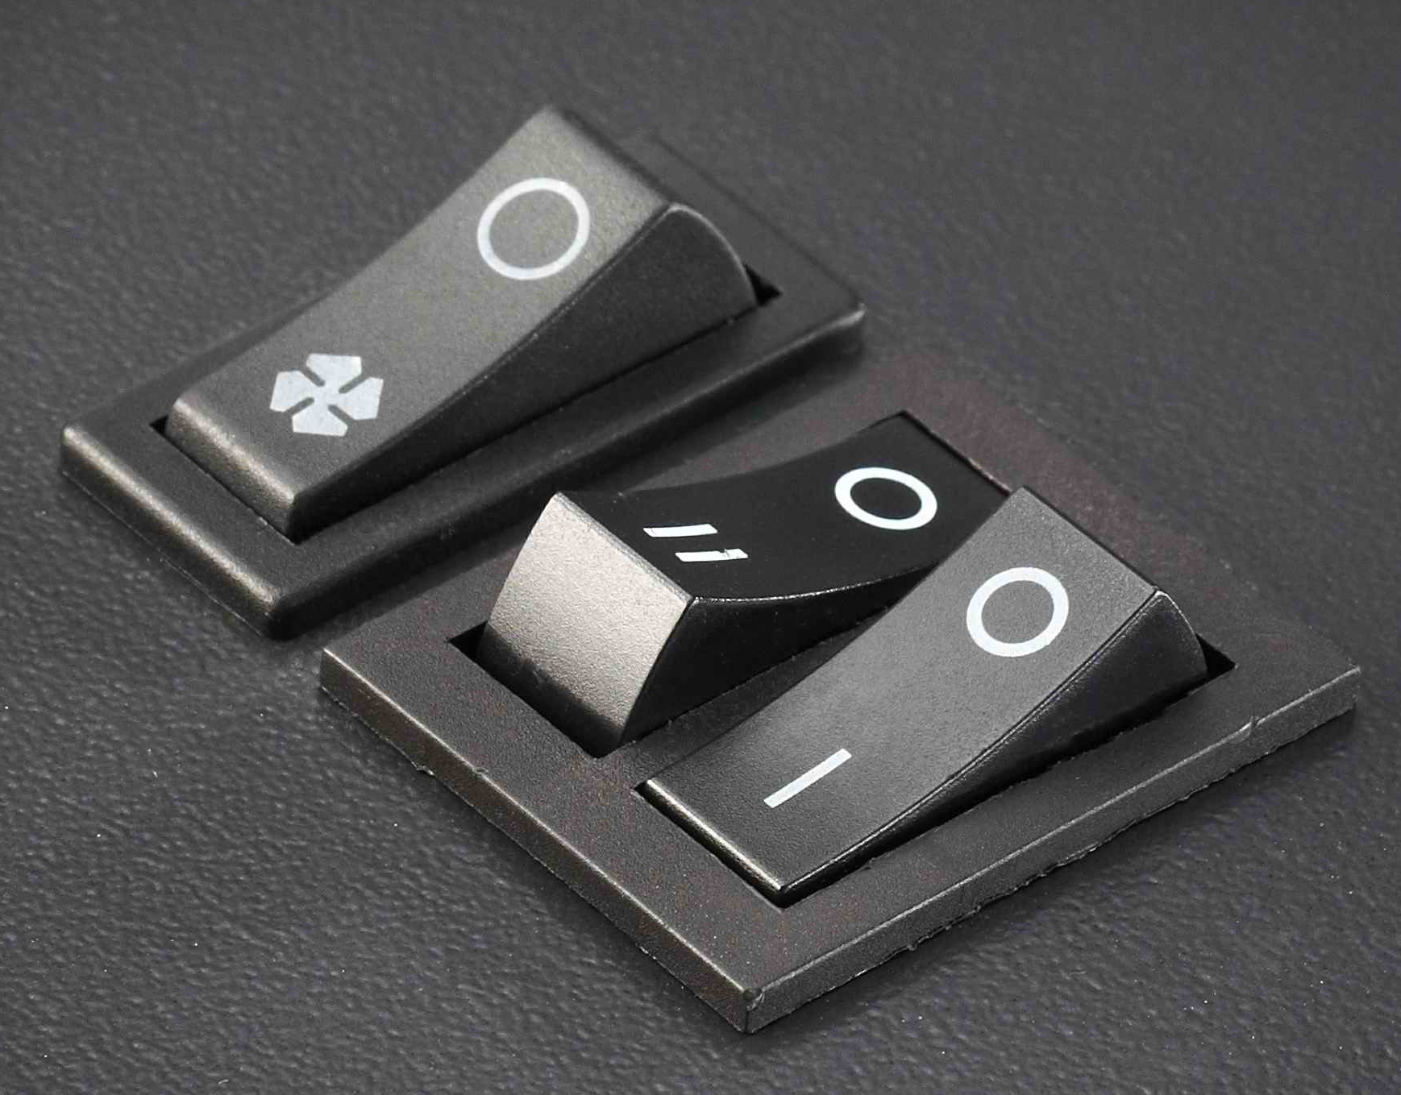
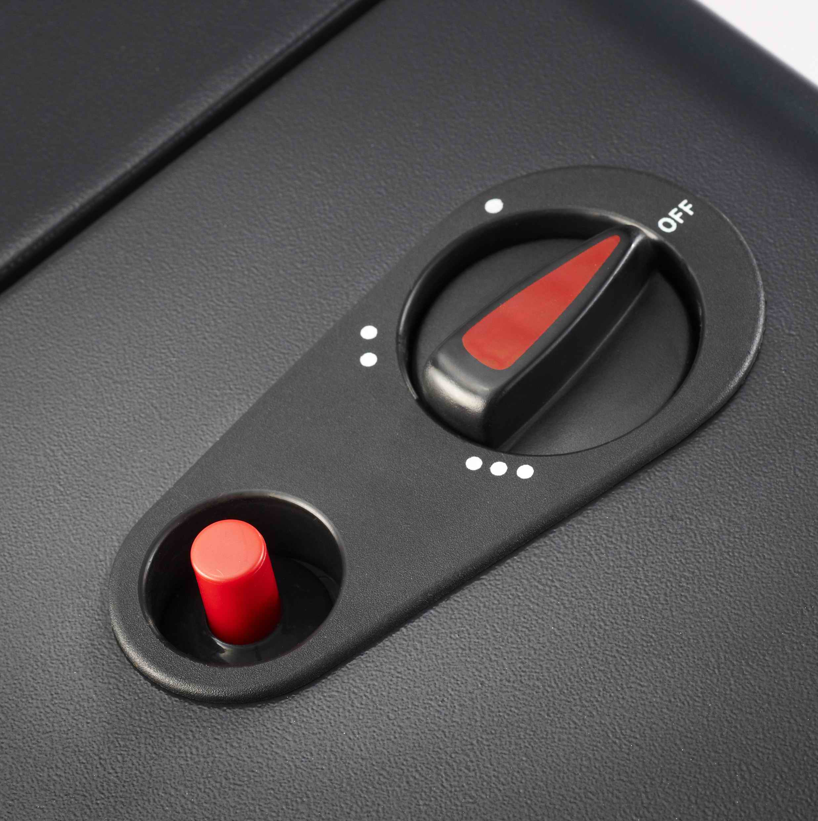
Fan Heater Switches
Spark and 1 Flame Mark
Piezo Ignition Button
Heat Selection Knob
Zero/Off Position

TO TEST FOR GAS LEAKS
- Extinguish all naked flames (open flames) and do not smoke or bring naked flames near the gas heater whilst testing.
- Take the heater outside.

- Turn the heater OFF at the cylinder (clockwise ) and undo (clockwise ) the regulator.
- Check all the hose connections and inspect the condition of the seal fitted on the regulator.

- Refit the regulator and then slowly turn the gas ON (anticlockwise ) one and a half turns. Coat all the connections with a cloth or brush moistened with soapy water or detergent.
- A gas leak will form bubbles in the areas where the solution has been applied. If a gas leak is detected, turn the gas cylinder control valve OFF (clockwise ). Inform the nearest service agent.
- Do not use the heater again until an approved/authorised service agent has inspected it.

OPERATING INSTRUCTIONS

CAUTION!
- Turn the gas ON and OFF at the Gas Cylinder Valve only.
- A max 13.1 kg cylinder (includes max 9.0 kg gas) is suitable for use with this heater.
- Unpack the heater and remove all protective wrapping.
- Untie the regulator from its shipping location and ensure that the hose is in perfect condition (fig. 3)
- Unclip the gas cylinder retaining panel from the back of the heater body (fig. 3)
- Place the full LPG cylinder beside the rear of the heater. Ensure that the valve is clean and free of any obstructions or foreign matter and screw the regulator (anticlockwise ) onto the cylinder valve. Turn by hand and do not use a spanner.
- Turn the gas supply ON (anticlockwise ) one and half turns at the cylinder control valve.
- Before first use it is advisable to check the connection between the gas cylinder and the regulator for gas leaks as described above.
- If there are no gas leaks, place the gas cylinder into the rear of the heater body making sure that the cylinder is placed in such a manner that the hose is not trapped or blocked in any way.
- Fit the rear retaining panel back onto the body ensuring that it is clipped on to both sides of the heater.

LIGHTING THE HEATER
- The regulator must be securely and fully fastened to the gas cylinder valve.
- To turn the gas ON – carefully open the cylinder valve (anticlockwise ) to a maximum of one and a half turns.
- 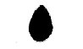Turn the heat selection knob on the top panel of the heater to the first position( 0 )
- Push the heat selection knob down and hold it down for 10 seconds. The gas will flow through the pipe to the heater.
- While holding the selector knob down, depress the ignition button repeatedly until the pilot flame ignites. Panel 1 will start. Release the ignition button.
- The heater is now turned onto Level 1, with one ceramic panel heating. Select your required heating level by turning the heat selection knob:
  - ( 0 ) : Level 1 – No panel Heating/Off Position
  - () : Level 2 – centre panel heating
  - ( 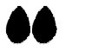) : Level 3 – two panels heating
  - ( 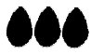 ) : Level 4 – three panels heating

TURNING THE GAS HEATER “OFF”
- Turn the heat control knob to ( 0 )
- Turn OFF the gas clockwise at the gas cylinder’s control valve.
- The flame at the bottom of the centre panel should automatically extinguish itself. Should it not do so, check that the gas cylinder is OFF.

CHANGING THE GAS CYLINDER
- Take the heater outside and remove the rear panel.
- Remove the gas cylinder from the heater and place it on the floor next to the heater. MAKE SURE THAT THE CYLINDER VALVE IS CLOSED BEFORE ATTEMPTING TO DISCONNECT THE REGULATOR. Unscrew the regulator clockwise .
- Before connecting the refilled cylinder, check that the nose seal on the regulator is not damaged and is still in good condition. If in doubt, take the regulator to an authorised dealer to be checked.
- Screw the regulator anticlockwise onto the new cylinder and fit the cylinder into the rear of the heater body. Ensuring that it is placed in such a manner that the hose is not trapped or block in any way.
- Fit the retaining panel back on to the body securing the clips on both sides.

MAINTENANCE AND SERVICING INSTRUCTIONS
- Ensure that the voltage on the rating label corresponds to the mains voltage in your home.
- Check the power cord and plug regularly for any damage. If the cord or the plug is damaged, it must be replaced by the manufacturer or a qualified person in order to avoid electrical hazard.
- Remove the plug from the socket by gripping the plug. Do not pull on the cord to disconnect the appliance from the mains.
- Always unplug the unit when not in use, before cleaning or when adding or removing parts.
- Ensure that the cord is not in a position where it can be pulled on inadvertently.
- Do not allow the cord to touch hot surfaces.
- Use of an extension cord with this appliance is not recommended. However, if it is necessary to use an extension cord, ensure that the lead is suited to the power consumption of the appliance to avoid overheating of the extension cord, appliance or plug point. Always unwind the extension cord fully before use. Do not place the extension cord in a position where it can be pulled on by children or animals or tripped over.
- DO NOT pull or move the appliance by the power cord.
- Always unplug the unit when not in use and before cleaning.
- Ensure the switch is in the “off” position after each use.
- The manufacturer does not accept responsibility for any damage or injury caused by the improper or incorrect use, or for repairs carried out by unauthorized personnel.

MAINTENANCE AND SERVICING INSTRUCTIONS
There is very little maintenance required on this appliance. Important points to remember are:
- Always check that the regulator seal is undamaged when changing the gas cylinder.
- Always check that the hose is in good condition before using, and that it is securely clamped on to the appliance and the regulator.
- It is recommended that the hose be replaced every two years whether it has been used or not. When replacing the hose, ensure that the replacement hose is suitable for LPG. Hoses should only be bought from certified gas dealers. Remember, when replacing the hose, to replace the hose clamps at the same time.
- With the exception of the hose and the regulator, there are no user fitted parts available for this heater. Should the heater not be functioning properly, an authorised service agent must check it, and if replacement parts are required, they will ensure that the correct parts are supplied and fitted correctly.
- It is recommended to have your heater checked at your local hardware store at the beginning of every season.

CLEANING
- Wipe the exterior of the heater with a soft cloth moistened with a mild detergent.
- Do not use metal or furniture polish on the heater.
- If the elements appear dusty then clean them using a soft brush or dry cloth.
- Only clean the heater when it is cold and not in use.
- Do not use abrasive cleaners, as these will damage the paint surface.
- When not in use, store the heater by covering and placing it in a cool, dry and dust free area.

WARNING
- Never immerse the unit in water or let water come into contact with the burners.

If you need to return the appliance ensure that:
- The unit is packed carefully back into its original packaging.
- Proof of purchase is attached.

TROUBLE SHOOTING

Problem | Possible cause and solution
Heater will not light or runs poorly | Cylinder is empty. Replace with filled cylinder.
Heater will not light or runs poorly | If the cylinder is new, it may not have been purged of air properly.
Heater will not light or runs poorly | Check that the regulator is properly attached and that the cylinder valve is open (anticlockwise).
Heater will not light or runs poorly | Heater components may be dust contaminated or dirty. Have the heater serviced by an authorised service agent
Heater will not light or runs poorly | Try another brand of gas.
Heater cannot be turned off | Cabinet heaters must always be turned OFF by closing the gas cylinder valve (clockwise ). Note that it may be in the fully open position and will require some effort to start the closing operation.
Heater will not remain alight when the ignition button is released | The Oxygen Depletion Sensor solenoid is not keeping the control open. Have the heater serviced by an authorised service agent.  Should this happen after storage, the components may require cleaning.

TECHNICAL DATA

Brand | Model | Rated Gas Consumption |  | Rated Power
Russell Hobbs | RHG03 | - 1 panel (ghr⁻¹) | 103 | - 1 panel (W) | 1 400
Operating Pressure |  | - 2 panel (ghr⁻¹) | 206 | - 2 panel (W) | 2 800
2.8 kPa |  | - 3 panel (ghr⁻¹) | 310 | - 3 panel (W) | 4 200
 |  | Electric Heater
 |  | Element 1 |  | 1000W 230V
 |  | Element 2 |  | 1000W 203V

CHANGING THE PLUG
Should the need arise to change the fitted plug, follow the instructions below.
This unit is designed to operate on 230V current only. Connecting to other power sources may damage the appliance. Connect a three-pin plug as follows:
The wires in this mains lead are coloured in
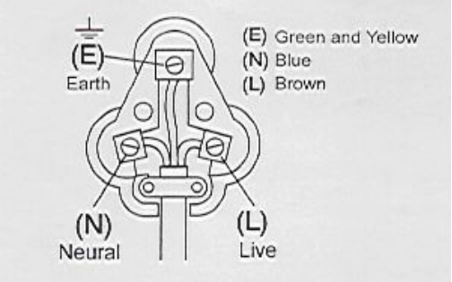
accordance with the following code:

Green/Yellow = Earth
Blue = Neutral
Brown = Live
PLEASE AFFIX YOUR PROOF OF PURCHASE/RECEIPT HERE
IN THE EVENT OF A CLAIM UNDER WARRANTY THIS RECEIPT MUST BE PRODUCED.

2 YEAR WARRANTY
1 year retail ⵏ 1 year extended warranty upon registration*
visit www.russellhobbs.co.za

W A R R A N T Y AND EXTENDED WARRANTY

- Home of Living Brands (Pty) Limited ("Home of Living Brands") warrants to the original purchaser of this product ("the customer") that this product will be free of defects in quality and workmanship which under normal personal, family or household use and purpose may manifest within a period of 1 (one) year from the date of purchase ("warranty period").
- Home of Living Brands shall extend the warranty period for a further period of 1(one) year (“extended warranty period*”), on condition that the purchaser registers the product on the website, within 12 months from the date of purchase of the product. The website address for registration is as follows: http://russellhobbs.co.za/info-pages/warranty-info.aspx. The extended warranty period only applies to products purchased on or after 1 October 2017.
- Where the customer has purchased a product and it breaks, is defective or does not work properly for the intended purpose, the customer must notify the supplier from whom the customer bought the product ("the supplier") thereof within the warranty period or if applicable, the extended warranty period. Any claim in terms of this warranty must be supported by a proof of purchase. If proof of purchase is not available, then repair, and/or service charges may be payable by the customer to the supplier.
- The faulty product must be taken to the supplier's service centre to exercise the warranty.
- The supplier will refund, repair or exchange the product in terms of this warranty subject to legislative requirements. This warranty shall be valid only where (a) the customer is not the cause of the product breaking, and (b) the product has been used for the intended purpose stipulated in the product manual. The warranty does not include and will not be construed to cover products damaged as a result of disaster, misuse, tamper, abuse or any unauthorised modification or repair of the product.
- This warranty will extend only to the product provided at the date of the purchase and not to any expendables attached or installed by the customer. In this regard any accessories supplied with the product by the supplier, may be excluded in this warranty or extended warranty (see Exclusions to Warranty and Extended Warranty document).
- If the customer requests that the supplier repairs the product and the product breaks or fails to work properly within 3 (three) months of the repair and not as a result of misuse, tampering or modification by or on behalf of the customer, then the supplier may replace the product or pay a refund to the customer, subject to the supplier’s discretion.
- The customer may be responsible for certain costs where products returned are not in the original packaging, or if the packaging is damaged. This will be deducted from any refund paid to the customer.
HOME OF LIVING BRANDS (PTY) LTD (JOHANNESBURG)
JOHANNESBURG TEL NO. (011) 490-9600
CAPE TOWN TEL NO. (021) 552-5161
DURBAN TEL NO. (031) 303-1163
www.homeoflivingbrands.com
www.russellhobbs.co.za
www.facebook.com/RussellHobbsSA

EXCLUSIONS TO W A R R A N T Y AND EXTENDED WARRANTY

- Any accessories supplied with the product, including but not limited to, bowls, jugs, mills or carafes made either of glass or plastic and supplied with this appliance (hereinafter referred to as “the accessory or accessories”), is warranted to be free from material and workmanship defects for the duration of the appliance warranty.
- The accessories should give trouble free service when used in accordance with the directions described in the instruction manual. However, the accessories will be damaged if subjected to impact, and this damage is not covered by the warranty. Such impact damage can occur either from the outside (if for example it is dropped or knocked against a hard surface), or from within (if for example foreign objects are placed within the accessories and the power is switched on).
- Should you need to replace an accessory during the warranty period; a claim for a free replacement will only be considered if the item (including all shards and broken parts) is returned to the nearest HOLB service centre for examination.
- The remains of the accessory will be carefully examined by the relevant professionals and if it is determined (at the sole discretion of HOLB) that the damage was caused by impact, then the claim will be refused and will not be covered by the warranty or any extended warranty.
- Any replacement part provided in terms of clause 4 above will become a chargeable item payable by the customer.

Parabéns por ter comprado o seu aquecedor a gás/de ventoinha eléctrica da Russell Hobbs. Cada unidade é fabricada de forma a garantir segurança e fiabilidade. Antes de utilizar este aparelho pela primeira vez, leia o manual de instruções atentamente e guarde-o para futura referência.

SALVAGUARDAS IMPORTANTES:
Quando utilizar qualquer aparelho elétrico, deve seguir sempre as precauções de segurança básicas, incluindo o seguinte:

- Leia atentamente as instruções antes de utilizar qualquer aparelho.
- Certifique-se sempre de que a tensão na etiqueta de classificação corresponde à tensão da corrente elétrica na sua residência.
- A operação incorreta e utilização imprópria podem danificar o aparelho e causar lesões no utilizador.
- Utilize apenas GPL (gás de petróleo liquefeito) com este aquecedor.
- O aquecedor tem de ser DESLIGADO no cilindro de gás.
- Certifique-se sempre de que existe uma ventilação adequada para o desempenho seguro e eficaz do aparelho.
- As crianças devem ser supervisionadas para garantir que não brincam com o aparelho.
- Nunca tente abrir qualquer parte do aquecedor nem desmantelar os controlos. O fornecedor não aceita responsabilidade por quaisquer possíveis falhas da unidade caso esta instrução seja ignorada.
- O aparelho destina-se apenas a utilização doméstica. A utilização comercial invalida a garantia e o fornecedor não pode ser responsabilizado por lesões ou danos causados quando o aparelho for utilizado para qualquer outra finalidade diferente da prevista.
- É necessária uma supervisão de perto quando qualquer aparelho for utilizado perto ou por crianças ou pessoas com incapacidades.
- Não utilize o aparelho se este tiver sido deixado cair ou estiver danificado de qualquer forma. Em caso de danos, devolva a unidade para verificação e/ou reparação por parte de um agente de assistência autorizado
- Nunca coloque a unidade dentro de água ou qualquer outro líquido para fins de limpeza.
- A utilização de acessórios não recomendados ou fornecidos pelo fabricante pode resultar em lesões, incêndios ou choque elétrico.
- Não utilize o aparelho sobre uma superfície de cozimento a gás ou elétrica ou sobre ou perto de uma chama.
- Utilize sempre o aparelho numa superfície suave, uniforme e estável.
- Certifique-se de que o interruptor está na posição "Off" (desligado) após cada utilização.
- O fabricante não aceita responsabilidade por qualquer dano ou lesão causados devido a uma utilização imprópria ou incorreta ou a reparações realizadas por pessoal não autorizado.
- Em caso de problemas técnicos, desligue o aparelho e não tente repará-lo você próprio. Devolva o aparelho a um agente de assistência autorizado para verificação, ajuste ou reparação. Insista sempre em utilizar peças sobresselentes originais. O não cumprimento das precauções e instruções acima poderá afetar o funcionamento seguro desta máquina.
- Se for necessário substituir a mangueira, certifique-se de que a mangueira de substituição é adequada para GPL. As mangueiras devem ser compradas em distribuidores de gás certificados.
- Não utilize o aquecedor para cozinhar ou aquecer alimentos ou gorduras.
- Utilize o aquecedor sempre numa posição vertical.
- Direccione sempre o aquecedor para o centro do compartimento.
- Não deixe o aquecedor ligado durante a noite.
- Não cubra o aquecedor com qualquer tipo de pano, tecido ou objecto estranho nem bloqueie o fluxo de ar de qualquer forma.
- O cilindro de gás tem de estar sempre na posição vertical. Não vire o cilindro ao contrário para o esvaziar completamente.
- Nunca utilize uma chama aberta (fósforos, isqueiro, vela) para testar fugas de gás.
- Esteja ciente que o aparelho permanece quente durante algum tempo depois de utilizar.
- Apenas para utilização doméstica.
- NÃO CUBRA O APARELHO.

DIAGRAMA DE PEÇAS
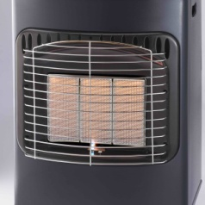
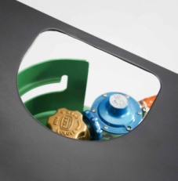
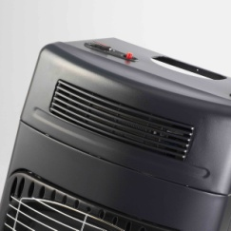
Grelha do aquecedor de ventoinha
Painel de aquecimento
Abertura de acesso à botija de gás
Cobertura de segurança
Chama-piloto

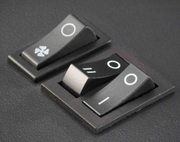
Interruptores do aquecedor de ventoinha
Botão de selecção de temperatura
Posição Zero/Desligado
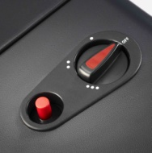
Marca de Chama 1 e Faísca
Botão de ignição Piezo

PARA TESTAR FUGAS DE GÁS
- Deixe extinguir todas as chamas abertas e mão fume nem aproxime chamas abertas do aquecedor a gás durante o teste.
- Leve o aquecedor para o exterior.

- Desligue o aquecedor no cilindro (sentido dos ponteiros do relógio ) e desaperte o regulador (sentido dos ponteiros do relógio ).
- Verifique todas as ligações da mangueira e inspeccione a condição da vedação incorporada no regulador.

- Volte a inserir o regulador e depois ligue lentamente o gás (sentido contrário ao dos ponteiros do relógio ) uma volta e meia de cada vez. Revista todas as ligações com água com sabão ou detergente utilizando um pano ou escova humedecidos.
- Uma fuga de gás forma bolhas nas áreas onde a solução foi aplicada. Caso detecta uma fuga de gás, desligue a válvula de controlo do cilindro de gás (sentido dos ponteiros do relógio ). Informe o agente de assistência mais próximo.
- Não utilize o aquecedor novamente até que um agente técnico aprovado/autorizado o inspeccione.

INSTRUÇÕES DE FUNCIONAMENTO

CUIDADO!
- LIGUE e DESLIGUE o gás apenas na Válvula do cilindro de gás.
- É adequado um cilindro com, no máximo, 13,1 kg (inclui no máximo 9,0 kg de gás) para utilizar com este aquecedor.
- Retire o aquecedor da embalagem e remova todas as películas protectoras.
- Desembrulhe o regulador da sua embalagem e certifique-se de que o tubo está em perfeitas condições (fig. 3).
- Desengate o painel de retenção do cilindro de gás da parte posterior do corpo do aquecedor (fig. 3).
- Coloque o cilindro de GPL ao lado da parte posterior do aquecedor. Certifique-se de que a válvula está limpa e sem quaisquer obstruções ou objectos estranhos e aperte o regulador (sentido contrário ao dos ponteiros do relógio ) na válvula do cilindro. Rode manualmente e não utilize uma chave.
- Ligue a fonte de distribuição de gás (sentido contrário ao dos ponteiros do relógio ) uma volta e meia de cada vez na válvula de controlo do cilindro.
- Antes de o utilizar é recomendável verificar a ligação entre o cilindro de gás e o regulador para verificar a existência de fugas de gás conforme descrito acima.
- Se não ocorrerem fugas de gás, coloque o cilindro de gás na parte posterior do corpo do aquecedor certificando-se de que o cilindro é colocado de tal forma que o tubo não fique preso nem bloqueado de nenhuma forma.
- Coloque o painel de retenção posterior novamente no corpo garantindo que está engatado em ambos os lados do aquecedor.
ACENDER O AQUECEDOR
- O regulador tem de estar devidamente encaixado e apertado na válvula do cilindro de gás.
- Para LIGAR o gás – abra cuidadosamente a válvula do cilindro (no sentido contrário ao dos ponteiros do relógio ) até um máximo de uma volta e meia.
- Rode o botão de selecção de temperatura no painel superior do aquecedor para a primeira posição ( 0 )
- Empurre o botão de selecção de temperatura para baixo e mantenha-o nessa posição durante 10 segundos. O gás irá fluir através do cano para o aquecedor.
- Enquanto mantém o botão de selecção para baixo, pressione o botão de ignição repetidamente até que a chama-piloto acenda. O Painel 1 inicia. Solte o botão de ignição.
- O aquecedor é agora rodado para o Nível 1, com o aquecimento de um painel de cerâmica. Seleccione o seu nível de aquecimento necessário ao rodar o botão de selecção da temperatura:
  - ( 0 ) : Nível 1 – sem aquecimento dos painéis/desligado
  - () : Nível 2 – aquecimento do painel central
  - ( ) : Nível 3 – aquecimento de dois painéis
  - ( ) : Nível 4 – aquecimento de três painéis

DESLIGAR O AQUECEDOR DE GÁS
- Rode o botão de controlo de temperatura para ( 0 )
- DESLIGUE o gás no sentido dos ponteiros do relógio na válvula de controlo do cilindro de gás.
- A chama na parte inferior do painel central deve extinguir-se automaticamente. Caso isso não aconteça, verifique se o cilindro de gás está DESLIGADO.

MUDAR O CILINDRO DE GÁS
- Mova o aquecedor para o exterior e retire o painel posterior.
- Retire o cilindro de gás do aquecedor e coloque-o no chão junto ao aquecedor. CERTIFIQUE-SE DE QUE A VÁLVULA DO CILINDRO ESTÁ FECHADA ANTES DE TENTAR DESLIGAR O REGULADOR. Desaperte o regulador no sentido dos ponteiros do relógio .
- Antes de ligar o cilindro reabastecido, verifique se a vedação do tubo no regulador não está danificada e continua em boas condições. Em caso de dúvida, leve o regulador a um distribuidor autorizado para ser verificado.
- Aperte o regulador no sentido contrário ao dos ponteiros do relógio no novo cilindro e encaixe o cilindro na parte posterior do corpo do aquecedor. Garanta que é colocado de tal forma que o tubo não fique preso ou bloqueado de nenhuma forma.
- Encaixe o painel de retenção novamente no corpo fixando os grampos em ambos os lados.

INSTRUÇÕES DE MANUTENÇÃO E REPARAÇÃO
- Certifique-se de que a tensão na etiqueta de classificação corresponde à tensão da corrente elétrica na sua residência.
- Verifique o cabo de alimentação e a ficha regularmente para verificar a existência de quaisquer danos. Se o cabo ou a ficha estiverem danificados, devem ser substituídos pelo fabricante ou por uma pessoa qualificada de forma a evitar um perigo elétrico.
- Remova a ficha da tomada ao agarrar na ficha. Não puxe pelo cabo para desligar o aparelho da corrente elétrica.
- Desligue sempre a unidade quando esta não estiver a ser utilizada, antes de limpar ou quando adicionar ou remover peças.
- Certifique-se de que o cabo não se encontra numa posição em que possa ser puxado inadvertidamente.
- Não permita que o cabo toque em superfícies quentes.
- A utilização de uma extensão com este aparelho não é recomendada. No entanto, caso seja necessário utilizar uma ficha de extensão, certifique-se de que a ficha é adequada para o consumo de energia do aparelho para evitar o sobreaquecimento do cabo da extensão, aparelho ou tomada. Desenrole sempre o cabo de extensão até ao fim antes de utilizar. Não coloque o cabo da extensão numa posição em que possa ser puxada por crianças ou animais ou que possibilite o tropeçamento.
- NÃO puxe ou desloque o aparelho pelo cabo de alimentação.
- Desligue sempre a unidade quando não estiver a ser utilizada e antes de limpar.
- Certifique-se de que o interruptor está na posição "Off" (desligado) após cada utilização.
- O fabricante não aceita responsabilidade por qualquer dano ou lesão causados devido a uma utilização imprópria ou incorreta ou a reparações realizadas por pessoal não autorizado.

INSTRUÇÕES DE MANUTENÇÃO E REPARAÇÃO
Existem poucos procedimentos de manutenção necessários neste aparelho. Os pontos importantes a relembrar são:
- Verifique sempre se a vedação do regulador está intacta quando mudar o cilindro de gás.
- Verifique sempre se a mangueira está em boas condições antes de utilizar e se está devidamente fixa no aparelho e regulador.
- É recomendável que a mangueira seja substituída a cada dois anos quer tenha sido utilizada ou não. Quando substituir a mangueira, certifique-se de que a mangueira de substituição é adequada para GPL. As mangueiras devem ser compradas em distribuidores de gás certificados. Lembre-se, quando substituir a mangueira, substitua também os grampos de fixação da mangueira.
- Com a excepção da mangueira e do regulador, não existem peças incorporadas pelo utilizador disponíveis para este fogão. Caso o fogão não esteja a funcionar correctamente, um agente técnico autorizado deverá verifica-lo e se forem necessárias peças de substituição, o agente garantirá que as peças correctas são fornecidas e incorporadas correctamente.
- É recomendável que o seu aquecedor seja verificado na sua loja de ferragens local no início de cada estação.

LIMPEZA
- Limpe o exterior do aquecedor com um pano humedecido suave em solução de detergente suave.
- Não utilize agentes de verniz para metal ou móveis no aquecedor.
- Se os elementos parecerem poeirentos, limpe-os utilizando uma escova de cerdas macias ou um pano seco.
- Limpe o aquecedor apenas quando estiver frio e não estiver em utilização.
- Não utilize agentes de limpeza abrasivos, uma vez que danificarão a superfície pintada.
- Quando não estiver a ser utilizado, guarde o aquecedor ao cobri-lo e coloca-lo num local fresco, seco e sem poeira.

AVISO
- Nunca coloque a unidade dentro de água nem deixe que a água entre em contacto com os bicos.

Se necessitar de devolver o aparelho, garanta que:
- A unidade está devidamente embalada na sua embalagem original.
- Apresenta uma prova de compra.

RESOLUÇÃO DE PROBLEMAS
Problema | Possível causa e solução
O aquecedor não acende ou apresenta uma chama fraca | O cilindro está vazio. Substitua por um cilindro cheio.
O aquecedor não acende ou apresenta uma chama fraca | Se o cilindro é novo, o ar poderá não ter sido devidamente purgado.
O aquecedor não acende ou apresenta uma chama fraca | Verifique se o regulador está devidamente ligado e se a válvula do cilindro está aberta (sentido contrário ao dos ponteiros do relógio).
O aquecedor não acende ou apresenta uma chama fraca | Os componentes do aquecedor poderão estar contaminados com pó ou sujos. Leve o aquecedor a um agente de assistência autorizado.
O aquecedor não acende ou apresenta uma chama fraca | Tente outra marca de gás.
Não é possível desligar o aquecedor | Os aquecedores de armário têm de ser sempre DESLIGADOS ao fechar a válvula do cilindro de gás (sentido dos ponteiros do relógio ). Observe que poderá estar na posição totalmente aberta e irá exigir algum esforço para iniciar a operação de fecho.
O aquecedor não permanece aceso quando o botão de ignição é libertado | O solenóide do Sensor de esgotamento de oxigénio não está a manter o controlo aberto. Leve o aquecedor a um agente de assistência autorizado.  Caso isto ocorra após o armazenamento, os componentes poderão ter de ser limpos.

DADOS TÉCNICOS

Marca | Modelo | Consumo de gás definido |  | Potência nominal
Russell Hobbs | RHG03 | - 1 painel (ghr⁻¹) | 103 | - 1 painel (W) | 1 400
Pressão de funcionamento |  | - 2 painéis (ghr⁻¹) | 206 | - 2 painéis (W) | 2 800
2,8 kPa |  | - 3 painéis (ghr⁻¹) | 310 | - 3 painéis (W) | 4 200
 |  | Aquecedor eléctrico
 |  | Elemento 1 |  | 1000 W 230 V
 |  | Elemento 2 |  | 1000 W 203 V

SUBSTITUIÇÃO DA FICHA
Cumpra com as instruções seguintes caso seja necessário substituir a ficha.
Esta unidade destina-se a operar apenas na corrente indicada. A ligação a outras fontes de alimentação poderá danificar o aparelho. Ligue uma ficha de três pinos da seguinte maneira:
Os fios neste terminal de alimentação estão coloridos de acordo com o seguinte código:

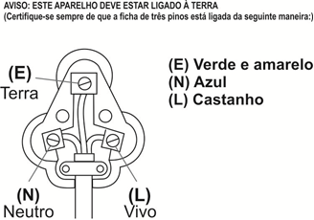
Verde/Amarelo = Terra
Azul = Neutro
Castanho = Vivo

ANEXE A SUA PROVA DE COMPRA/RECIBO AQUI
EM CASO DE RECLAMAÇÃO AO ABRIGO DE GARANTIA, É NECESSÁRIO PRODUZIR ESTE RECIBO.

2 ANOS DE GARANTIA
1 ano de retalho ⵏ 1 ano de garantia prolongada mediante o registo*
visite www.russellhobbs.co.za

G A R A N T I A E GARANTIA PROLONGADA

- Home of Living Brands (Pty) Limited (“Home of Living Brands”) garante ao comprador original deste produto (“o cliente") que este produto não apresenta defeitos de material e fabrico que se manifestam na utilização normal pessoal, familiar ou doméstica num período de 1 (um) ano desde a data de compra (“período de garantia”).
- Home of Living Brands alargará o período da garantia para um período adicional de 1 (um) ano (“período de extensão da garantia*”), desde que o comprador registe o produto no sítio Web dentro de 12 meses a partir da data de compra do produto. O endereço do sítio Web para registo é o seguinte: http://russellhobbs.co.za/info-pages/warranty-info.aspx. O período de extensão da garantia só se aplica a produtos adquiridos em ou após 1 de outubro de 2017.
- No caso de um cliente comprar um produto e este se quebrar, apresentar defeitos ou não funcionar corretamente para a finalidade prevista, o cliente tem de notificar o fornecedor ao qual comprou o produto ("o fornecedor") desse fato dentro do período de garantia, ou, se aplicável, o período de extensão da garantia. Qualquer reclamação nos termos da garantia deve ser acompanhada por uma prova de compra. Caso não esteja disponível uma prova de compra, então as despesas da reparação e/ou manutenção poderão ter de ser pagas pelo cliente ao fornecedor.
- O produto avariado tem de ser devolvido ao centro de assistência do fornecedor para aplicar a garantia.
- O fornecedor irá reembolsar, reparar ou trocar o produto nos termos desta garantia, sujeito aos requisites legislativos. Esta garantia será válida apenas quando (a) o cliente não for a causa de danos do produto, e (b) o produto tiver sido utilizado para a finalidade prevista estipulada no manual do produto. A garantia não inclui e não será interpretada como abrangendo produtos danificados como resultado de um desastre, utilização imprópria, manipulação, abuso ou qualquer modificação não autorizada ou reparação do produto.
- Esta garantia aplicar-se-á apenas ao produto fornecido na data de compra e não a quaisquer acessórios incluídos ou instalados pelo cliente. A este respeito, quaisquer acessórios fornecidos com o produto pelo fornecedor podem ser excluídos nesta garantia ou garantia prolongada (consulte o documento Exclusões à garantia e garantia prolongada).
- Se o cliente solicitar que o fornecedor repare o produto e o produto se quebrar ou não funcionar corretamente nos 3 (três) meses após a reparação, considerando que não seja resultado de utilização imprópria, manipulação ou modificação por ou em nome do cliente, então o fornecedor poderá substituir o produto ou pagar um reembolso ao cliente, sujeito à discrição do fornecedor.
- O cliente poderá ser responsável por certos custos quando os produtos devolvidos não estiverem na embalagem original, ou caso a embalagem esteja danificada. Este custo será deduzido de qualquer reembolso pago ao cliente.

HOME OF LIVING BRANDS (PTY) LTD (JOHANESBURGO)
JOANESBURGO N.º TEL. (011) 490-9600
CIDADE DO CABO N.º TEL. (021) 552-5161
DURBAN N.º TEL. (031) 303-1163
www.homeoflivingbrands.com
www.russellhobbs.co.za
www.facebook.com/RussellHobbsSA

EXCLUSÕES À G A R A N T I A E GARANTIA PROLONGADA
- Quaisquer acessórios fornecidos com o produto, incluindo, mas sem limitação, taças, jarras, moinhos ou garrafas, feitos de vidro ou plástico e fornecidos com este aparelho (daqui em diante designados “o acessório" ou "acessórios”), são garantidos como estando isentos de defeitos de material e fabrico durante o período de garantia do aparelho.
- Os acessórios devem permitir um serviço isento de problemas quando são utilizados de acordo com as instruções descritas no manual de instruções. No entanto, os acessórios serão danificados se forem submetidos a impacto e estes danos não estão abrangidos pela garantia. Esses danos provocados pelo impacto podem ocorrer do exterior (se, por exemplo, cair ou colidir contra uma superfície dura), ou do interior (se, por exemplo, forem colocados objetos estranhos dentro dos acessórios e se ligar a alimentação).
- Se for necessário substituir um acessório durante o período de garantia; uma reivindicação de uma substituição gratuita será considerada apenas se o item (incluindo os pedaços e peças partidas) for devolvido ao centro de reparação HOLB mais próximo para análise.
- Os restos do acessório serão examinados cuidadosamente pelos profissionais relevantes e se for determinado (ao exclusivo critério da HOLB) que os danos foram causados por impacto, a reivindicação será recusada e não será abrangida pela garantia ou qualquer garantia prolongada.
- Qualquer peça de substituição fornecida nos termos da cláusula 4 acima torna-se num item a cobrar que será pago pelo cliente.

Félicitations pour l'achat de votre radiateur soufflant à gaz/électrique Russell Hobbs. Chaque unité est fabriquée afin de d’assurer la sécurité et la fiabilité. Avant d’utiliser cet appareil pour la première fois, merci de lire le manuel avec soin et de le garder à titre de référence.

GARANTIES IMPORTANTES
Lors de l’utilisation de n’importe quel appareil électrique, des précautions de sécurité élémentaires devraient toujours être suivies, ainsi que les points suivants :

- Merci de lire les instructions avec attention avant d’utiliser tout appareil quel qu’il soit.
- Toujours vous assurer que le voltage indiqué sur la plaque signalétique correspond aux voltages principaux dans votre maison.
- Une opération incorrecte et une utilisation inappropriée peuvent endommager l’appareil et entraîner des blessures pour l’utilisateur.
- Utilisez du GPL (gaz de pétrole liquéfié) uniquement avec ce radiateur.
- Le radiateur doit toujours être ÉTEINT au niveau de la bouteille de gaz.
- Afin de permettre une performance à la fois sûre et efficace de l’appareil, assurez-vous toujours que la ventilation est adéquate.
- Les enfants devraient être surveillés pour s’assurer qu’ils ne jouent pas avec l’appareil.
- N’essayez jamais d’ouvrir toute partie quel qu’elle soit du radiateur ou de démonter les contrôles. Le fournisseur ne peut pas accepter la responsabilité de toutes pannes possibles de l’unité, dans le cas où cette instruction a été ignorée.
- L’appareil est destiné à uniquement à un usage domestique. Une utilisation commerciale annule la garantie et le fournisseur ne peut pas être tenu pour responsable des blessures ou des dommages causent lors de l’utilisation de l’appareil pour tout autre usage que celui auquel il est destiné.
- Une surveillance étroite est requise lorsque tout appareil est utilisé près d’enfants ou de personnes invalides.
- Ne pas utiliser l’appareil s’il est tombé ou s’il a été endommagé de quelque manière que ce soit. En cas de dommage, rapporter l’unité pour un examen et / ou une réparation par un agent de maintenance agréé.
- Ne jamais immerger l’unité dans l’eau ou dans tout autre liquide pour le nettoyer.
- L’utilisation d’accessoires se fixant à l’unité qui ne sont ni recommandés ou fournis par le fabricant pourrait entraîner des blessures, un incendie ou un choc électrique.
- Ne pas utiliser l’appareil sur une plaque à gaz ou électrique ou au-dessus d’une flamme.
- Faire toujours fonctionner l’appareil sur une surface régulière et stable.
- S’assurer que l’interrupteur est en position « ARRÊT » après chaque utilisation.
- Le fabricant n’accepte de prendre aucune responsabilité pour tout dommage ou blessure que ce soit, qui seraient dues à une utilisation incorrecte ou inappropriée, ou celle de réparations exécutées par un personnel non-agréé.
- En cas de problèmes techniques, éteindre l’appareil et ne pas essayer de la réparer vous-même. Renvoyer l’appareil à un service de maintenance habileté pour un examen, un ajustement ou pour une réparation. Insister toujours pour que les pièces détachées d’origines soient utilisées. Le non-respect avec les précautions et les instructions mentionnées ci-dessus pourrait empêcher le bon fonctionnement de cette machine.
- Si le tuyau doit être remplacé, assurez-vous que le tuyau de remplacement convient au GPL. Les tuyaux devraient être uniquement achetés auprès de fournisseurs de gaz certifiés.
- N’utilisez pas le radiateur pour cuisiner ou pour chauffer de la nourriture ou des graisses.
- Utilisez toujours le radiateur en position verticale.
- Orientez toujours le radiateur vers le centre de la pièce.
- Ne laissez pas le radiateur allumé pendant la nuit.
- Ne couvrez pas le radiateur avec quelque type de tissu que ce soit, avec des objets étrangers ou ne bloquez en aucune manière la circulation d’air.
- La bouteille de gaz doit toujours se trouver en position verticale. Ne renversez pas la bouteille pour la vider complètement.
- N’utilisez jamais une flamme nue (des allumettes, un briquet, une bougie) pour tester les fuites de gaz.
- Souvenez-vous que le réchaud restera chaud pendant un certain temps, une fois que vous aurez terminé de l’utiliser.
- Utilisation domestique uniquement.
- NE PAS COUVRIR L’APPAREIL.

SCHÉMA DES PIÈCES
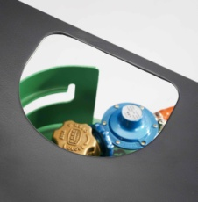
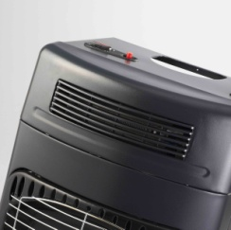
Grille du radiateur soufflant
Ouverture d’accès à la bouteille de gaz
Panneau chauffant
Grille de sécurité
Flamme pilote

Interrupteurs du radiateur soufflant
Marque de l'étincelle et de la flamme 1
Allumage piézo
Bouton de sélection de la température
Position zéro/Arrêt

POUR TESTER LES FUITES DE GAZ
- Éteignez toutes les flammes nues (les flammes ouvertes) et ne fumez pas ou n’approchez pas les flammes nues près du radiateur à gaz pendant l’essai.
- Mettez le radiateur à l’extérieur.
- Éteignez le radiateur au niveau de la bouteille de gaz (dans le sens des aiguilles d’une montre ) et démontez le régulateur (dans le sens des aiguilles d’une montre ).
- Vérifiez toutes les connexions des tuyaux et inspectez l’état des verrouillages qui sont ajustés sur le régulateur.
- Réajustez le régulateur, puis ouvrez lentement le gaz d’un tour et demi (dans le sens contraire des aiguilles d’une montre ). Recouvrez toutes les connexions avec de l’eau savonneuses ou du détergent en utilisant un chiffon ou une brosse humide.
- Une fuite de gaz forme des bulles dans les zones où la solution a été appliquée. Si une fuite de gaz est détectée, FERMEZ la valve de contrôle de la bouteille de gaz (dans le sens des aiguilles d’une montre ). Informez l’agent de service le plus proche.
- N’utilisez pas le radiateur avant qu’un agent d’entretien approuvé/autorisé ne l’ai inspecté.

INSTRUCTIONS D’UTILISATION

ATTENTION !
- Tournez le gaz sur MARCHE et ARRÊT uniquement au niveau de la vanne de la bouteille de gaz.
- Une bouteille d’un maximum de 13,1 kg (elle comprend un max de 9,0 kg de gaz) convient pour l’utilisation de ce radiateur.
- Déballez le radiateur et retirez tous les emballages de protection.
- Enlevez le régulateur de son emballage d’origine et assurez-vous que le tuyau soit en parfait état (fig. 3)
- Enlevez le panneau de retenue de a bouteille de gaz de l’arrière du radiateur (fig. 3)
- Placez la bouteille pleine de GPL à côté de l’arrière du radiateur. Assurez-vous que la vanne soit propre et dégagée de toutes obstructions par des corps étrangers et vissez le régulateur (dans le sens contraire des aiguilles d’une montre ) sur la vanne de la bouteille. Tournez- la manuellement et n’utilisez pas de clé.
- Tournez l’alimentation de gaz d’un tour et demi sur OUVERT (dans le sens contraire des aiguilles d’une montre ) au niveau de la valve de contrôle.
- Avant la première utilisation, il est conseillé de vérifier la connexion entre la bouteille de gaz et le régulateur, pour les cas de fuites de gaz, telles qu’elles ont été décrites ci-dessus.
- S’il n’y a pas de fuites de gaz, placez la bouteille à l’arrière du radiateur en vous assurant qu’elle soit placée de manière à ce que le tuyau ne soit pas coincé ou bloqué de quelque manière que ce soit.
- Ajustez le panneau de retenue à l’arrière du radiateur en vous assurant qu’il soit attaché aux deux côtés du radiateur.
ALLUMAGE DU RADIATEUR
- Le régulateur doit être complètement attaché de manière sûre à la vanne de la bouteille de gaz.
- Pour tourner le gaz sur MARCHE - ouvrez prudemment la vanne de la bouteille (dans le sens contraire des aiguilles d’une montre ) jusqu’au maximum d’un tour et demi.
- Tournez le bouton de sélection de la température situé sur le panneau supérieur du radiateur, sur la première position ( 0 )
- Poussez le bouton de sélection de la température vers le bas et maintenez-le pendant 10 secondes. Le gaz circulera à travers le tuyau vers le radiateur.
- Tout en maintenant le bouton de sélection vers le bas, abaissez le bouton d’allumage de manière répétitive, jusqu’à ce que la flamme de la veilleuse s’allume. Le panneau 1 démarrera. Relâchez le bouton d’allumage.
- Le radiateur est maintenant tourné sur le Niveau 1, avec un panneau en céramique qui chauffe. Sélectionnez votre niveau de chauffage requis en tournant le bouton de sélection de la température :
  - ( 0 ) : Niveau 1 – aucun panneau de chauffage/Position ARRÊT
  - () : Niveau 2 – panneau de chauffage du centre
  - ( ) : Niveau 3 – deux panneaux de chauffage
  - ( ) : Niveau 4 – trois panneaux de chauffage

TOURNEZ LE RADIATEUR A GAZ SUR « ARRÊT »
- Tournez le bouton de contrôle de la température sur ( 0 )
- Tournez le gaz sur « ARRÊT » au niveau de la vanne de contrôle de la bouteille de gaz.
- La flamme située à la base du panneau du centre devrait s’éteindre automatiquement d’elle-même. Si cela n'était pas le cas, vérifiez que la bouteille de gaz est FERMÉE.

CHANGER LA BOUTEILLE DE GAZ
- Mettez le radiateur dehors et retirez le panneau arrière.
- Retirez la bouteille de gaz du radiateur et placez-la sur le sol à côté du radiateur. ASSUREZ-VOUS QUE LA VANNE DE LA BOUTEILLE SOIT FERMÉE AVANT D’ESSAYER DE DÉCONNECTER LE RÉGULATEUR. Dévissez le régulateur dans le sens des aiguilles d’une montre .
- Avant de connecter la bouteille à nouveau remplie, vérifiez que le joint de la valve sur le régulateur n’est pas endommagé et qu’il est encore en bon état. En cas de doute, apportez le régulateur chez un fournisseur agréé, afin qu’il soit vérifié.
- Vissez le régulateur dans le sens contraire des aiguilles d’une montre sur la nouvelle bouteille de gaz et ajustez la bouteille à l’arrière du radiateur. Assurez-vous qu’elle soit placée de manière à ce que le tuyau ne soit ni coincé, ni bloqué de quelque manière que ce soit.
- Ajustez le panneau de retenue à l’arrière du radiateur en sécurisant les clips des deux côtés.

INSTRUCTION RELATIVES A LA MAINTENANCE ET A L’ENTRETIEN
- Toujours vous assurer que le voltage indiqué sur la plaque signalétique correspond aux voltages principaux dans votre maison.
- Vérifier le cordon d’alimentation et brancher régulièrement pour éviter que le cordon ne soit endommagé. Si le cordon ou la prise sont endommagés, ils doivent être remplacés par le fabricant ou par une personne qualifiée afin d’éviter un danger électrique.
- Retirer la fiche de la prise en tenant la fiche. Ne pas tirer sur le cordon pour déconnecter l’appareil du secteur.
- Toujours débrancher l’unité lorsqu’elle n’est pas utilisée, avant le nettoyage ou lors de l’ajout ou du retrait de parties.
- S’assurer que le cordon n’est pas dans une position ou il peut être tire par inadvertance.
- Ne laissez pas la corde toucher les surfaces chaudes.
- L’utilisation d’un cordon d’extension avec cet appareil n’est pas recommandée. Cependant, s’il s’avère nécessaire d’utiliser une rallonge électrique qui est adaptée à la consommation d’énergie de l’appareil, afin d’éviter le surchauffement du cordon d’extension, de l’appareil ou de la prise de courant. Déroulez toujours la rallonge complètement avant utilisation. Ne pas mettre la rallonge dans une position où elle peut être tirée par des enfants, ou des animaux, ou bien où ils risquent de trébucher dessus.
- NE tirez PAS ou ne déplacez pas l’appareil avec le cordon d’alimentation.
- Débrancher toujours l’unité lorsqu’elle n’est pas utilisée, et avant de la nettoyer.
- S’assurer que l’interrupteur est en position « ARRÊT » après chaque utilisation.
- Le fabricant n’accepte de prendre aucune responsabilité pour tout dommage ou blessure que ce soit, qui seraient dues à une utilisation incorrecte ou inappropriée, ou celle de réparations exécutées par un personnel non-agréé.

INSTRUCTION RELATIVES A LA MAINTENANCE ET A L’ENTRETIEN
Cet appareil ne demande que très peu d’entretien. Les points importants, dont il faut se souvenir sont les suivants :
- Lorsque vous changez la bouteille de gaz, vérifiez toujours que le verrouillage du régulateur n’est pas endommagé.
- Avant de l’utiliser, vérifiez que le tuyau est en bon état, et qu’il est fermement fixé à l’appareil et au régulateur.
- Il est conseillé de remplacer le tuyau tous les deux ans, qu’il ait été utilisé ou non. Lorsque vous remplacez le tuyau, assurez-vous que le tuyau de remplacement convient pour le GPL. Les tuyaux devraient être uniquement achetés auprès de fournisseurs de gaz certifiés. Au moment du remplacement du tuyau, souvenez-vous de remplacer en même temps les colliers de serrage.
- Il n’existe pas de pièces qui soient ajustables par l’utilisateur, mis à part le tuyau et le régulateur. Dans le cas où le réchaud ne fonctionnerait pas correctement, un agent d’entretien doit le vérifier et si le remplacement de pièces est nécessaire, les agents d’entretien s’assureront que les pièces adéquates sont fournies et correctement ajustées.
- Il est recommandé que votre radiateur soit vérifié à votre quincaillerie locale au début de chaque saison.

NETTOYAGE
- Essuyez l’extérieur du radiateur avec un chiffon doux humidifié avec un détergent doux.
- N’utilisez pas de métal ou un produit d’entretien pour meubles sur le radiateur.
- Si les éléments semblent être poussiéreux, alors nettoyez-le en utilisant avec une brosse souple ou avec un chiffon sec.
- Nettoyez le radiateur uniquement lorsqu’il est froid et lorsqu’il ne fonctionne pas.
- N’utilisez pas de nettoyants abrasifs, car ils endommageraient la surface peinte.
- Lorsqu’il n’est pas utilisé, rangez le radiateur en le couvrant et en le plaçant dans un endroit frais, sec et exempt de poussières.

AVERTISSEMENT
- N’immergez jamais l’unité dans l’eau ou ne laissez pas d’eau entrer dans les brûleurs.

Si vous devez renvoyer l’appareil, assurez-vous que :
- L’unité est emballée avec soin dans son emballage d’origine.
- La preuve d’achat est jointe.

DÉPANNAGE
Problème | Cause possible et solution
Le radiateur ne s’allumera pas ou fonctionne mal | La bouteille est vide. Remplacez-la avec une bouteille pleine.
Le radiateur ne s’allumera pas ou fonctionne mal | Si la bouteille est nouvelle, elle pourrait ne pas avoir été purgée de l’air correctement.
Le radiateur ne s’allumera pas ou fonctionne mal | Vérifiez que le régulateur est correctement attaché et que la vanne de la bouteille est ouverte (dans le sens contraire des aiguilles d’une montre).
Le radiateur ne s’allumera pas ou fonctionne mal | Les composants du radiateur peuvent être contaminés par de la poussière ou sales. Faites entretenir le radiateur par un agent de service agréé.
Le radiateur ne s’allumera pas ou fonctionne mal | Essayez une autre marque de gaz.
Le radiateur ne peut pas être éteint | Les chauffages d’armoire doivent toujours être sur ARRÊT en fermant la vanne de la bouteille de gaz ( dans le sens des aiguilles d’une montre). Notez qu’elle peut être en position complètement ouverte et qu’elle requerra des efforts certains pour commencer la manœuvre de fermeture.
Le radiateur ne restera pas allumé lorsque le bouton d’allumage est relâché | L’électrovanne du capteur de la diminution de l’oxygène ne maintient pas le contrôle ouvert. Faites entretenir le radiateur par un agent de service agréé.  Si cela devait avoir lieu après le rangement, les composants pourraient nécessiter un nettoyage.

DONNÉES TECHNIQUES

Marque | Modèle | Taux de consommation de gaz |  | Puissance nominale
Russell Hobbs | RHG03 | - 1 panneau (ghr⁻¹) | 103 | - 1 panneau (W) | 1 400
Pression de fonctionnement |  | - 2 panneaux (ghr⁻¹) | 206 | - 2 panneaux (W) | 2 800
2,8 kPa |  | - 3 panneaux (ghr⁻¹) | 310 | - 3 panneaux (W) | 4 200
 |  | Radiateur électrique
 |  | Élément 1 |  | 1000 W 230 V
 |  | Élément 2 |  | 1000 W 203 V

LE CHANGEMENT DE LA PRISE
Si la prise intégrée devait être change, suivez les instructions ci-dessous.
Cette unité est uniquement conçue pour fonctionner au courant indiqué. La connexion à d’autres sources d’alimentation pourrait endommager l’appareil. Connecter la prise à trois chiffes de la manière suivante :
Les fils de ce réseau sont colorés selon le code suivant :

Vert/jaune = Terre
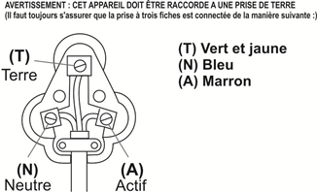
Bleu = Neutre
Marron = Actif

VEUILLEZ APPOSER VOTRE PREUVE D’ACHAT / REÇU ICI
EN CAS DE RÉCLAMATION PENDANT LA PÉRIODE DE GARANTIE, CE REÇU DOIT ÊTRE PRÉSENTÉ.

GARANTIE DE 2 ANS
1 an au détail ⵏ Garantie prolongée de 1 an après enregistrement*
visitez www.russellhobbs.co.za

G A R A N T I E ET GARANTIE PROLONGÉE

- Home of Living Brands (Pty) Limited (« Home of Living Brands ») garantit à l’acheteur d’origine de ce produit (« le client »), que ce dernier ne présentera pas de défauts de qualité, ni de fabrication qui dans le cadre d’une utilisation normale, familiale ou domestique pourrait apparaître en l’espace de 1 (une) année suivant la date d’achat (« période de garantie »).
- Home of Living Brands devra étendre la période de garantie de 1 (une) année supplémentaire (« période de garantie prolongée* »), à condition que l’acheteur enregistre le produit sur le site web, sous 12 mois à compter de la date d’achat du produit. L’adresse du site web pour l’enregistrement est la suivante : http://russellhobbs.co.za/info-pages/warranty-info.aspx. La période de garantie prolongée s’applique uniquement aux produits achetés le 1er octobre 2017 ou par la suite.
- Lorsque le client a acheté un produit qui se casse, présente des défauts ou ne fonctionne pas correctement pour l’utilisation pour laquelle il était destiné, le client doit signaler cela au fournisseur auprès duquel il a acheté le produit (« le fournisseur ») durant la période de garantie, ou, le cas échéant, la période de garantie prolongée. Toute réclamation selon les conditions de la garantie doit être accompagnée d’une preuve d’achat. Si la preuve d’achat n’est pas disponible, à ce moment-là, les frais de réparation ou d’entretien peuvent être à la charge du client vis-à-vis du fournisseur.
- Un produit défectueux doit être rapporté au centre d’entretien du fournisseur pour faire jouer la garantie.
- Le fournisseur remboursera, réparera ou échangera le produit selon les termes de cette garantie qui est assujettie aux exigences légales. La présente garantie ne devra être valide que lorsque (a) le client n’est pas la cause du produit cassé, et (b) le produit a été utilisé aux fins prévues stipulées dans le manuel du produit. La garantie ne comprend pas et saurait être considérée comme couvrant les dommages affectant le produit, qui seraient le résultat d’un accident, d’une mauvaise utilisation, d’une modification, d’un abus ou de toute modification ou réparation non autorisée du produit.
- La garantie couvrira uniquement le produit fourni à la date d’achat et elle ne s’appliquera pas à toute pièce ajoutée ou installée par le client. À cet égard, tout accessoire fourni avec le produit par le fournisseur peut être exclu de la garantie ou de la garantie prolongée (voir le document Exclusions de la garantie et de la garantie prolongée).
- Si le client demande au fournisseur de réparer le produit et si le produit casse ou ne fonctionne pas correctement dans les 3 (trois) mois de la réparation, et si ceci n’est pas le résultat d’une mauvaise utilisation, d’une altération ou d’une modification par le client ou pour le compte de celui-ci, à ce moment-là le fournisseur pourrait remplacer le produit ou rembourser le client, à la discrétion du fournisseur.
- Le client pourrait être tenu pour responsable de certains frais lorsque les produits ne sont pas renvoyés dans leur emballage d’origine, ou si l’emballage est endommagé. Ceci sera déduit de tout remboursement fait au client.

HOME OF LIVING BRANDS (PTY) LTD (JOHANNESBURG)
JOHANNESBURG N° DE TÉL. : (011) 490-9600
LE CAP N° DE TÉL. : (021) 552-5161
DURBAN N° DE TÉL. : (031) 303-1163
www.homeoflivingbrands.com
www.russellhobbs.co.za
www.facebook.com/RussellHobbsSA

EXCLUSION DE LA G A R A N T I E ET DE LA GARANTIE PROLONGÉE
- Tout accessoire fourni avec le produit, notamment, mais sans s’y limiter, les bols, pots, moulins ou carafes fabriqués soit en verre, soit en plastique, fourni avec l’appareil (ci-après dénommés « l’accessoire » ou « les accessoires »), est garanti comme exempte de défauts de qualité ou de fabrication pendant la durée de la garantie de l’appareil.
- Les accessoires devraient fonctionner sans problèmes en cas d’utilisation conformément aux instructions décrites dans le manuel d’utilisation. Cependant, les accessoires seront endommagés s’ils sont soumis à des impacts, et ces dommages ne sont pas couverts par la garantie. De tels dommages par impact peuvent se produire soit depuis l’extérieur (par exemple, si l’accessoire tombe ou heurte une surface dure), soit depuis l’intérieur (par exemple, si des objets étrangers sont placés dans les accessoires et que l’appareil est allumé).
- Si vous devez remplacer un accessoire pendant la période de garantie, une demande de remplacement gratuit ne sera prise en compte que si l’article (y compris la totalité des éclats et des pièces cassées) est renvoyé à votre centre d’entretien HOLB le plus proche pour examen.
- Les restes de l’accessoire seront examinés attentivement par les professionnels pertinents et s’il est jugé (à l’entière discrétion d’HOLB) que les dommages ont été causés par un impact, alors la demande sera refusée et ne sera pas couverte par la garantie ou la garantie prolongée.
- Toute pièce de remplacement fournie aux termes de la clause 4 ci-dessus deviendra un article facturable payable par le client.

