INSTRUCTIONS AND WARRANTY

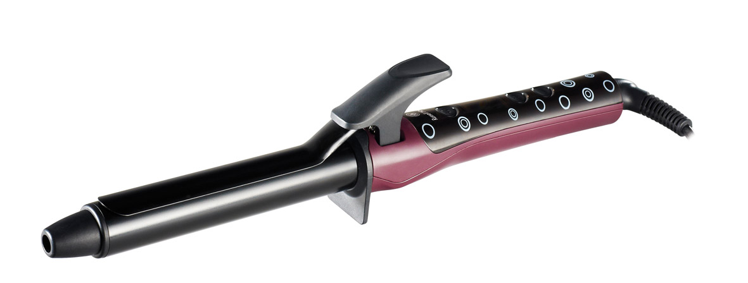

MODEL NO. RHHC05
RUSSELL HOBBS LCD CURLING TONG

Congratulations on purchasing our Russell Hobbs LCD Curling Tong. Each unit is manufactured to ensure safety and reliability. Before using this appliance for the first time, please read the instruction manual carefully and keep it for future reference.

FEATURES OF THE RUSSELL HOBBS LCD CURLING IRON
- Korean Nano Silver & Tourmaline technology
- 25mm barrel diameter
- Ceramic heater and quick 30 second heat-up time to 180 ºC
- Fixed tong stand to avoid heat damage to surfaces
- LCD display
- 11 variable temperatures ranging from 100 ºC – 200 ºC
- Memory function to save the last temperature used
- Switch settings avoid accidental switch off during use (only after 2 seconds)
- 1.8 metre and 360° swivel PVC cord
- Automatic switch off in 72 minutes

IMPORTANT SAFEGUARDS
When using any electrical appliance, basic safety precautions should always be followed including the following:
- Please read the instructions carefully before using any appliance.
- Always ensure that the voltage on the rating label corresponds to the mains voltage in your home.
- Incorrect operation and improper use can damage the appliance and cause injury to the user.
- The appliance is intended for household use only. Commercial use invalids the warranty and the supplier cannot be held responsible for injury or damage caused when using the appliance for any other purpose than that intended.
- Avoid any contact with moving parts.
- This appliance is not intended for use by persons (including children) with reduced physical, sensory or mental capabilities, or lack of experience and knowledge, unless they have been given supervision or instruction concerning use of the appliance by a person responsible for their safety.
- Children should be supervised to ensure that they do not play with the appliance.
- Check the power cord and plug regularly for any damage. If the cord or the plug is damaged, it must be replaced by the manufacturer or a qualified person in order to avoid an electrical hazard.
- Do not use the appliance if it has been dropped or damaged in any way. In case of damage, take the unit in for examination and/or repair by an authorised service agent
- To reduce the risk of electric shock, do not immerse or expose the motor assembly, plug or the power cord to water or any other liquid.
- Never immerse the unit in water or any other liquid for cleaning purposes.
- Remove the plug from the socket by gripping the plug. Do not pull on the cord to disconnect the appliance from the mains. Always unplug the unit when not in use, before cleaning or when adding or removing parts.
- The use of accessory attachments that are not recommended or supplied by the manufacturer may result in injuries, fire or electric shock.
- A short cord is provided to reduce the hazards resulting from becoming entangled in or tripping over a longer cord.
- Do not let the cord hang over the edge of a table or counter. Ensure that the cord is not in a position where it can be pulled on inadvertently.
- Do not allow the cord to touch hot surfaces and do not place on or near a hot gas or electric burner or in a heated oven.
- Do not use the appliance on a gas or electric cooking top or over or near an open flame.
- Use of an extension cord with this appliance is not recommended. However, if it is necessary to use an extension lead, ensure that the lead is suited to the power consumption of the appliance to avoid overheating of the extension cord, appliance or plug point. Do not place the extension cord in a position where it can be pulled on by children or animals or tripped over.
- This appliance is not suitable for outdoor use. Do not use this appliance for anything other than its intended use.
- DO NOT carry the appliance by the power cord.
- Do not leave this appliance unattended during use. Always unplug the unit when not in use or before cleaning.
- Always operate the appliance on a smooth, even, stable surface. Do not place the unit on a hot surface.
- Ensure that the switch is in the “Off” position after each use.
- The manufacturer does not accept responsibility for any damage or injury caused by improper or incorrect use, or for repairs carried out by unauthorised personnel.
- In case of technical problems, switch off the machine and do not attempt to repair it yourself. Return the appliance to an authorised service facility for examination, adjustment or repair. Always insist on the use of original spare parts. Failure to comply with the above mentioned pre-cautions and instructions, could affect the safe operation of this machine.

ADDITIONAL SAFEGUARDS
- The appliance should only be used on real hair. Do not use on animal or artificial hair types.
- Do not use the heating elements to dry any other objects.
- Do not use the appliance in the bathroom. The appliance must never be used in the bath, shower, over a filled wash basin or with wet hands.
- Do not use the appliance on dripping wet hair.
- Never use near petrol, spirits, or harsh cleaning liquids.
- To prevent overheating and the risk of fire, never place towels or similar items over or under the appliance.
- Do not use the appliance near flammable gasses or liquids.
- Should the curling barrel be damaged, the use of any styling products is strictly prohibited.
- Do not let paper or tinder touch the curling barrel as this may present a fire hazard.
- Avoid contact with eyes and skin.
- The cable should not come into contact with the heating barrel.
- Do not wind the cable around the appliance as this may damage the cable’s wiring.
- While connected or switched on, do not put the appliance on any wooden, paper or material surface, but instead on a flat heat-resistant surface.
- Do not leave this appliance unattended whilst plugged in.
- Allow the appliance to cool down completely before storing away.
- This appliance is designed for indoor use only.
- This appliance is only intended for use as a hair styling iron and with products specifically designed for use with heated styling.
- Avoid touching any hot parts of the appliance.
- Do not use the appliance with wet hands.

For domestic use only.

PARTS DIAGRAM

OPERATING INSTRUCTIONS
- Plug the curling iron into a standard outlet (220-240V). Press the ON button (the digital display on LCD screen will flash).
- Section dry hair evenly and comb each section before winding. Press the spring grip. Place the curling iron midway up the hair section chosen and then spread the hair evenly between the spoon and the barrel. Release the spring grip to hold the hair in place. Gently slide the curling iron down to the hair ends. To avoid crimped ends, make sure the ends are securely wound under the spoon in the same direction as the desired curl.
Remember, always place the spoon above the hair strand when doing a flip style and do not let the iron touch your scalp.
- Hold in place for 8-12 seconds depending on the texture and length of the hair. For tighter bouncier curls, roll less hair. For looser free flowing curls, roll more hair.
- To remove the curling iron, unwind the hair and press the spring grip. To set the curl, do not comb or brush hair until it has cooled down.
- Unplug once you have finished the styling process.

CLEANING AND MAINTENANCE
- Before cleaning the appliance, it must be switched off and unplugged.
- This appliance is for household use only and is not user-serviceable.
- Do not open or change any parts by yourself. Please refer to a qualified electrical service department or return to the supplier if servicing is necessary.
- The body of the appliance and the stand should be cleaned with a damp cloth.
- Do not use bleach or other abrasive substance or solvents to clean your appliance as it can be damaging to the finish. To remove stubborn spots/marks, wipe the surfaces with a cloth slightly dampened in soapy water or mild non-abrasive cleaner. Rinse and dry with a clean, dry, soft cloth.
- Do not immerse the appliance in water or any other liquid, or hold it under a running tap to clean.
- Clean the appliance regularly to ensure continued performance.

STORING THE APPLIANCE
- Unplug the unit from the wall outlet and clean all the parts as instructed above.
- After use, let the appliance cool off before storing.
- Ensure that all parts are dry before storing.
- Never store the appliance while it is still wet or dirty.
- Never wrap the power cord around the appliance.

SERVICING THE APPLIANCE
There are no user serviceable parts in this appliance. If the unit is not operating correctly, please check the following:
You have followed the instructions correctly
- That the unit has been wired correctly and that the wall socket is switched on.
- That the mains power supply is ON.
- That the plug is firmly in the mains socket.

If the appliance still does not work after checking the above:
- Consult the retailer for possible repair or replacement. If the retailer fails to resolve the problem and you need to return the appliance, make sure that:
- The unit is packed carefully back into its original packaging.
- Proof of purchase is attached.
- A reason is provided for why it is being returned.

If the supply cord is damaged, it must be replaced by the manufacturer or an authorised service agent, in order to avoid any hazard. If service becomes necessary within the warranty period, the appliance should be returned to an approved Tedelex Trading (Pty) Limited service centre. Servicing outside the warranty period is still available, but will, however, be chargeable.

CHANGING THE PLUG

Should the need arise to change the fitted plug, Follow the instructions below.
This unit is designed to operate on the stated current only. Connecting to other power sources may damage the appliance. Connect a three-pin plug as follows:
The wires in this mains lead are coloured in accordance with the following code:
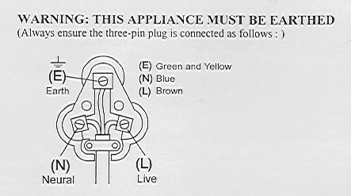
Green/Yellow = Earth
Blue = Neutral
Brown = Live

PLEASE AFFIX YOUR PROOF OF PURCHASE/RECEIPT HERE
IN THE EVENT OF A CLAIM UNDER WARRANTY THIS RECEIPT MUST BE PRODUCED.

W A R R A N T Y

- Tedelex Trading (Pty) Limited (“Tedelex”) warrants to the original purchaser of this product (“the customer”) that this product will be free of defects in quality and workmanship which under normal personal, family or household use and purpose may manifest within a period of 1 (one) year from the date of purchase (“warranty period”).
- Where the customer has purchased a product and it breaks, is defective or does not work properly for the intended purpose, the customer must notify the supplier from whom the customer bought the product (“the supplier”) thereof within the warranty period. Any claim in terms of this warranty must be supported by a proof of purchase. If proof of purchase is not available, then repair, and/or service charges may be payable by the customer to the supplier.
- The faulty product must be taken to the supplier's service centre to exercise the warranty.
- The supplier will refund, repair or exchange the product in terms of this warranty subject to legislative requirements. This warranty shall be valid only where the customer has not broken the product himself, or used the product for something that it is not supposed to be used for. The warranty does not include and will not be construed to cover products damaged as a result of disaster, misuse, tamper, abuse or any unauthorised modification or repair of the product.
- This warranty will extend only to the product provided at the date of the purchase and not to any expendables attached or installed by the customer.
- If the customer requests that the supplier repairs the product and the product breaks or fails to work properly within 3 (three) months of the repair and not as a result of misuse, tampering or modification by or on behalf of the customer, then the supplier may replace the product or pay a refund to the customer.
- The customer may be responsible for certain costs where products returned are not in the original packaging, or if the packaging is damaged. This will be deducted from any refund paid to the customer.

TEDELEX TRADING (PTY) LTD (JOHANNESBURG)

JOHANNESBURG TEL NO. (011) 490-9600

CAPE TOWN TEL NO. (021) 552-5161

DURBAN TEL NO. (031) 792-6000

www.amap.co.za * www.russellhobbs.co.za

