INSTRUCTIONS AND WARRANTY

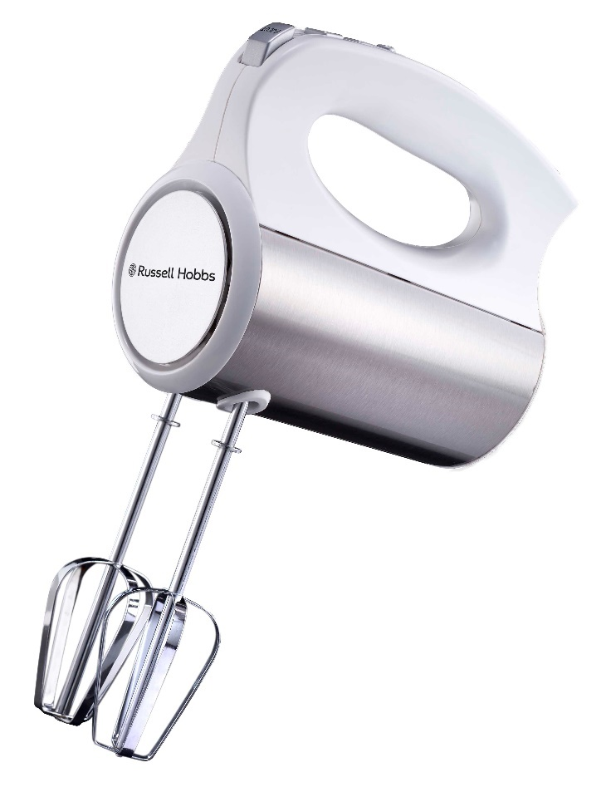

MODEL NO. RHHM33
RUSSELL HOBBS INFINITY HAND MIXER
Thank you for purchasing the Russell Hobbs Infinity Hand Mixer. Each unit has been manufactured to ensure safety, reliability and ease of use. Before use, please read the instructions carefully and keep it for future reference. Should you pass the unit on, please ensure that you also pass the instruction manual.

FEATURES OF THE RUSSELL HOBBS INFINITY HAND MIXER
- Bringing versatility, efficiency and effortless food preparation to your kitchen
- 400W
- 5 speed settings plus turbo function
- Easy-release eject button for easy and safe removal of attachments
- Includes: 2 x beaters, 2 x hooks
- Mix, whisk, beat, cream and mash!
- For domestic use only
- 2-year warranty (1 year retail • 1 year extended upon online registration of product • visit www.russellhobbs.co.za)

IMPORTANT SAFEGUARDS

When using any electrical hand mixer, basic safety precautions should always be followed including the following:

- Please read the instructions carefully before using any hand mixer.
- Always ensure that the voltage on the rating label corresponds to the mains voltage in your home.
- Incorrect operation and improper use can damage the hand mixer and cause injury to the user.
- The hand mixer is intended for household use only. Commercial use invalidates the warranty and the supplier cannot be held responsible for injury or damage caused when using the hand mixer for any other purpose than that intended.
- Avoid any contact with moving parts.
- Always disconnect the appliance from the power supply if it is left unattended and before assembling, disassembling or cleaning.
- Do not operate the appliance for longer than a minute. Allow the appliance to cool down for a few seconds after each cycle to avoid overheating.
- Check the power cord and plug regularly for any damage. If the cord or the plug is damaged, it must be replaced by the manufacturer or a qualified person in order to avoid any electrical hazard.
- Do not use the hand mixer if it has been dropped or damaged in any way. In case of any damage, take the unit in for examination and/or repairs by an authorised service agent.
- To reduce the risk of electric shock, do not immerse the unit plug or the power cord into water or any other liquid. Do not use the appliance with wet hands.
- Never immerse the unit in water or any other liquid for cleaning purposes.
- Remove the plug from the socket by gripping the plug. Do not pull on the cord to disconnect the appliance from the mains. Always unplug the unit when not in use or before cleaning or when adding or removing parts.
- The use of accessory attachments that are not recommended or supplied by the manufacturer may result in injuries, fire or electric shock.
- A short cord is provided to reduce the hazards resulting from becoming entangled in or tripping over a longer cord.
- This appliance is not intended for use by persons (including children) with reduced physical, sensory or mental capabilities, or lack of experience and knowledge, unless they are under supervision or instruction concerning use of the appliance by a person responsible for their safety. Children should be supervised to ensure that they do not play with the appliance.
- A short cord is provided to reduce the hazards resulting from becoming entangled in or tripping over a longer cord.
- Do not let the cord hang over the edge of a table or counter. Ensure that the cord is not in a position where it can be pulled on accidentally.
- Do not allow the cord to touch hot surfaces and do not place it on or near a hot gas, electric burner or in a heated oven.
- Do not use the appliance on a gas or electric cooking top, over or near an open flame.
- Keep the appliance and cord away from direct radiant heat from the sun, damp areas, sharp edges and other dangers.
- Use of an extension cord with this appliance is not recommended. However, if it is necessary to use an extension cord, ensure that the cord is suited to the power consumption of the appliance to avoid overheating of the extension cord, appliance or plug point. Do not place the extension cord in a position where it can be pulled on by children or animals or tripped over.
- The manufacturer does not accept responsibility for any damage or injury caused by improper or incorrect use, or for repairs carried out by unauthorised personnel.
- Never pull the cord to disconnect it from the outlet. Grasp the plug and pull it from the outlet.
- This hand mixer is not suitable for outdoor use. Do not use this hand mixer for anything other than its intended use.
- Never lift or carry the hand mixer by the cord.
- Do not leave this hand mixer unattended during use. Always unplug the unit when not in use or before cleaning.
- Always operate the hand mixer on a smooth, even, stable surface. Do not place the unit on a hot surface.
- Ensure both beaters/hooks are fitted properly into the hand mixer before use.
- It is extremely important to keep this appliance clean at all times as it comes into direct contact with food.
- Ensure that the switch is on the “0” position after each use.
- The manufacturer does not accept responsibility for any damage or injury caused by improper or incorrect use, or for repairs carried out by unauthorised personnel.
- Caution: Please keep this product away from fire or similar hazardous substances.
- DISPOSAL: Do not dispose this product as unsorted municipal waste. Collection of such waste separately for special treatment is necessary.
- In case of technical problems, switch off the hand mixer and do not attempt to repair it yourself. Return the hand mixer to an authorised service facility for examination, adjustment or repair. Always insist on the use of original spare parts. Failure to comply with the above-mentioned pre-cautions and instructions, could affect the safe operation of this appliance.
NOTE: This appliance is not for professional use. When using the hand mixer, do not use it for longer than 5 minutes per cycle (1-5 speed settings) and for no longer than 1 minute for the turbo function, as this puts pressure on the motor which could lead to overheating and product malfunction. It is recommended to allow the hand mixer to cool down to room temperature after each cycle. You should follow the given cycle times. Failure to follow this instruction may result in damage to the motor.

PARTS DIAGRAM

1. Eject button
2. Turbo button
3. Speed control
4. Power cord
5. Body
6. Body cover
7. Beaters
8. Hooks

BEFORE FIRST USE
Before using your appliance for the first time remove the appliance from the box and take off any protective wrappings.
Note: Do not leave protective packaging lying around, as it could be dangerous around infants.

OPERATING INSTRUCTIONS

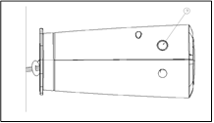

Fig (1)
- Fit the beaters (7) or hooks (8) into the designated holes (Fig 1).

- Plug in the appliance.
- Hold the handle and lower the beaters or hooks into the ingredients.
- Select the desired speed on the speed control (3) and the hand mixer will begin to mix the ingredients in the bowl.
- Once you have finished mixing, stop the hand mixer by pushing the speed button to "0" immediately.
- Wait until the beaters / hooks have come to a complete stop, press the eject knob (1) to remove the beaters / hooks. Switch off the appliance before changing accessories.
- You can press turbo button to accelerate the speed during mixing.
- Unplug the appliance when you have finished mixing. Clean the beaters / hooks with water. Dry the accessories and store them in its original box with the main body or store in a cool or dry place.

CAUTION: When using the hand mixer, do not use it for longer than 5 minutes per cycle (1-5 speed settings) and for no longer than 1 minute for the turbo function, as this puts pressure on the motor which could lead to overheating and product malfunction. It is recommended to allow the hand mixer to cool down to room temperature after each cycle.

MIXING GUIDE:
SPEED | DESCRIPTION
1  WHIP | For making icings, whipping cream etc.
2-3  CREAM | For beating butter and sugar. Beating uncooked candy, desserts etc.
4  FOLD or MIX | This is a good starting speed for bulk and dry foods such as flour, butter, cooked potatoes, mixing cakes, cookies and for beating eggs.

CLEANING AND MAINTENANCE
- Always remember to unplug the unit from the electrical outlet when not in use and before cleaning. Ensure that the speed control is set to “0”.
- It is much easier to clean the accessories directly after they have been used. Wash them in warm, soapy water, rinse and dry well.
- To remove stubborn spots/marks on the body of the hand mixer, wipe the surface with a cloth slightly dampened in soapy water or a mild non-abrasive cleaner.
- Do not use bleach or other abrasive substances or solvents to clean your hand mixer as it can be damaging to the finish.
- Do not immerse the hand mixer in water or any other liquid or hold it under a running tap to clean.

STORING THE HAND MIXER
- Unplug the unit from the wall outlet and clean all the parts as instructed above. Ensure that all parts are dry before storing.
- Store the hand mixer is in its box or in a clean, dry place.
- Never store the hand mixer while it is still wet or dirty.
- Never wrap the power cord around the hand mixer.

SERVICING THE APPLIANCE
There are no user serviceable parts in this hand mixer. If the unit is not operating correctly, please check the following:
- You have followed the instructions correctly
- That the unit has been wired correctly and that the wall socket is switched on.
- That the mains power supply is ON.
- That the plug is firmly in the mains socket.

If the hand mixer still does not work after checking the above:
- Consult the retailer for possible repair or replacement. If the retailer fails to resolve the problem and you need to return the hand mixer and make sure that:
- The unit is packed carefully back into its original packaging.
- Proof of purchase is attached.
- A reason is provided for why it is being returned.
If the supply cord is damaged, the manufacturer or an authorised service agent must replace it, in order to avoid any hazard. If service becomes necessary within the warranty period, the hand mixer should be returned to an approved Home Of Living Brands (Pty) Limited service centre. Servicing outside the warranty period is still available, but will, however, be chargeable.

CHANGING THE PLUG
Should the need arise to change the fitted plug, follow the instructions below.
This unit is designed to operate on the stated current only. Connecting to other power sources may damage the appliance.

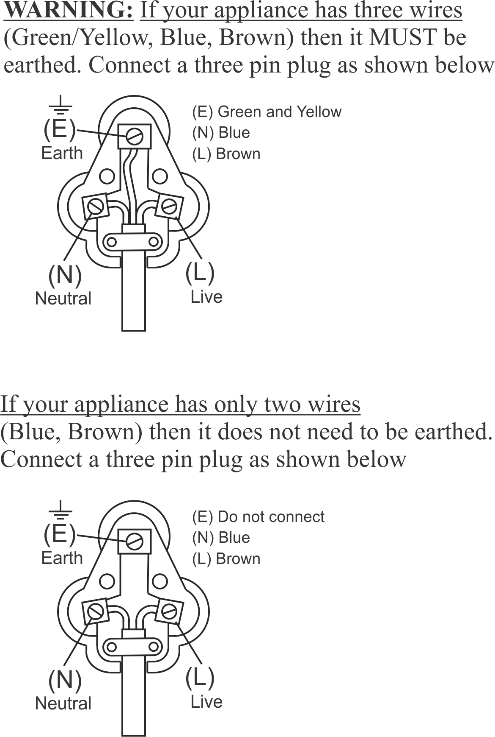

PLEASE AFFIX YOUR PROOF OF PURCHASE/RECEIPT HERE
IN THE EVENT OF A CLAIM UNDER WARRANTY THIS RECEIPT MUST BE PRODUCED.

2 YEAR WARRANTY
1 year retail ⵏ 1 year extended warranty upon registration*
visit www.russellhobbs.co.za

W A R R A N T Y AND EXTENDED WARRANTY

- Home of Living Brands (Pty) Limited ("Home of Living Brands") warrants to the original purchaser of this product ("the customer") that this product will be free of defects in quality and workmanship which under normal personal, family or household use and purpose may manifest within a period of 1 (one) year from the date of purchase ("warranty period").

- Home of Living Brands shall extend the warranty period for a further period of 1(one) year (“extended warranty period*”), on condition that the purchaser registers the product on the website, within 12 months from the date of purchase of the product. The website address for registration is as follows: http://russellhobbs.co.za/info-pages/warranty-info.aspx. The extended warranty period only applies to products purchased on or after 1 October 2017.

- Where the customer has purchased a product and it breaks, is defective or does not work properly for the intended purpose, the customer must notify the supplier from whom the customer bought the product ("the supplier") thereof within the warranty period or if applicable, the extended warranty period. Any claim in terms of this warranty must be supported by a proof of purchase. If proof of purchase is not available, then repair, and/or service charges may be payable by the customer to the supplier.

- The faulty product must be taken to the supplier's service centre to exercise the warranty.

- The supplier will refund, repair or exchange the product in terms of this warranty subject to legislative requirements. This warranty shall be valid only where (a) the customer is not the cause of the product breaking, and (b) the product has been used for the intended purpose stipulated in the product manual. The warranty does not include and will not be construed to cover products damaged as a result of disaster, misuse, tamper, abuse or any unauthorised modification or repair of the product.

- This warranty will extend only to the product provided at the date of the purchase and not to any expendables attached or installed by the customer. In this regard any accessories supplied with the product by the supplier, may be excluded in this warranty or extended warranty (see Exclusions to Warranty and Extended Warranty document).

- If the customer requests that the supplier repairs the product and the product breaks or fails to work properly within 3 (three) months of the repair and not as a result of misuse, tampering or modification by or on behalf of the customer, then the supplier may replace the product or pay a refund to the customer, subject to the supplier’s discretion.

- The customer may be responsible for certain costs where products returned are not in the original packaging, or if the packaging is damaged. This will be deducted from any refund paid to the customer.

HOME OF LIVING BRANDS (PTY) LTD (JOHANNESBURG)

JOHANNESBURG TEL NO. (011) 490-9600
CAPE TOWN TEL NO. (021) 552-5161
DURBAN TEL NO. (031) 303-1163
www.homeoflivingbrands.com
www.russellhobbs.co.za
www.facebook.com/RussellHobbsSA

