

INSTRUCTIONS AND WARRANTY
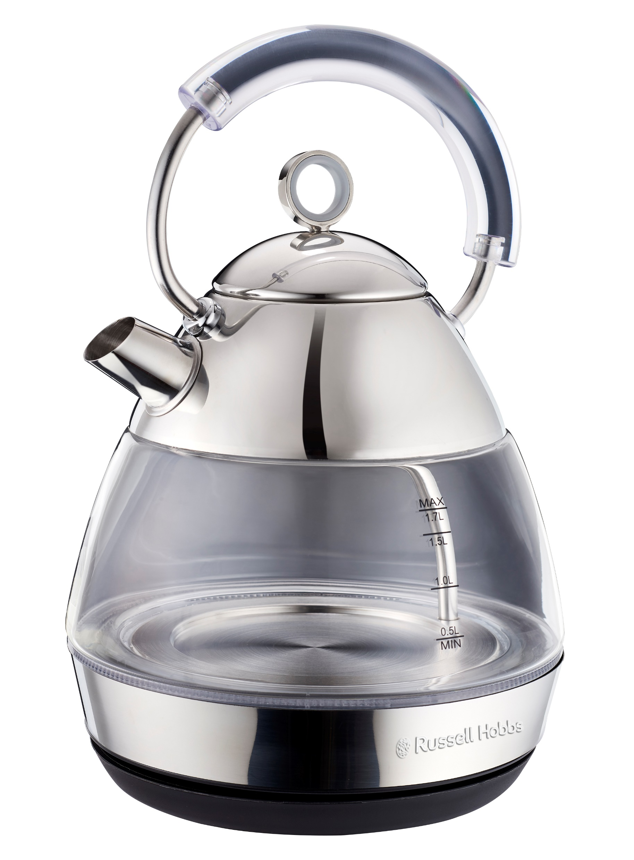

MODEL NO. RHKAP3G

RUSSELL HOBBS GLASS DOME KETTLE

Congratulations on purchasing your Russell Hobbs Glass Dome Kettle. Each unit is manufactured to ensure safety and reliability. Before using this appliance for the first time, please read the instruction manual carefully and keep it for future reference.
FEATURES OF THE RUSSELL HOBBS 2ND GENERATION CREAM LEGACY KETTLE
- 3000W
- 1.7L large capacity
- Elegant glass design with a transparent handle
- Easy pour spout
- Easy removeable pull off lid
- 360° cordless base with integrated cord storage
- Concealed heating element for easy cleaning
- Blue Illuminating light
- Safe, long-lasting Strix control
- Boil-dry and overheat protection
- Automatic shut-off after boiling
- For domestic use only
- 2 year warranty (1 year retail • 1 year extended upon online registration of product • visit www.russellhobbs.co.za)

PARTS DIAGRAM
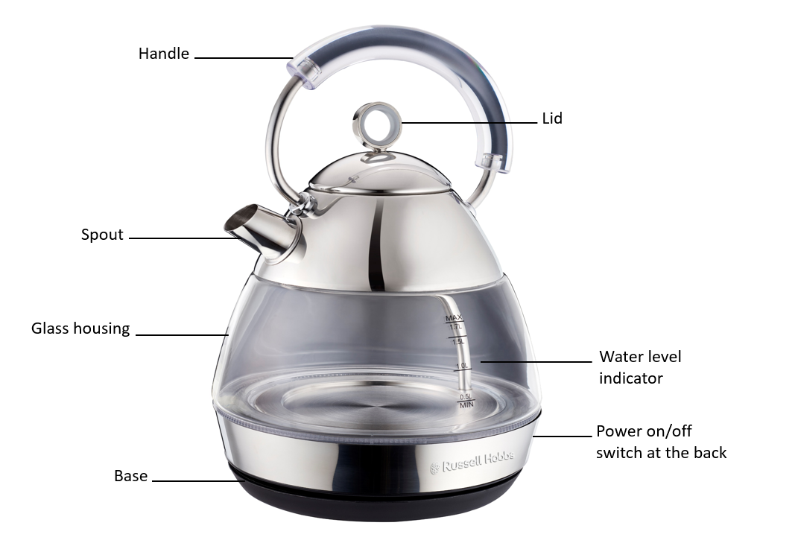

IMPORTANT SAFEGUARDS

When using any electrical appliance, basic safety precautions should always be followed including the following:
- Please read the instructions carefully before using any appliance.
- Always ensure that the voltage on the rating label corresponds to the mains voltage in your home.
- Incorrect operation and improper use can damage the appliance and cause injury to the user.
- The appliance is intended for household use only. Commercial use invalidates the warranty and the supplier can not be held responsible for injury or damage caused when using the appliance for any other purpose than that intended.
- Avoid any contact with moving parts.
- This appliance is not intended for use by persons (including children) with reduced physical, sensory or mental capabilities, or lack of experience and knowledge, unless they have been given supervision or instruction concerning use of the appliance by a person responsible for their safety.
- Children should be supervised to ensure that they do not play with the appliance.
- Check the power cord and plug regularly for any damage. If the cord or the plug is damaged, it must be replaced by the manufacturer or a qualified person in order to avoid an electrical hazard.
- Do not use the appliance if it has been dropped or damaged in any way. In case of damage, take the unit in for examination and/or repair by an authorised service agent.
- Do not open the lid while the kettle is in use.
- Only fill the kettle with cold water. Do not fill the kettle above the MAX level (1.7L). Boiling water may overflow.
- Unplug from outlet when not in use and before cleaning. Allow it to cool down completely before cleaning the appliance.
- Do not insert any objects into holes or slots in this appliance.
- To reduce the risk of electric shock, do not immerse or expose the motor assembly, plug or the power cord to water or any other liquid.
- Never immerse the unit in water or any other liquid for cleaning purposes. Do not allow liquid to penetrate into the electrical parts of this kettle.
- Remove the plug from the socket by gripping the plug. Do not pull on the cord to disconnect the appliance from the mains.
- The use of accessory attachments that are not recommended or supplied by the manufacturer may result in injuries, fire or electric shock. The kettle is to be used only with the base provided.
- A short cord is provided to reduce the hazards resulting from becoming entangled in or tripping over a longer cord.
- Do not let the cord hang over the edge of a table or counter. Ensure that the cord is not in a position where it can be pulled on inadvertently.
- Do not allow the cord to touch hot surfaces and do not place on or near a hot gas or electric burner or in a heated oven.
- Children younger than 8 years of age should NOT be allowed to clean or maintain the kettle. If children of 8 years and older operate/clean/maintain the kettle, they should do so under supervision.
- Keep the device and the cable away from heat, direct sunlight, moisture, sharp edges, etc.
- Do not use the appliance on a gas or electric cooking top or over or near an open flame.
- Use of an extension cord with this appliance is not recommended. However, if it is necessary to use an extension cord, ensure that the cord is suited to the power consumption of the appliance to avoid overheating of the extension cord, appliance or plug point. The extension cord should not be placed in a position where it can be pulled on by children or animals or tripped over.
- This appliance is not suitable for outdoor use. Do not use this appliance for anything other than its intended use.
- DO NOT carry the appliance by the power cord.
- Do not leave this appliance unattended during use. Always unplug the unit when not in use, before cleaning, or when adding/removing parts.
- Always operate the appliance on a smooth, even, stable surface. Do not place the unit on a hot surface.
- Ensure that the switch is in the “Off” position after each use.
- The manufacturer does not accept responsibility for any damage or injury caused by improper or incorrect use, or for repairs carried out by unauthorised personnel.
- In case of technical problems, switch off the appliance and do not attempt to repair it yourself. Return the appliance to an authorised service facility for examination, adjustment or repair. Always insist on the use of original spare parts. Failure to comply with the above mentioned pre-cautions and instructions, could affect the safe operation of this appliance.
- Take care when pouring – pour slowly, and don’t over-tilt the kettle.
- Wind excess cable beneath the base.
- Check that the lid is fully closed before switching the kettle on - otherwise it may not switch off.
- Check the kettle is properly placed on the base before switching on.
- Kettle may only be switched on if the watch level is equal to or above the MINIMUM water level.
- Do not fill the kettle through the spout and the water must not exceed the MAXIMUM millage level.
- Remove the kettle from its base before filling or pouring.
- This appliance must not be operated by an external timer or remote control system.
- Do not put the kettle or its base on a wet place/surface or in water – do not operate it with wet hands.

OPERATING INSTRUCTIONS

PREPARATION FOR USE
Carefully remove your kettle from the box. You may wish to retain the packaging for further use.

BEFORE USING THE KETTLE FOR THE FIRST TIME
- Before first use, fill the kettle with cold water to the MAX water level mark, bring to boil and discard the boiling water – do this twice. This will ensure that any residues left over from the manufacturing process are completely removed.

POSITIONING THE KETTLE
- Position the power base on a dry flat surface away from any potential heat source.
- The underside of the power base is fitted with a cable storage feature. Unwind the length of the mains cable required to reach the mains socket.
- Ensure the mains cable does not hang over the work surface edge.

FILLING THE KETTLE
- Remove the kettle from the power base.
- Open the lid by pulling the lid upwards.
- Fill the kettle between the MIN and MAX markings on the water level indicator with cold water.
- Close the lid and place the kettle back on the power base. Make sure the lid is securely closed before boiling.
- Always remove the kettle from the power base before filling. Do not fill the kettle above the MAX mark or below the MIN mark on the water gauge.

SWITCHING ON
- Position the kettle on the power base.
- Plug the kettle into a mains supply socket.
- To start boiling the kettle, press the on/off switch down to “1” (on) position.
- The power indicator light will illuminate and the kettle will start to boil.
- Never open the lid during boiling.
- Do not operate this kettle without the filter fitted.

Please beware of escaping steam from the lid of the kettle when in use.

BOIL DRY HEATING PROTECTION
- If you have forgotten to add water or the water inside is below the minimum accepted level, the metal sheet for dry heating protection of the temperature controller will disconnect automatically when the kettle is switched on in order to protect the kettle from being damaged by dry heating.
- If the above situation happens, please turn off the power supply, unplug the kettle and wait 10 minutes for it to cool down. Once this is done, the temperature controller connects and the kettle will operate normally again.

Note: Do not add cold water in the kettle in an attempt to cool it down quicker – this will decrease the life span of the kettle’s heating plate.

SWITCHING OFF
- When the water has boiled, the kettle will switch off automatically. You can stop the boiling process at any time by lifting the on/off switch to the “0” (off) position.

GENERAL
- Always remove the kettle from the base before pouring.
- To avoid the risk of splashing, pour slowly and do not over-tilt the kettle.
- Do not tilt the kettle backwards - water might get on to the control area. If this happens, let the kettle dry thoroughly before use – place it somewhere warm for 12 hours.
- When you lift the kettle, you may see moisture on the base. Do not worry – it’s the steam used to switch the kettle off automatically, which then condenses and escapes via vents under the kettle.
- You may see some discolouration on the inner heating pad of the kettle. Again, do not worry – it is due to the bonding of the heating pad to the kettle floor.

CLEANING AND MAINTENANCE
- This appliance is for household use only and is not user-serviceable.
- Do not open or change any parts by yourself. Please refer to a qualified electrical service department or return to the supplier if servicing is necessary.
- Always remember to unplug the unit from the electrical outlet when not in use and before cleaning.
- Do not immerse the appliance in water or any other liquid, or hold it under a running tap to clean.
- To remove stubborn spots/marks, wipe the surfaces with a cloth slightly dampened in soapy water or mild non-abrasive cleaner. Rinse and dry with a clean, dry, soft cloth.
- Unplug the base from the wall socket, and let the kettle cool down before cleaning.
- Wipe the kettle, inside and out, with a damp cloth. You may use a little household detergent, but if you do, rinse well to avoid tainting the water.
- Wipe the base with a damp cloth.
- Keep all connectors and sockets dry.
- Do not immerse the kettle or kettle base in liquid.
- Do not use harsh or abrasive cleaning agents or solvents.

We recommend that you descale your kettle regularly, even in soft water areas. Lime scale may be white, coloured, or even rusty-looking, but it is normally visible. Phosphate scale is not generally visible, but there is always a build-up, even in soft water areas. Any build-up of scale causes overheating, which reduces the life of the element, and may trigger the boil-dry cut-out to engage. So, even in a soft water area, descale at least monthly, to help keep your kettle in working order.

To descale your kettle:
- We suggest use of a kettle descaler in order to dissolve chalky deposits or scale.
- Use a descaler suitable for plastic products (all kettles have plastic parts). Follow the instructions on the descaler, then rinse several times, fill, boil and discard the water, to remove all chemical residues.
- Follow the directions on the descaler package. If a commercial descaler is not available, fill the kettle with enough white vinegar to cover the bottom by about 1.5cm. Bring the vinegar to a boil. You may need to repeat this several times with cooled vinegar to remove the calcium build-up completely. When the descaling process is complete, empty the kettle and rinse out several times with clean water
- Products returned under guarantee with faults related to scale will be subject to a repair charge.
- If you notice your kettle getting noisier – descale it.
- Do not rely on visible scale, as phosphate scale is not visible. Rather descale the kettle for preventative purposes.

Water filter:
- Scale particles suspended in the water may give it a cloudy or greasy appearance.
- The filter will prevent these particles going into your drink. If you see deposits on the filter, clean it, otherwise the performance of your kettle will drop, your drinks may contain scale, and the water inside the kettle may look cloudy.
Cleaning the filter:
- The filter is located inside the kettle behind the spout.
- With the lid open, gently pull the filter out of its retaining slot.
- Lift the filter out of the kettle.
- Rinse the filter in warm water and gently remove any scale with a soft brush.
- To replace the filter, slide it down into its slot until it clicks into place.

STORING THE APPLIANCE
- Unplug the unit from the electrical outlet and clean all the parts as instructed above. Ensure that all parts are dry before storing.
- Store the appliance in its box or in a clean, dry place.
- Never store the appliance while it is still wet or dirty.
- Never wrap the power cord around the appliance.

SERVICING THE APPLIANCE
There are no user serviceable parts in this appliance. If the unit is not operating correctly, please check the following:
- You have followed the instructions correctly
- That the unit has been wired correctly and that the wall socket is switched on.
- That the mains power supply is ON.
- That the plug is firmly in the mains socket.

If the appliance still does not work after checking the above:
- Consult the retailer for possible repair or replacement. If the retailer fails to resolve the problem and you need to return the appliance, make sure that:
- The unit is packed carefully back into its original packaging.
- Proof of purchase is attached.
- A reason is provided for why it is being returned.

If the supply cord is damaged, it must be replaced by the manufacturer or an authorised service agent, in order to avoid any hazard. If service becomes necessary within the warranty period, the appliance should be returned to an approved Home of Living Brands (Pty) Limited service centre. Servicing outside the warranty period is still available, but will, however, be chargeable.

CHANGING THE PLUG
Should the need arise to change the fitted plug, follow the instructions below.
This unit is designed to operate on the stated current only. Connecting to other power sources may damage the appliance. Connect a three-pin plug as follows:
The wires in this mains lead are coloured in accordance with the following code:
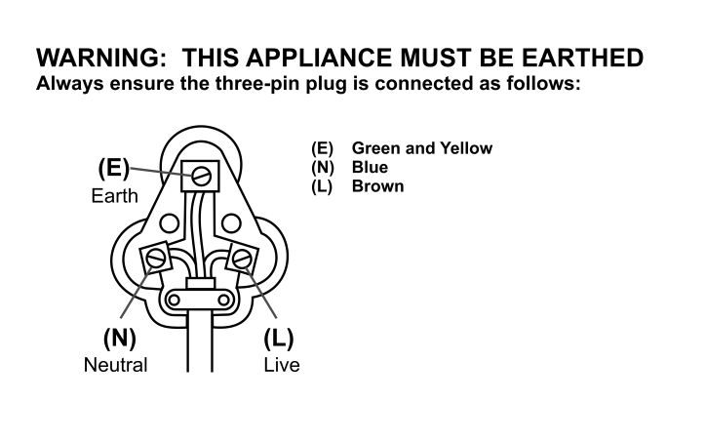

PLEASE AFFIX YOUR PROOF OF PURCHASE/RECEIPT HERE
IN THE EVENT OF A CLAIM UNDER WARRANTY THIS RECEIPT MUST BE PRODUCED.

WARRANTY AND EXTENDED WARRANTY

- Home of Living Brands (Pty) Limited ("Home of Living Brands ") warrants to the original purchaser of this product ("the customer") that this product will be free of defects in quality and workmanship which under normal personal, family or household use and purpose may manifest within a period of 1 (one) year from the date of purchase ("warranty period").

- Home of Living Brands shall extend the warranty period for a further period of 1 (one) year (“extended warranty period”), on condition that the purchaser registers the product on the website, within 12 months from the date of purchase of the product. The website address for registration is as follows: http://russellhobbs.co.za/info-pages/warranty-info.aspx. The extended warranty period only applies to products purchased on or after 1 October 2017.

- Where the customer has purchased a product and it breaks, is defective or does not work properly for the intended purpose, the customer must notify the supplier from whom the customer bought the product ("the supplier") thereof within the warranty period or if applicable, the extended warranty period. Any claim in terms of this warranty must be supported by a proof of purchase. If proof of purchase is not available, then repair, and/or service charges may be payable by the customer to the supplier.

- The faulty product must be taken to the supplier's service centre to exercise the warranty.

- The supplier will refund, repair or exchange the product in terms of this warranty subject to legislative requirements. This warranty shall be valid only where the customer has not broken the product themselves, or used the product for something that it is not supposed to be used for. The warranty does not include and will not be construed to cover products damaged as a result of disaster, misuse, tamper, abuse or any unauthorised modification or repair of the product.

- This warranty will extend only to the product provided at the date of the purchase and not to any expendables attached or installed by the customer.

- If the customer requests that the supplier repairs the product and the product breaks or fails to work properly within 3 (three) months of the repair and not as a result of misuse, tampering or modification by or on behalf of the customer, then the supplier may replace the product or pay a refund to the customer, subject to the supplier’s discretion.

- The customer may be responsible for certain costs where products returned are not in the original packaging, or if the packaging is damaged. This will be deducted from any refund paid to the customer.

HOME OF LIVING BRANDS (PTY) LTD (JOHANNESBURG)

JOHANNESBURG TEL NO. (011) 490 9600

CAPE TOWN TEL NO. (021) 552 5161

DURBAN TEL NO. (031) 303 1163

www.homeoflivingbrands.com

EXCLUSIONS TO W A R R A N T Y AND EXTENDED WARRANTY

1. Any accessories supplied with the product, including but not limited to, bowls, jugs, mills or carafes made either of glass or plastic and supplied with this appliance (hereinafter referred to as “the accessory or accessories”), is warranted to be free from material and workmanship defects for the duration of the appliance warranty.

2. The accessories should give trouble free service when used in accordance with the directions described in the instruction manual. However, the accessories will be damaged if subjected to impact, and this damage is not covered by the warranty. Such impact damage can occur either from the outside (if for example it is dropped or knocked against a hard surface), or from within (if for example foreign objects are placed within the accessories and the power is switched on).

3. Should you need to replace an accessory during the warranty period; a claim for a free replacement will only be considered if the item (including all shards and broken parts) is returned to the nearest HOLB service centre for examination.

4. The remains of the accessory will be carefully examined by the relevant professionals and if it is determined (at the sole discretion of HOLB) that the damage was caused by impact, then the claim will be refused and will not be covered by the warranty or any extended warranty.

5. Any replacement part provided in terms of clause 4 above will become a chargeable item payable by the customer.

