INSTRUCTIONS AND WARRANTY

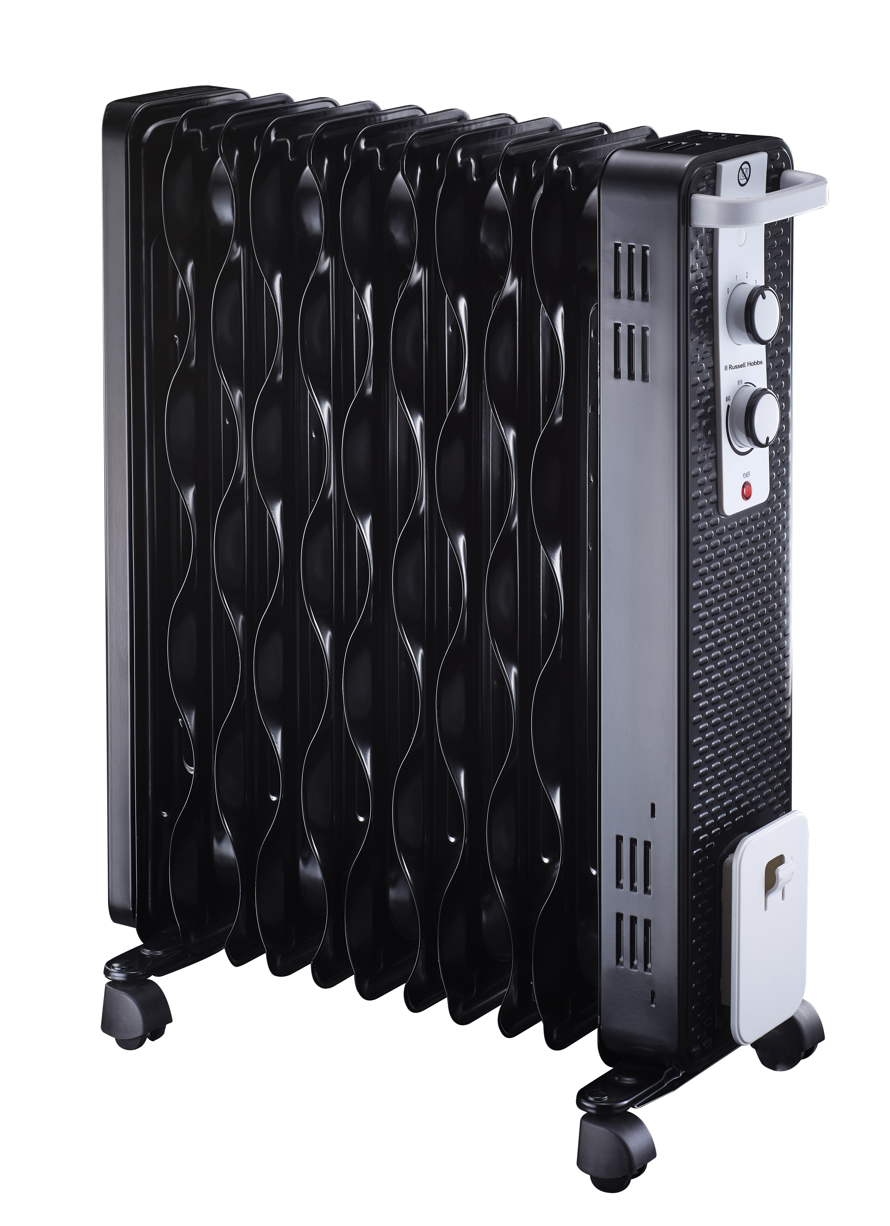

MODEL NO. RHOH11FC

RUSSELL HOBBS 11 FIN OIL HEATER

Congratulations on purchasing your Russell Hobbs 11 Fin Oil Heater. Each unit is manufactured to ensure safety and reliability. Before using this appliance for the first time, please read the instruction manual carefully and keep it for future reference.
FEATURES OF THE 11 FIN OIL HEATER
- 11 Fins
- Heating range from 1000 to 2500w
- 3 Heat settings
- Patented Eco-fins
- Adjustable thermostat
- Over heat protection
- Power indicator light
- Power cord storage

IMPORTANT SAFEGUARDS
When using any electrical appliance, basic safety precautions should always be followed including the following:
- Please read the instructions carefully before using the oil heater.
- Always ensure that the voltage on the rating label corresponds to the mains voltage in your home.
- Incorrect operation and improper use can damage the oil heater and cause injury to the user.
- The oil heater is intended for household use only. Commercial use invalidates the warranty and the supplier cannot be held responsible for injury or damage caused when using the appliance for any other purpose than that intended.
- Avoid any contact with moving parts.
- This oil heater is not intended for use by persons (including children) with reduced physical, sensory or mental capabilities, or lack of experience and knowledge, unless they have been given supervision or instruction concerning use of the heater by a person responsible for their safety.
- Children should be supervised to ensure that they do not play with the oil heater.
- Check the power cord and plug regularly for any damage. If the cord or the plug is damaged, the manufacturer or a qualified person must replace it in order to avoid an electrical hazard.
- Do not use the oil heater if it has been dropped or damaged in any way. In case of damage, take the unit in for examination and/or repair by an authorised service agent.
- To reduce the risk of electric shock, do not in immerse or expose the oil heater assembly, plug or the power cord to water or any other liquid.
- Never immerse the unit in water or any other liquid for cleaning purposes.
- Remove the plug from the socket by gripping the plug. Do not pull on the cord to disconnect the heater from the mains. Always unplug the unit when not in use, before cleaning or when adding or removing parts.
- The use of accessory attachments that are not recommended or supplied by the manufacturer may result in injuries, fire or electric shock.
- A short cord is provided to reduce the hazards resulting from becoming entangled in or tripping over a longer cord.
- Do not let the cord hang over the edge of a table or counter. Ensure that the cord is not in a position where it can be pulled on inadvertently.
- Do not allow the cord to touch hot surfaces and do not place on or near a hot gas or electric burner or in a heated oven.
- Do not use the oil heater on a gas or electric cooking top or over or near an open flame.
- Use of an extension cord with this heater is not recommended. However, if it is necessary to use an extension lead, ensure that the lead is suited to the power consumption of the oil heater to avoid overheating of the extension cord, appliance or plug point. Do not place the extension cord in a position where it can be pulled on by children or animals or tripped over.
- This oil heater is not suitable for outdoor use. Do not use this appliance for anything other than its intended use.
- DO NOT carry the oil heater by the power cord.
- Do not leave this heater unattended during use. Always unplug the unit when not in use or before cleaning.
- Always operate the heater on a smooth, even, stable surface. Do not place the unit on a hot surface.
- Ensure that the switch is in the “Off” position after each use.
- The manufacturer does not accept responsibility for any damage or injury caused by improper or incorrect use, or for repairs carried out by unauthorised personnel.
- In case of technical problems, switch off the heater and do not attempt to repair it yourself. Return the base board heater to an authorised service facility for examination, adjustment or repair. Always insist on the use of original spare parts. Failure to comply with the above-mentioned pre-cautions and instructions, could affect the safe operation of this heater.
- Ensure the unit is intact without visible damages which could be caused by transport. In case of doubt do not use it and contact our service centre.
- Do not leave packaging materials like plastic bags, foam polystyrene, buttons and staples within reach of children.
- Do not place the heater on windowsills or other places where it may be exposed to dripping or splashing water; do not place vases or similar objects filled with liquids near the heater.
- Never touch the appliance with wet or damp hands or feet.
- Do not use the appliance in bathrooms or in areas with high damp and humidity or close to water.
- Never expose the appliance to atmospheric conditions such as rain, sun, wind etc.
- To avoid the risk of overheating, ensure the cable is completely unwound when in use.
- Only plug in and switch on the appliance when it is in use, when not in use always switch the appliance off and unplug it.
- Ensure the air inlet and outlet is not obstructed.
- Ensure the appliance is installed in a horizontal position only. The appliance should never be installed vertically or at an incline.
- Do not leave the appliance unattended when it is on.
- Ensure that the cord is not in front of warm air outlet grille when in use.
- Ensure the grills are kept clean.
- Never install and use the appliance directly below a fixed outlet.
- Do not use the appliance near liquids or flammable gasses or materials.
- Do not cover the appliance.
- Ensure the appliance is kept clean.
- Do not use the appliance in rooms that are smaller than 4m².
- Do not use this heater with a programmer; timer, separate control system or any other device that switches the heater on automatically.
CAUTION — Some parts of this product can become very hot and cause burns. Particular attention must be given where children and vulnerable people are
present.
PARTS DIAGRAM
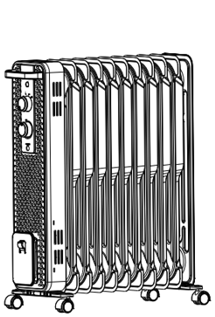
4
3
2
1.
5
- Handle
- Temperature controls
- Power cord Storage
- Castor wheels
- Radiator body

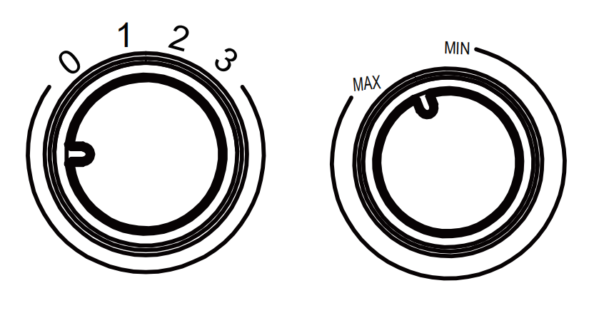
1
2

- Temperature control knob
- Thermostat control knob

ASSEMBLY INSTRUCTIONS
The heater is packaged with the feet unattached. You must attach them before operating the heater.

WARNING: Do not operate without feet attached. Do operate the heater only in upright position (feet on the bottom, controls on the top), any other position could create a hazardous situation.

- 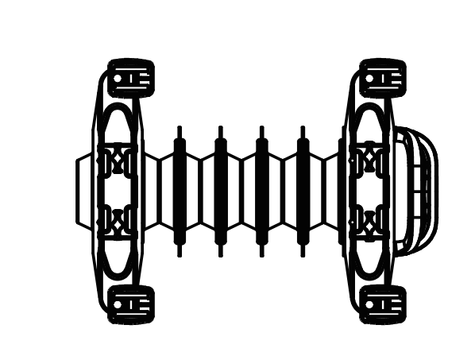Place the radiator body upside-down on a scratch-free location, make sure it is stable and will not fall.
Front Cover
- Screw off the wing nuts from the U-shaped bolt provided, attach the U-shaped bolt to the U-facing flange between first and second fins (near the front cover).
- 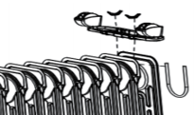To attach the castor mounting plate to the radiator body, you should insert the threaded ends of the U bolt in the holes on the castor mounting plate.
Wingnuts
U Bolt

- Screw the wing nuts back to the U bolt and fasten the wing nut properly.
Note: do not over tighten, which may cause the damage of radiator flange.
- Repeat 2, 3, and 4 on the rear of radiator for mounting of the rear castors.
Note: the rear castors must be mounted between the two fins on the end.

OPERATING INSTRUCTIONS
Switching the heater On
- Connect the heater to the electric mains by plugging the power cord into an electric outlet.
- Turn the temperature control knob to desired temperature setting.
  - 0 – Off
  - 1 – 1000watt
  - 2 – 1400watt
  - 3 – 2400watt
- Turn the thermostat control knob clock or anti-clockwise, to the selected temperature range between “min” and “max”.

Note: The thermostat control will automatically turn the heater on and off to keep the temperature within the desired temperature range. The heater will not work when the set temperature is lower than the room temperature.

Switching the heater Off
- Turn the heater temperature control knob to “0”.
- Turn the thermostat control knob to “min” position.

IMPORTANT: ALWAYS UNPLUG THE UNIT FROM THE WALL OUTLET WHEN NOT IN USE.

CLEANING AND MAINTENANCE
- This appliance is for household use only and is not user-serviceable.
- Do not open or change any parts by yourself. Please refer to a qualified electrical service department or return to the supplier if servicing is necessary.
- Always remember to unplug the unit from the electrical outlet when not in use and before cleaning. Ensure that the heater is switched off.
- The body of the appliance should be cleaned with a damp cloth. Do not let water enter the appliance.
- Do not use bleach or other abrasive substances or solvents to clean your appliance as it can be damaging to the finish.
- Do not immerse the heater in water or any other liquid or hold it under a running tap to clean.
- To remove stubborn spots/marks, wipe the surfaces with a cloth slightly dampened in soapy water or mild non-abrasive cleaner.

STORING THE APPLIANCE
- Unplug the unit from the wall outlet and clean all the parts as instructed above. Ensure that all parts are dry before storing.
- Store the appliance in its box or in a clean, dry place.
- Never store the appliance while it is still wet or dirty.
- Never wrap the power cord around the appliance.

SERVICING THE APPLIANCE
There are no user serviceable parts in this appliance. If the unit is not operating correctly, please check the following:
- You have followed the instructions correctly
- That the unit has been wired correctly and that the wall socket is switched on.
- That the mains power supply is ON.
- That the plug is firmly in the mains socket.

If the appliance still does not work after checking the above:
- Consult the retailer for possible repair or replacement. If the retailer fails to resolve the problem and you need to return the appliance, make sure that:
- The unit is packed carefully back into its original packaging.
- Proof of purchase is attached.
- A reason is provided for why it is being returned.

If the supply cord is damaged, it must be replaced by the manufacturer or an authorised service agent, in order to avoid any hazard. If service becomes necessary within the warranty period, the appliance should be returned to an approved Home of Living Brands service centre. Servicing outside the warranty period is still available, but will, however, be chargeable.

CHANGING THE PLUG
Should the need arise to change the fitted plug, follow the instructions below.
This unit is designed to operate on the stated current only. Connecting to other power sources may damage the appliance.
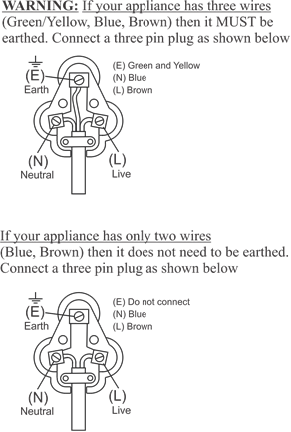

PLEASE AFFIX YOUR PROOF OF PURCHASE/RECEIPT HERE
IN THE EVENT OF A CLAIM UNDER WARRANTY THIS RECEIPT MUST BE PRODUCED.

2 YEAR WARRANTY
1 year retail ⵏ 1 year extended warranty upon registration*
visit www.russellhobbs.co.za

W A R R A N T Y AND EXTENDED WARRANTY

- Home of Living Brands (Pty) Limited ("Home of Living Brands") warrants to the original purchaser of this product ("the customer") that this product will be free of defects in quality and workmanship which under normal personal, family or household use and purpose may manifest within a period of 1 (one) year from the date of purchase ("warranty period").
- Home of Living Brands shall extend the warranty period for a further period of 1(one) year (“extended warranty period*”), on condition that the purchaser registers the product on the website, within 12 months from the date of purchase of the product. The website address for registration is as follows: http://russellhobbs.co.za/info-pages/warranty-info.aspx. The extended warranty period only applies to products purchased on or after 1 October 2017.
- Where the customer has purchased a product and it breaks, is defective or does not work properly for the intended purpose, the customer must notify the supplier from whom the customer bought the product ("the supplier") thereof within the warranty period or if applicable, the extended warranty period. Any claim in terms of this warranty must be supported by a proof of purchase. If proof of purchase is not available, then repair, and/or service charges may be payable by the customer to the supplier.
- The faulty product must be taken to the supplier's service centre to exercise the warranty.
- The supplier will refund, repair or exchange the product in terms of this warranty subject to legislative requirements. This warranty shall be valid only where (a) the customer is not the cause of the product breaking, and (b) the product has been used for the intended purpose stipulated in the product manual. The warranty does not include and will not be construed to cover products damaged as a result of disaster, misuse, tamper, abuse or any unauthorised modification or repair of the product.
- This warranty will extend only to the product provided at the date of the purchase and not to any expendables attached or installed by the customer. In this regard any accessories supplied with the product by the supplier, may be excluded in this warranty or extended warranty (see Exclusions to Warranty and Extended Warranty document).
- If the customer requests that the supplier repairs the product and the product breaks or fails to work properly within 3 (three) months of the repair and not as a result of misuse, tampering or modification by or on behalf of the customer, then the supplier may replace the product or pay a refund to the customer, subject to the supplier’s discretion.
- The customer may be responsible for certain costs where products returned are not in the original packaging, or if the packaging is damaged. This will be deducted from any refund paid to the customer.
HOME OF LIVING BRANDS (PTY) LTD (JOHANNESBURG)

NATIONAL CONTACT TEL NO. (087) 245-0029
JOHANNESBURG TEL NO. (011) 490-9600
CAPE TOWN TEL NO. (021) 552-5161
DURBAN TEL NO. (031) 303-1163
www.homeoflivingbrands.com
www.russellhobbs.co.za
www.facebook.com/RussellHobbsSA

EXCLUSIONS TO W A R R A N T Y AND EXTENDED WARRANTY

- Any accessories supplied with the product, including but not limited to, bowls, jugs, mills or carafes made either of glass or plastic and supplied with this appliance (hereinafter referred to as “the accessory or accessories”), is warranted to be free from material and workmanship defects for the duration of the appliance warranty.
- The accessories should give trouble free service when used in accordance with the directions described in the instruction manual. However, the accessories will be damaged if subjected to impact, and this damage is not covered by the warranty. Such impact damage can occur either from the outside (if for example it is dropped or knocked against a hard surface), or from within (if for example foreign objects are placed within the accessories and the power is switched on).
- Should you need to replace an accessory during the warranty period; a claim for a free replacement will only be considered if the item (including all shards and broken parts) is returned to the nearest HOLB service centre for examination.
- The remains of the accessory will be carefully examined by the relevant professionals and if it is determined (at the sole discretion of HOLB) that the damage was caused by impact, then the claim will be refused and will not be covered by the warranty or any extended warranty.
- Any replacement part provided in terms of clause 4 above will become a chargeable item payable by the customer.

