INSTRUCTIONS AND WARRANTY

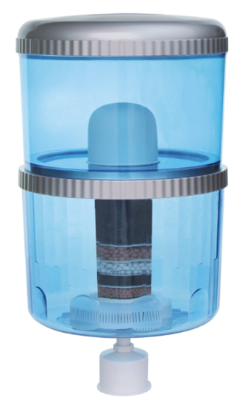

MODEL NO.: RHPM1
Russell Hobbs Purification and Mineralization Bottle
Congratulations on purchasing our Russell Hobbs Purification and Mineralization bottle. Each unit is manufactured to ensure safety and reliability. Before using this appliance for the first time, please read the instruction manual carefully and keep it for future reference.
FEATURES OF THE RUSSELL HOBBS PURIFICATION AND MINERALIZATION BOTTLE:
- Ceramic Dome – the ceramic dome removes rust and sediment particles of 0.3 microns and larger.
- Carbon Filter - Activated carbon removes chlorine, trihalomethanes (as a result of chlorination), organic chemicals, unpleasant tastes and odours, creating fresh and clean purified water.
- Mineral Stones - contains germanium which is known for improving health and aiding towards cancer prevention. This stage adds minerals back into the water that may have been lost in stages 1 and 2.
- For Domestic use only
- 2 year warranty

BENEFITS OF THE RUSSELL HOBBS P & M BOTTLE:
- Harmful bacteria is removed from the water and re-mineralized with ionised minerals.
- Filters up to 99% of all harmful bacteria and chlorine, improving taste and odour of the water.
- Provides, healthier, cleaner, safer drinking water.
- The storage capacity of the purifier helps in keeping the water safe without getting re-contaminated.
- Have up to 10L of pre-filtered water at any given time.
- The bottle includes a complimentary filter.
- Filters are generally replaced every 3-6 months depending on the calcium content/ quality of water in your area.
- The Russell Hobbs P & M bottle is universal and can fit any appliance brand.
- Cost saving as there is no need to buy pre filtered water as the bottle purifies it for you.

PARTS DIAGRAM:
4. Middle Connector Ring
7. Lower Barrel
5. Carbon Cartridge
1. Top cover
6. Mineral Stones
3. Ceramic Dome
2. Upper Barrel
8. Float
Preparation
- Opening the packing box and check that the all parts are in accordance with the above illustration.
- Take the float, lower barrel, ceramic dome, active carbon and mineral stones out of the water purifier and wash these parts gently under running water before first time use. The interior of the lower barrel should also be washed with tap water.
- Pre-soak the ceramic dome for 1-2 hrs before first time of use.
Assembly
- Insert the float into the lower barrel and tighten it securely with the hexagonal nut on the inside of the barrel
Note: Imperative for the float to be sealed tightly onto the base of the lower barrel to prevent leaking.
- Place the mineral stones above the hexagonal nut inside the lower barrel.
- Attach the middle connector ring to the lower barrel.
- Attach the ceramic dome to the top barrel utilizing the wing nut and ensure that it is tightened securely.
- Screw the carbon cartridge to the base of the upper barrel.
- Place the top barrel on top of the middle connector ring ensuring that the carbon cartridge is seated in the concave of the mineral stones.
- Installing the Purification & Mineralization Bottle:
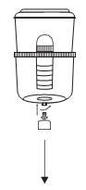
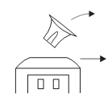
1. Take the smart device out of the water dispenser.

2. Put the assembled unit into the opening on top of the Water Dispenser.
NOTE: It may seem unstable however once filled with water it will become steady on top of the unit.

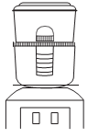

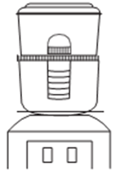
3. Fill the top Barrel with water to the “Max Fill” line and allow it to filter through the system.
NOTE: Allow the system to filter 3 times before first use to remove any residue, impurities and odors in the water.
NOTE: The first 3 times/ cycles will take between 40 -45mins to filter through the ceramic dome until the system is porous. Thereafter it will take 20-25mins for the water to be filtered through the system.

Important Notes:
- The water purifier should not be exposed to direct sunlight.
- The Ceramic dome should be soaked in water for 1-2hrs before use.
- NOTE: To avoid leaking between the two barrels at the middle circle, please do not pour water into the upper barrel when the lower barrel is full of water.
- Ensure to change your filter every 3 to 8 months (depending on the condition of the water in your area)

AFFIX YOUR PROOF OF PURCHASE/RECEIPT HERE
IN THE EVENT OF A CLAIM UNDER WARRANTY THIS RECEIPT MUST BE PRODUCED.

2 YEAR WARRANTY
1 year retail ⵏ 1 year extended warranty upon registration*
visit www.russellhobbs.co.za

W A R R A N T Y AND EXTENDED WARRANTY

- Home of Living Brands (Pty) Limited ("Home of Living Brands") warrants to the original purchaser of this product ("the customer") that this product will be free of defects in quality and workmanship which under normal personal, family or household use and purpose may manifest within a period of 1 (one) year from the date of purchase ("warranty period").
- Home of Living Brands shall extend the warranty period for a further period of 1(one) year (“extended warranty period*”), on condition that the purchaser registers the product on the website, within 12 months from the date of purchase of the product. The website address for registration is as follows: http://russellhobbs.co.za/info-pages/warranty-info.aspx. The extended warranty period only applies to products purchased on or after 1 October 2017.
- Where the customer has purchased a product and it breaks, is defective or does not work properly for the intended purpose, the customer must notify the supplier from whom the customer bought the product ("the supplier") thereof within the warranty period or if applicable, the extended warranty period. Any claim in terms of this warranty must be supported by a proof of purchase. If proof of purchase is not available, then repair, and/or service charges may be payable by the customer to the supplier.
- The faulty product must be taken to the supplier's service centre to exercise the warranty.
- The supplier will refund, repair or exchange the product in terms of this warranty subject to legislative requirements. This warranty shall be valid only where the customer has not broken the product themselves, or used the product for something that it is not supposed to be used for. The warranty does not include and will not be construed to cover products damaged as a result of disaster, misuse, tamper, abuse or any unauthorised modification or repair of the product.
- This warranty will extend only to the product provided at the date of the purchase and not to any expendables attached or installed by the customer.
- If the customer requests that the supplier repairs the product and the product breaks or fails to work properly within 3 (three) months of the repair and not as a result of misuse, tampering or modification by or on behalf of the customer, then the supplier may replace the product or pay a refund to the customer, subject to the supplier’s discretion.
- The customer may be responsible for certain costs where products returned are not in the original packaging, or if the packaging is damaged. This will be deducted from any refund paid to the customer.

HOME OF LIVING BRANDS (PTY) LTD (JOHANNESBURG)
JOHANNESBURG TEL NO. (011) 490-9600
CAPE TOWN TEL NO. (021) 552-5161
DURBAN TEL NO. (031) 303-1163
www.homeoflivingbrands.com
www.russellhobbs.co.za
www.facebook.com/RussellHobbsSA

