

Instruction manual

RHSEB – Single fitted fleecy electric blanket

RHDEB – Double fitted fleecy electric blanket

RHQEB – Queen fitted fleecy electric blanket

RHKEB - King fitted fleecy electric blanket

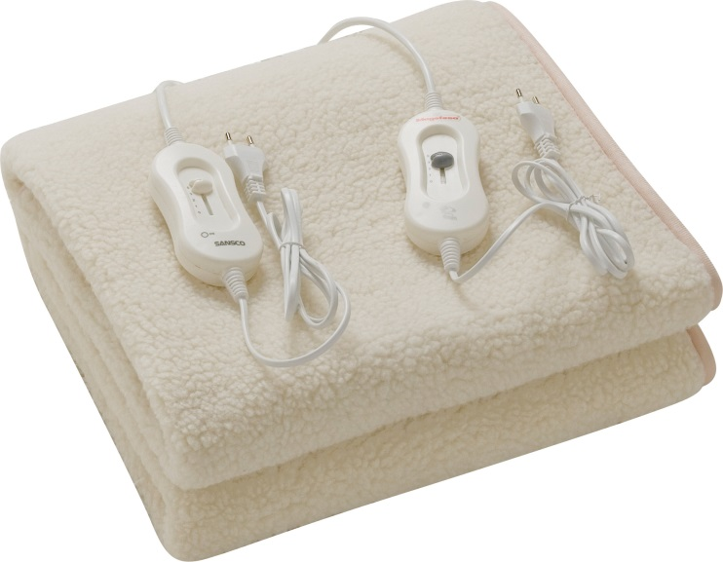

IMPORTANT INSTRUCTIONS

RETAIN FOR FUTUR E USE

Instructions for the following Electric Blankets:

RHSEB – Single fitted fleecy electric blanket- 220-240V -50Hz 60W

RHDEB – Double fitted fleecy electric blanket- 220-240V- 50Hz 60W X2

RHQEB – Queen fitted fleecy electric blanket - 220-240V- 50Hz 60W X2

RHKEB - King fitted fleecy electric blanket- 220-240V - 50Hz 60W X2

IMPORTANT SAFEGUARDS • PLEASE RETAIN FOR REFERENCE

Carefully read this manual before using this product

* Use this electric blanket as an under-blanket only.
* Ensure that you know how your electric blanket functions and how to operate it.
* Maintain the electric blanket in accordance with the instructions to ensure that it functions properly.
* Keep this manual with the electric blanket. If the electric blanket is to be used by a third party, this instruction manual must be supplied with it.
* The safety instructions do not by themselves eliminate any danger completely and proper accident prevention measures must always be used.

No liability can be accepted for any damage caused by non-compliance with these instructions or any other improper use or mishandling.

When using electrical goods always observe the safety regulations to reduce the risk of failure, fire, personal injury and electric shock. Always ensure you check the power supply corresponds to the voltage on the rating label.

* When storing the blanket, allow it to cool down before folding.
* This electric blanket is not to be used by children under 3 years.
* The appliance is not intended for use by young children or infirm persons unless they have been adequately supervised by a responsible person to ensure they can use the appliance safely.
* Check to ensure that the controller(s) and supply cord(s) cannot become trapped in any bed or bedding. Keep the controller(s) outside the bedding as much as possible.
* Avoid extended use of your electric blanket at a high setting. This may result in skin burns.
* Inspect your blanket regularly for signs of wear or damage. If there are signs of or if the blanket has been misused, return it to the supplier prior to any further use.
* This electric blanket is designed for domestic use only. It is not intended for use in hospitals.
* This electric blanket is not to be used by people who are helpless, by infants, or by people who are insensitive to heat.

WARNING:

1. Do NOT use on or under a waterbed.
2. Do NOT use on an adjustable bed such as a bunk or sofa bed.
3. Do NOT switch on if moist or wet.
4. Do NOT allow the heating wires to lie over the edge of your mattress.
5. Do NOT insert safety pins, needles or other sharp items into the blanket.
6. Do NOT use the electric blanket folded or rucked and avoid creasing.
7. Do NOT use a Double blanket on a single bed.
8. Do NOT tuck the blanket in.
9. Do NOT leave the electric blanket on indefinitely.
10. Do NOT use plastic, rubber backed, heavy or dense overlays as they may lead to overheating.
11. Do NOT crease the blanket by placing items on top of it during storage.

This electric blanket is designed for domestic use only.

##### FITMENT

* Place the electric blanket on your bed with the controller at the pillow end ensuring it does NOT overhang the bed edge and is not under the area intended for the pillow(s).
* Smooth out the folds and wrinkles then unwind the tie tags and secure the electric blanket to the bed as indicated.
* Pass the tape under each corner of the mattress and through each loop then under the next corner and through the loop then back to the other side before securing firmly with a knot.
* A single control blanket may be turned over so that the control is on the preferred side of the bed however this may result in the control facing towards the bed.
* Secure each corner and also the middle as indicated.

Note: Fitted electric blankets

If you have purchased a ''fitted" electric blanket, you will notice there is no tie tags to secure.

Your ''fitted" electric blanket has an elastic skirt sewn in to keep it flat

and taut on the mattress and makes it easier to fit and remove from the bed.

Place the electric blanket on your bed with the controller at the pillow end.

Ensure it does not overhang the bed edge and is not under the area intended for the pillow(s). Smooth out the folds and wrinkles then secure the elastic ''fitted" skirt over each of the four comers of the bed.

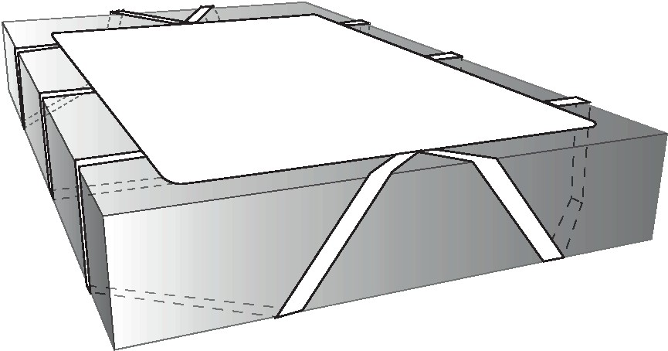

**OPERATION - BEFORE USE**

* Once the electric blanket has been installed correctly in position and the bedding completed, connect the controller supply plug to a suitable power outlet.
* Ensure the controller is set to OFF.
* Switch the power ON. Select the desired heat setting on the controller.
* The indicator lamp indicates when the blanket is ON.
* For first time use it is recommended that the electric blanket be set to HIGH for two hours before sleeping on the bed.
* This will assist in drying any moisture out of the mattress.
* Ignore any initial odour which may occur with first time use.

**EVERYDAY USE**

1. With normal use your electric blanket will require 20 minutes of pre-heating on the maximum setting before bed time. We recommend that you tum the blanket off when sleeping.
2. For normal use select the desired heat on the controller.

WARNING: Do NOT sleep with the controller set to HIGH. Use the HIGH setting only to pre-heat the bed, then reduce the heat setting to MEDIUM or LOW. Set to OFF when the heat is no longer required. Remember to switch the blanket off at the end of use.

1. It is recommended that this blanket is used with a residual current safety device (safety switch) with a rated residual operating current not exceeding 30 mA.
2. This blanket is not to be used by young children unless the controls have been pre-set by a parent or guardian or unless the child has been adequately instructed on how to operate the controls safely.

#### CONTROLS

#### The braille markings on the control switch allow easy adjustment of the temperature in the dark.

Each controller has the following settings:

1. Off
2. Low heat
3. Medium heat (all night use)
4. High or pre-heat. Use this setting to pre-heat the bed one or two hours before use only. WARNING: Do NOT sleep with the control set to this setting.

#### SUPPLY

* This electric blanket must be connected to a suitable 230/240V-50Hz power supply.
* If using an extension cord, ensure the extension is of suitable 1O amp power rating.
* Fully unwind the power supply cord when in use as a coiled cord may overheat.
* Always unplug from the mains supply when not in use.
* The lead between the blanket and controller may get warm during operation - this is normal and safe.
* If the supply cord or controller is damaged, it must be replaced by the manufacturer or its service agent or similarly qualified person in order to avoid a hazard.

**STORING YOUR BLANKET**

If you wish to remove your blanket from the bed when not in use, roll or fold the blanket LOOSELY and store in a blanket bag or the polybag it was supplied in.

Avoid pressing sharp creases into the blanket when storing as this could damage the blanket's heating wires.

**CLEANING**

WARNING: Do NOT dry clean this electric blanket. This may damage the heating element or controller.

* Do NOT iron this blanket.
* Do NOT machine wash or machine dry. The heating wires are fully water-proofed to allow for washing.
* When not in use and before cleaning, always disconnect the blanket from the mains supply.
* Roll up the securing tie tapes before cleaning. This will prevent them becoming tangled or damaged.

**HAND WASHING**

* Immerse the blanket ONLY in luke warm neutral detergent or mild soapy water solution.
* Do NOT allow controller or the section of blanket where the cord enters to be immersed in any liquid.
* Soak for five minutes, remove and gently squeeze the liquid from the blanket as much as possible without wringing the blanket.
* Rinse only in clean water and remember never to immerse the controller in water.
* Drape the blanket over a clothes line to dry.
* Allow the blanket to dry naturally and ensure liquid never enters the controller by securing it away from dripping water.
* Do NOT use pegs to secure. Never use any appliance such as a heater or hair dryer to hasten the drying process
* Do NOT use pegs to secure. Never use any appliance such as a heater or hair dryer to hasten the drying process.

**SPOT CLEANING**



Unplug and remove the control unit. Wet sponge the affected area using a mild soap and luke warm water. Ensure the water temperature is less than 30 degrees Celsius. Gently sponge the affected area with new clean water and use a white coloured towel to absorb excess moisture.

|  |  |
| --- | --- |
|  | Hand wash only |
|  | Do not bleach |
|  | Line Dry/hang to dry – hang damp from line or bar and allow to dry |
|  | Do not iron or press with heat |
|  | Do not dry clean |



**MAINTENANCE**

Always check that the blanket is in good working condition before use. Check the controller, power supply cord and plug frequently for cuts and damage.

Do NOT attempt to service this blanket. There are NO user serviceable parts. If it is faulty in anyway, return it to the retailer immediately.

This electric blanket should be checked annually by a suitably qualified person to ensure its safety and suitability for use.

When not in use, store your blanket and instruction manual in a safe and dry place.