INSTRUCTIONS & WARRANTY
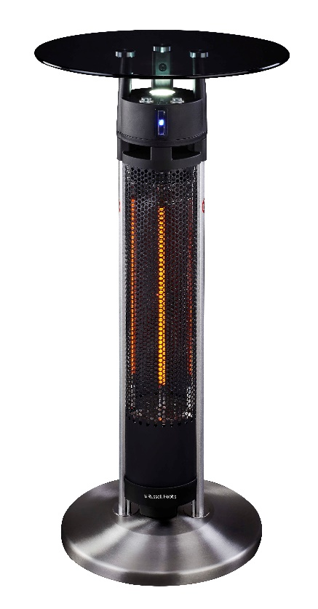

MODEL NO: RHTH02

RUSSELL HOBBS TABLE HEATER WITH INFRARED SENSORS

Congratulations on purchasing our Russell Hobbs Table Heater with Infrared Sensors. Each unit is manufactured to ensure safety and reliability. Before using this appliance for the first time, please read the instruction manual carefully and keep it for future reference.

Please be advised this unit comes packaged in two separate boxes, please ensure you have both boxes pertaining to model RHTH02.

FEATURES OF THE RUSSELL HOBBS TABLE HEATER WITH INFRARED SENSORS
- Bar table heater
- Triple Infrared sensors
- Automatically turns on when movement close by is detected
- Automatically shuts off when no movement is detected
- Infrared sensors can be switched off
- Anodized extruded aluminium alloy frame
- High efficiency carbon fibre heating element
- LED lighting
- 1600W
- Extra-long 2.5m power cord
- Tempered glass top
- Stainless steel base cover
- 95cm in height
- 360 Degree tip over switch
- IP44 approved

IMPORTANT SAFEGUARDS
When using any electrical appliance, basic safety precautions should always be followed including the following:
- Please read the instructions carefully before using any appliance.
- Always ensure that the voltage on the rating label corresponds to the mains voltage in your home.
- Incorrect operation and improper use can damage the appliance and cause injury to the user.
- The appliance is intended for household use only. Commercial use invalidates the warranty and the supplier cannot be held responsible for injury or damage caused when using the appliance for any other purpose than that intended.
- Avoid any contact with moving parts.
- This appliance is not intended for use by persons (including children) with reduced physical, sensory or mental capabilities, or lack of experience and knowledge, unless they have been given supervision or instruction concerning use of the appliance by a person responsible for their safety.
- Children should be supervised to ensure that they do not play with the appliance.
- Check the power cord and plug regularly for any damage. If the cord or the plug is damaged, it must be replaced by the manufacturer or a qualified person to avoid an electrical hazard.
- Do not use the appliance if it has been dropped or damaged in any way. In case of damage, take the unit in for examination and/or repair by an authorised service agent.
- To reduce the risk of electric shock, do not immerse or expose the motor assembly, plug or the power cord to water or any other liquid.
- Never immerse the full unit in water or any other liquid for cleaning purposes.
- Remove the plug from the socket by gripping the plug. Do not pull on the cord to disconnect the appliance from the mains. Always unplug the unit when not in use, before cleaning or when adding or removing parts.
- The use of accessory attachments that are not recommended or supplied by the manufacturer may result in injuries, fire or electric shock.
- Do not let the cord hang over the edge of a table or counter. Ensure that the cord is not in a position where it can be pulled on inadvertently.
- Do not allow the cord to touch hot surfaces and do not place on or near a hot gas or electric burner or a heated oven.
- Do not use near an open flame or any other flammable substances.
- Use of an extension cord with this appliance is not recommended. However, if it is necessary to use an extension lead, ensure that the lead is suited to the power consumption of the appliance to avoid overheating of the extension cord, appliance or plug point. Do not place the extension cord in a position where it can be pulled on by children or animals or tripped over.
- Do not use this appliance for anything other than its intended use.
- Do not carry the appliance by the power cord.
- Do not leave this appliance unattended during use. Always unplug the unit when not in use or before cleaning.
- Always operate the appliance on a smooth, even, stable surface. Do not place the unit on a hot surface.
- Ensure that the switch is in the “Off” position after each use.
- The manufacturer does not accept responsibility for any damage or injury caused by improper or incorrect use, or for repairs carried out by unauthorised personnel.
- In case of technical problems, switch off the machine and do not attempt to repair it yourself. Return the appliance to an authorised service facility for examination, adjustment or repair. Always insist on the use of original spare parts. Failure to comply with the above-mentioned pre-cautions and instructions, could affect the safe operation of this machine.
- Caution - Some parts of this product can become very hot. Attention must be given where children and vulnerable people are present.
- Do not use this heater with a programmer, timer or any other device that switches the heater on automatically, since a fire risk exists if the heater is covered or positioned incorrectly.
- Do not use this heater in the immediate surroundings of a bath, a shower or a swimming pool.
- Do not place the unit close to curtains and/or other flammable objects.
- Do not cover the unit with anything during operation or after it's been shut off.
- Do not wrap the power supply cord around the unit.
- Do not use this unit in areas where dust, steam, gas or other any other flammable substances or gassed are present.
- Do not use this unit to dry any materials or objects.
- Do not use this unit as a sauna heater.
- Do not use this unit as a room heater.
- Do not use this unit near animals.
- Do not immerse this unit into water for cleaning.
- Ensure the unit is placed with a clearance of at least 150cm from a wall.
- The unit must be securely placed on a horizontal and flat surface
- Do not touch the unit after it has been switched off as it will remain hot for a period after it has been used, ensure it is completely cooled down after use before attempting to touch or move the unit.
- The unit must be handled with care. Avoid bumping the unit.
- The unit must be securely grounded during operation.
- When assembling, keep clear from any flammable material.
- The unit is for outdoor use only. It's not allowed to be used in building sites, greenhouses, barns or stables.
- Do not touch the body of the unit while in operation or after operation.
- Do not move the unit during operation.
- Unplug the unit and wait until it has cooled down before cleaning.
- The unit should be plugged in a socket, which is easily visible and that is within close reach.
WARNING: This heater is not equipped with a device to control the room temperature. Do not use this heater in small rooms when they are occupied by persons not capable of leaving the room on their own, unless constant supervision is provided.

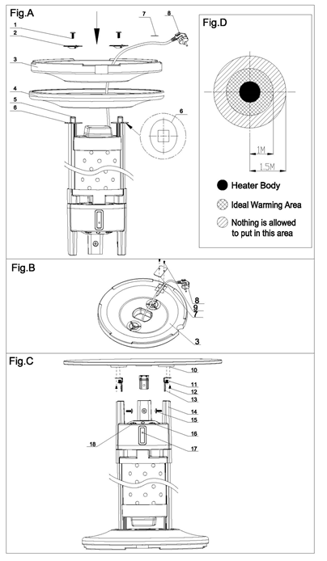
PARTS DIAGRAM

No. | Part Name | No. | Part Name
1 | Screw M6*20 | 10 | Aluminium Fixture
2 | Washer | 11 | Screw M4*6
3 | Base | 12 | Screw M8*6
4 | Base Cover | 13 | L Bracket
5 | Base Bracket | 14 | Control Box
6 | Stability ring | 15 | Screw M6*16
7 | Cord Clip | 16 | ON/ Off switch
8 | Plug | 17 | IR Sensor indicator light
9 | Screw M4*28 | 18 | LED Light Switch

Accessories Check List:
Accessory Name | Qty | Accessory Name | Qty
Screw M6*20 | 2 | Screw M6*16 | 3
Washer | 2 | Allen Key | 1
Stability ring | 2 | Cord Clip | 1
Screw M4*6 | 3 | Screw M4*28 | 2
Screw M8*6 | 3

ASSEMBLY INSTRUCTIONS
- Turn the main body up-side-down (Fig. A).
- Slide the stability ring (#6) onto the base bracket (#5)
- Place the plug (#8) and power supply cord through the holes in the center of the base cover (#4) and base (#3).
- Slide the base cover (#4), the base (#3) and washer (#2) onto base bracket (#5) respectively.
- Fasten the washer (#2), the base (#3), base cover (#4) and base bracket (#5) together with screw M6*20 (#1).
- Place the power supply cord on the groove of the base. Place the cord clip (#7) over the groove and the supply cord and fasten it onto the base (#3) with screw M4*28 (#9).
- Stand the unit back to its upright position (Fig. C).
- Screw the L bracket (#13) onto the aluminium fixtures (#10) underneath the table top using screws M8*6 (#12) & M4*6 (#11) respectively.
- To attach the table top to the base the Slide the L brackets (#13) into the holes of control box (#14).
- Fasten the L brackets (#13) onto the control box (#14) with screws M6*16 (#15).

OPERATING INSTRUCTIONS
- Plug the unit to the wall socket, ensure the power supply is the same as the rated power.
- Press the LED light switch (#18) to switch the LED light on or off.
- Press On / off switch (#16) to position “l” to switch on the heater. This setting does not activate the infrared sensors.
- Press On / off switch (#16) to position “II” to switch the heater on and activate the infrared settings. The sub heating element will switch on immediately and the infrared sensor indicator light (#17) will start to flash.
- When movement is detected or when people or objects come into proximity with the sensors (approximately 0.6m) the infrared sensor indicator light (#17) will light up. During this stage the main heating element is switched on automatically, while the sub heating element is switched off automatically.
- When people or other objects are not in proximity of the infrared sensor, the main heating element is switched off after 5 seconds, while the sub heating element is switched on again automatically. This is to indicate that the unit is on, but not fully heated as there is no movement detected near the infrared sensor. The infrared sensor LED will start to flash again.
Note: Infrared sensing distance may differ based on reflections of different materials and colours. For example, if glass, stainless steel or aluminium reflects off the heater the sensing distance may extend to 3.5m.

CLEANING AND MAINTANANCE
- Before cleaning, always ensure the unit switched off and disconnected from the electrical socket.
- Ensure the unit has completely cooled down after use.
- Wipe off dust and dirt with a warm damp cloth and wipe once more with a dry cloth.
- Do not immerse the unit in water or other liquids.
- Never use polish or any corrosive or abrasive liquids or substances that will damage the paint, metal or plastic.

STORING THE APPLIANCE
Unplug the unit from the wall outlet and clean all the parts as instructed above. Ensure that all parts are dry before storing.
- Store the appliance in its box or in a clean, dry place.
- Never store the appliance while it is still wet or dirty.

SERVICING THE APPLIANCE

There are no user serviceable parts in this appliance. If the unit is not operating correctly, please check the following:
- You have followed the instructions correctly
- That the unit has been wired correctly and that the wall socket is switched on.
- That the mains power supply is ON.
- That the plug is firmly in the mains socket.

If the appliance still does not work after checking the above:
- Consult the retailer for possible repair or replacement. If the retailer fails to resolve the problem and you need to return the appliance, make sure that:
- The unit is packed carefully back into its original packaging.
- Proof of purchase is attached.
- A reason is provided for why it is being returned.

If the supply cord is damaged, it must be replaced by the manufacturer or an authorised service agent, in order to avoid any hazard. If service becomes necessary within the warranty period, the appliance should be returned to an approved Home Of Living Brands (Pty) Limited service centre. Servicing outside the warranty period is still available, but will, however, be chargeable.

CHANGING THE PLUG
Should the need arise to change the fitted plug, follow the instructions below.
This unit is designed to operate on the stated current only. Connecting to other power sources may damage the appliance. Connect a three-pin plug as below.

The wires in this mains lead are coloured in accordance with the following code:

Green/Yellow = Earth; Blue = Neutral; Brown = Live

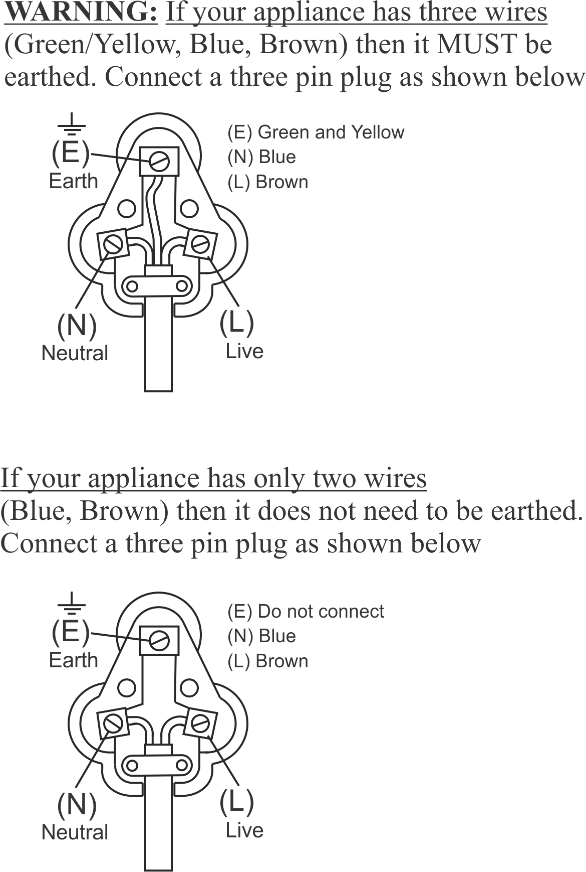

PLEASE AFFIX YOUR PROOF OF PURCHASE/RECEIPT HERE
IN THE EVENT OF A CLAIM UNDER WARRANTY THIS RECEIPT MUST BE PRODUCED.

2 YEAR WARRANTY
1 year retail ⵏ 1 year extended warranty upon registration*
visit www.russellhobbs.co.za

W A R R A N T Y AND EXTENDED WARRANTY

- Home of Living Brands (Pty) Limited ("Home of Living Brands") warrants to the original purchaser of this product ("the customer") that this product will be free of defects in quality and workmanship which under normal personal, family or household use and purpose may manifest within a period of 1 (one) year from the date of purchase ("warranty period").
- Home of Living Brands shall extend the warranty period for a further period of 1(one) year (“extended warranty period*”), on condition that the purchaser registers the product on the website, within 12 months from the date of purchase of the product. The website address for registration is as follows: http://russellhobbs.co.za/info-pages/warranty-info.aspx. The extended warranty period only applies to products purchased on or after 1 October 2017.
- Where the customer has purchased a product and it breaks, is defective or does not work properly for the intended purpose, the customer must notify the supplier from whom the customer bought the product ("the supplier") thereof within the warranty period or if applicable, the extended warranty period. Any claim in terms of this warranty must be supported by a proof of purchase. If proof of purchase is not available, then repair, and/or service charges may be payable by the customer to the supplier.
- The faulty product must be taken to the supplier's service centre to exercise the warranty.
- The supplier will refund, repair or exchange the product in terms of this warranty subject to legislative requirements. This warranty shall be valid only where (a) the customer is not the cause of the product breaking, and (b) the product has been used for the intended purpose stipulated in the product manual. The warranty does not include and will not be construed to cover products damaged as a result of disaster, misuse, tamper, abuse or any unauthorised modification or repair of the product.
- This warranty will extend only to the product provided at the date of the purchase and not to any expendables attached or installed by the customer. In this regard any accessories supplied with the product by the supplier, may be excluded in this warranty or extended warranty (see Exclusions to Warranty and Extended Warranty document).
- If the customer requests that the supplier repairs the product and the product breaks or fails to work properly within 3 (three) months of the repair and not as a result of misuse, tampering or modification by or on behalf of the customer, then the supplier may replace the product or pay a refund to the customer, subject to the supplier’s discretion.
- The customer may be responsible for certain costs where products returned are not in the original packaging, or if the packaging is damaged. This will be deducted from any refund paid to the customer.
HOME OF LIVING BRANDS (PTY) LTD (JOHANNESBURG)
JOHANNESBURG TEL NO. (011) 490-9600
CAPE TOWN TEL NO. (021) 552-5161
DURBAN TEL NO. (031) 303-1163
www.homeoflivingbrands.com
www.russellhobbs.co.za
www.facebook.com/RussellHobbsSA

EXCLUSIONS TO W A R R A N T Y AND EXTENDED WARRANTY

- Any accessories supplied with the product, including but not limited to, bowls, jugs, mills or carafes made either of glass or plastic and supplied with this appliance (hereinafter referred to as “the accessory or accessories”), is warranted to be free from material and workmanship defects for the duration of the appliance warranty.
- The accessories should give trouble free service when used in accordance with the directions described in the instruction manual. However, the accessories will be damaged if subjected to impact, and this damage is not covered by the warranty. Such impact damage can occur either from the outside (if for example it is dropped or knocked against a hard surface), or from within (if for example foreign objects are placed within the accessories and the power is switched on).
- Should you need to replace an accessory during the warranty period; a claim for a free replacement will only be considered if the item (including all shards and broken parts) is returned to the nearest HOLB service centre for examination.
- The remains of the accessory will be carefully examined by the relevant professionals and if it is determined (at the sole discretion of HOLB) that the damage was caused by impact, then the claim will be refused and will not be covered by the warranty or any extended warranty.
- Any replacement part provided in terms of clause 4 above will become a chargeable item payable by the customer.

