
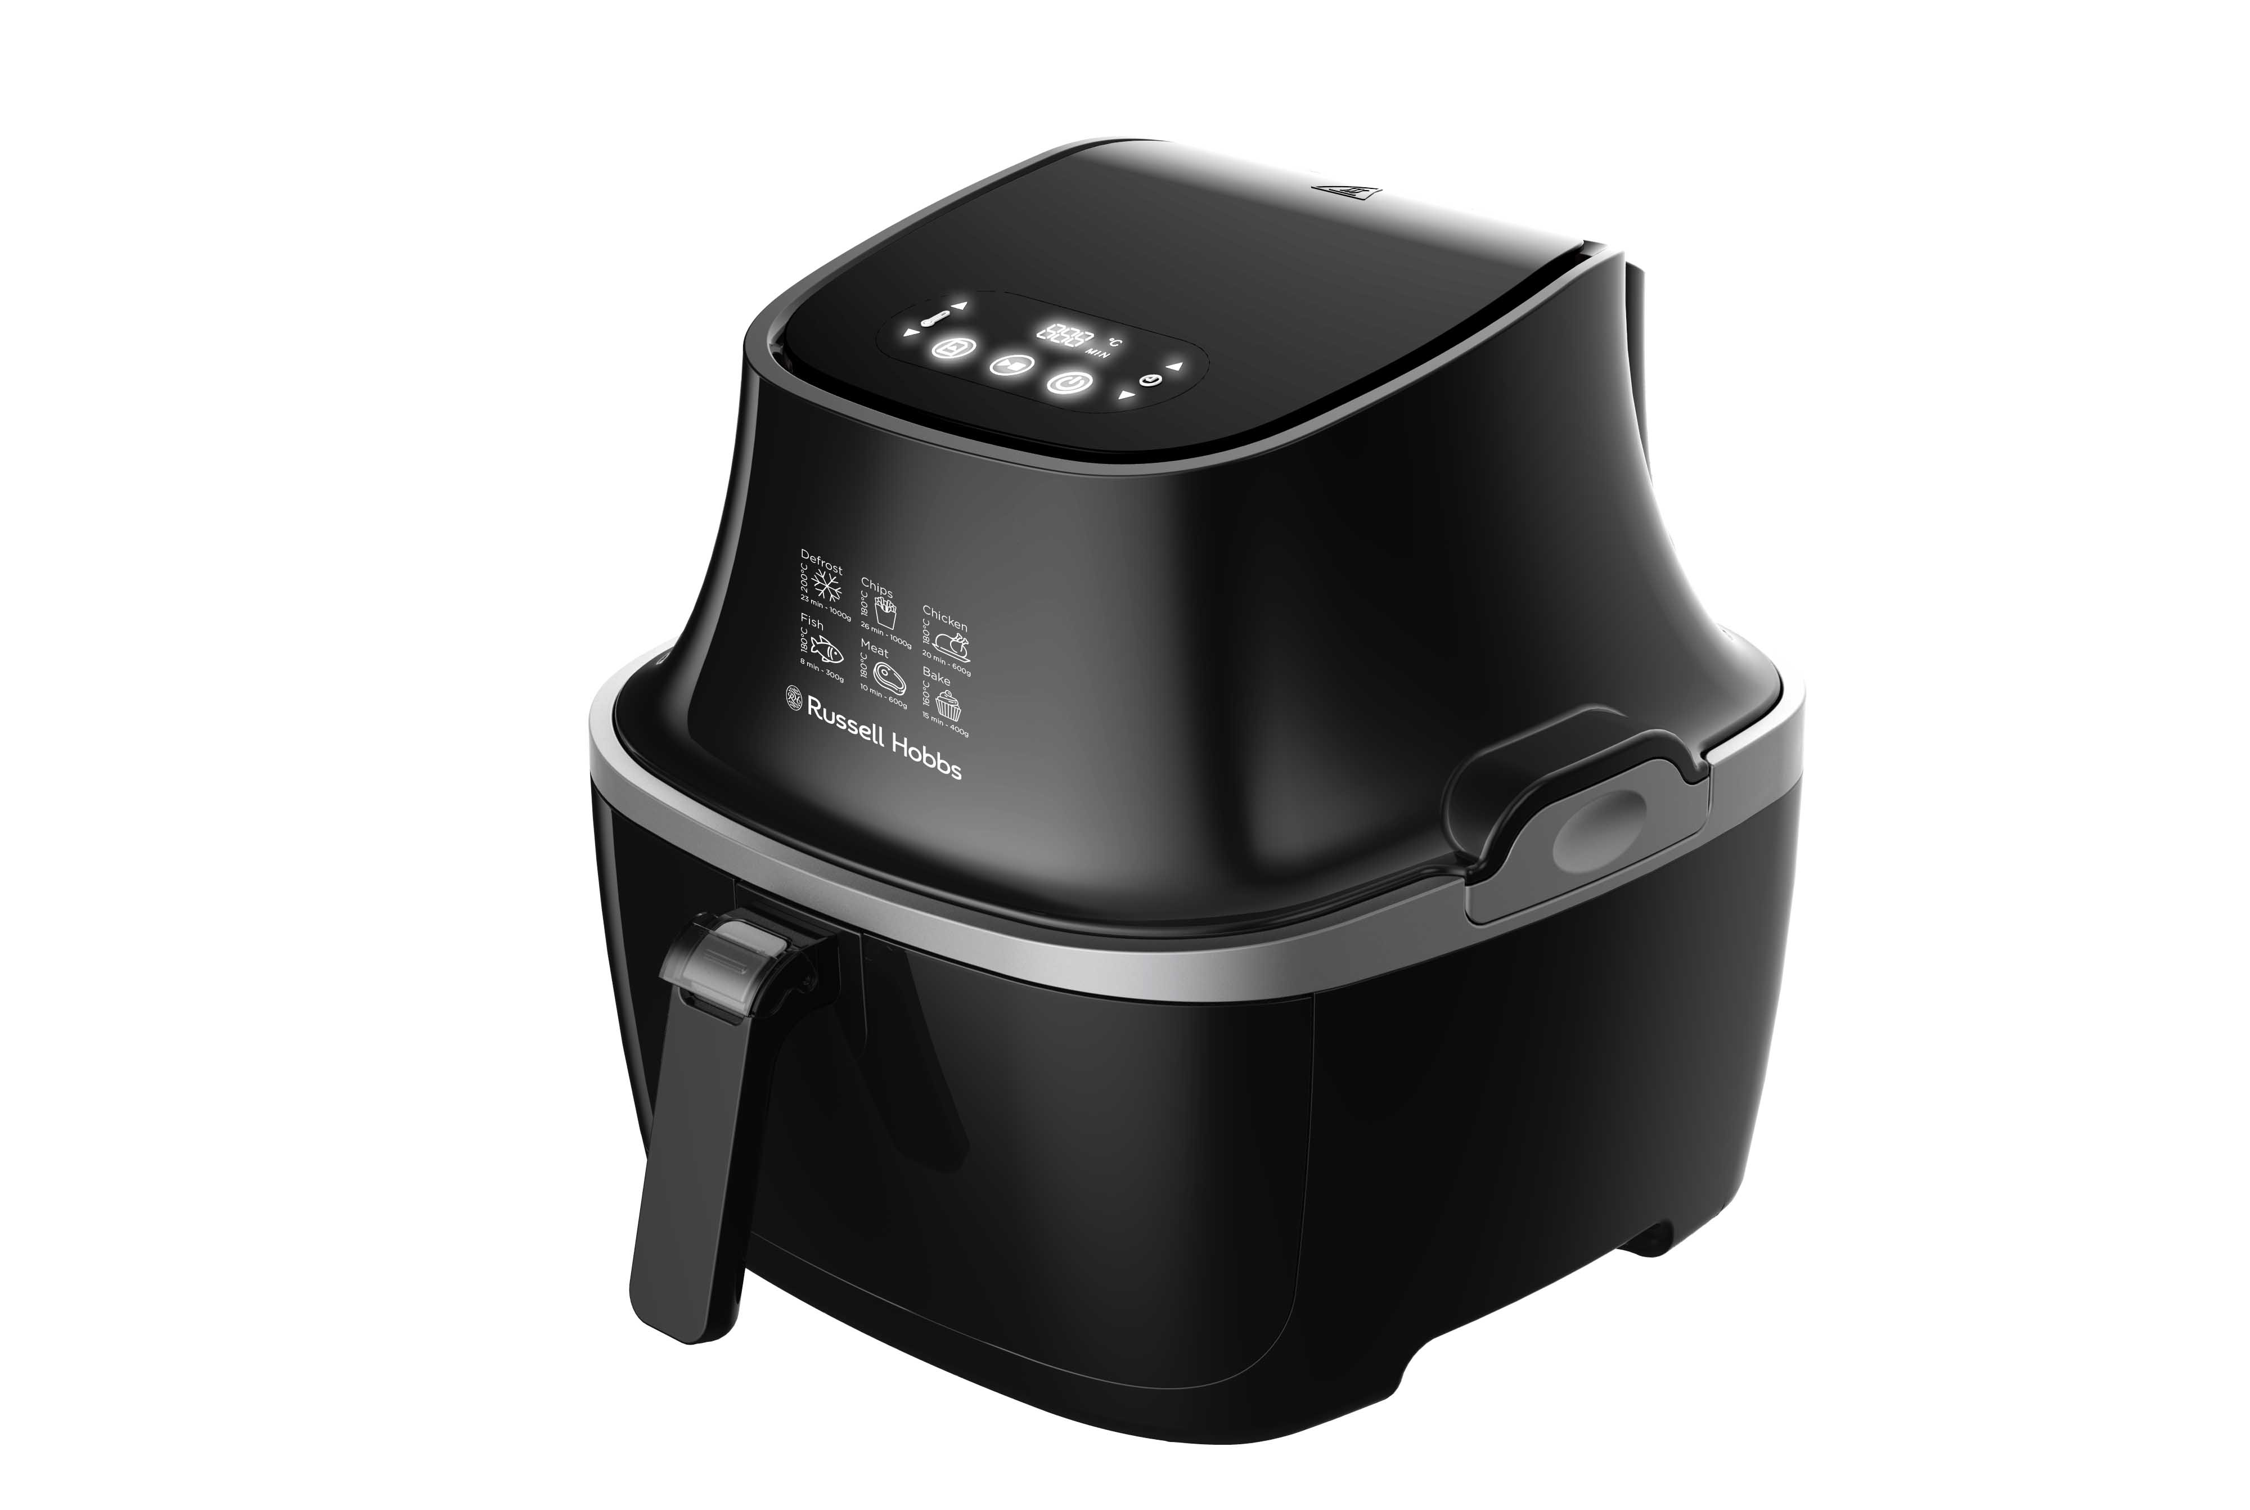
INSTRUCTIONS AND WARRANTY

MODEL NO. RHXL1000

PURIFRY MAX AIR FRYER

Congratulations on purchasing our Russell Hobbs Purifry MAX Air Fryer. Each unit is manufactured to ensure safety and reliability. Before using this appliance for the first time, please read the instruction manual carefully and keep it for future reference.

FEATURES OF THE RUSSELL HOBBS PURIFRY MAX AIR FRYER
The Purifry MAX Air Fryer from Russell Hobbs uses clever technology to harness the cooking power of pure, fast-circulating air to cook family favourites like chips or chicken nuggets without using oil or fat. The coatings are still crispy, and the taste will speak for itself:

- Powerful 2050W Air fryer for the fastest and crispiest cooking results
- Large family size 3.2L capacity: fits whole chicken or 500g of fries
- Crispy and tasty fried food with little to no oil
- Innovative detachable and dish-washable heating element for easy cleaning
- Simple to use, easy to clean - unlock and lift up for easy cleaning
- Digital Touch screen
- Adjustable timer and temperature for customized cooking
- Heats up to 200℃ for fast and evenly cooked meals
- Smart Memory Technology - Save your desired time and temperature settings for all your favorite meals
- Intelligent pause and stop button - able to remove pot whilst cooking and machine will pause and resume cooking once the pot is put back into the tray
- Uses patented "Cyclone Heating Technology": Provides 80% faster and oil less cooking
- Provides crispy and delicious meals for the whole family
- Versatile, fast & family sized meals
- Fry, bake, grill and roast your favorite and tastiest meals at home
- Recipes included
- For domestic use only
- 2 years warranty

IMPORTANT SAFEGUARDS
When using any electrical appliance, basic safety precautions should always be followed including the following:

- Please read the instructions carefully before using any appliance.
- Always ensure that the voltage on the rating label corresponds to the mains voltage in your home.
- Incorrect operation and improper use can damage the appliance and cause injury to the user.
- The appliance is intended for household use only. Commercial use invalids the warranty and the supplier cannot be held responsible for injury or damage caused when using the appliance for any other purpose than that intended.
- Avoid any contact with moving parts.
- This appliance is not intended for use by persons (including children) with reduced physical, sensory or mental capabilities, or lack of experience and knowledge, unless they have been given supervision or instruction concerning use of the appliance by a person responsible for their safety.
- Children should be supervised to ensure that they do not play with the appliance.
- Check the power cord and plug regularly for any damage. If the cord or the plug is damaged, the manufacturer or a qualified person must replace it in order to avoid an electrical hazard.
- Do not allow this appliance to touch curtains, wall coverings, clothing, dishtowels or other flammable materials during use. Allow a minimum of 200mm distance. Caution is required on surfaces where heat may cause damage - an insulated heat pad is recommended. Never place the appliance on a plastic, fabric or carpeted surface while cooking.
- The appliance is not intended to be operated by means of an external timer or separate remote-control system.
- Do not touch hot surfaces – use the handles and knobs.
- Let the unit cool down completely before you clean or store it.
- Extreme caution must be used when moving the unit. It is recommended that you do not move it when it is switched on or before it has cooled down.
- Do not use the appliance if it has been dropped or damaged in any way. In case of damage, take the unit in for examination and/or repair by an authorised service agent.
- Do not use harsh abrasives, caustic cleaners or oven cleaners when cleaning this appliance.
- To reduce the risk of electric shock, do not immerse or expose the body, plug or the power cord to water or any other liquid.
- Remove the plug from the socket by gripping the plug. Do not pull on the cord to disconnect the appliance from the mains. Always unplug the unit when not in use before cleaning or when adding or removing parts.
- A short detachable cord is provided to reduce the hazards resulting from becoming entangled in or tripping over a longer cord.
- Do not let the cord hang over the edge of a table or counter. Ensure that the cord is not in a position where it can be pulled on inadvertently.
- Do not allow the cord to touch hot surfaces and do not place on or near a hot gas or electric burner or in a heated oven.
- Do not use the appliance on a gas or electric cooking top or over or near an open flame.
- Use of an extension cord with the appliance is not recommended. However, if it is necessary to use an extension lead, ensure that the lead is suited to the power consumption of the appliance to avoid overheating of the extension cord, appliance or plug point. Do not place the extension cord in a position where it can be pulled on by children or animals or tripped over.
- This appliance is not suitable for outdoor use. For household use only. Do not use this appliance for anything other than its intended use.
- DO NOT carry the appliance by the power cord.
- Do not leave the appliance unattended during use. Always unplug the unit when not in use or before cleaning.
- The manufacturer does not accept responsibility for any damage or injury caused by improper or incorrect use, or for repairs carried out by unauthorised personnel.
- In case of technical problems, switch off the machine and do not attempt to repair it yourself. Return the appliance to an authorised service facility for examination, adjustment or repair. Always insist on the use of original spare parts. Failure to comply with the above-mentioned pre-cautions and instructions, could affect the safe operation of this machine.
- Do not use accessories or attachments other than those we supply.
- Do not use anything metal or sharp, you will damage the non-stick surfaces.
- Keep clear of the vent at the rear of the appliance – hot air will immerse from it.

PARTS DIAGRAM

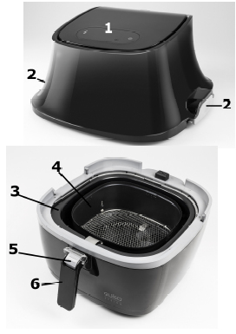
1. Control Panel
2. Release buttons for upper device
3. Frying Pot
4. Frying Basket
5. Release button for frying basket
6. Handle

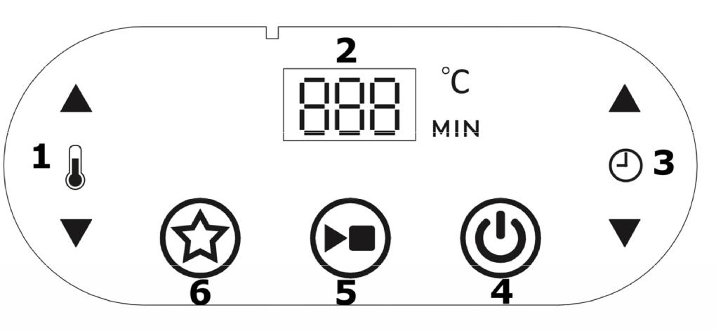
CONTROL PANEL

4. On/off button
5. Start/stop button
6. Memory function
1. Temperature setting
2. LED Display
3. Time setting

BEFORE FIRST USE
- Place the box containing the unit on a countertop or table.
- Remove the device from the box and remove the outer packaging.
- Remove all the stickers or labels (except for the rating label)
- Thoroughly clean the basket and the pot with hot water, some washing-up liquid and a non-abrasive sponge.
- Wipe the inside and outside of the appliance with a moist cloth.

OPERATIONS AND HANDLING

SECURE SWITCH:
- This appliance is equipped with a secure switch. When pulling the pot out of the fryer during operation, the fryer will stop heating and timer will be on hold automatically until the pot is put back.
- It’s better to pull out the pot for no longer than 30 seconds, to make sure that there is a stable temperature inside of the pot to give you the best results.
HOW TO USE THE DEVICE
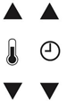
- Connect the main plug into a socket.
- The display shows the latest selected temperature and time.
- Set the desired temperature and time.
- Let the device preheat for 3-4 Min. without food or add 3 Min. to your cooking time.
- Pull out the frying basket on the handle and fill it with your desired food
- Slide the pot back into the fryer

IMPORTANT: Never fill the basket to exceed the amount indicated in the table, as this could affect the quality of the results

FRYING:

- After you adjusted time and temperature, press  to start the device. The desired time is shown and will counts down.

- Temperature and time are adjustable during frying. In addition
- You can choose the memory function to save your favorite time and temperature setting, press  again to save and continue

- Some ingredients require shaking halfway through the preparation time. To shake or turn over the ingredients, pull the pot out of the appliance by the handle and shake it or turn over the ingredients by fork (or tongs). Then put the pot back into the fryer

START/STOP FUNCTION
- Press  to stop and restart the device.
- You can hear a beep sound when the time has elapsed.

SETTING THE MEMORY FUNCTION

- This function allows you to you to save a desired temperature and time.
- Switch on the device with . Press the button of memory function. The display shows the currently saved settings and the star symbol flashes.
- Set the desired temperature and time and confirm with button.
- You can hear a beep sound and the star symbol lights up continously to indicate, that the settings have been saved.
- You can recall the saved settings at any time. Press the button and the saved settings are displayed. Confirm with  and start the device with
In order to recall the old settings and input new settings.

AFTER FRYING:

- At end of cooking time you can hear a beep sound. But in order for the fryer to cool down and protect the interior fuse, the fan will run for 1 minute longer and then stop automatically.
- Pull out the frying basket using the handle and put it on a heat-resistant surface. Check, whether the food is cooked through. If not, you can slide the basket back into the fryer and set the timer for a few minutes.

PLEASE NOTE: TAKE CAUTION! Take caution when handling the device after frying as basket and food are very hot.

GUIDELINES FOR AIR FRYING

- After the fryer has started its program you will still be able to adjust the time and temperature at any moment by pressing the appropriate buttons.
- Smaller ingredients usually require a slightly shorter preparation time than larger ingredients.
- Shaking smaller ingredients halfway through the preparation time optimises the result and can help prevent unevenly fried ingredients.
- Add a little bit of oil to potatoes for a crispy result. Fry your ingredients in the fryer within a few minutes after you added the oil.
- Do not prepare extremely greasy ingredients such as sausages in the fryer. Snacks that can be prepared in an oven can also be prepared in the fryer. The optimal amount for preparing crispy fries is 500 grams.
- Use pre-made dough to prepare filled snacks quickly and easily. Pre-made dough also requires a shorter preparation time than home-made dough.
- You can also use the fryer to reheat ingredients. To reheat ingredients, set the temperature to 150°C for up to 10 minutes.

The table below helps you to select the basic settings for the ingredients you want to prepare. Keep in mind that these settings are indications. As ingredients differ in origin, size, shape as well as brand, we cannot guarantee the best setting for your ingredients.

Food | Quantity/ Weigth | Temperature | Time
French fries (frozen) | 200 – 1000 g | 200 °C | 12-20min
Home made French fries | 200 – 1000 g | 180 °C | 16-30min
Breadcrumbed cheese | 200 – 600 g | 200 °C | 8-15min
snacks
Chicken nuggets | 100 - 1000 g | 200 °C | 10-15min
Fillet of Chicken | 100 - 500 g | 200 °C | 18-25min
Drumsticks | 100 - 500 g | 180 °C | 18-22min
Steak | 100 - 500 g | 180 °C | 8-15min
Pork chops | 100 - 500 g | 180 °C | 10-20min
Hamburger | 100 - 500 g | 180 °C | 7-14min
Frozen fish fingers | 100 - 1000 g | 200 °C | 6-12min
Muffin | 5 pieces | 200 °C | 15-18min

.

CLEANING AND MAINTENANCE
- Before cleaning, switch the unit off and disconnect the plug from the power socket.
- Allow the unit to cool.
- Wipe the unit with warm, soapy water using a sponge or dishcloth only. Normal dish washing liquid should be sufficient.
- Use a non-abrasive sponge or damp dish cloth to clean the exterior of the unit. Do not use bleach, solvents, abrasive cleaners or scouring pads to clean the exterior of your appliance as it can be damaging to the finish.
- You may wash the removable parts in a dishwasher from time to time, but hand wash is recommended. A dishwasher may cause the surface to deteriorate, however, this will not affect the operation of the appliance.
- This appliance is for household use only and is not user-serviceable.
- Do not open or change any parts by yourself. Please refer to a qualified electrical service department or return to the supplier if servicing is necessary.
- Let parts dry completely before reassembling.

STORING THE APPLIANCE
- Unplug the unit from the power socket and clean all the parts as instructed above. Ensure that all parts are dry before storing.
- Store the appliance in its box or in a clean, dry place.
- Never store the appliance while it is still wet or dirty.
- Never wrap the power cord around the appliance.
- Take caution when storing the temperature control knob – do not knock or drop it as that may damage it. If damage is suspected, report it to customer services.

SERVICING THE APPLIANCE
There are no user serviceable parts in this appliance. If the unit is not operating correctly, please check the following:
- You have followed the instructions correctly
- That the unit has been wired correctly and that the wall socket is switched on.
- That the mains power supply is ON.
- That the plug is firmly in the mains socket.

If the appliance still does not work after checking the above:
Consult the retailer for possible repair or replacement. If the retailer fails to resolve the problem and you need to return the appliance, make sure that:
- The unit is packed carefully back into its original packaging.
- Proof of purchase is attached.
- A reason is provided for why it is being returned.

If the supply cord is damaged, it must be replaced by the manufacturer or an authorised service agent, in order to avoid any hazard. If service becomes necessary within the warranty period, the appliance should be returned to an approved Home of Living Brands (Pty) Limited service centre. Servicing outside the warranty period is still available, but will, however, be chargeable.

CHANGING THE PLUG
Should the need arise to change the fitted plug, follow the instructions below.
This unit is designed to operate on the stated current only. Connecting to other power sources may damage the appliance. Connect a three-pin plug as follows:
The wires in this mains lead are coloured in accordance with the following code:
Green/Yellow = Earth
Blue = Neutral
Brown = Live
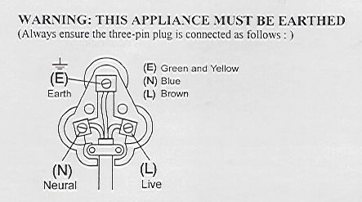

PLEASE AFFIX YOUR PROOF OF PURCHASE/RECEIPT HERE
IN THE EVENT OF A CLAIM UNDER WARRANTY THIS RECEIPT MUST BE PRODUCED.

2 YEAR WARRANTY
1 year retail ⵏ 1 year extended warranty upon registration*
visit www.russellhobbs.co.za

W A R R A N T Y AND EXTENDED WARRANTY

- Home of Living Brands (Pty) Limited ("Home of Living Brands") warrants to the original purchaser of this product ("the customer") that this product will be free of defects in quality and workmanship which under normal personal, family or household use and purpose may manifest within a period of 1 (one) year from the date of purchase ("warranty period").
- Home of Living Brands shall extend the warranty period for a further period of 1(one) year (“extended warranty period*”), on condition that the purchaser registers the product on the website, within 12 months from the date of purchase of the product. The website address for registration is as follows: http://russellhobbs.co.za/info-pages/warranty-info.aspx. The extended warranty period only applies to products purchased on or after 1 October 2017.
- Where the customer has purchased a product and it breaks, is defective or does not work properly for the intended purpose, the customer must notify the supplier from whom the customer bought the product ("the supplier") thereof within the warranty period or if applicable, the extended warranty period. Any claim in terms of this warranty must be supported by a proof of purchase. If proof of purchase is not available, then repair, and/or service charges may be payable by the customer to the supplier.
- The faulty product must be taken to the supplier's service centre to exercise the warranty.
- The supplier will refund, repair or exchange the product in terms of this warranty subject to legislative requirements. This warranty shall be valid only where (a) the customer is not the cause of the product breaking, and (b) the product has been used for the intended purpose stipulated in the product manual. The warranty does not include and will not be construed to cover products damaged as a result of disaster, misuse, tamper, abuse or any unauthorised modification or repair of the product.
- This warranty will extend only to the product provided at the date of the purchase and not to any expendables attached or installed by the customer. In this regard any accessories supplied with the product by the supplier, may be excluded in this warranty or extended warranty (see Exclusions to Warranty and Extended Warranty document).
- If the customer requests that the supplier repairs the product and the product breaks or fails to work properly within 3 (three) months of the repair and not as a result of misuse, tampering or modification by or on behalf of the customer, then the supplier may replace the product or pay a refund to the customer, subject to the supplier’s discretion.
- The customer may be responsible for certain costs where products returned are not in the original packaging, or if the packaging is damaged. This will be deducted from any refund paid to the customer.
HOME OF LIVING BRANDS (PTY) LTD (JOHANNESBURG)
JOHANNESBURG TEL NO. (011) 490-9600
CAPE TOWN TEL NO. (021) 552-5161
DURBAN TEL NO. (031) 303-1163
www.homeoflivingbrands.com

