INSTRUCTIONS AND WARRANTY

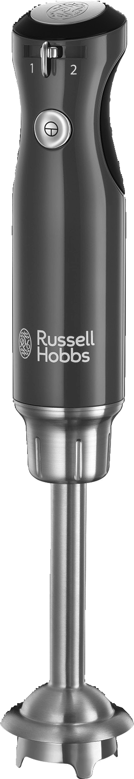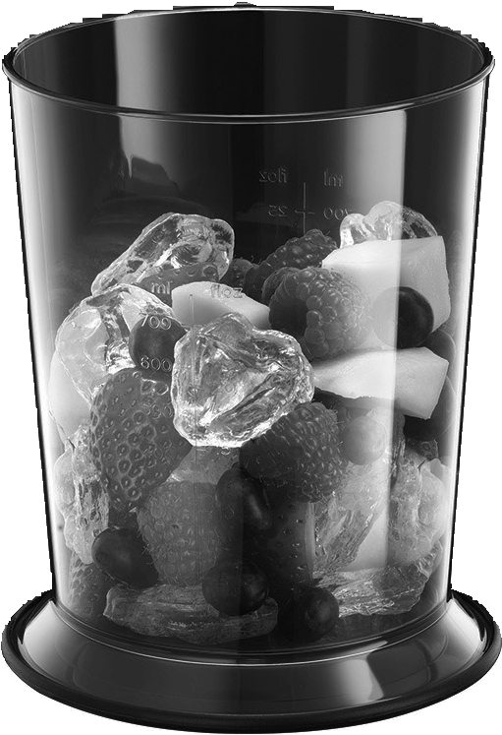

MODEL NO. 25230-56, 25232-56, 25234-56, 25236-56

RUSSELL HOBBS RETRO STICK BLENDER

1

2

3

4

7
M

6

5

GB
Read the instructions, keep them safe, pass them on if you pass the appliance on. Remove all packaging before use.

IMPORTANT SAFEGUARDS
Please read the instructions carefully before using the appliance.
- Always ensure that the voltage on the rating label corresponds to the mains voltage in your home.
- Incorrect operation and improper use can damage the appliance and cause injury to the user.
- The appliance is intended for household use only. Commercial use invalidates the warranty and the supplier cannot be held responsible for injury or damage caused when using the appliance for any other purpose than that intended.
- Always disconnect the appliance from the power supply if it is left unattended and before assembling, disassembling or cleaning.
- Avoid any contact with moving parts. Never touch the rotating tools while still in motion - always wait for them to come to a complete stop.
- Close supervision is required when any appliance is used near or by children.
- Check the power cord and plug regularly for any damage. If the cord or the plug is damaged, it must be replaced by the manufacturer or a qualified person in order to avoid an electrical hazard.
- Do not use the appliance if it has been dropped or damaged in any way. In a case where it has been damaged, take the unit in for examination and/or repair by an authorised service agent.
- To reduce the risk of electric shock, do not immerse or expose the motor assembly, plug or the power cord to water or any other liquid. Do not use it with wet hands.
- Never immerse the motor unit in water or any other liquid for cleaning purposes.
- Remove the plug from the socket by gripping the plug. Do not pull on the cord to disconnect the appliance from the mains. Always unplug the unit when not in use, before cleaning or when adding or removing parts.
- Insert only original parts. The use of accessory attachments that are not recommended or supplied by the manufacturer may result in injuries, fire or electric shock.
- A short cord is provided to reduce hazards resulting from becoming entangled in or tripping over a longer cord.
- Do not let the cord hang over the edge of a table or counter. Ensure that the cord is not in a position where it can be pulled on inadvertently.
- Do not allow the cord to touch hot surfaces and do not place on or near a hot gas or electric burner or in a heated oven.
- Do not use the appliance on a gas or electric cooking top or over or near an open flame.
- Keep the appliance and cord away from direct radiant heat from the sun, damp areas, sharp edges and other dangers.
- Use of an extension cord with this appliance is not recommended. However, if it is necessary to use an extension cord, ensure that the cord is suited to the power consumption of the appliance to avoid overheating the appliance or plug point. Do not place the extension cord in a position where it can be pulled on by children or animals or tripped over.
- This appliance is not suitable for outdoor use. Do not use this appliance for anything other than its intended use.
- DO NOT carry the appliance by the power cord.
- Do not leave this appliance unattended during use. Always unplug the unit when not in use or before cleaning.
- Always operate the appliance on a smooth, even, stable surface. Do not place the unit on a hot surface.
- Do not operate this appliance by means of an external timer or remote-control system.
- Never use this appliance to mix, blend or stir anything other than foods.
- Do not use during cooking processes or with boiling liquids.
- The blades are very sharp. Be cautious when handling the sharp blades, emptying the bowl and during cleaning.
- Ensure that after each cycle the stick blender is switched off by pressing the power button on the blender.
- The manufacturer does not accept responsibility for any damage or injury caused by improper or incorrect use, or for repairs carried out by unauthorised personnel.
- In case of technical problems, switch off the blender and do not attempt to repair it yourself. Return the appliance to an authorised service facility for examination, adjustment or repair. Always insist on the use of original spare parts. Failure to comply with the above-mentioned pre-cautions and instructions, could affect the safe operation of this unit.
- This appliance is not intended for use by persons (including children) with reduced physical, sensory or mental capabilities, or lack of experience and knowledge, unless they are under supervision or instruction concerning use of the appliance by a person responsible for their safety. Children should be supervised to ensure that they do not play with the appliance.
- Don’t run the motor continuously for more than two minutes, it will overheat. After two minutes switch off for at least two minutes, to recover.

FOR HOUSEHOLD USE ONLY

DIAGRAMS
- Speed control
- Switch
- Motor unit
- Wand attachment

FITTING/REMOVING ATTACHMENTS

- Blade
- Non-slip base
- Beaker
Dishwasher safe

- Unplug the appliance before fitting or removing attachments.
- To fit an attachment, push it on to the end of the motor unit, and turn it clockwise.
- To remove the attachment, turn it anti-clockwise, then pull the attachment off the motor unit.

OPERATING INSTRUCTIONS
- Put the plug into the power socket.
- Press the switch to start the motor, release it to switch off.
- Turn the speed control to the speed you want (1 = low, 2 = high).
Generally, the wand can do anything a normal blender can do. You can blend or purée ingredients in the pan or bowl you’re going to cook them in.
Whatever container you use, make sure it’s on a stable, flat surface, and support it with your free hand, to prevent it wandering over the work surface.

  - Don’t immerse the wand past the top of the parallel-sided tube.
  - When using it in hot liquids, don’t let the blade break the surface at an angle, as you might spray liquid outside the bowl/pan/container.
  - Don’t switch on till the blade is inside the food container.
  - Switch off before lifting the blade from the food container.

BEAKER
  - Don’t fill the beaker more than about half full.
  - Place it on a stable, flat work surface, and support it with your free hand.
  - Don’t lift it off the work surface and hold it in your hand, this is a potential hazard.
  - For storage, you may use the non-slip base as a lid.

CARE AND MAINTENANCE
- Unplug the appliance.
- Wipe all surfaces with a clean damp cloth.
- For best results, wash the wand immediately after use. Clean the blade end of the wand in hot soapy water with a nylon brush. Do not wash the wand in a dishwasher. Always ensure that the wand is dried thoroughly before storing.
- You may wash these parts in a dishwasher.

SERVICING THE APPLIANCE
There are no user serviceable parts in this appliance. If the unit is not operating correctly, please check the following:
- You have followed the instructions correctly
- That the unit has been wired correctly and that the wall socket is switched on.
- That the mains power supply is ON.
- That the plug is firmly in the mains socket.
If the appliance still does not work after checking the above:
- Consult the retailer for possible repair or replacement. If the retailer fails to resolve the problem and you need to return the appliance, make sure that:
- The unit is packed carefully back into its original packaging.
- Proof of purchase is attached.
- A reason is provided for why it is being returned.

If the supply cord is damaged, it must be replaced by the manufacturer or an authorised service agent, in order to avoid any hazard. If service becomes necessary within the warranty period, the appliance should be returned to an approved Home Of Living Brands (Pty) Limited service centre. Servicing outside the warranty period is still available, but will, however, be chargeable.

CHANGING THE PLUG
Should the need arise to change the fitted plug, follow the instructions below.
This unit is designed to operate on the stated current only. Connecting to other power sources may damage the appliance.
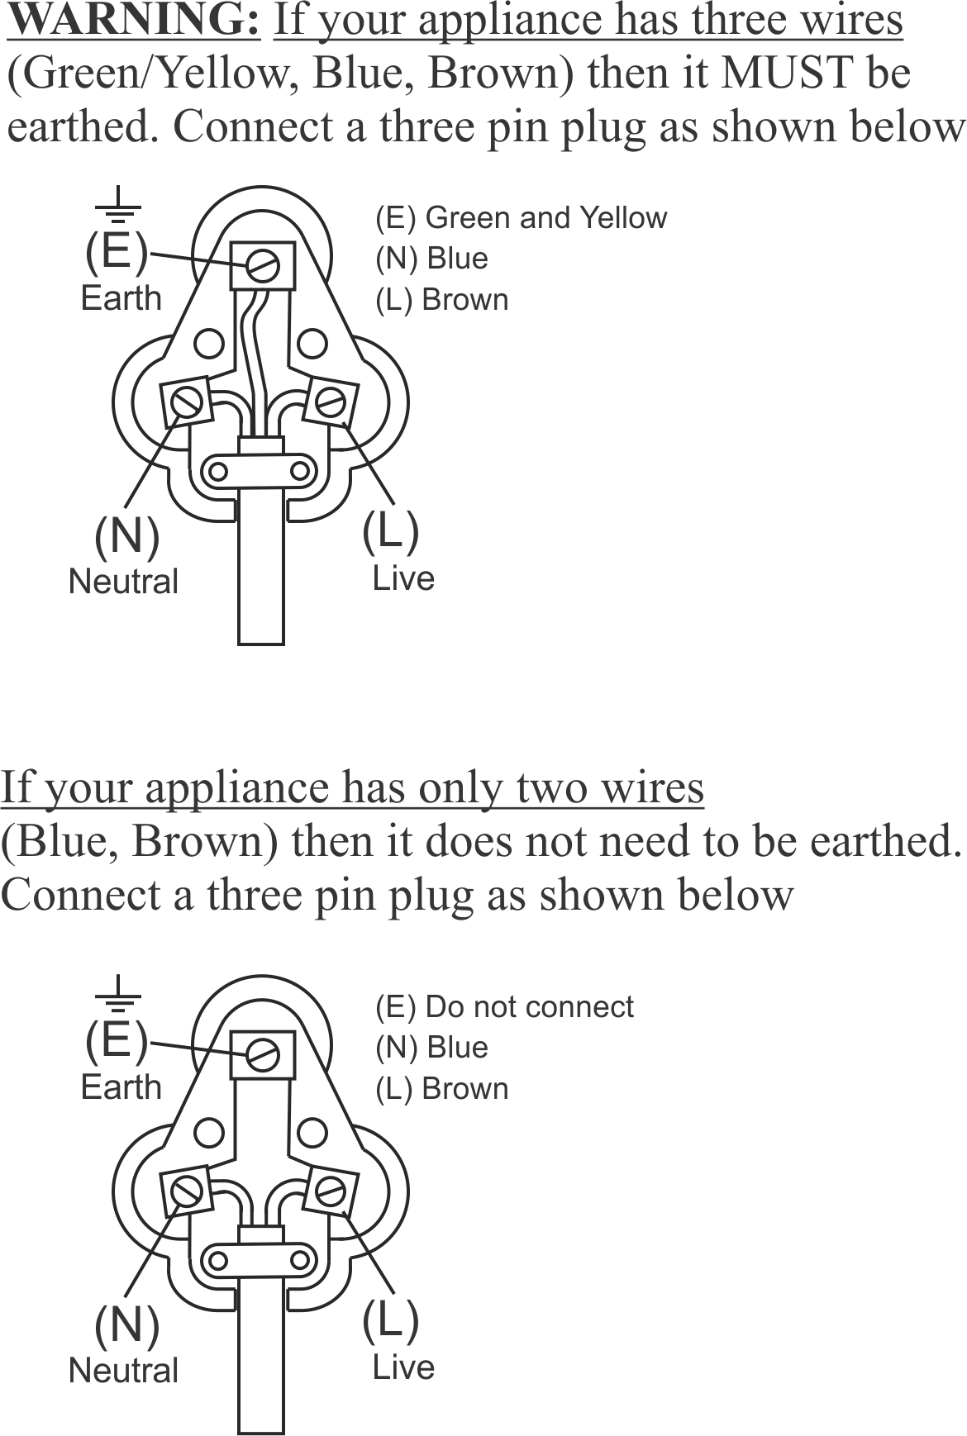
RECYCLING
To avoid environmental and health problems due to hazardous substances, appliances and rechargeable and non-rechargeable batteries marked with one of these symbols must not be disposed of with unsorted municipal waste. Always dispose of electrical and electronic products and, where applicable, rechargeable and non-rechargeable batteries, at an appropriate official recycling/collection point.

For recipes, please visit http://eu.russellhobbs.com/recipes/

PLEASE AFFIX YOUR PROOF OF PURCHASE/RECEIPT HERE
IN THE EVENT OF A CLAIM UNDER WARRANTY THIS RECEIPT MUST BE PRODUCED.

2 YEAR WARRANTY
1 year retail ⵏ 1 year extended warranty upon registration*
visit www.russellhobbs.co.za

W A R R A N T Y AND EXTENDED WARRANTY

- Home of Living Brands (Pty) Limited ("Home of Living Brands") warrants to the original purchaser of this product ("the customer") that this product will be free of defects in quality and workmanship which under normal personal, family or household use and purpose may manifest within a period of 1 (one) year from the date of purchase ("warranty period").
- Home of Living Brands shall extend the warranty period for a further period of 1(one) year (“extended warranty period*”), on condition that the purchaser registers the product on the website, within 12 months from the date of purchase of the product. The website address for registration is as follows: http://russellhobbs.co.za/info-pages/warranty-info.aspx. The extended warranty period only applies to products purchased on or after 1 October 2017.
- Where the customer has purchased a product and it breaks, is defective or does not work properly for the intended purpose, the customer must notify the supplier from whom the customer bought the product ("the supplier") thereof within the warranty period or if applicable, the extended warranty period. Any claim in terms of this warranty must be supported by a proof of purchase. If proof of purchase is not available, then repair, and/or service charges may be payable by the customer to the supplier.
- The faulty product must be taken to the supplier's service centre to exercise the warranty.
- The supplier will refund, repair or exchange the product in terms of this warranty subject to legislative requirements. This warranty shall be valid only where (a) the customer is not the cause of the product breaking, and (b) the product has been used for the intended purpose stipulated in the product manual. The warranty does not include and will not be construed to cover products damaged as a result of disaster, misuse, tamper, abuse or any unauthorised modification or repair of the product.
- This warranty will extend only to the product provided at the date of the purchase and not to any expendables attached or installed by the customer. In this regard any accessories supplied with the product by the supplier, may be excluded in this warranty or extended warranty (see Exclusions to Warranty and Extended Warranty document).
- If the customer requests that the supplier repairs the product and the product breaks or fails to work properly within 3 (three) months of the repair and not as a result of misuse, tampering or modification by or on behalf of the customer, then the supplier may replace the product or pay a refund to the customer, subject to the supplier’s discretion.
- The customer may be responsible for certain costs where products returned are not in the original packaging, or if the packaging is damaged. This will be deducted from any refund paid to the customer.

HOME OF LIVING BRANDS (PTY) LTD (JOHANNESBURG)

JOHANNESBURG TEL NO. (011) 490-9600
CAPE TOWN TEL NO. (021) 552-5161
DURBAN TEL NO. (031) 303-1163

www.homeoflivingbrands.com
www.russellhobbs.co.za
www.facebook.com/RussellHobbsSA

EXCLUSIONS TO W A R R A N T Y AND EXTENDED WARRANTY

- Any accessories supplied with the product, including but not limited to, bowls, jugs, mills or carafes made either of glass or plastic and supplied with this appliance (hereinafter referred to as “the accessory or accessories”), is warranted to be free from material and workmanship defects for the duration of the appliance warranty.
- The accessories should give trouble free service when used in accordance with the directions described in the instruction manual. However, the accessories will be damaged if subjected to impact, and this damage is not covered by the warranty. Such impact damage can occur either from the outside (if for example it is dropped or knocked against a hard surface), or from within (if for example foreign objects are placed within the accessories and the power is switched on).
- Should you need to replace an accessory during the warranty period; a claim for a free replacement will only be considered if the item (including all shards and broken parts) is returned to the nearest HOLB service centre for examination.
- The remains of the accessory will be carefully examined by the relevant professionals and if it is determined (at the sole discretion of HOLB) that the damage was caused by impact, then the claim will be refused and will not be covered by the warranty or any extended warranty.
- Any replacement part provided in terms of clause 4 above will become a chargeable item payable by the customer.

UTILISATION
- Mettez la fiche dans la prise de courant.
- Appuyez sur l’interrupteur pour démarrer le moteur, relâchez l’interrupteur pour l’arrêter.
- Réglez le contrôle de vitesse sur la vitesse souhaitée (1 = faible, 2 = élevée).
FR
Généralement, le batteur fait tout ce qu’un mixeur normal peut faire. Vous pouvez mixer, réduire en pulpe ou en purée les ingrédients dans la casserole ou le bol dans lequel vous les cuisinez.
Quelque soit le récipient que vous utilisez, posez-le sur une surface plate et stable et tenez-le avec votre main libre pour éviter qu’il se déplace sur le plan de travail.
- Ne pas plonger le batteur dans un liquide au-delà de la partie supérieure du tube parallèle.
- Lorsque vous l’utilisez dans des liquides chauds, ne laissez pas la lame briser la surface dans un angle, car le liquide risque de déborder du bol/de la casserole/du récipient.
- Ne le mettez pas en marche tant que la lame n’est pas dans le récipient.
- Éteignez-le avant de retirer la lame du récipient.

LE GOBELET DOSEUR
- Ne remplissez pas le gobelet doseur à plus de la moitié de sa capacité environ.
- Posez-le sur un plan de travail plat et stable et tenez-le avec votre main libre.
- Ne le soulevez pas du plan de travail et tenez-le dans votre main ; s’il glisse, vous risquez de vous blesser.
- Lors du rangement de l’appareil, vous pouvez utiliser la base antidérapante comme couvercle.

SOINS ET ENTRETIEN
- Débranchez le bloc moteur.
- Essuyez toutes les surfaces avec un tissu humide et propre.
- Pour obtenir des résultats optimaux, lavez le batteur immédiatement après utilisation. Nettoyez l’extrémité de la lame du batteur dans de l’eau chaude savonneuse, avec une brosse en nylon. Ne lavez pas le batteur dans un lave-vaisselle. Assurez-vous dans tous les cas que le batteur est complètement sec avant de le ranger. Dans le cas où de l’eau pénètrerait dans le batteur, retournez- le et placez-le en position verticale jusqu’à ce que l’eau se soit écoulée.
` Vous pouvez laver ces pièces dans un lave-vaisselle.
Toutefois, les conditions de lavage du lave-vaisselle affecteront la finition de la surface de l'appareil. Cela affecte l’apparence de l’appareil, non pas son fonctionnement.

RECYCLAGE
Afin d’éviter les problèmes occasionnés à l’environnement et à la santé par des substances dangereuses, les appareils et les batteries rechargeables et non rechargeables présentant l’un de ces symboles ne doivent pas être éliminés avec les déchets municipaux non triés. Éliminez dans tous les cas les produits électriques et électroniques et, le cas échéant, les batteries rechargeables et non rechargeables, dans un centre officiel et approprié de collecte/recyclage.
Rezepte finden Sie auf unserer Website: http://eu.russellhobbs.com/recipes/

UTILIZAÇÃO
- Ligue a ficha à tomada elétrica.
- Prima o interruptor para arrancar o motor, liberte-o para desligar.
- Gire o controlo de velocidade para a velocidade que pretende (1 = baixa, 2 = alta).
Em geral, a varinha pode fazer qualquer coisa que uma picadora normal pode fazer. Também pode picar ou passar ingredientes no recipiente em que os for cozinhar.
PT
Seja qual for o recipiente que utilizar, certifique-se sempre que o coloca numa superfície estável e nivelada, e segure-o com a sua mão livre para evitar que se mova pela superfície de trabalho.
- Não submirja a varinha para lá tubo com lados paralelos.
- Quando a utilizar em líquidos quentes, não deixe que a lâmina gire sobre a superfície de forma inclinada, já que poderia salpicar líquido quente para fora do recipiente.
- Não ligue o aparelho enquanto a lâmina não se encontrar dentro do recipiente para os alimentos.
- Desligue o aparelho antes de retirar a lâmina do recipiente para os alimentos.

O COPO
- Não encha o copo até mais de meio.
- Coloque-o numa superfície de trabalho estável e nivelada, e aguente-o com a sua mão livre.
- Não levante o copo da superfície de trabalho nem o segure só com a mão. Se o copo escorregar, poderá magoar-se.
- Para armazenar, poderá usar a base anti-deslizante como tampa.

CUIDADOS E MANUTENÇÃO
- Desligue o aparelho da corrente elétrica.
- Limpe todas as superfícies com um pano limpo e húmido.
- Para obter os melhores resultados, lave a varinha imediatamente após a utilização. Limpe a extremidade com a lâmina da varinha em água quente, com detergente, usando uma escova de nylon. Não lave a varinha na máquina de lavar loiça. Certifique-se sempre de que a varinha está seca na totalidade antes de a armazenar. Se água penetrar na varinha, coloque-a na vertical invertida até que toda a água tenha sido drenada.
` Poderá lavar estas peças na máquina de lavar loiça.
Se utilizar uma máquina de lavar loiça, o ambiente agressivo no seu interior afectará o acabamento da superfície. Os danos deveriam ser apenas cosméticos e não deveriam afectar o funcionamento do aparelho.

RECICLAGEM
Para evitar problemas ambientais e de saúde devido a substâncias perigosas, os aparelhos e baterias recarregáveis e não recarregáveis com um destes símbolos não deverão ser eliminados com o lixo doméstico normal. Elimine sempre os produtos elétricos e eletrónicos e, quando aplicável, as baterias recarregáveis e não recarregáveis, no ponto de reciclagem/recolha oficial apropriado.
Receitas disponíveis no nosso website: http://eu.russellhobbs.com/recipes/

