INSTRUCTIONS AND WARRANTY

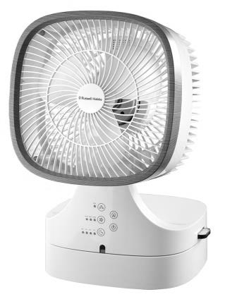

MODEL NO. RHDF16

RUSSELL HOBBS FOLDABLE DESK FAN
Thank you for purchasing the Russell Hobbs Foldable Desk Fan. Each unit has been manufactured to ensure safety, reliability and ease of use. Before use, please read these instructions carefully and keep them for further reference.

FEATURES OF THE RUSSELL HOBBS FOLDABLE DESK FAN
- Foldable desk fan
- Ionizer, aroma and timer function
- Remote control
- Touch control panel
- 20W
- 120° Oscillation
- 3 fan speed settings: low/med/high
- Timer function: up to 8 hrs
- Distance covered (max):5-7m
- The foldable feature allows for improved space saving
- Modern wood finish trimming

IMPORTANT SAFEGUARDS
When using any electrical appliance, basic safety precautions should always be followed including the following:
- Please read the instructions carefully before using any appliance.
- Use the fan only for purposes described in the instruction manual.
- Always ensure that the voltage on the rating label corresponds to the mains voltage in your home.
- Incorrect operation and improper use can damage the appliance and cause injury to the user.
- The appliance is intended for household use only. Commercial use invalidates the warranty and the supplier cannot be held responsible for injury or damage caused when using the appliance for any other purpose than that intended.
- This appliance is not intended for use by persons (including children) with reduced physical, sensory or mental capabilities, or lack of experience and knowledge, unless they have been given supervision or instruction concerning use of the appliance by a person responsible for their safety.
- Avoid any contact with moving parts.
- To reduce the risk of fire or electric shock, do not use this fan with any solid-state speed control device.
- Do not disassemble the appliance. There are no user serviceable parts inside.
- Do not immerse appliance in water or other liquids. Do not use near sinks, baths and showers
- The appliance should not be used outdoors, placed near a hot gas, electrical burner or placed in a heated oven
- Do not block any ventilation openings.
- Turn off and unplug before cleaning or storing.
- No liability can be accepted for any damage caused by non-compliance with these instructions or any other improper use or mishandling of appliance.
- To protect against electrical shock, do not immerse the fan, plug or cord in water or any other liquid or spray with liquids.
- Children should be supervised to ensure that they do not play with the appliance
- Close supervision is required when any appliance is used near or by children, pets and invalids.
- Check the power cord and plug regularly for any damage. If the cord or the plug is damaged, it must be replaced by the manufacturer or a qualified person in order to avoid an electrical hazard.
- Do not operate the fan in the presence of explosive and/or flammable fumes.
- Do not use the appliance if it has been dropped or damaged in any way. In case of damage, take the unit in for examination and/or repair by an authorised service agent
- To reduce the risk of electric shock, do not immerse or expose the motor assembly, plug or the power cord to water or any other liquid.
- Place the fan on a dry level surface
- Do not hang or mount fan on a wall or ceiling
- Remove the plug from the socket by gripping the plug. Do not pull on the cord to disconnect the appliance from the mains. Always unplug the fan when not in use, before cleaning or when adding or removing parts.
- This fan should not be placed in a damp place or where there is high humidity, such as a bathroom.
- Do not allow the cord to touch hot surfaces and do not place on or near a hot gas or electric burner or in a heated oven.
- DO NOT carry the appliance by the power cord.
- In case of technical problems, switch off the machine and do not attempt to repair it yourself. Return the appliance to an authorised service facility for examination, adjustment or repair.
Always insist on the use of original spare parts. Failure to comply with the above mentioned pre-cautions and instructions, could affect the safe operation of this machine.
- The fan should be placed on a flat and stable surface when operating to avoid overturning.
- Do not use force to turn the fan casing left and right or when in operation as it will cause damage to the oscillation gear.
- Do not operate with wet hands or if the plug is wet.
- Do not operate this appliance without a fan blade or with broken/bent fan blade.
- Do not insert finger or other objects into the fan grill.
- Do not use outdoors or near windows. Rain drops may cause electrical hazards
- Do not operate this appliance in dirty, dusty or polluted environments.
- Do not place the appliance against walls or curtains or other objects which might block the air flow.
- Do not use this appliance in locations containing inflammable or explosive gases. Do not expose it directly to sunlight for a long period of time.

PARTS DIAGRAM
Main unit

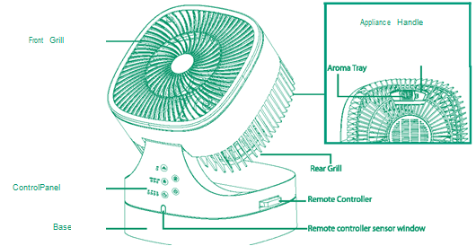
Front grill
Aroma tray
Rear grill
Base
Control panel
Remote control and remote storage
Remote control sensor
Handle

Control Panel
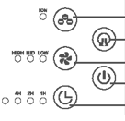
Ionizer function
Oscillation function
Speed setting
Power button
Timer setting

Remote control
Ionizer function
Oscillation function
Speed setting
Power button
Timer setting
LED display setting

OPERATING INSTRUCTIONS
- Connect the appliance to the mains plug.
- The fan should not be operated in the below position, but can be packed and stored in this position to save space.
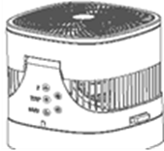

- During operation the fan can be used in the following 45 degree or 90 degree angle simply by tilting it.
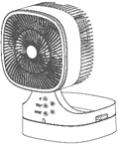
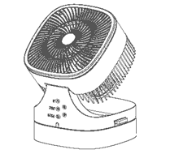

- Press the On/Off switch
- Adjust the fan speed on the control panel or remote controller to the desired speed. There are 3 speed selections to choose from.
- The timer function can be used to cease operation after a pre-determined period of time. It can be set to go off any time from 1 -8 hours based on your selected setting.
- Press the ionizer button to activate or deactivate air cleaning and ionizer functions.
- The oscillation function will start or stop oscillation.
- To turn the LED light indicators on the control panel on or off, press LED display button on the remote control.
- If you wish to use the aroma function open the aroma tray outlet & drop some essential oil onto the sponge.
Note: use the oil very sparingly as to avoid leakage from the aroma tray.
- Ensure the unit is switched off and unplugged after use

CLEANING AND MAINTENANCE
- Unplug the appliance before cleaning. After the motor has cooled down, use a damp cloth to clean the grill and appliance's surface.

- Remove the 4 safety screws on the rear grill sides and detach the front grill from the rear grill to clean fan blades and other parts with a damp cloth.
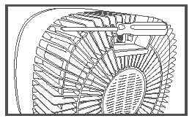
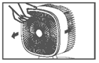

- Do not use a wet cloth or pour water on the appliance when cleaning. Excess water may enter the motor and cause an electric shock.
- The grilles can be cleaned by vacuuming with a brush attachment.
- Ensure the unit is wiped dry after wiping with the cloth.
- Never spray with liquids or submerge the fan in water or any other liquid.
- Do not use flammable liquids, chemicals, abrasive creams, steel wool or scouring pads for cleaning.
- Refit the front grille assembly and ensure all the screws are tightened properly.

STORING THE APPLIANCE
- Unplug the unit from the wall outlet and clean all the parts as instructed above. Ensure that all parts are dry before storing.
- Store the appliance in its box or in a clean, dry place.
- Never store the appliance while it is still wet or dirty.
- Never wrap the cord around the appliance

SERVICING THE APPLIANCE
There are no user serviceable parts in this appliance. If the unit is not operating correctly, please check the following:
- You have followed the instructions correctly
- That the unit has been wired correctly and that the wall socket is switched on.
- That the mains power supply is ON.
- That the plug is firmly in the mains socket.

If the appliance still does not work after checking the above:
- Consult the retailer for possible repair or replacement. If the retailer fails to resolve the problem and you need to return the appliance, make sure that:
- The unit is packed carefully back into its original packaging.
- Proof of purchase is attached.
- A reason is provided for why it is being returned.

If the supply cord is damaged, it must be replaced by the manufacturer or an authorised service agent, in order to avoid any hazard. If service becomes necessary within the warranty period, the appliance should be returned to an approved Home of Living Brands (Pty) Limited service centre. Servicing outside the warranty period is still available, but will, however, be chargeable.

CHANGING THE PLUG
Should the need arise to change the fitted plug, follow the instructions below.
This unit is designed to operate on the stated current only. Connecting to other power sources may damage the appliance.
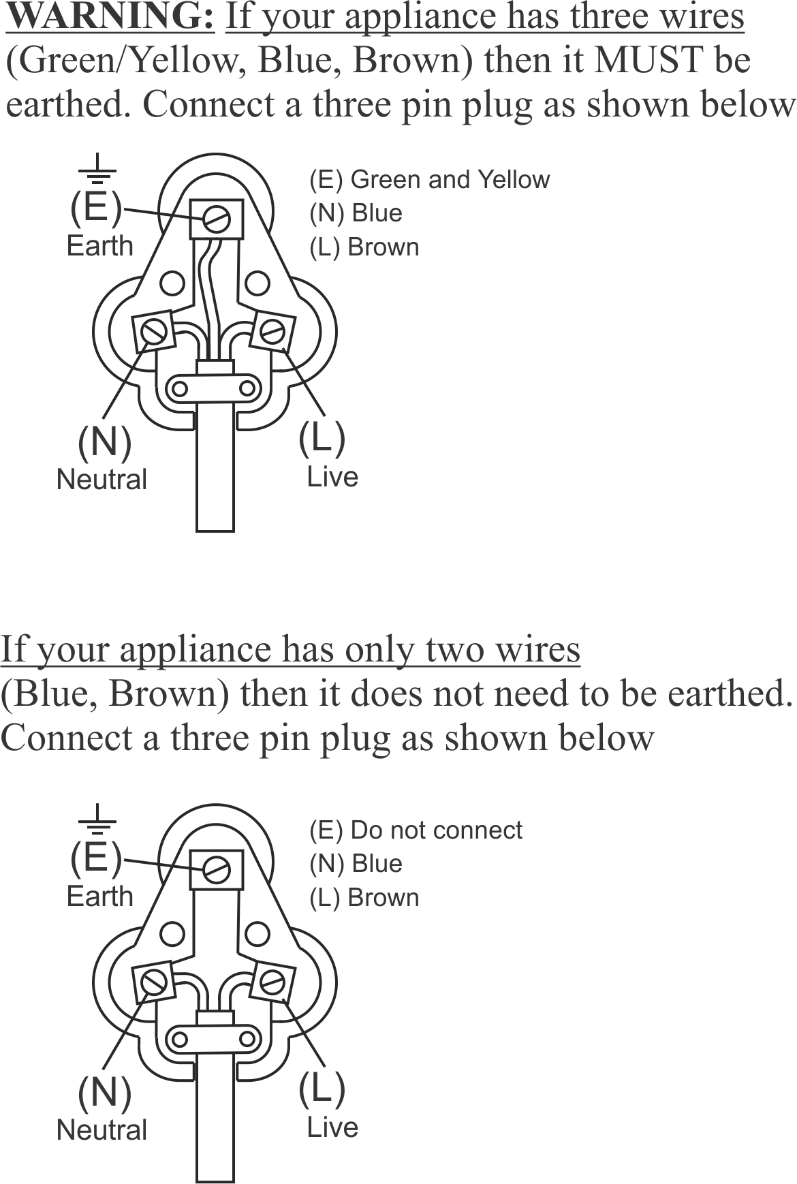

PLEASE AFFIX YOUR PROOF OF PURCHASE/RECEIPT HERE
IN THE EVENT OF A CLAIM UNDER WARRANTY THIS RECEIPT MUST BE PRODUCED.

2 YEAR WARRANTY
1 year retail ⵏ 1 year extended warranty upon registration*
visit www.russellhobbs.co.za

W A R R A N T Y AND EXTENDED WARRANTY

- Home of Living Brands (Pty) Limited ("Home of Living Brands") warrants to the original purchaser of this product ("the customer") that this product will be free of defects in quality and workmanship which under normal personal, family or household use and purpose may manifest within a period of 1 (one) year from the date of purchase ("warranty period").
- Home of Living Brands shall extend the warranty period for a further period of 1(one) year (“extended warranty period*”), on condition that the purchaser registers the product on the website, within 12 months from the date of purchase of the product. The website address for registration is as follows: http://russellhobbs.co.za/info-pages/warranty-info.aspx. The extended warranty period only applies to products purchased on or after 1 October 2017.
- Where the customer has purchased a product and it breaks, is defective or does not work properly for the intended purpose, the customer must notify the supplier from whom the customer bought the product ("the supplier") thereof within the warranty period or if applicable, the extended warranty period. Any claim in terms of this warranty must be supported by a proof of purchase. If proof of purchase is not available, then repair, and/or service charges may be payable by the customer to the supplier.
- The faulty product must be taken to the supplier's service centre to exercise the warranty.
- The supplier will refund, repair or exchange the product in terms of this warranty subject to legislative requirements. This warranty shall be valid only where (a) the customer is not the cause of the product breaking, and (b) the product has been used for the intended purpose stipulated in the product manual. The warranty does not include and will not be construed to cover products damaged as a result of disaster, misuse, tamper, abuse or any unauthorised modification or repair of the product.
- This warranty will extend only to the product provided at the date of the purchase and not to any expendables attached or installed by the customer. In this regard any accessories supplied with the product by the supplier, may be excluded in this warranty or extended warranty (see Exclusions to Warranty and Extended Warranty document).
- If the customer requests that the supplier repairs the product and the product breaks or fails to work properly within 3 (three) months of the repair and not as a result of misuse, tampering or modification by or on behalf of the customer, then the supplier may replace the product or pay a refund to the customer, subject to the supplier’s discretion.
- The customer may be responsible for certain costs where products returned are not in the original packaging, or if the packaging is damaged. This will be deducted from any refund paid to the customer.
HOME OF LIVING BRANDS (PTY) LTD (JOHANNESBURG)
JOHANNESBURG TEL NO. (011) 490-9600
CAPE TOWN TEL NO. (021) 552-5161
DURBAN TEL NO. (031) 303-1163
www.homeoflivingbrands.com
www.russellhobbs.co.za
www.facebook.com/RussellHobbsSA

EXCLUSIONS TO W A R R A N T Y AND EXTENDED WARRANTY

- Any accessories supplied with the product, including but not limited to, bowls, jugs, mills or carafes made either of glass or plastic and supplied with this appliance (hereinafter referred to as “the accessory or accessories”), is warranted to be free from material and workmanship defects for the duration of the appliance warranty.
- The accessories should give trouble free service when used in accordance with the directions described in the instruction manual. However, the accessories will be damaged if subjected to impact, and this damage is not covered by the warranty. Such impact damage can occur either from the outside (if for example it is dropped or knocked against a hard surface), or from within (if for example foreign objects are placed within the accessories and the power is switched on).
- Should you need to replace an accessory during the warranty period; a claim for a free replacement will only be considered if the item (including all shards and broken parts) is returned to the nearest HOLB service centre for examination.
- The remains of the accessory will be carefully examined by the relevant professionals and if it is determined (at the sole discretion of HOLB) that the damage was caused by impact, then the claim will be refused and will not be covered by the warranty or any extended warranty.
- Any replacement part provided in terms of clause 4 above will become a chargeable item payable by the customer.

