INSTRUCTIONS AND WARRANTY
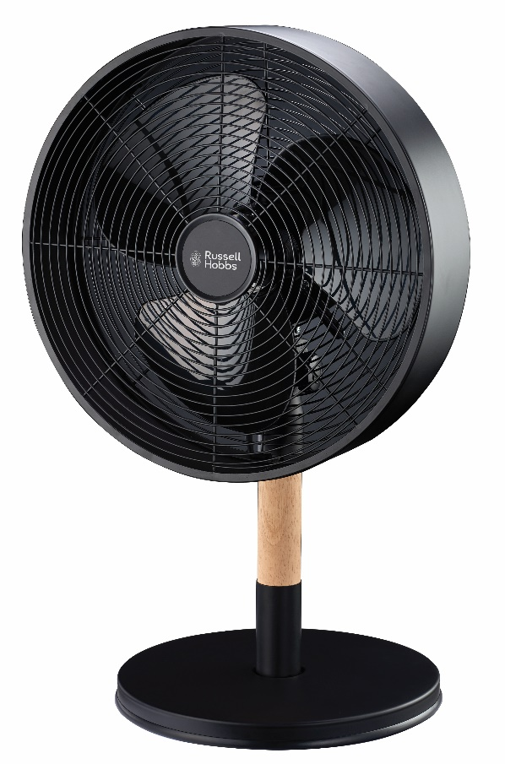

MODEL NO. RHMDF3

RUSSELL HOBBS METAL DESK FAN
Thank you for purchasing the Russell Hobbs Metal Desk Fan. Each unit has been manufactured to ensure safety, reliability and ease of use. Before use, please read these instructions carefully and keep them for further reference.

FEATURES OF THE RUSSELL HOBBS METAL DESK FAN
- 12” Metal desk fan
- 35W motor
- Matt black finish with wooden accents
- Adjustable height
- Three speed settings
- Oscillating function
- Classic and elegant design
- For domestic use only

IMPORTANT SAFEGUARDS
When using any electrical appliance, basic safety precautions should always be followed including the following:
- Please read the instructions carefully before using any appliance.
- Use the fan only for purposes described in the instruction manual.
- Always ensure that the voltage on the rating label corresponds to the mains voltage in your home.
- Incorrect operation and improper use can damage the appliance and cause injury to the user.
- The appliance is intended for household use only. Commercial use invalidates the warranty and the supplier cannot be held responsible for injury or damage caused when using the appliance for any other purpose than that intended.
- This appliance is not intended for use by persons (including children) with reduced physical, sensory or mental capabilities, or lack of experience and knowledge, unless they have been given supervision or instruction concerning use of the appliance by a person responsible for their safety.
- Avoid any contact with moving parts.
- To reduce the risk of fire or electric shock, do not use this fan with any solid-state speed control device.
- Do not disassemble the appliance. There are no user serviceable parts inside.
- Do not immerse appliance in water or other liquids. Do not use near sinks, baths and showers
- This appliance uses natural untreated wood. Do not allow the wood to get wet as this can cause the wood to deteriorate, stain, develop mould or fungus. Keep the wood away from any heat source as it is a flammable material.
- Appliance should not be used outdoors, placed near a hot gas, electrical burner or placed in a heated oven
- Do not block any ventilation openings.
- Turn off and unplug before cleaning or storing.
- No liability can be accepted for any damage caused by non-compliance with these instructions or any other improper use or mishandling of appliance.
- To protect against electrical shock, do not immerse the fan, plug or cord in water or any other liquid or spray with liquids.
- Children should be supervised to ensure that they do not play with the appliance
- Close supervision is required when any appliance is used near or by children, pets and invalids.
- Check the power cord and plug regularly for any damage. If the cord or the plug is damaged, it must be replaced by the manufacturer or a qualified person in order to avoid an electrical hazard.
- Do not operate the fan in the presence of explosive and/or flammable fumes.
- Do not use the appliance if it has been dropped or damaged in any way. In case of damage, take the unit in for examination and/or repair by an authorised service agent
- To reduce the risk of electric shock, do not immerse or expose the motor assembly, plug or the power cord to water or any other liquid.
- Place the fan on a dry level surface
- Do not hang or mount fan on a wall or ceiling
- Remove the plug from the socket by gripping the plug. Do not pull on the cord to disconnect the appliance from the mains. Always unplug the fan when not in use, before cleaning or when adding or removing parts.
- This fan should not be placed in a damp place or where there is high humidity, such as a bathroom.
- Do not allow the cord to touch hot surfaces and do not place on or near a hot gas or electric burner or in a heated oven.
- DO NOT carry the appliance by the power cord.
- In case of technical problems, switch off the machine and do not attempt to repair it yourself. Return the appliance to an authorised service facility for examination, adjustment or repair. Always insist on the use of original spare parts. Failure to comply with the above mentioned pre-cautions and instructions, could affect the safe operation of this machine.
- The fan should be placed on a flat and stable surface when operating to avoid overturning

1 | Oscillating Knob | 8 | Base Thumb Screw
2 | On / Off / Speed Knob | 9 | Fan Head Assembly
3 | Tilt Range Knob | 10 | Tilt Range Screw
4 | Tilt Adjustment Bolt | 11 | Tilt Adjustment Knob
5 | Post Top | 12 | Wooden Post
6 | Post Securing Screws | 13 | Post Holder
7 | Base Washer | 14 | Base

PARTS DIAGRAM

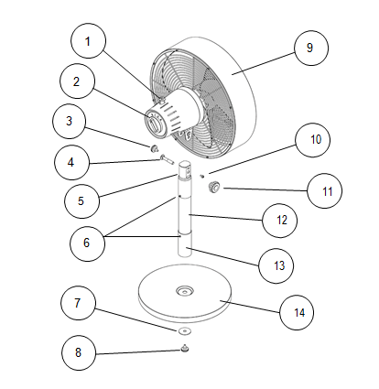

ASSEMBLY INSTRUCTIONS
Your Fan has been packaged unassembled to minimise packaging waste.

Each part is designed to fit together and be disassembled easily for cleaning or storage.

Start with the base and post as follows:
Remove the tilt adjustment knob by unscrewing the knob and slide the tilt adjustment bolt out, then remove the base thumb screw and the base washer by unscrewing it as shown.
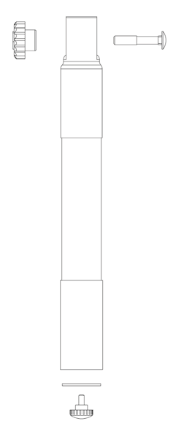

The next step involves the base, the base thumb screw, the base washer and post.
Slide the post into the top of the base and whilst holding it in place, turn it over so that the bottom of the base is facing upward.
Place the washer over the hole and then insert the base thumb screw.
Tighten securely, then turn the assembly the right way up and place on a flat surface.
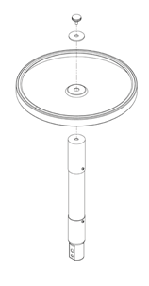

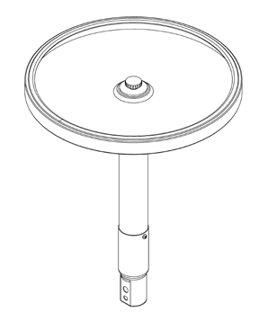

Using a screwdriver remove the small tilt range screw from the coupling bracket on the fan neck and then unscrew the small tilt range knob.

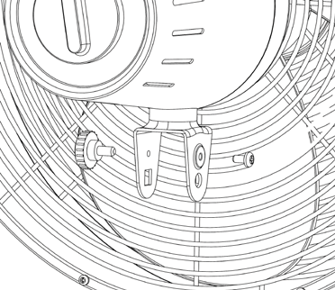
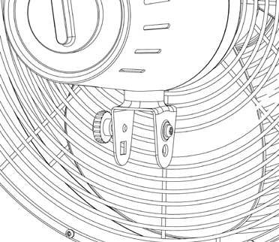

Note: It is important that the post and fan head are in the correct position when assembled.
The top section of the post has a small horizontal open slot one side and a small horizontal depression on the other as shown.

The side with the open slot is for the small tilt range screw to screw into.
The side with the small depression is for the tilt range knob to tighten up onto.
Take the head assembly and position the matching neck section over the post end as shown.
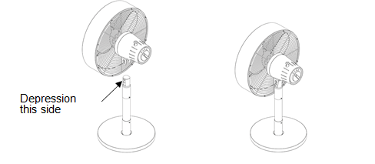

Note: The following assembly order is important.
Slide the tilt adjustment bolt all the way through as shown.

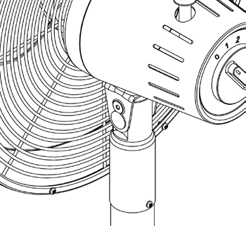
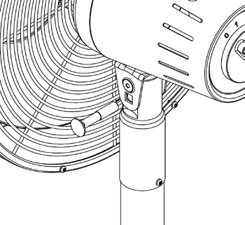

Screw in the tilt range knob as shown and just nip up.
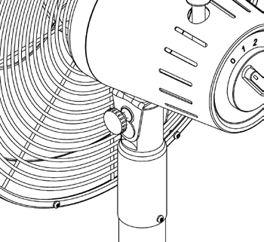
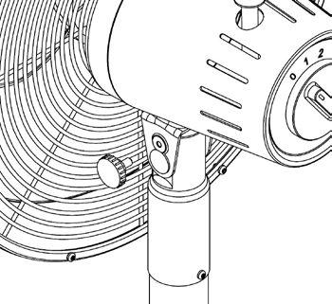

Using a screwdriver, screw in the small tilt range screw and tighten up.
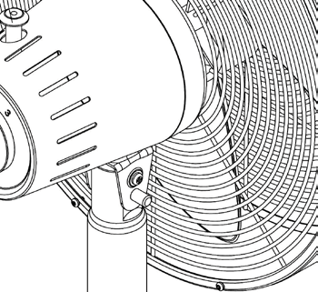
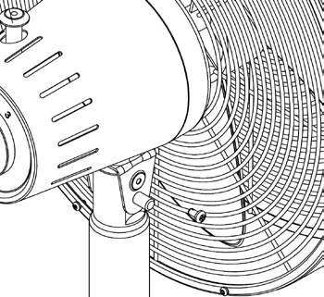

Next, screw on the tilt adjustment knob as shown and just nip up.
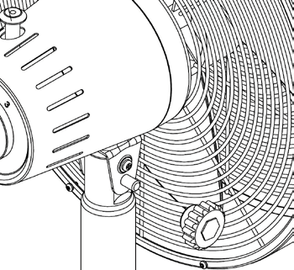
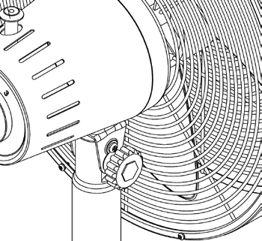

OPERATING INSTRUCTIONS
Remove the cable tie and unravel the cord set before operation.
1. Head tilt function
The fan and motor assembly can be tilted up and down to your desired angle.
To adjust the tilt angle, loosen both the larger tilt adjustment knob and the smaller tilt range knob and then tilt the head to the desired angle and tighten both knobs..
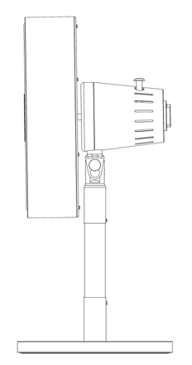

2. Fan On / Off / Speed
Rotate the knob located on the rear of the motor housing to position I for a low speed, 2 for a medium speed and 3 for a high speed.
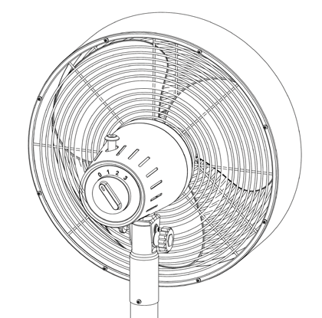
Rotate the knob to position 0 to switch the Fan off.

3. Oscillation
Press the clutch knob down to activate the oscillating function. The fan head will swing from side to side whilst blowing air.
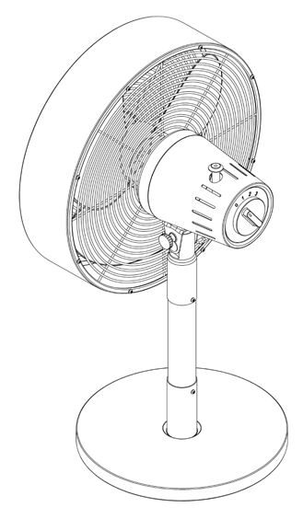
To stop oscillation, allow the fan head to move into the desired position and then pull the clutch knob up.

CLEANING AND MAINTENANCE

- Turn off and unplug the unit prior to cleaning.

- The grilles can be cleaned by vacuuming with a brush attachment.

- To clean the blade, first remove the front grille / cowl assembly by unscrewing the small screws around the edge of the rear safety grille.

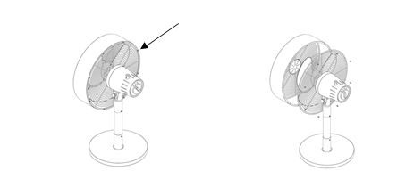

- Wipe the blades clean with a slightly damp cloth.

- Clean the motor housing and body assembly with a clean, damp cloth and wipe dry.

- Never spray with liquids or submerge the fan in water or any other liquid.

- Do not use flammable liquids, chemicals, abrasive creams, steel wool or scouring pads for cleaning.

- Refit the front grille / cowl assembly and ensure all the screws and washers are inserted and tightened properly.

STORING THE APPLIANCE
- Unplug the unit from the wall outlet and clean all the parts as instructed above. Ensure that all parts are dry before storing.
- Store the appliance in its box or in a clean, dry place.
- Never store the appliance while it is still wet or dirty.
- Never wrap the cord around the appliance

SERVICING THE APPLIANCE
There are no user serviceable parts in this appliance. If the unit is not operating correctly, please check the following:
- You have followed the instructions correctly
- That the unit has been wired correctly and that the wall socket is switched on.
- That the mains power supply is ON.
- That the plug is firmly in the mains socket.

If the appliance still does not work after checking the above:
- Consult the retailer for possible repair or replacement. If the retailer fails to resolve the problem and you need to return the appliance, make sure that:
- The unit is packed carefully back into its original packaging.
- Proof of purchase is attached.
- A reason is provided for why it is being returned.

If the supply cord is damaged, it must be replaced by the manufacturer or an authorised service agent, in order to avoid any hazard. If service becomes necessary within the warranty period, the appliance should be returned to an approved Home of Living Brands (Pty) Limited service centre. Servicing outside the warranty period is still available, but will, however, be chargeable.

CHANGING THE PLUG
Should the need arise to change the fitted plug, follow the instructions below.
This unit is designed to operate on the stated current only. Connecting to other power sources may damage the appliance. Connect a three-pin plug as follows:
The wires in this mains lead are coloured in accordance with the following code:
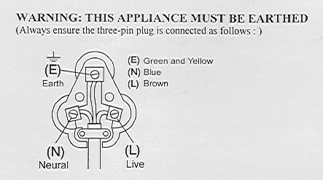
Green/Yellow = Earth
Blue = Neutral
Brown = Live

If the mains cord does not have a green and yellow wire then do not connect anything to the Earth pin.

PLEASE AFFIX YOUR PROOF OF PURCHASE/RECEIPT HERE
IN THE EVENT OF A CLAIM UNDER WARRANTY THIS RECEIPT MUST BE PRODUCED.

2 YEAR WARRANTY
1 year retail ⵏ 1 year extended warranty upon registration*
visit www.russellhobbs.co.za

W A R R A N T Y AND EXTENDED WARRANTY

- Home of Living Brands (Pty) Limited ("Home of Living Brands") warrants to the original purchaser of this product ("the customer") that this product will be free of defects in quality and workmanship which under normal personal, family or household use and purpose may manifest within a period of 1 (one) year from the date of purchase ("warranty period").
- Home of Living Brands shall extend the warranty period for a further period of 1(one) year (“extended warranty period*”), on condition that the purchaser registers the product on the website, within 12 months from the date of purchase of the product. The website address for registration is as follows: http://russellhobbs.co.za/info-pages/warranty-info.aspx. The extended warranty period only applies to products purchased on or after 1 October 2017.
- Where the customer has purchased a product and it breaks, is defective or does not work properly for the intended purpose, the customer must notify the supplier from whom the customer bought the product ("the supplier") thereof within the warranty period or if applicable, the extended warranty period. Any claim in terms of this warranty must be supported by a proof of purchase. If proof of purchase is not available, then repair, and/or service charges may be payable by the customer to the supplier.
- The faulty product must be taken to the supplier's service centre to exercise the warranty.
- The supplier will refund, repair or exchange the product in terms of this warranty subject to legislative requirements. This warranty shall be valid only where (a) the customer is not the cause of the product breaking, and (b) the product has been used for the intended purpose stipulated in the product manual. The warranty does not include and will not be construed to cover products damaged as a result of disaster, misuse, tamper, abuse or any unauthorised modification or repair of the product.
- This warranty will extend only to the product provided at the date of the purchase and not to any expendables attached or installed by the customer. In this regard any accessories supplied with the product by the supplier, may be excluded in this warranty or extended warranty (see Exclusions to Warranty and Extended Warranty document).
- If the customer requests that the supplier repairs the product and the product breaks or fails to work properly within 3 (three) months of the repair and not as a result of misuse, tampering or modification by or on behalf of the customer, then the supplier may replace the product or pay a refund to the customer, subject to the supplier’s discretion.
- The customer may be responsible for certain costs where products returned are not in the original packaging, or if the packaging is damaged. This will be deducted from any refund paid to the customer.
HOME OF LIVING BRANDS (PTY) LTD (JOHANNESBURG)
JOHANNESBURG TEL NO. (011) 490-9600
CAPE TOWN TEL NO. (021) 552-5161
DURBAN TEL NO. (031) 303-1163
www.homeoflivingbrands.com
www.russellhobbs.co.za
www.facebook.com/RussellHobbsSA

EXCLUSIONS TO W A R R A N T Y AND EXTENDED WARRANTY

- Any accessories supplied with the product, including but not limited to, bowls, jugs, mills or carafes made either of glass or plastic and supplied with this appliance (hereinafter referred to as “the accessory or accessories”), is warranted to be free from material and workmanship defects for the duration of the appliance warranty.
- The accessories should give trouble free service when used in accordance with the directions described in the instruction manual. However, the accessories will be damaged if subjected to impact, and this damage is not covered by the warranty. Such impact damage can occur either from the outside (if for example it is dropped or knocked against a hard surface), or from within (if for example foreign objects are placed within the accessories and the power is switched on).
- Should you need to replace an accessory during the warranty period; a claim for a free replacement will only be considered if the item (including all shards and broken parts) is returned to the nearest HOLB service centre for examination.
- The remains of the accessory will be carefully examined by the relevant professionals and if it is determined (at the sole discretion of HOLB) that the damage was caused by impact, then the claim will be refused and will not be covered by the warranty or any extended warranty.
- Any replacement part provided in terms of clause 4 above will become a chargeable item payable by the customer.

