INSTRUCTIONS & WARRANTY
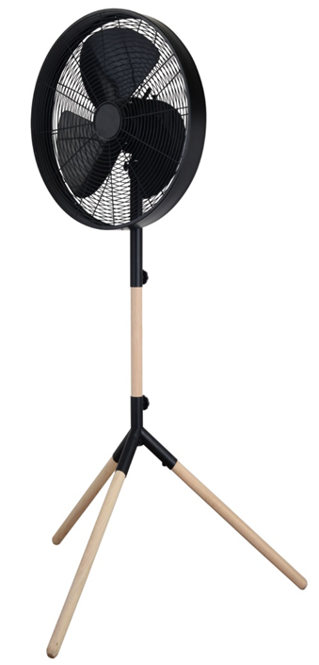

MODEL NO: RHMPF4

RUSSELL HOBBS METAL PEDESTAL FAN

Congratulations on purchasing our Russell Hobbs Pedestal Fan. Each unit is manufactured to ensure safety and reliability. Before using this appliance for the first time, please read the instruction manual carefully and keep it for future reference.

FEATURES OF THE RUSSELL HOBBS METAL PEDESTAL FAN

- 16” Metal pedestal fan
- 50W motor
- Matt black finish with wood accents
- Adjustable height
- Three speed settings
- Oscillating function
- Classic and elegant design
- Unique tripod stand
- For domestic use only

IMPORTANT SAFEGUARDS
When using any electrical appliance, basic safety precautions should always be followed including the following:
- Please read the instructions carefully before using any appliance.
- Use the fan only for purposes described in the instruction manual.
- Always ensure that the voltage on the rating label corresponds to the mains voltage in your home.
- Incorrect operation and improper use can damage the appliance and cause injury to the user.
- The appliance is intended for household use only. Commercial use invalidates the warranty and the supplier cannot be held responsible for injury or damage caused when using the appliance for any other purpose than that intended.
- This appliance is not intended for use by persons (including children) with reduced physical, sensory or mental capabilities, or lack of experience and knowledge, unless they have been given supervision or instruction concerning use of the appliance by a person responsible for their safety.
- Avoid any contact with moving parts.
- To reduce the risk of fire or electric shock, do not use this fan with any solid-state speed control device.
- Do not disassemble the appliance. There are no user serviceable parts inside.
- Do not immerse appliance in water or other liquids. Do not use near sinks, baths and showers
- This appliance uses natural untreated wood. Do not allow the wood to get wet as this can cause the wood to deteriorate, stain, develop mould or fungus. Keep the wood away from any heat source as it is a flammable material.
- Appliance should not be used outdoors, placed near a hot gas, electrical burner or placed in a heated oven
- Do not block any ventilation openings.
- Turn off and unplug before cleaning or storing.
- No liability can be accepted for any damage caused by non-compliance with these instructions or any other improper use or mishandling of appliance.
- To protect against electrical shock, do not immerse the fan, plug or cord in water or any other liquid or spray with liquids.
- Children should be supervised to ensure that they do not play with the appliance
- Close supervision is required when any appliance is used near or by children, pets and invalids.
- Check the power cord and plug regularly for any damage. If the cord or the plug is damaged, it must be replaced by the manufacturer or a qualified person in order to avoid an electrical hazard.
- Do not operate the fan in the presence of explosive and/or flammable fumes.
- Do not use the appliance if it has been dropped or damaged in any way. In case of damage, take the unit in for examination and/or repair by an authorised service agent
- To reduce the risk of electric shock, do not immerse or expose the motor assembly, plug or the power cord to water or any other liquid.
- Place the fan on a dry level surface
- Do not hang or mount fan on a wall or ceiling
- Remove the plug from the socket by gripping the plug. Do not pull on the cord to disconnect the appliance from the mains. Always unplug the fan when not in use, before cleaning or when adding or removing parts.
- This fan should not be placed in a damp place or where there is high humidity, such as a bathroom.
- Do not allow the cord to touch hot surfaces and do not place on or near a hot gas or electric burner or in a heated oven.
- DO NOT carry the appliance by the power cord.

- In case of technical problems, switch off the machine and do not attempt to repair it yourself. Return the appliance to an authorised service facility for examination, adjustment or repair. Always insist on the use of original spare parts. Failure to comply with the above mentioned pre-cautions and instructions, could affect the safe operation of this machine.
- The fan should be placed on a flat and stable surface when operating to avoid overturning

1. Fan assembly

2. Tilt Range Screw
3. Tilt Adjustment Knob
4. Height Adjustment Knob
5. Leg / Post Coupling
6. Grub Screws (3 off)
7. Oscillating Knob
8. On / Off / Speed Knob
9. Tilt Range Knob
10. Tilt Adjustment Bolt
11. Height Adjustment Slot
12. Wooden Post
13. Post Securing Knob
14. Wooden Legs
PARTS DIAGRAM

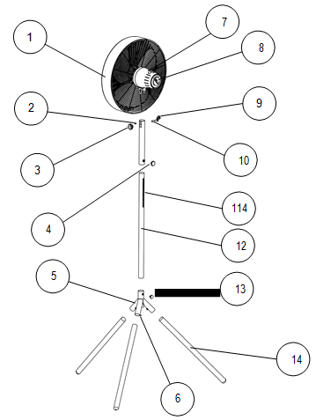

Assembly Instructions

The fan has been packaged unassembled to minimise packaging waste.

Each part is designed to fit together and be disassembled easily for cleaning or storage. To assemble you will need a screw driver and the supplied Allen key.
Start with the tripod leg assembly as follows:

Using the Allen key, unscrew all three grub screws from the leg/post coupling until they are sticking out approximately 4mm from the top of the nuts as shown below.
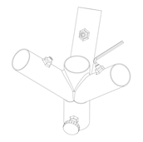
Whilst holding the leg / post coupling upside down, take a wooden leg and insert the flat end into one of the leg tubes and push down all the way as shown below. Using the Allen key, tighten the grub screw until it is firm and holding the wooden leg in place
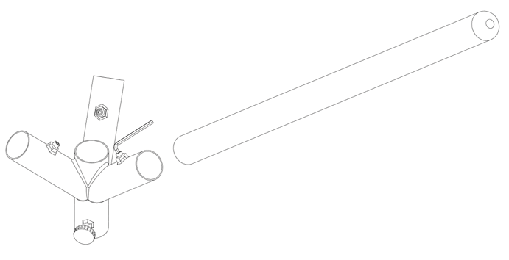
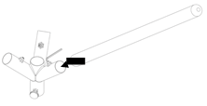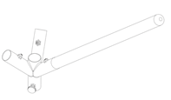
Repeat the steps above for the remaining two legs and then rotate the tripod over and stand on its three legs.
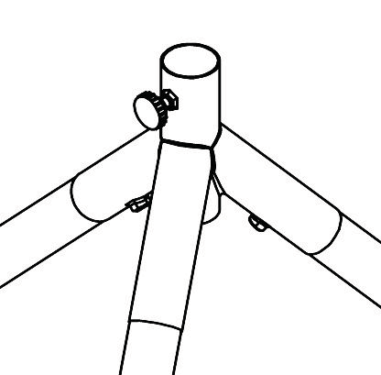
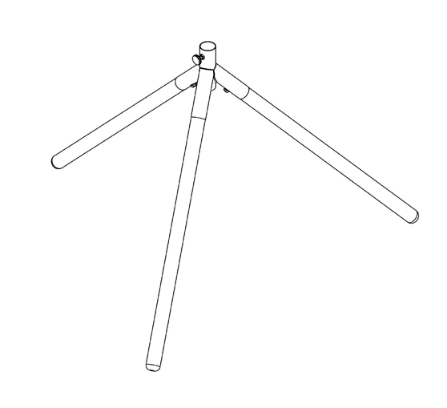
Loosen the post securing knob by turning it anti-clockwise and remove it.

Insert the wooden post into the top of the tripod
Ensure the slot is at the top and the small hole in the side at the bottom of the wooden post is aligned with the post securing knob as shown and then push all the way down.
This is very important as it ensures the head of the fan is positioned over a leg for maximum stability.

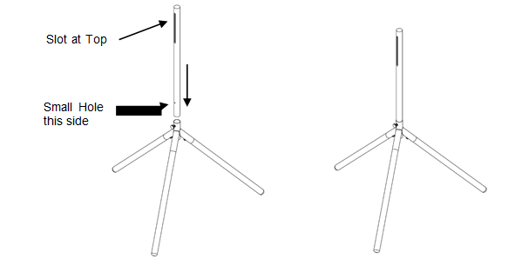

Tighten the post securing knob clockwise into the hole in the side of the post until fully secure.
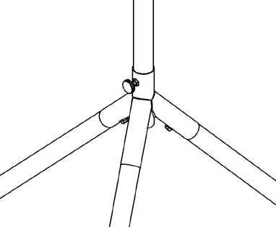

The next step is to assemble the post / adjustable fan head mount to the wooden post.
First, remove the tilt range knob by unscrewing it and slide the tilt adjustment bolt out as shown below.

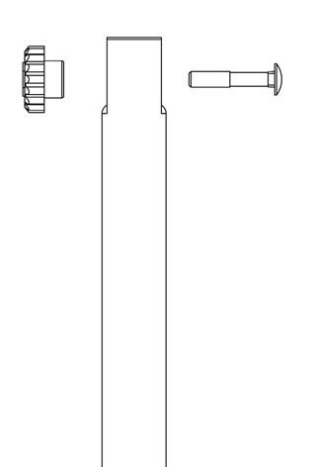
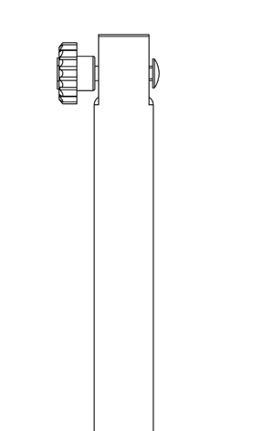

Next, loosen the height adjustment knob by turning it anti-clockwise and then slide it over the wooden post as shown below.

NOTE: Ensure the height adjustment knob is on the side where the slot is located in the wooden post.
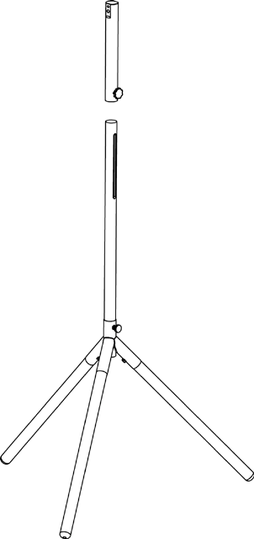
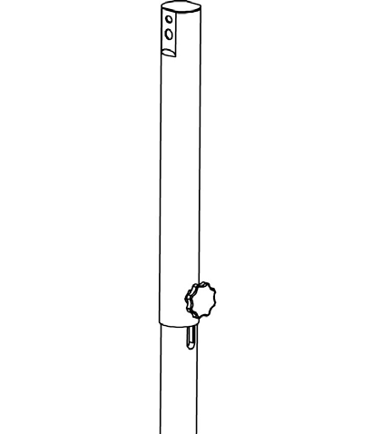

Turn the height adjustment knob clockwise so that the screw thread is located inside the slot.
Allow the assembly to slide down to the bottom of the slot and then fully tighten the height adjustment knob.
Using a screwdriver remove the small tilt range screw from the coupling bracket on the fan neck and then unscrew the small tilt range knob.
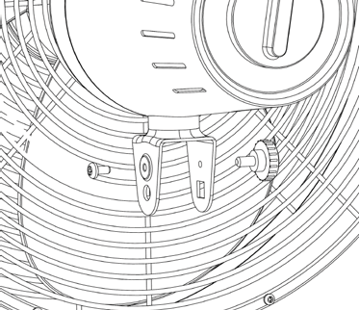
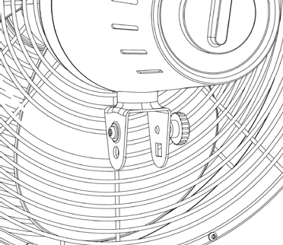

NOTE: It is important that the post and fan head are in the correct orientation when assembled.
The top section of the post has a small horizontal open slot one side and a small horizontal depression on the other as shown
The side with the open slot is for the small tilt range screw to screw into
The side with the small depression is for the tilt range knob to tighten up onto.
Take the head assembly and position the matching neck section over the post end as shown.
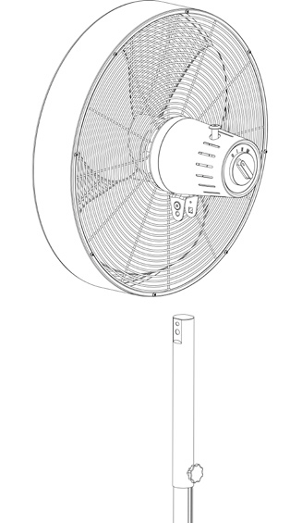
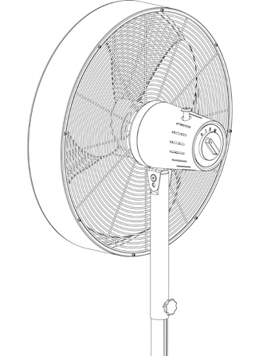

NOTE: The following assembly order is important.
Slide the tilt adjustment bolt all the way through as shown.
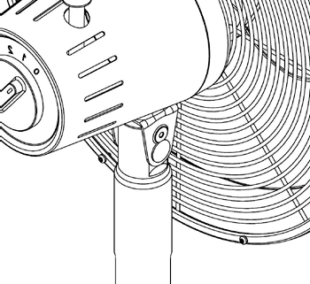
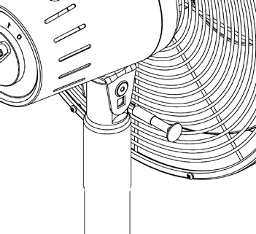

Screw in the tilt range knob as shown and just nip it up.
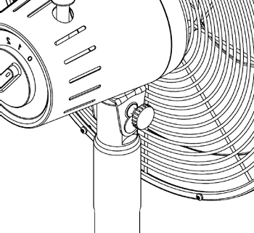
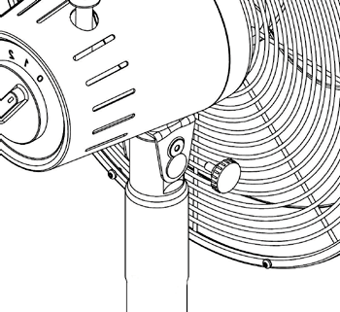

Using a screwdriver, screw in the small tilt range screw and tighten it.
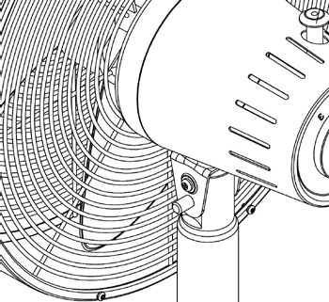
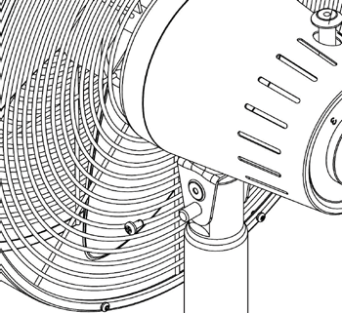

Next, screw on the tilt adjustment knob as shown and just nip it up.
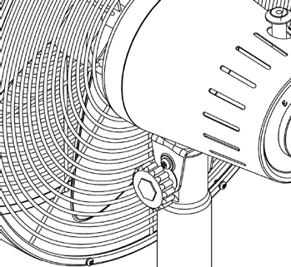
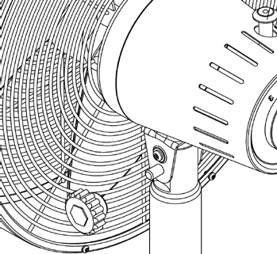

OPERATING INSTRUCTIONS
Remove the cable tie and unravel the cord set before operation.

Head Tilt
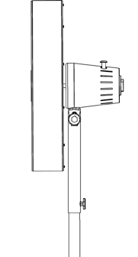

The fan and motor assembly can be tilted up and down to your desired angle.
To adjust the tilt angle, loosen both the larger tilt adjustment knob and the smaller tilt range knob, then tilt the head to the desired angle and then re-tighten the knobs tight.
To adjust the height of the fan head, loosen the height adjustment knob enough to allow the head to slide up and down the wooden post (within the slot).
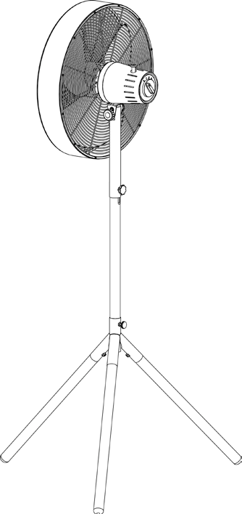
When at your desired height, tighten the height adjustment knob securely.

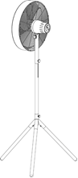
Fan On / Off / Speed
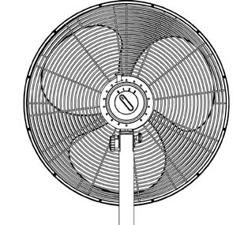
Rotate the knob located on the rear of the motor housing to position I for a low speed, II for a medium speed and III for a high speed.
Rotate the knob to position 0 to switch the fan off.

Oscillation
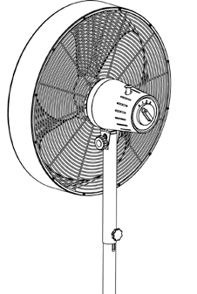

Press the clutch knob down to activate the oscillating function. The fan head will swing from side to side whilst blowing air.
To stop oscillation, allow the fan head to move into the desired position and then pull the clutch knob up.

CLEANING AND MAINTANANCE
- Turn off and unplug the unit prior to cleaning.
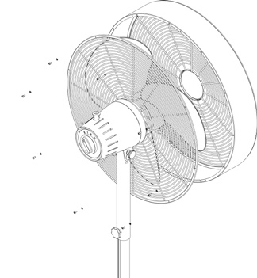
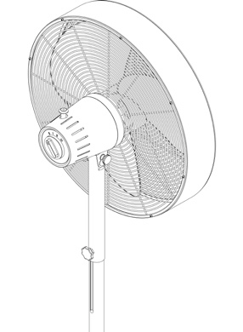
- To clean the blade and grille assembly, first remove the front grille / cowl assembly by unscrewing the small screws around the edge of the rear safety grille.

- Never spray with liquids or submerge the fan in water or any other liquid.
- Do not use flammable liquids, chemicals, abrasive creams, steel wool or scouring pads for cleaning.
- Clean the motor housing and body assembly with a clean, damp cloth and wipe dry.
- Refit the front grille/cowl assembly and ensure all the screws and washers are inserted and tightened properly

STORING THE APPLIANCE

- Unplug the unit from the wall outlet and clean all the parts as instructed above. Ensure that all parts are dry before storing.
- Store the appliance in its box or in a clean, dry place.
- Never store the appliance while it is still wet or dirty.

SERVICING THE APPLIANCE

There are no user serviceable parts in this appliance. If the unit is not operating correctly, please check the following:
- You have followed the instructions correctly
- That the unit has been wired correctly and that the wall socket is switched on.
- That the mains power supply is ON.
- That the plug is firmly in the mains socket.

If the appliance still does not work after checking the above:
- Consult the retailer for possible repair or replacement. If the retailer fails to resolve the problem and you need to return the appliance, make sure that:
- The unit is packed carefully back into its original packaging.
- Proof of purchase is attached.
- A reason is provided for why it is being returned.

If the supply cord is damaged, it must be replaced by the manufacturer or an authorised service agent, in order to avoid any hazard. If service becomes necessary within the warranty period, the appliance should be returned to an approved Home Of Living Brands (Pty) Limited service centre. Servicing outside the warranty period is still available, but will, however, be chargeable.

CHANGING THE PLUG
Should the need arise to change the fitted plug, follow the instructions below.
This unit is designed to operate on the stated current only. Connecting to other power sources may damage the appliance.

Connect a three-pin plug as follows:

The wires in this mains lead are coloured in accordance with the following code:

Green/Yellow = Earth
Blue = Neutral
Brown = Live

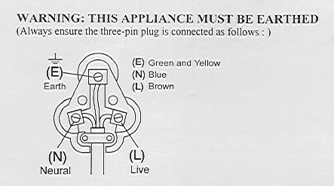

PLEASE AFFIX YOUR PROOF OF PURCHASE/RECEIPT HERE
IN THE EVENT OF A CLAIM UNDER WARRANTY THIS RECEIPT MUST BE PRODUCED.

W A R R A N T Y

- Home Of Living Brands (Pty) Limited warrants to the original purchaser of this product (“the customer”) that this product will be free of defects in quality and workmanship which under normal personal, family or household use and purpose may manifest within a period of 1 (one) year from the date of purchase (“warranty period”).
- Where the customer has purchased a product and it breaks, is defective or does not work properly for the intended purpose, the customer must notify the supplier from whom the customer bought the product (“the supplier”) thereof within the warranty period. Any claim in terms of this warranty must be supported by a proof of purchase. If proof of purchase is not available, then repair, and/or service charges may be payable by the customer to the supplier.
- The faulty product must be taken to the supplier's service center to exercise the warranty.
- The supplier will refund, repair or exchange the product in terms of this warranty subject to legislative requirements. This warranty shall be valid only where the customer has not broken the product himself, or used the product for something that it is not supposed to be used for. The warranty does not include and will not be construed to cover products damaged as a result of disaster, misuse, tamper, abuse or any unauthorized modification or repair of the product.
- This warranty will extend only to the product provided at the date of the purchase and not to any expendables attached or installed by the customer.
- If the customer requests that the supplier repairs the product and the product breaks or fails to work properly within 3 (three) months of the repair and not as a result of misuse, tampering or modification by or on behalf of the customer, then the supplier may replace the product or pay a refund to the customer.
- The customer may be responsible for certain costs where products returned are not in the original packaging, or if the packaging is damaged. This will be deducted from any refund paid to the customer.

HOME OF LIVING BRANDS (PTY) LTD
www.homeoflivingbrands.com
011 490-9600 (Jhb)
031 303-1163 (Dbn)
021 552-5161 (CT)
www.russellhobbs.co.za
www.facebook.com/RussellHobbsSA

