INSTRUCTIONS AND WARRANTY

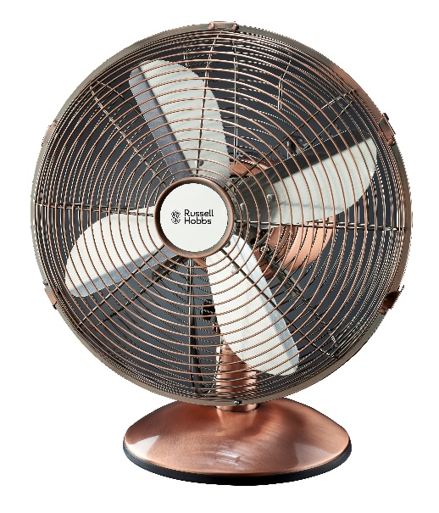

MODEL NO. RHDF12

Russell Hobbs 30cm Desk Fan

SAFETY PRECAUTIONS

When using any electrical appliance, basic safety precautions should always be followed, including the following:

1. Read all instructions and keep for future reference.

2. This appliance is not intended for use by persons (including children) with reduced physical, sensory or mental capabilities, or lack of experience and knowledge. Unless they are under supervision or given instructions concerning the use of the appliance by a person responsible for their safety.

3. Young children should be supervised to ensure that they do not play with the appliance.

4. Always unplug the appliance from the socket when not in use.

5. To disconnect the appliance, switch the control to OFF, then unplug from the socket.

6. To unplug the appliance, always grasp the plug; do not pull the cord.

7. If the supply cord is damaged it must be replaced by the manufacturer, it’s service agent or a similarly qualified person in order to avoid any hazard.

8. Do not use outdoors. This appliance is designed for household use only.

9. Keep the power cable away from areas where people walk so that it cannot be stepped on or tripped over.

10. Always use the appliance on a flat, stable surface.

11. Never clean this appliance when it is plugged in. Do not immerse it in water, clean the outside surface with a damp cloth or soft brush and dry with a soft dry cloth.

12. Use the appliance only as directed in this manual. Misuse could void your warranty.

13. Avoid contact with moving parts, never insert any objects through the grill when the fan is in operation.
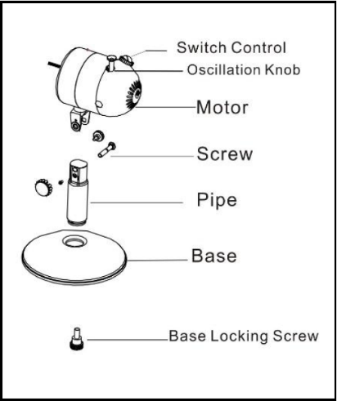
ASSEMBLY INSTRUCTIONS:

Body Assemble
- Unscrew the Base Locking Screw from the Pipe.
- Insert the Pipe through the hole in the center of the Base
and twist into position.
- Tighten the Base with the Base Locking Screw.
4. Unscrew the Locking Nut (Screw) from the Fan Head.
- Put the Fan Head into the Pipe and use the
Screw to tighten the Fan Head and the Pipe

Fan Grill Assemble
- Turn the Screw clockwise to tighten Rear Grill and the Motor firmly.
- Install the Blade onto the Motor Shaft by tightening the blade screw.
- Centre the Front Grill by aligning the logo on the grill Hub so it is horizontal and parallel to the floor. Then secure the Front and Rear Grills completely together by snapping grill clips into place. Lastly, tighten the grill locking screw at the bottom of the Rear Grill.
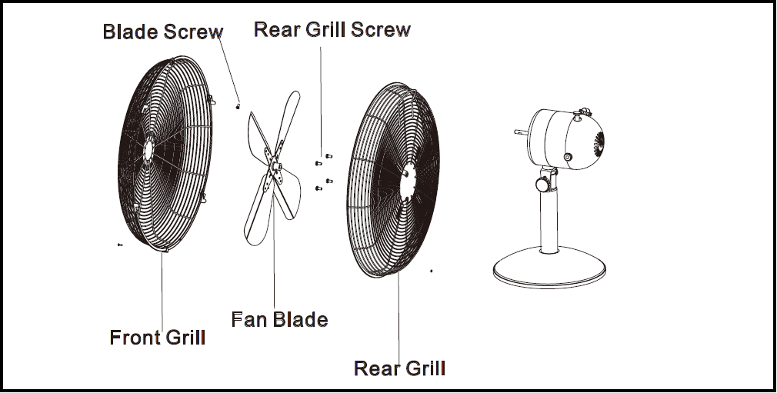

OPERATING INSTRUCTIONS
Ensure voltage used corresponds with the voltage indicated.
a) Use the switch control to select the speed.
b) Never touch the blades with hand or any object!
c) Do not pull the cord. If the cord or plug gets damaged, it must be checked by a qualified repairer before further use.
CLEANING AND MAINTENANCE INSTRUCTIONS:
To clean: Disconnect the power cord from the socket. Remove the guard and the blades carefully. Do not drop the blades! First use soft cloth with light soap to clean off oil stains. Then wipe and polish with dry cloth. Never use polish or any corrosive liquid that will damage the paint, metal or plastic! Put back the blades and lock the guard securely before use.

WARNING: Unplug from electrical supply source before cleaning. After servicing, any safety device (including grills and blades) must be reinstalled or remounted as previously installed. Use soft damp cloth then wipe with dry cloth. Do not use harmful cleaners. Do not bend the blades.

If the plug and supply cord is damaged, it must be replaced by the manufacturer, it’s service agent or a suitable qualified person in order to avoid any hazard.
The appliance is not intended for use by persons (including children) with reduced physical, sensory or mental capabilities, or lack of experience and knowledge, unless they are under supervision or given instructions concerning use of the appliance by a person responsible for their safety

Technical Specifications
Power Supply: AC 220-240V ~ 50Hz
Power Consumption: 35W
NOTE: As a result of continual improvements, the design and specifications of the product within may differ slightly to the unit illustrated on the packaging.
PLEASE AFFIX YOUR PROOF OF PURCHASE/RECEIPT HERE
IN THE EVENT OF A CLAIM UNDER WARRANTY THIS RECEIPT MUST BE PRODUCED.
2 YEAR WARRANTY
1 year retail ⵏ 1 year extended
warranty upon registration*
visit www.russellhobbs.co.za

WARRANTY AND EXTENDED WARRANTY
- Home of Living Brands (Pty) Limited ("Home of Living Brands ") warrants to the original purchaser of this product ("the customer") that this product will be free of defects in quality and workmanship which under normal personal, family or household use and purpose may manifest within a period of 1 (one) year from the date of purchase ("warranty period").
- Home of Living Brands shall extend the warranty period for a further period of 1 (one) year (“extended warranty period”), on condition that the purchaser registers the product on the website, within 12 months from the date of purchase of the product. The website address for registration is as follows: http://russellhobbs.co.za/info-pages/warranty-info.aspx. The extended warranty period only applies to products purchased on or after 1 October 2017.
- Where the customer has purchased a product and it breaks, is defective or does not work properly for the intended purpose, the customer must notify the supplier from whom the customer bought the product ("the supplier") thereof within the warranty period or if applicable, the extended warranty period. Any claim in terms of this warranty must be supported by a proof of purchase. If proof of purchase is not available, then repair, and/or service charges may be payable by the customer to the supplier.
- The faulty product must be taken to the supplier's service centre to exercise the warranty.
- The supplier will refund, repair or exchange the product in terms of this warranty subject to legislative requirements. This warranty shall be valid only where the customer has not broken the product themselves or used the product for something that it is not supposed to be used for. The warranty does not include and will not be construed to cover products damaged as a result of disaster, misuse, tamper, abuse or any unauthorised modification or repair of the product.
- This warranty will extend only to the product provided at the date of the purchase and not to any expendables attached or installed by the customer.
- If the customer requests that the supplier repairs the product and the product breaks or fails to work properly within 3 (three) months of the repair and not as a result of misuse, tampering or modification by or on behalf of the customer, then the supplier may replace the product or pay a refund to the customer, subject to the supplier’s discretion.
- The customer may be responsible for certain costs where products returned are not in the original packaging, or if the packaging is damaged. This will be deducted from any refund paid to the customer.
HOME OF LIVING BRANDS (PTY) LTD (JOHANNESBURG)
JOHANNESBURG TEL NO. (011) 490 9600
CAPE TOWN TEL NO. (021) 552 5161
DURBAN TEL NO. (031) 303 1163
www.homeoflivingbrands.co.za
www.russellhobbs.co.za
www.facebook.com/RussellHobbsSA

