

**INSTRUCTIONS AND WARRANTY**

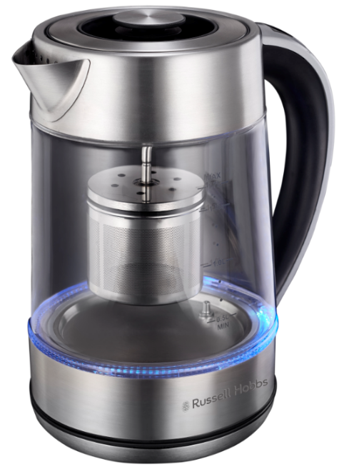

**RHGDGK**

# RUSSELL HOBBS

# 2 IN 1 DIGITAL GLASS KETTLE

Congratulations on purchasing our Russell Hobbs 2 in 1 digital glass kettle. Each unit is manufactured to ensure safety and reliability. Before using this appliance for the first time, please read the instruction manual carefully and keep it for future reference.

**FEATURES OF THE RUSSELL HOBBS 2 IN 1 DIGITAL GLASS KETTLE:**

* 2200W
* 1.7L capacity
* 2 in 1: Tea maker and traditional water kettle
* 360 Degree cordless base
* Digital control handle with variable temperature settings for different kinds of tea
* Variable temperature control from 40℃ to 95℃
* Keep warm function at desired temperature for up to 60min; 40℃ to 95℃
* Removable tea infuser
* Water level indicator
* Strix controller
* Illuminating light indicator
* Automatic Switch-off
* Boil-dry protection
* For domestic use only
* 2 Year warranty

## IMPORTANT SAFEGUARDS

* When using any electrical appliance, basic safety precautions should always be followed including the following:

1. Please read the instructions carefully before using any appliance.
2. Always ensure that the voltage on the rating label corresponds to the mains voltage in your home.
3. Incorrect operation and improper use can damage the appliance and cause injury to the user.
4. The appliance is intended for household use only. Commercial use invalidates the warranty and the supplier can not be held responsible for injury or damage caused when using the appliance for any other purpose than that intended.
5. This appliance is intended to be used in household and similar applications such as:
   1. Staff kitchen areas in shops, offices and other working environments
   2. Farm houses
   3. By clients in hotels, motels and other residential type environments
   4. Bed and breakfast type environments
6. Avoid any contact with moving parts.
7. This appliance is not intended for use by persons (including children) with reduced physical, sensory or mental capabilities, or lack of experience and knowledge, unless they have been given supervision or instruction concerning use of the appliance by a person responsible for their safety**.**
8. Children should be supervised to ensure that they do not play with the appliance.
9. Check the power cord and plug regularly for any damage. If the cord or the plug is damaged, it must be replaced by the manufacturer or a qualified person in order to avoid an electrical hazard.
10. Do not use the appliance if it has been dropped or damaged in any way. In case of damage, take the unit in for examination and/or repair by an authorised service agent.
11. Do not open the lid while the kettle is in use.
12. Only fill the kettle with cold water. Do not fill the kettle above the MAX level (1.7L). Boiling water may splash out if overfilled.
13. Do not insert any objects into holes or slots in this appliance.
14. To reduce the risk of electric shock, do not immerse or expose the electrical base element/controller of the kettle, the plug or the power cord to water or any other liquid.
15. Never immerse the unit in water or any other liquid for cleaning purposes. Do not allow liquid to penetrate the electrical parts of this kettle.
16. Remove the plug from the socket by gripping the plug. Do not pull on the cord to disconnect the appliance from the mains. Always unplug the unit when not in use before cleaning or when adding or removing parts.
17. The use of accessory attachments that are not recommended or supplied by the manufacturer may result in injuries, fire or electric shock.
18. The kettle is only to be used with the base provided.
19. A short cord is provided to reduce the hazards resulting from becoming entangled in or tripping over a longer cord.
20. Do not let the cord hang over the edge of a table or counter. Ensure that the cord is not in a position where it can be pulled on inadvertently.
21. Do not allow the cord to touch hot surfaces and do not place on or near a hot gas or electric burner or in a heated oven.
22. Cleaning and user maintenance shall not be made by children unless they are older than 12 years and supervised. Keep the appliance and its cord away from reach of children.
23. Keep the device and the cable away from heat, direct sunlight, moisture & sharp edges.
24. Do not use the appliance on a gas or electric cooking top or over or near an open flame.
25. Use of an extension cord with this appliance is not recommended. However, if it is necessary to use an extension lead, ensure that the lead is suited to the power consumption of the appliance to avoid overheating of the extension cord, appliance or plug point. Remember to not place the extension cord in a position where it can be pulled on by children or animals or tripped over.
26. This appliance is not suitable for outdoor use. Do not use this appliance for anything other than its intended use.
27. DO NOT carry the appliance by the power cord.
28. Do not leave the appliance unattended during use. Always unplug the unit when not in use or before cleaning and allow it to cool down completely before cleaning.
29. Always operate the appliance on a smooth, even, stable surface. Do not place the unit on a hot surface.
30. Ensure that the switch is in the “Off” position after each use.
31. The manufacturer does not accept responsibility for any damage or injury caused by improper or incorrect use, or for repairs carried out by unauthorised personnel.
32. In case of technical problems, switch off the machine and do not attempt to repair it yourself. Return the appliance to an authorised service facility for examination, adjustment or repair. Always insist on the use of original spare parts. Failure to comply with the above-mentioned pre-cautions and instructions could affect the safe operation of this machine.
33. Do not touch hot surfaces. Use the kettle handle.
34. Check that the lid is fully closed before switching the kettle on - otherwise it may not switch off.
35. Check the kettle is properly located on the base before switching on.
36. Do not switch on unless the kettle contains at least 2 cups of water.
37. This kettle is intended for boiling water only.

**Note:** Do not use it to heat up milk, soup or any other liquids.

1. Disconnect the power supply if something unusual occurs during boiling.
2. Remove the kettle from its base before filling or pouring.
3. This appliance must not be operated by an external timer or remote-control system.

**PARTS DIAGRAM**

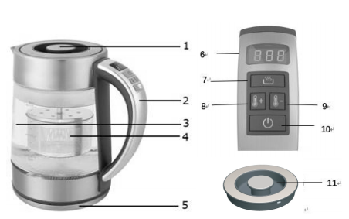

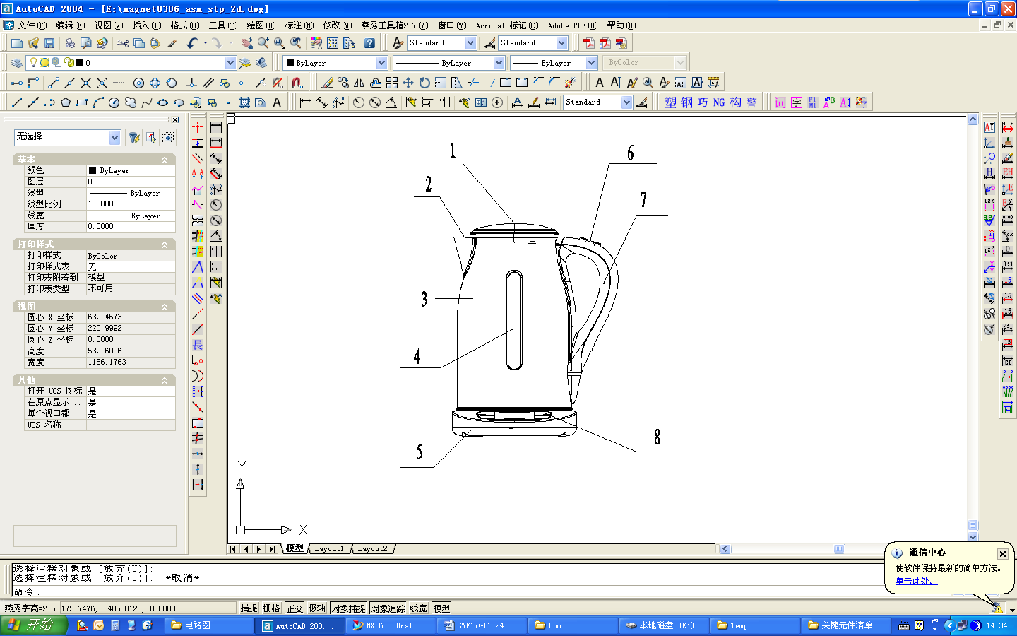(1) Tea infuser Lid

(2) Handle

(3) Glass kettle body

(4) Tea basket/infuser

(5) Power base

(6) LED display

(7) Keep warm function button (]Y{XM@ZLCB5R[}I3Y2@E8M

(8) Temperature adjustment button (up) 

(9) Temperature adjustment button (down) 

(10) Start heating(On) button /cancel heating(Off) button 

(11) Kettle lid

**Note:** Min / Max capacity **0.5L / 1.7L** for boiling water

Min / Max capacity **0.5L / 1.5L** for making tea

**USING THE KETTLE FOR THE FIRST TIME**

**/**

Take the appliance out of the box and take off any protective wrappings.

**REMEMBER: DO NOT LEAVE PROTECTIVE PACKAGING LYING AROUND, AS IT COULD BE DANGEROUS AROUND INFANTS.** Wipe the body with a slightly dampened cloth. DO NOT allow any liquid to touch the motor body.

**OPERATING INSTRUCTIONS**

Before first use, fill the kettle with cold water to the MAX water level mark, bring to boil and discard the boiling water – do this twice. This will ensure that any residues left over from the manufacturing process are completely removed.

**USING THE KETTLE**

* Position the power base/stand on a dry flat surface away from any potential heat source.
* Ensure the mains cable does not hang over the work surface edge.
* Open the lid and pour in a sufficient amount of water. Remember to keep the water level above the MIN level, but not exceeding the MAX level.

**NOTE: Always fill the Kettle between the minimum (0.5L) and maximum (1.7L) mark. Too little water will result in the Kettle switching off due to the safety boil-dry protection. Filling above the maximum mark (MAX) may result in boiling water splashing from the kettle.**

Close the lid and place the kettle on the power base/stand.

**Note: the kettle must always be used with the power base provided.**

Insert the plug into a power outlet and switch on. The LED light will illuminate.

**To Boil Water:**

To fill water into the kettle, remove it from the power base (5) and open the lid by lifting it, fill the kettle with the desired amount of water. **Always fill the kettle between the minimum (0.5L) and maximum (1.7L) marks. Too little water will result in the kettle switching off before the water has boiled.**

**NOTE:** Do not fill the water over the maximum level, as the water may spill out of the spout when boiling. Ensure that the lid is firmly in place before connecting the mains power cable to the mains power socket.

1. Position the kettle on the power base.
2. Connect the plug into a mains power socket. The display turns on for a moment, all buttons and indicator lights will illuminate, which means that the base is connected to the power source and the kettle is placed on the base.
3. Close the lid and place the kettle on the power base (5), the display turns on and the ON/OFF (10) }~Q{)VP`B%9D8]9$`UR8{4L will start to flash blue. On the display you will see the current water temperature which will be visible for about 5 seconds. If you do not perform any actions, the kettle turns off automatically, the ON/OFF button (10) }~Q{)VP`B%9D8]9$`UR8{4L stays blue.
4. Press the ON/OFF button (10) }~Q{)VP`B%9D8]9$`UR8{4L without setting other functions. The kettle turns on, and the ON/OFF button will illuminate red. The kettle boils water up to 100°C, then switches off automatically.
5. If you just want to heat up the water, use the boiling temperature buttons 8  or 9 . Press once to change the temperature. The temperature setting will be shown on the display. You may select between the predefined temperature settings: from 40°C up to 100°C, 5°C for each press. After setting the temperature, then press the ON/OFF button (10) }~Q{)VP`B%9D8]9$`UR8{4L (will illuminate to red) to start heating. If the temperature set is lower than the temperature of water in the kettle, the kettle will enter into standby mode (no heating).
6. After reaching the desired temperature of water, the kettle switches off.
7. If you want to select the keep-warm function, press the button (7) (]Y{XM@ZLCB5R[}I3Y2@E8M, the keep-warm button illuminate light will keep flashing. In this mode press the button  or  to set the desired temperature. The temperature adjustment (increase and decrease) step is 5°C. Temperature control from 40°C to 95°C, increase or decrease by 5°C by pressing  or , increase or decrease by 10°C by pressing and hold  or .
8. The available range of temperature setting is from 40°C up to 100°C. In order to switch off the keep-warm function, press the keep-warm button (7) (]Y{XM@ZLCB5R[}I3Y2@E8M again. Otherwise the water temperature will be maintained at the pre-set level. If no action is taken for 60 minutes under the keep-warm mode, the kettle will switch off. Press the ON/OFF button (10) }~Q{)VP`B%9D8]9$`UR8{4L again to turn on the kettle.
9. Lift the kettle from the power base and then pour out the water.

**NOTE:** Operate crefully when pouring the water from your kettle as boiling water may result in scalding, Don’t open the lid while the water in the kettle is hot. Ensure that the mains power supply is turned off when the kettle is not in use. The kettle may be stored on the power base when not in use.

**VARIABLE TEMPERATURE SETTINGS**

* Temperature control from 40°C to 100°C, increase or decrease each 5°C by press  or , increase or decrease each 10°C by press and hold  or 
* Keep warm from 40°C to 95°C
* Keep warm for 60 minutes
* Two lids included, lid (11) for normal use, and lid (1) with tea basket for brewing your favorite tea.
* If you are using tea leaves for your brewing cycle, simply add them into tea basket (4).
* Attached the tea basket back onto the lid (1) by turning anti-clockwise

**NOTE:** Please ensure you only use the power base supplied with the kettle.

**Optimum Temperatures for Tea/Coffee**

The general guide on water temperature is as follows;

* Black Teas, Herbal Infusions (including Rooibos), Fruit Infusions **100° C**
* Green Teas **70° -80° C**
* Oolong’s **85° -90° C**
* White Tea **70° -75° C**

**Note:** that the guide (link provided below) refers to steep times for specific teas, this refers to the amount of time the tea leaves stay in contact with the water, very important for the more delicate teas such as White & Green. If these times are exceeded the result will be a more bitter tea, the same result if the water temperature is to high.

Please note that his kettle is not suitable to make filter coffee, either using a filter cone, siphon or aeropres.

Source, for more information please go to; [https://www.peacockteaandcoffee.co.za/tea-brewing/](https://protect-za.mimecast.com/s/dIlYCmwkmpT5JLDptGz0lm)



[www.peacock.co.za](https://protect-za.mimecast.com/s/SjJgCqjoq0FO0pYAuXamXZ)

**Other ideal tempratures:**

Blends for babies **40 - 60°C**

Instant coffee **90°C**

**Boil-Dry Protection**

The Kettle is fitted with a boil-dry protection safety function, which protects the Kettle against overheating should the appliance be operated with insufficient water. If this should occur and the boil-dry protection is activated, you will need to let the Kettle cool down for at least 10 minutes before it will work again.

Please ensure that you add water to the Kettle before proceeding.

**CAUTION:** After the kettle has switched off it may need time to cool down. After 15-20 seconds, the kettle can be switched on again. If the kettle ever boils dry, allow 15 minutes to cool before refilling with cold water.

**Note:** do not add cold water to cool down the kettle faster – this will damage the kettle and decrease its lifespan.

**GENERAL**

* Always remove the kettle from the base before pouring.
* To avoid the risk of splashing, pour slowly and do not over-tilt the kettle.
* Do not tilt the kettle backwards - water might get on to the control area. If this happens, let the kettle dry thoroughly before use – place it somewhere cool for 12 hours.
* When you lift the kettle, you may see moisture on the base. Do not worry – it’s the steam used to switch the kettle off automatically, which then condenses and escapes via vents under the kettle.
* You may see some discolouration on the floor of the kettle. Again, do not worry – it is due to the bonding of the element to the kettle floor.

**CLEANING AND MAINTENANCE**

Before cleaning your kettle please unplug the kettle from mains power supply and make sure it has completely cooled down.

**Never immerse any part of the cable, plug, power cord base or kettle in water or any other liquid.**

**Exterior of the kettle**

* Wipe the exterior of the kettle with a piece of damp cloth and then dry it with a piece of dry cloth.
* Never use harsh chemicals or abrasive cleaning agents as these may damage the finish of your kettle.

**Interior of the kettle**

Depending on the water quality in your area, lime deposits may build up inside of your kettle.

**To remove lime deposits**

1. Half fill the kettle with water and add the citric acid (Lemon juice) or vinegar
2. Boil up the mixture and allow it to stand for 15 minutes before discarding.
3. Repeat steps 1 and 2 several times, please using cold water only.

We recommend that you descale your kettle regularly, even in soft water areas. Lime scale may be white, coloured, or even rusty-looking, but it is normally visible. Phosphate scale is not generally visible, but there is always a build-up, even in soft water areas. Any build-up of scale causes overheating, which reduces the life of the element, and may trigger the boil-dry cut-out to engage. So, even in a soft water area, descale at least monthly, to help keep your kettle in working order.

**DESCALING:**

* Use a descaler suitable for plastic products (all kettles have plastic parts). Follow the instructions on the descaler, then rinse several times, fill, boil and discard the water, to remove all chemical residues.
* Products returned under guarantee with faults related to scale will be subject to a repair charge.
* If you notice your kettle getting noisier – descale it.
* Do not rely on visible scale, as phosphate scale is not visible. Rather descale the kettle for preventative purposes.
* Do not try to move or remove the diffuser – you will break it.
* If a commercial descaler is not available, fill the kettle with enough white vinegar to cover the bottom by about 1.5cm. Bring the vinegar to a boil. You may need to repeat this several times with cooled vinegar to remove the calcium build-up completely. When the descaling process is complete, empty the kettle and rinse out several times with clean water.

**STORING THE APPLIANCE**

* Unplug the unit from the electrical outlet and clean all the parts as instructed above. Ensure that all parts are dry before storing.
* Store the appliance in its box or in a clean, dry place.
* Never store the appliance while it is still wet or dirty.
* Never wrap the power cord around the appliance.

**SERVICING THE APPLIANCE**

There are no user serviceable parts in this appliance. If the unit is not operating correctly, please check the following:

* You have followed the instructions correctly
* That the unit has been wired correctly and that the wall socket is switched on.
* That the mains power supply is ON.
* That the plug is firmly in the mains socket.

If the appliance still does not work after checking the above:

- Consult the retailer for possible repair or replacement. If the retailer fails to resolve the problem and you need to return the appliance, make sure that:

The unit is packed carefully back into its original packaging.

Proof of purchase is attached.

A reason is provided for why it is being returned.

If the supply cord is damaged, it must be replaced by the manufacturer or an authorised service agent, in order to avoid any hazard. If service becomes necessary within the warranty period, the appliance should be returned to an approved Home of Living Brands (Pty) Limited service centre. Servicing outside the warranty period is still available, but will, however, be chargeable.

**CHANGING THE PLUG**

Should the need arise to change the fitted plug, follow the instructions below.

**This unit is designed to operate on the stated current only. Connecting to other power sources may damage the appliance. Connect a three-pin plug as follows:**

The wires in this mains lead are coloured in accordance with the following code:

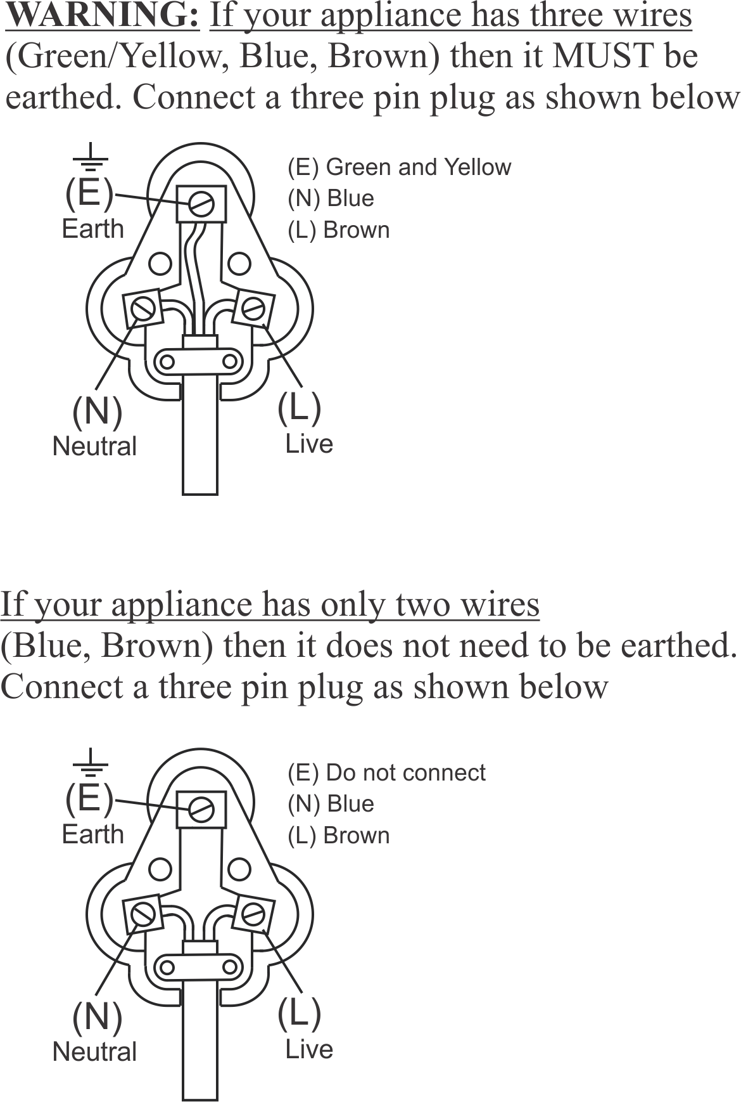



**PLEASE AFFIX YOUR PROOF OF PURCHASE/RECEIPT HERE**

**IN THE EVENT OF A CLAIM UNDER WARRANTY THIS RECEIPT MUST BE PRODUCED.**

***2 YEAR WARRANTY***

*1 year retail* ⵏ *1 year extended*

*warranty upon registration\**

*visit www.russellhobbs.co.za*

***W A R R A N T Y AND EXTENDED WARRANTY***

1. Home of Living Brands (Pty) Limited ("Home of Living Brands") warrants to the original purchaser of this product ("the customer") that this product will be free of defects in quality and workmanship which under normal personal, family or household use and purpose may manifest within a period of 1 (one) year from the date of purchase ("warranty period").
2. Home of Living Brands shall extend the warranty period for a further period of 1(one) year (“extended warranty period*”), on condition that the purchaser registers the product on the website, within 12 months from the date of purchase of the product. The website address for registration is as follows: http://russellhobbs.co.za/info-pages/warranty-info.aspx. The extended warranty period only applies to products purchased on or after 1 October 2017.
3. Where the customer has purchased a product and it breaks, is defective or does not work properly for the intended purpose, the customer must notify the supplier from whom the customer bought the product ("the supplier") thereof within the warranty period or if applicable, the extended warranty period. Any claim in terms of this warranty must be supported by a proof of purchase. If proof of purchase is not available, then repair, and/or service charges may be payable by the customer to the supplier.
4. The faulty product must be taken to the supplier's service centre to exercise the warranty.
5. The supplier will refund, repair or exchange the product in terms of this warranty subject to legislative requirements. This warranty shall be valid only where (a) the customer is not the cause of the product breaking, and (b) the product has been used for the intended purpose stipulated in the product manual. The warranty does not include and will not be construed to cover products damaged as a result of disaster, misuse, tamper, abuse or any unauthorised modification or repair of the product.
6. This warranty will extend only to the product provided at the date of the purchase and not to any expendables attached or installed by the customer. In this regard any accessories supplied with the product by the supplier, may be excluded in this warranty or extended warranty (see Exclusions to Warranty and Extended Warranty document).
7. If the customer requests that the supplier repairs the product and the product breaks or fails to work properly within 3 (three) months of the repair and not as a result of misuse, tampering or modification by or on behalf of the customer, then the supplier may replace the product or pay a refund to the customer, subject to the supplier’s discretion.
8. The customer may be responsible for certain costs where products returned are not in the original packaging, or if the packaging is damaged. This will be deducted from any refund paid to the customer.

HOME OF LIVING BRANDS (PTY) LTD (JOHANNESBURG)

JOHANNESBURG TEL NO. (011) 490-9600

CAPE TOWN TEL NO. (021) 552-5161

DURBAN TEL NO. (031) 303-1163

www.homeoflivingbrands.com

www.russellhobbs.co.za

www.facebook.com/RussellHobbsSA

**EXCLUSIONS TO W A R R A N T Y AND EXTENDED WARRANTY**

* Any accessories supplied with the product, including but not limited to, bowls, jugs, mills or carafes made either of glass or plastic and supplied with this appliance (hereinafter referred to as “the accessory or accessories”), is warranted to be free from material and workmanship defects for the duration of the appliance warranty.
* The accessories should give trouble free service when used in accordance with the directions described in the instruction manual. However, the accessories will be damaged if subjected to impact, and this damage is not covered by the warranty. Such impact damage can occur either from the outside (if for example it is dropped or knocked against a hard surface), or from within (if for example foreign objects are placed within the accessories and the power is switched on).
* Should you need to replace an accessory during the warranty period; a claim for a free replacement will only be considered if the item (including all shards and broken parts) is returned to the nearest HOLB service centre for examination.
* The remains of the accessory will be carefully examined by the relevant professionals and if it is determined (at the sole discretion of HOLB) that the damage was caused by impact, then the claim will be refused and will not be covered by the warranty or any extended warranty.
* Any replacement part provided in terms of clause 4 above will become a chargeable item payable by the customer.