

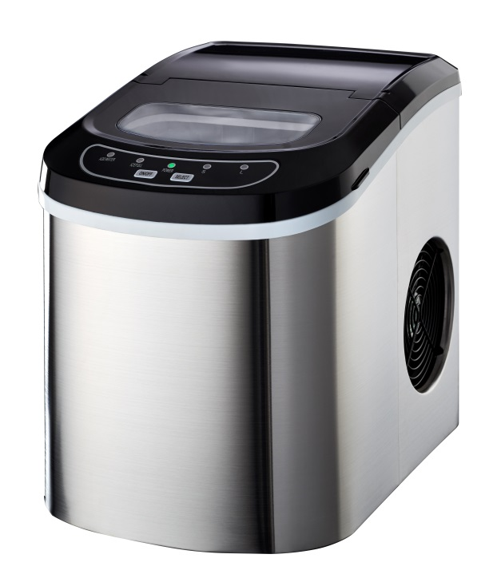

RHIM12

Russell Hobbs 12kg Ice Maker

**INSTRUCTION MANUAL**

It is important that you read these instructions before using your Russell Hobbs ice maker and

***TABLE OF CONTENTS***

we strongly recommend that you keep them in a safe place for future reference.

***IMPORTANT SAFETY INSTRUCTIONS***………………………………………………..….2

***PREPARING YOUR ICE MAKER FOR USE***

IMPORTANT SAFETY TIPS………………………………………………………………………3

***GETTING TO KNOW YOUR UNIT***………………………………………………………….5

***OPERATING PROCEDURES & MAINTENANCE***

UNPACKING YOUR ICE MAKER………………….……………………………………………..7

CONNECTING YOUR ICE MAKER……………….……….……………………………………..7

CLEANING AND MAINTAINING YOUR ICE MAKER….………………………………………….7

***USING YOUR ICE MAKER***……………….……..………………………………………….8

TROUBLESHOOTING…………………………….……………………………………………..8

***TECHNICAL PARAMETERS & CIRCUIT DIAGRAM***……………………..….………....9

***EXPLOSIVE DRAWINGS***……………………………………………………………………10

***Warranty Information****………………………………………………………………..*11

***TABLE OF CONTENTS***

**Your safety and the safety of others are extremely important.**

Always read and obey all safety massages.

This is the danger alert symbol:

**!**

All safety messages will follow the danger alert symbol and the word “DANGER” or “WARNING”.

***IMPORTANT SAFETY INSTRUCTIONS***

## DANGER

未命名

未命名

## WARNING

These words mean:

**You can be killed or seriously injured if you don’t follow the instructions immediately.**

All safety messages will tell you what the potential hazard is, tell you how to reduce the chance of injury and tell you what can happen if the instructions are not followed.

***PREPARING YOUR ICE MAKER FOR USE***

When using electrical appliances, basic safety precautions should be followed to reduce the risk of fire, electric shock, and injury to persons or property. Read all instructions before using any appliance.

* Do not operate this，or any other appliance with a damaged cord.

If the supply cord is damaged, it must be replaced by the manufacturer or its service agent or a similarly qualified person in order to avoid any hazard from occurring.

* This ice-maker must be positioned so that the plug is accessible.
* Connect to properly polarized outlets only. No other appliance should be plugged into the same outlet. Be sure that the plug is fully inserted into the socket.
* Do not run the power cord over carpeting or other heat insulators. Do not cover the cord. Keep cord away from traffic areas, and do not immerse in water.
* We do not recommend the use of an extension cord, as it may overheat and become a risk of fire. If you must use an extension cord, use No. 0.75mm2 minimum size and rated no less than 16A/250V~ with a plug.
* Unplug the ice maker before cleaning or making any repairs or servicing.
* Exercise caution and supervision when appliance is used near children.
* Do not use your ice-maker outdoors. Place the ice-maker away from direct sunlight and make sure that there is at least 10cm of space between the back of your unit and wall. Keep a minimum distance of 10cm on each side of your unit free.
* Do not use other liquids to make the ice-cubes other than water.
* Do not clean your ice maker with flammable fluids. The fumes can create a fire hazard or explosion.
* Do not tip over.
* If the ice maker is brought in from outside in wintertime, give it a few hours to warm up to room temperature before plugging it in.
* This appliance is not intended for use by persons (including children) with reduced physical, sensory or mental capabilities, or lack of experience and knowledge, unless they are under supervision or instruction concerning use of the appliance by a person responsible for their safety.
* Children should be supervised to ensure that they do not play with the appliance.
* According to local regulations regarding disposal of the appliance for its flammable blowing gas. Please ensure that the doors are removed to prevent children from being trapped inside the appliance.

**WARNING**: This appliance must be earthed.

**IMPORTANT**:

The wires in this mains lead are colored in accordance with the following code:

Green or Green with a stripe of Yellow: Grounding

Blue: Neutral

Brown: Live

To avoid any hazard due to instability of the appliance, it must be placed on an even or flat surface.

***GETTING TO KNOW YOUR UNIT***

1. Ice scoop.

2. Ice full sensor

3. Ice basket

4. Top cover with transparent window

5. Air outlet

6. Water drain cap: at the front bottom side of the unit.

7. MAXIMUM WATER LEVEL: ▲

*Note: Remove the ice basket so you can see the water level mark.*



**Position of control panel & function**

**Control Panel**: Easy to use, visible functions and touch display setting.

A. Select ice size as displayed: Small or Large.

B. Power indicator

C. Ice-Full indicator

D .Water shortage indicator

E. Button to turn on/off the unit.

F. Button to select ice cube size.

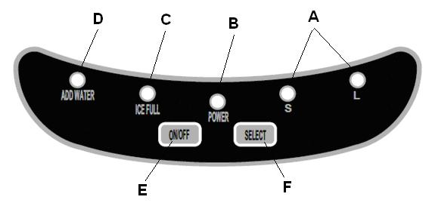



***OPERATING PROCEDURES & MAINTENANCE***

**UNPACKING YOUR ICE MAKER**

1. Remove the exterior and interior packaging. Check if ice basket and ice scoop are inside. If any parts are missing, please contact our customer service centre.
2. Remove the tapes from the ice shovel, ice basket & ice scoop. Clean the tank & ice basket.
3. Put the ice maker on a level surface or flat counter top without exposure to direct sunlight and other sources of heat (i.e.: stove, furnace, radiator). Make sure that there is at least 10cm gap between the back & LH/RH sides with the wall.
4. Allow one hour for the refrigerant fluid to settle before plugging the ice maker in.
5. The appliance must be positioned so that the plug is accessible.

**WARNING: fill ice maker with potable water only. Only use drinking water.**

**未命名**

## DANGER

**\* Improper use of the grounded plug can result in the risk of electrical shock. If the power cord is damaged please call our customer service centre.**

**CONNECTING YOUR ICE MAKER**

1. This unit should be properly grounded for your safety. The power cord of this appliance is equipped with a grounding plug which is in accordance with standard grounding wall outlets to minimize the possibility of electric shock.
2. Plug your appliance into an exclusive, properly installed grounding wall outlet. Do not under any circumstances damage the grounding means of the plug. Any questions concerning power and/or grounding should be directed toward a certified electrician.
3. This appliance requires a standard 220-240Volt, 50Hz electrical outlet with good grounding means.

**CLEANING AND MAINTAINING YOUR ICE MAKER**

Before using your ice maker, it is strongly recommended to clean it thoroughly.

1. Take out the ice basket.
2. Clean the interior with diluted detergent, warm water and a soft cloth.
3. Then use the water to rinse the inside parts, and drain out the water by unplugging the drain cap at the front bottom side of the appliance.
4. The outside of the ice maker should be cleaned regularly with a mild detergent solution and warm water.
5. Dry the interior and exterior with a clean soft cloth.
6. When the machine is not in use for a long period of time, drain water completely & dry the interior.

***USING YOUR ICE MAKER***

1. Open the cover, remove the ice basket and pour water into tank.

Keep water level below the MAXIMUM water level mark.

1. Press “ON/OFF” button on the control panel to begin the ice making cycle.
2. Select the ice cube size by pressing the “SELECT” button. If the room temperature is lower than 15℃, it is recommended to select small ice cube in order to avoid ice sticking together.
3. The ice making cycle lasts approximately 6 to 13 minutes, depending on selection of ice cube size and the room temperature. The recommended room temperature is 10℃ to 43℃
4. If the water pump can’t produce water, the ice maker will stop automatically and the “Add Water” indicator will be on. Press “ON/OFF” button, fill water up to the maximum water level mark and press “ON/OFF” button again to turn on the unit. Allow the refrigerant liquid inside the compressor at least 3 minutes to settle before restarting.
5. The unit stops when the ice basket is full and the “Ice Full” indicator will be on. **Warning: Direct sunlight or sunlight reflection may cause inferred sensor malfunction. If the unit doesn’t stop, even the ice cubes obstruct sensor. Move the unit where there is no sunlight.**
6. Change water in the water reservoir every 24 hours to ensure a reasonable hygiene level is maintained.

If unit won’t be used, drain all the water and dry the tank.

***TROUBLESHOOTING***

|  |  |  |
| --- | --- | --- |
| PROBLEM | POSSIBLE CAUSE | SOLUTION: |
| **“Add Water” indicator is on.** | Lack of Water. | Stop the ice maker, fill water, and press “ON/OFF” button again to restart the unit. |
| **“Ice Full” indicator is on.** | The basket is full of ice. | Remove ice from ice basket. **Continuous press “Select” button 5 seconds, the unit could make ice 10 cycles even “Ice” indicator is on.** |
| **Ice cubes stick together.** | The ice making cycle is too long. | Stop the ice maker, and restart it when the ice blocks melt. Select the small size ice cube selection. |
| Water temperature in inner tank is too low. | Replace the water. Temperature of water recommended at 8-32℃ |
| **Ice making cycle is normal but no ice formed.** | Room temperature or water temperature in inner tank is too high. | The room temperature should be 10-43℃, water temperature should be 8-32℃ |
| Refrigerant in cooling system leaks. | Verify via a qualified technician. |
| Pipe in the cooling system is blocked. | Verify via a qualified technician. |

***TECHNINCAL PARAMETERS & CIRCUIT DIAGRAM***

Model HZB-12/A HZB-12/SA

Protection Type I I

Climate Type SN/N/ST/T SN/N/ST/T

Power 220-240V/50Hz 220-240V/50Hz

Ice Making Current 0.7A 0.7A

Ice Harvest Current 1.2A 1.2A

Refrigerant R134a/62g R134a/62g

Net Weight 8.3Kg 8.4kg

Vesicant C5H10 C5H10

Enclosure Plastic Stainless

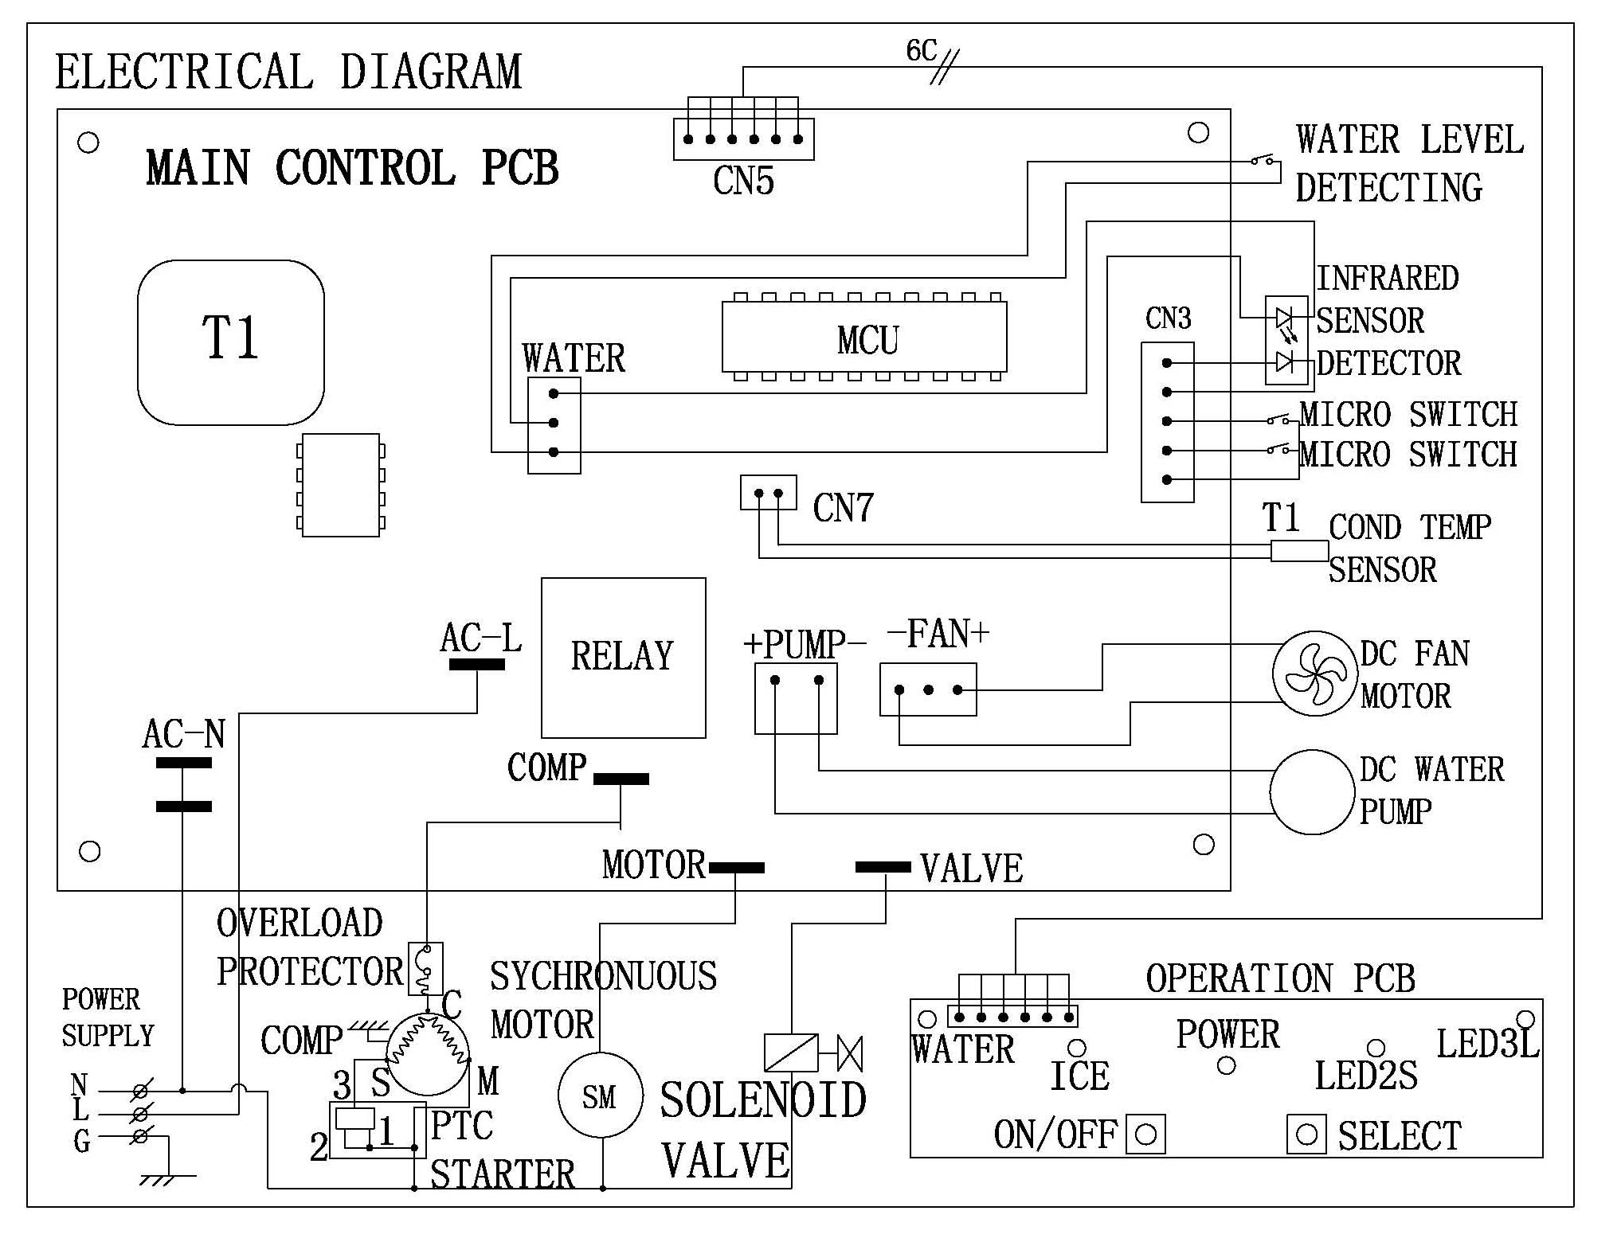

***EXPLOSIVE DRAWINGS***



1. Power cord 2. Back panel 3. Plate inforce

4. Magnetism valve 5. Evaporator 6. Control box cover

7. Main PCB 8. Control box 9. Ice making box

10. Micro switch 11. Inner tank bracket, LH 12. Cam

13. Ice scoop link 14. Ice scoop 15. Back btm panel

16. Back top panel 17. Clear window 18. Displaying PCB

19. Touch pad 20. Front top panel 21. Front btm panel

22. Ice basket 23. Foaming asm 24. Water filter

25. Inner tank bracket, RH 26. Synchronous motor 27. Stainless wire

28. Condenser 29. DC Fan motor 30. Filter dryer

31. Copper tube filter 32. Silicon plug drain 33. Nylon plug drain

34. Silicon sealing pump 35. DC water pump 36. Compressor

37. Plate bottom 38. Rubber foot 39. Air grille

**Warranty Information**

**– WARNING:** Keep ventilation openings, in the appliance enclosure or in the built-in structure, clear of obstruction.

**– WARNING:** Do not damage the refrigerant circuit.

The manufacturer provides warranty in accordance with the legislation of the customer's own country of residence, with a minimum of 1 year (Germany: 2 years), starting from the date on which the appliance is sold to the end user.

The warranty only covers defects in material or workmanship.

The repairs under warranty may only be carried out by an authorized service centre. When making a claim under the warranty, the original bill of purchase (with purchase date) must be submitted.

The warranty will not apply in cases of:

- Normal wear and tear

- Incorrect use, e.g. overloading of the appliance, use of non-approved accessories

- Use of force, damage caused by external influences

- Damage caused by non-observance of the user manual, e.g. connection to an unsuitable mains supply or non-compliance with the installation instructions

- Partially or completely dismantled appliances

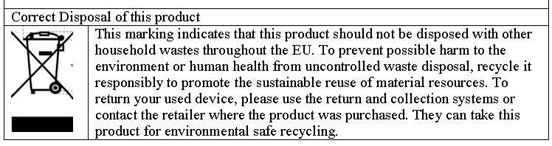

**PLEASE AFFIX YOUR PROOF OF PURCHASE/RECEIPT HERE**

**IN THE EVENT OF A CLAIM UNDER WARRANTY THIS RECEIPT MUST BE PRODUCED.**

**W A R R A N T Y**

1. Home of Living Brands (Pty) Limited warrants to the original purchaser of this product (“the customer”) that this product will be free of defects in quality and workmanship which under normal personal, family or household use and purpose may manifest within a period of 1 (one) year from the date of purchase (“warranty period”).
2. Where the customer has purchased a product and it breaks, is defective or does not work properly for the intended purpose, the customer must notify the supplier from whom the customer bought the product (“the supplier”) thereof within the warranty period. Any claim in terms of this warranty must be supported by a proof of purchase. If proof of purchase is not available, then repair, and/or service charges may be payable by the customer to the supplier.
3. The faulty product must be taken to the supplier's service centre to exercise the warranty.
4. The supplier will refund, repair or exchange the product in terms of this warranty subject to legislative requirements. This warranty shall be valid only where the customer has not broken the product himself, or used the product for something that it is not supposed to be used for. The warranty does not include and will not be construed to cover products damaged as a result of disaster, misuse, tamper, abuse or any unauthorised modification or repair of the product.
5. This warranty will extend only to the product provided at the date of the purchase and not to any expendables attached or installed by the customer.
6. If the customer requests that the supplier repairs the product and the product breaks or fails to work properly within 3 (three) months of the repair and not as a result of misuse, tampering or modification by or on behalf of the customer, then the supplier may replace the product or pay a refund to the customer.
7. The customer may be responsible for certain costs where products returned are not in the original packaging, or if the packaging is damaged. This will be deducted from any refund paid to the customer.

**HOME OF LIVING BRANDS (PTY) LTD**

JOHANNESBURG TEL NO. (011) 490-9600

CAPE TOWN TEL NO. (021) 552-5161

DURBAN TEL NO. (031) 792-6000

www.homeoflivingbrands.co.za

www.russellhobbs.co.za

www.facebook.com/RussellHobbsSA