

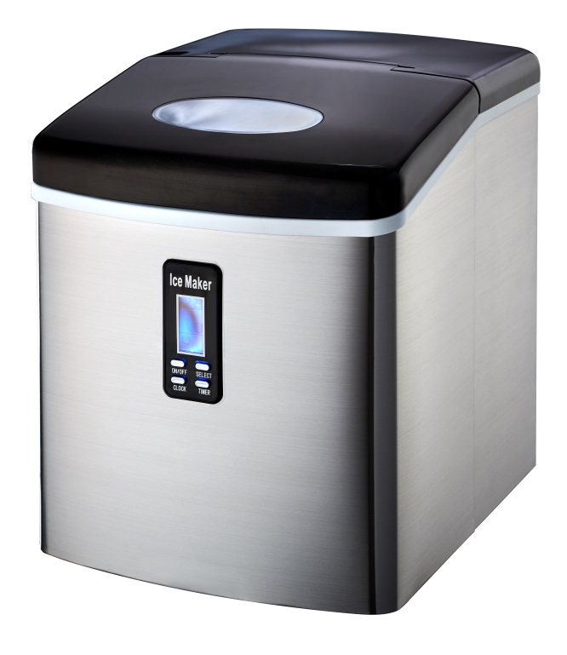

RHIM15

Russell Hobbs 15kg Ice Maker

***TABLE OF CONTENTS***

***IMPORTANT SAFETY INSTRUCTIONS***…………………………………………………2

***PREPARING YOUR ICE MAKER FOR USE***

IMPORTANT SAFETY TIPS…………………………………………………………………….3

***GETTING TO KNOW YOUR UNIT***………………………………………………………..4

***OPERATING PROCEDURES & MAINTENANCE***

UNPACKING YOUR ICE MAKER………………….…………………………………………...5

CONNECTING YOUR ICE MAKER……………….……….…………………………………...5

CLEANING AND MAINTAINING YOUR ICE MAKER….………………………………………..5

***USING YOUR ICE MAKER***

START TO MAKE THE ICE-CUBE…………………………………………………….….6

TIMER SETTING……………………………………………………………………………6

CLOCK DISPLAY & THE CORRECT TIME………………………………………………7

CLEANING REMINDING……………………………………………………………………7

TROUBLESHOOTING…………………………….……………………………………………8

***TECHNICAL PARAMETERS & CIRCUIT DIAGRAM***

TECHNICAL SPECIFICATION…………………………………………………………….8

CIRCUIT DIAGRAM…………………………………………………………………………9

***IMPORTANT SAFETY INSTRUCTIONS***

***TABLE OF CONTENTS***

**Your safety and the safety of others are very important.**

Always read and obey all safety massages.

This is the safety alert symbol:

**!**

All safety messages will follow the safety alert symbol and the word “DANGER” or “WARNING”.

**未命名**

## DANGER

## WARNING

**未命名**

These words mean:

**You can be killed or seriously injured if you don’t immediately follow the instructions.**

All safety messages will tell you what the potential hazard is, tell you how to reduce the chance of injury, and tell you what can happen if the instructions are not followed.

***PREPARING YOUR ICE MAKER FOR USE***

### IMPORTANT SAFETY TIPS

When using electrical appliances, basic safety precautions should be followed to reduce the risk of fire, electric shock, and injury to persons or property. Read all instructions before using any appliance.

* This appliance can be used by children aged from 8 years and above and persons with reduced physical, sensory or mental capabilities or lack of experience and knowledge if they are under supervision or given instructions concerning use of the appliance in a safe way and understand the hazards involved. Children shall not play with the appliance. Cleaning and user maintenance shall also not be undertaken by children without supervision.
* Do not operate this or any other appliance with a damaged cord. If the supply cord is damaged, it must be replaced by the manufacturer or its service agent or a similarly qualified person in order to avoid any hazard.
* This ice-maker must be positioned so that the plug is accessible.
* Connect to properly polarized outlets only. No other appliance should be plugged into the same outlet. Be sure that the plug is fully inserted into the receptacle.
* Do not run the power cord over carpeting or other heat insulators.
* Do not cover the cord.
* Keep cord away from traffic areas and do not submerge in water.
* We do not recommend the use of an extension cord, as it may overheat and become a risk of fire. If you must use an extension cord, use No.0.75mm2 minimum size and rated no less than 16A/250V~ with a plug.
* Unplug the ice maker before cleaning or making any repairs or servicing.
* Exercise caution and use reasonable supervision when appliance is used near children.
* Do not use your ice-maker outdoors. Place the ice-maker away from direct sunlight and make sure that there is at least 4 inches of space between the back of your unit and wall. Keep a minimum distance of 4 inches on each side of your unit free.
* Do not use other liquids to make the ice-cubes other than water.
* Do not clean your ice maker with flammable fluids. The fumes can create a fire hazard or explosion.
* Do not tip over.
* If the ice maker is brought in from outside in wintertime, give it a few hours to warm up to room temperature before plugging it in.
* This appliance is not intended for use by persons (including children) with reduced physical, sensory or mental capabilities, or lack of experience and knowledge, unless they are under supervision or given instructions concerning use of the appliance by-a person responsible for their safety.
* Children should be supervised to ensure that they do not play with the appliance.
* According to local regulations in regards to disposal of the appliance for its flammable blowing gas, before you discard the appliance, please take off the doors to prevent children from being trapped.
* Do not store explosive substances such as aerosol cans with a flammable propellant in this appliance.
* This appliance is intended for use in household and similar environments, such as:
* Staff kitchen areas in shops, offices and other working environments;

– Farm houses and by clients in hotels, motels and other residential type environments;

* Bed and breakfast type environments;
* Catering and similar non-retail applications.
*  **Warning: Risk of fire/flammable materials used.** According to local regulations regarding disposal of the appliance for its flammable blowing gas.
* WARNING: Keep ventilation openings, in the appliance enclosure or in the built-in structure, clear of obstruction.
* WANING: Do not damage the refrigerant circuit.
* WARNING: Do not use mechanical devices or other means to accelerate the defrosting process or ice harvesting process, other than those recommended by the manufacturer.
* WARNING: Do not use other type of electrical appliances inside the ice-maker.
* This appliance must be earthed.

**IMPORTANT**:

The wires in this mains lead are colored in accordance with the following code:

Green and yellow: Grounding

Blue: Neutral

Brown: Live

To avoid a hazard due to instability of the appliance, it must be placed on an even or flat surface.

***GETTING TO KNOW YOUR UNIT***

1. Cover: With a transparent window to allow interior visibility.

2. Ice scoop.

3. Ice shovel.

4. Control Panel: Easy to use, visible functions and LCD display setting.

A. LCD display window.

1: Current Clock Time

2: No water display: when flashing, it means there’s no water in the unit, need to pour water in.

3. Ice-full display: when it displays, it means the ice basket is full of ice-cubes.

4. ON/OFF display: if the unit has been turned off, this symbol will flash. And if the unit is turned on, this symbol will always light up.

5. Clean symbol: when this symbol flashes, it means the unit needs to be cleaned.

6. Ice-cube size displaying: Small, Medium, and Large.

7. Timer delay display.

B. ON/OFF button: To start or stop the unit.

C. SELECT button: To select your desired size of ice-cubes (small, medium or large) or to change the time digit during the clock or timer setting program.

D. TIMER button: To set or cancel the timer program so that the unit can start to run at your desired time or stop the unit at your desired time.

E. CLOCK button: To set the displayed time to the correct current time.

5. Water drain cap: For draining water from water reservoir.

6. Air Outlet

7. Ice basket



***OPERATING PROCEDURES & MAINTENANCE***

##### UNPACKING YOUR ICE MAKER

1. Remove the exterior and interior packaging. Check that the ice basket and ice scoop is included. If any parts are missing, please contact our customer service centre.
2. Clean the interior with lukewarm water and a soft cloth. Take out the ice basket and clean it.
3. Find a location for your ice maker that is protected from direct sunlight and other sources of heat (i.e.: stove, furnace, radiator, etc.). Place the ice maker on a level surface. Make sure that there is at least 4 inches of space between the back and sides of your ice maker and the wall.
4. Allow one hour for the refrigerant fluid to settle before plugging the ice maker in.
5. The appliance must be positioned so that the plug is accessible.

WARNING: fill with potable water only.

## DANGER

**CONNECTING YOUR ICE MAKER**

**未命名** **\* Improper use of the grounded plug can result in the risk of electrical shock. If the power cord is damaged please call our customer service centre.**

1. This unit should be properly grounded for your safety. The power cord of this appliance is equipped with a grounding plug which is in accordance with standard grounding wall outlets to minimize the possibility of electric shock.
2. Plug your appliance into an exclusive, properly installed, grounding wall outlet. Do not under any circumstances damage the grounding means of the plug. Any questions concerning power and/or grounding should be directed to a certified electrician.
3. This appliance requires a standard 220-240Volt, 50Hz electrical outlet with good grounding means.

##### CLEANING AND MAINTAINING YOUR ICE MAKER

Before using your ice maker, it is strongly recommended to clean it thoroughly.

1. Take out the ice basket.
2. Clean the interior with diluted detergent, warm water and a soft cloth.
3. Then use the water to rinse the inside parts, and drain out the water by unplugging the

drain cap on the side.

1. The ice maker’s exterior should be cleaned regularly with a mild detergent solution and warm water.
2. Dry the interior and exterior with a soft cloth.
3. When the machine is not in use for a long period of time, open the water drain cap to empty out the water from water reservoir.

**Note:** Blowing gas inside the unit is flammable. Disposal of these materials shall be in accordance with national regulations.

***USING YOUR ICE MAKER***

1. Open the cover, remove the ice basket and pour water into the water reservoir.
2. Keep water level below the level mark.
3. Press “ON/OFF” button on the control panel to turn the unit on so as to begin the ice making cycle.
4. Select the size of the ice cube by pressing the “Select” button. Three sizes: SMALL, MEDIUM or LARGE can be selected:



If the room temperature is lower than 60℉, it is recommended to select the small or medium ice sign button in order to avoid the ice sticking together.

1. The ice making cycle lasts 6 to 13 minutes, depending on the size of the ice cube selection and the ambient temperature. In extreme hot room temperature, ice-making time may vary.
2. While the icemaker is on, verify water level periodically. If water pump can’t inject water, the ice maker will stop automatically, and the “” symbol will flash in the LCD display window.
3. Fill water up to the level mark and press “ON/OFF” button two times again to turn on the unit again. Allow the refrigerant liquid inside the compressor at least 3 minutes to settle before restarting.
4. The ice maker automatically stops working when the ice basket is full and the “” symbol will display in the LCD display window.
5. Change water in the water reservoir every 24 hours to ensure an adequate hygiene level.
6. If unit isn’t in use, drain all water left in the tank

**Timer SETTING**

Timer Delay Time Range: 0.5 - 19.5 hours.

Default Delay Time: 3 hours.

While the unit is running, you can set it on OFF-TIMER to let the unit stop running after your set delay time.

And once the unit has stopped, you can set the unit on ON-TIMER to let it run automatically after your set delay time.

**How to set the timer**

Press the TIMER button first, the default “3.0H” delay time will flash in LCD display window, then press the SELECT button to select your desired delay time. If you press SELECT button one time, the flashing delay time will increase 0.5 hour, and if you press the SELECT button for more than 3 seconds, the delay time will change very rapidly. Then after 5 seconds of flashing, the delay time digit will change from flashing to a still display. This means the timer program has been set.

**How to cancel the timer**

When the unit has been set with the timer or during the timer setting process, press the TIMER button, then the delay time digit will disappear. This means the timer set has been cancelled.

**CLOCK DISPLAY & the CORRECT TIME**



**This unit is supplied with a CLOCK displaying function.**

If the displayed time is not correct, you can adjust it to the correct digit through the CLOCK and SELECT button.

First press the CLOCK button once, the digital hour will start to flash first, then you can press SELECT button to change it. Each press will increase by an hour. Press the CLOCK button again, the digital minute will then start to flash, and you also press the SELECT button to change it. You can then press the CLOCK button for the third time to confirm it, and it will now display the new correct clock time. And during the adjusting process, after 5 seconds of flashing, the digit will automatically change to a still display which also means the new clock has been set.

Clock Time

**CLEANING REMINDER**

When the symbol “” flashes, it means the unit needs to be cleaned. And once you have cleaned the unit, always press the TIMER button for more than 5 seconds, this symbol will disappear from the LCD display window. The cleaning timer will reset to Zero and re-count again.

##### TROUBLESHOOTING

|  |  |  |
| --- | --- | --- |
| PROBLEM | POSSIBLE CAUSE | SOLUTION |
| **Symbol “****” flashes.** | Lack of Water. | Stop the ice maker, fill water, and press “ON/OFF” button again to restart the unit. |
| **Symbol “****” displays in LCD display window.** | Ice bucket is full. | Remove ice from ice basket. |
| **Ice cubes stick together.** | The ice cycle is too long. | Stop the ice maker and restart it once the ice blocks melt. Select the small size ice cube selection. |
| Water temperature in inner tank is too low. | Change the water in the inner tank. Temperature of water is better set between 8-32℃ |
| **Ice making cycle is normal but no ice is made.** | Ambient temperature or water temperature in inner tank is too high. | Please run the ice maker below 32℃ and pour colder water into tank. |
| Refrigerant in cooling system is leaking. | Verify via a qualified technician. |
| Pipe in the cooling system is blocked. | Verify via a qualified technician. |

**TECHNICAL PARAMETERS**

###### TECHNICAL PARAMETERS & CIRCUIT DIAGRAM

|  |  |
| --- | --- |
| Model | RHIM15 |
| Protection Type | I |
| Climate Type | SN/N/ST |
| Power | 220-240V/50Hz |
| Ice Making Current | 0.7A |
| Ice Harvest Current | 1.2A |
| Refrigerant | R600a/38g |
| Net Weight | 12.8kg |
| Vesicant | C5H10 |
| Enclosure | Stainless steel |

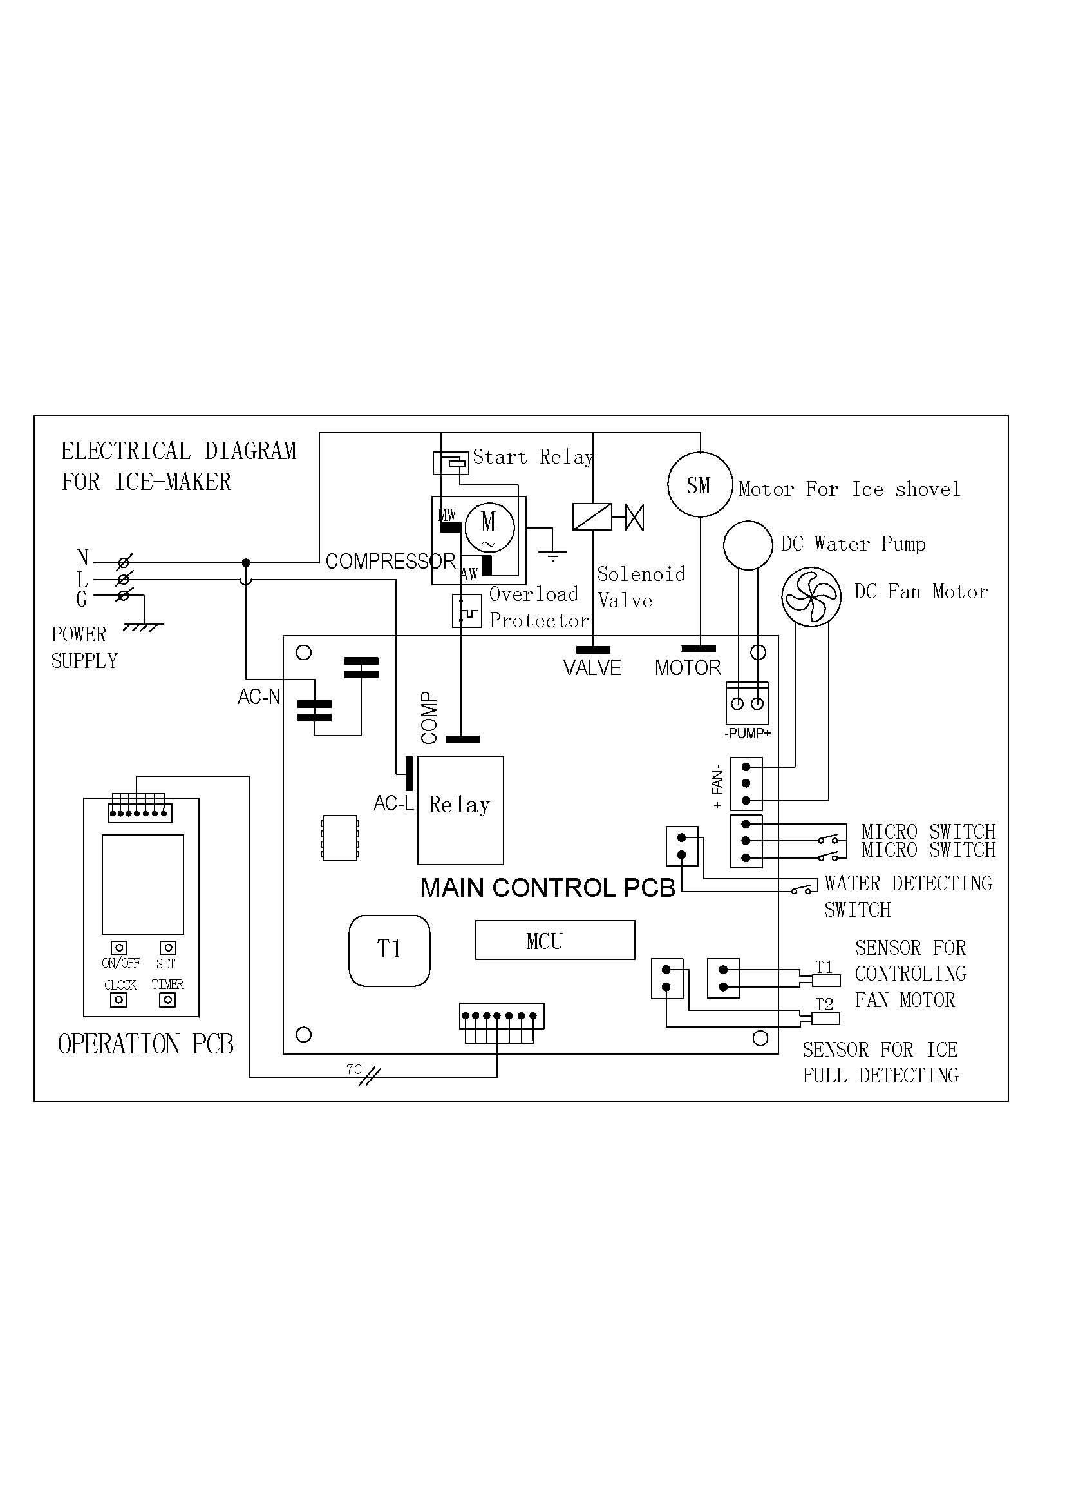

**CIRCUIT DIAGRAM**

**PLEASE AFFIX YOUR PROOF OF PURCHASE/RECEIPT HERE**

**IN THE EVENT OF A CLAIM UNDER WARRANTY THIS RECEIPT MUST BE PRODUCED.**

**W A R R A N T Y**

1. Home of Living Brands (Pty) Limited warrants to the original purchaser of this product (“the customer”) that this product will be free of defects in quality and workmanship which under normal personal, family or household use and purpose may manifest within a period of 1 (one) year from the date of purchase (“warranty period”).
2. Where the customer has purchased a product and it breaks, is defective or does not work properly for the intended purpose, the customer must notify the supplier from whom the customer bought the product (“the supplier”) thereof within the warranty period. Any claim in terms of this warranty must be supported by a proof of purchase. If proof of purchase is not available, then repair, and/or service charges may be payable by the customer to the supplier.
3. The faulty product must be taken to the supplier's service centre to exercise the warranty.
4. The supplier will refund, repair or exchange the product in terms of this warranty subject to legislative requirements. This warranty shall be valid only where the customer has not broken the product himself, or used the product for something that it is not supposed to be used for. The warranty does not include and will not be construed to cover products damaged as a result of disaster, misuse, tamper, abuse or any unauthorised modification or repair of the product.
5. This warranty will extend only to the product provided at the date of the purchase and not to any expendables attached or installed by the customer.
6. If the customer requests that the supplier repairs the product and the product breaks or fails to work properly within 3 (three) months of the repair and not as a result of misuse, tampering or modification by or on behalf of the customer, then the supplier may replace the product or pay a refund to the customer.
7. The customer may be responsible for certain costs where products returned are not in the original packaging, or if the packaging is damaged. This will be deducted from any refund paid to the customer.

**HOME OF LIVING BRANDS (PTY) LTD**

JOHANNESBURG TEL NO. (011) 490-9600

CAPE TOWN TEL NO. (021) 552-5161

DURBAN TEL NO. (031) 792-6000

www.homeoflivingbrands.co.za

www.russellhobbs.co.za

www.facebook.com/RussellHobbsSA