

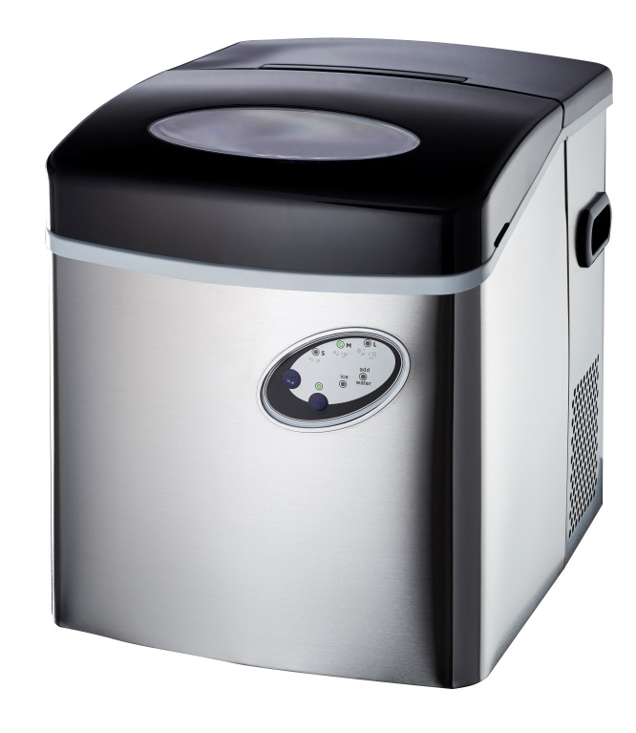

RHIM20

Russell Hobbs 20kg Ice Maker

***TABLE OF CONTENTS***

***IMPORTANT SAFETY INSTRUCTIONS*** …………………………………………………….2

***PREPARING YOUR ICE MAKER FOR USE***

IMPORTANT SAFETY TIPS …………………………………………………………………..3

***GETTING TO KNOW YOUR UNIT*** ……………………………………………………………4

***OPERATING PROCEDURES & MAINTENANCE***

UNPACKING YOUR ICE MAKER …………………………………………………………….5

CONNECTING YOUR ICE MAKER …………………………………………………………..5

CLEANING AND MAINTAINING YOUR ICE MAKER ………………………………………5

***USING YOUR ICE MAKER*** …………………………………………………………………….6

***TROUBLESHOOTING*** ………………………………………………………………………….7

***TECHNICAL PARAMETERS & CIRCUIT DIAGRAM*** ………………………………..8

***IMPORTANT SAFETY INSTRUCTIONS…***

It is important that you read these instructions before using your Russell Hobbs 20kg ice maker and we strongly recommend that you keep them in a safe place for future reference.

**Your safety and the safety of others is very important.**

Always read and obey all safety massages.

This is the safety alert symbol:

**!**

All safety messages will follow the safety alert symbol and the word “DANGER” or “WARNING”.

**You could be seriously injured if you do not immediately follow the instructions.**

All safety messages will describe the potential hazard, inform you on how to reduce the chance of injury and indicate what can happen if instructions are not followed.

## DANGER

未命名

## WARNING

未命名

DO NOT TOUCH THE EVAPORATOR WHILE THE UNIT IS IN USE OR DURING THE ICE MAKING PROCESS. IT MAY CAUSE SEVERE BURNING.

Evaporator rods

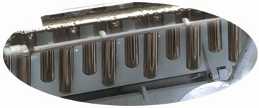

Evaporator Rods

***PREPARING YOUR ICE MAKER FOR USE***

When using electrical appliances, basic safety precautions should be followed to reduce the risk of fire, electric shock, and injury to persons or property. Read all instructions before using any appliance.

* This machine is not a freezer, therefore cannot store the readymade ice. To store ice and keep frozen, please transfer to a regular freezer.
* Do not operate this or any other appliance with a damaged cord.
* Connect to properly polarized outlets only. No other appliance should be plugged into the same outlet. Be sure that the plug is fully inserted into the receptacle.
* Do not run cord over carpeting or other heat insulators. Do not cover the cord. Keep cord away from traffic areas, and do not submerge in water.
* We do not recommend the use of an extension cord, as it may overheat and become a risk of fire. If you must use an extension cord, use No.2.0mm2 minimum size and rated no less than 1875 watts.
* Unplug the ice maker before cleaning or making repairs.
* Exercise caution and use reasonable supervision when appliance is used near children.
* Do not clean your ice maker with flammable fluids. The fumes can create a fire hazard or explosion.
* Do not tip over.
* If the ice maker is brought indoors from outdoors during the wintertime, give it a few hours to warm up to room temperature before plugging it in.

***GETTING TO KNOW YOUR UNIT***

* 1. Ice Case Panel: The panel that pushes already formed ice into the ice basket below.
  2. Ice Basket
  3. Control Panel: Easy to use, visible functions and 1-touch display setting.

A) Selects ice cube size.

B) Starts or stops ice making cycle.

* 1. Handle
  2. Water Drain Cap: For draining water from the water reservoir.
  3. Cover: With a transparent window to allow interior visibility.
  4. Ice Shovel/Scoop.
  5. Ice Sensor: Ice sensor determines when the ice basket is full.

MAXIMUM WATER LEVEL: ▼

*This marking can be found on the inside of the water tank.*

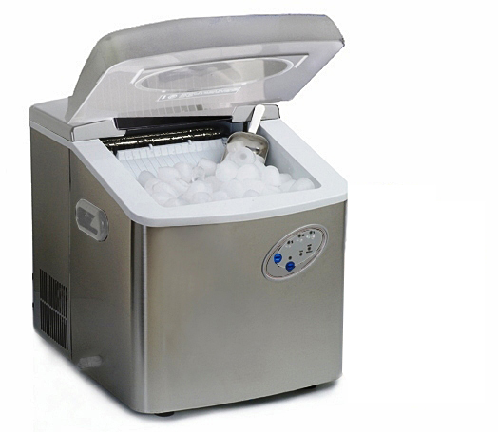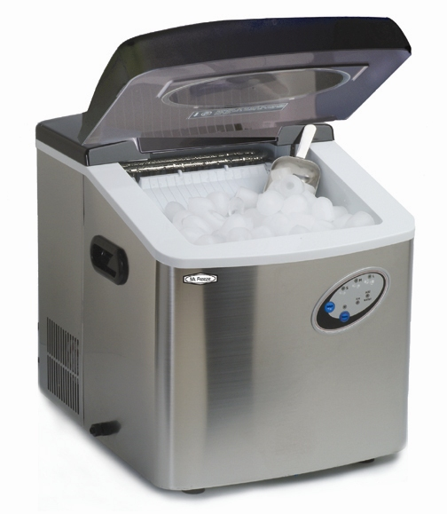

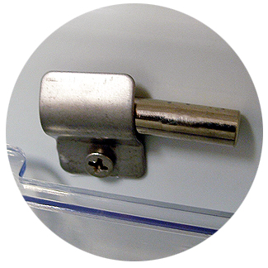

***OPERATING PROCEDURES & MAINTENANCE***

**UNPACKING YOUR ICE MAKER**

1. Remove all exterior and interior packaging. Check that ice basket and ice scoop is included. If any part or accessory is missing, please contact our customer service.
2. Clean the interior with lukewarm water and a soft cloth. Remove the ice basket and wash it in warm water.
3. Wipe clean the evaporator rods using a water/vinegar solution.
4. Find a location for your ice maker that is protected from direct sunlight and other sources of heat (i.e.: stove, furnace, radiator, etc.). Place the ice maker on a level surface. Make sure that there is at least 15cm of space between the back and sides of your ice maker and the wall.
5. **Allow the refrigerant fluid to settle for several hours before plugging in the unit.**
6. **未命名**The appliance must be positioned so that the plug is accessible.

**未命名**

## DANGER

**CONNECTING YOUR ICE MAKER**

**Improper use of the grounded plug can result in the risk of electrical shock. If the power cord is damaged please call our customer service centre.**

1. This unit should be properly grounded for your safety. The power cord of this appliance is equipped with a three-prong plug which mates with standard three prong wall outlets to minimize the possibility of electric shock.
2. Plug your appliance into an exclusive, properly installed, grounded wall outlet. Do not under any circumstances, cut or remove the third (ground) prong from the power cord. Any questions concerning power and/or grounding should be directed toward a certified electrician.
3. This appliance requires a standard 220-240 volt, 50Hz electrical outlet with three-prong ground.

Before using your ice maker, it is strongly recommended to clean it thoroughly.

The ice maker is not designed to be installed in an outside area such as a garage or a porch. Ambient temperatures of below 10℃ or above 38℃ will hinder the performance of the appliance.

**CLEANING AND MAINTAINING YOUR ICE MAKER**

Remove the ice basket.

1. Turn the drain cap counter clockwise to drain out the water.
2. Clean the interior with diluted detergent, warm water and a soft cloth.
3. The outside of the ice maker should be cleaned regularly with a mild detergent solution and warm water.
4. Dry the interior and exterior with a soft cloth.
5. Close the drain cap.
6. When the machine is not in use, open drain cap to drain water completely from water reservoir.

##### CARE AND MAINTENANCE

* The ice maker should be cleaned on a regular basis (See: “Cleaning and Maintaining your Ice Maker”).
* It is necessary to have an adequate ventilation space around the ice maker in order to sustain proper performance, airing of heat, maintain efficiency, and low power consumption. Clearance of minimum 15cm should be maintained at the rear and sides of the unit and 20cm at the top of the unit.
* To attain proper performance, be sure to plug the appliance into a properly grounded 220V/50Hz outlet.
* Do not modify the power cord under any circumstances to allow the unit to be plugged into a non-grounded outlet. To avoid heat damage to the power cord, please ensure that it does not come in proximity or in direct contact with the compressor of the ice maker.
* Please avoid installing the ice maker in a location where the appliance will come in contact with water or moisture to minimize rusting of metal parts.

***USING YOUR ICE MAKER***

* The ice maker should not be installed near any heat source or in a location where it will come in direct contact with the sunlight.



* 1. Clean your ice maker first.
  2. Open the cover, remove the ice basket and pour water into tank.
  3. Keep water level below the level mark: ▼
  4. Place the ice basket back into the ice maker and close the lid.
  5. Plug in the unit and the power indicator light will blink.
  6. Press “Power” on the control panel to begin the ice making cycle. The power indicator light will be lit.
  7. Select the size of the ice cube by pressing the “Select” button. If ambient temperature is below 15℃, it is recommended to select small or medium size to avoid ice sticking together.
  8. The ice making cycle lasts 6 to 15 minutes, depending on the size of the ice cube selection & room temperature.

**\*NOTE:** When the machine is brand new, it may sometimes take a few hours for the machine to adjust and get used to producing ice at a faster rate, and producing larger cubes of ice. This is considered normal.

* 1. While the icemaker is on, check water level periodically. If water pump can’t inject water, the ice maker will stop automatically, and the “Water” indicator will be on.

Press “Power” button, fill water up to the level mark and press “Power” again.

**Allow 3 minutes for the refrigerant to settle before restarting.**

* 1. The ice maker automatically stops working when the ice basket is full.
  2. Change water in the water reservoir every 24 hours to ensure a reasonable hygiene level.

If unit is not in use for a few days, drain all water in the tank reservoir and refill before operating again.

***TROUBLESHOOTING***

|  |  |  |
| --- | --- | --- |
| PROBLEM | POSSIBLE CAUSE | SOLUTION |
| **“Water” indicator is on.** | Water level is too low. | Stop the ice maker, fill up with water, and restart. |
| **“Ice” indicator is on.** | Ice basket is full. | Remove ice from ice basket. |
| **“Water” and “Ice” indicator are both flashing.** | Ice shovel is stuck. | Check if ice is blocking the ice shovel, otherwise consult a certified technician. |
| **Ice cubes stick together.** | Ice making cycle is too long. | Stop the ice maker, and restart when the ice blocks melt. Select the small ice size. |
| Water temperature in inner tank is too low. | Change the water in the reservoir. Use water between 5℃-32℃. |
| **Ice making cycle is normal but no ice is made.** | Ambient temperature or water temperature in inner tank is too high. | Please operate the ice maker below ambient temperature of 32℃ and use cold water. |
| Refrigerant liquid leakage. | Consult a qualified technician. |
| Pipe in the cooling system is blocked. | Consult a qualified technician. |
| **Ice Maker is leaking water** | The water drainage cap may not be tightened properly. | Tighten the drainage cap. |
| **The ice cubes are melting.** | Location of appliance may cause temperature changes.  Also constant opening and shutting of the lid may also cause variable temperature fluctuations.  Leaving ice in the appliance for an extended period of time may also result in the appliance recycling the ice by melting it down and making a new batch. | Make sure the appliance is always placed in a temperature regulated area.  Avoid leaving the lid open.  Transfer ready-made ice to another container and store in a cooler or freezer to avoid recycling. |

|  |  |  |
| --- | --- | --- |
| There is enough water in the water tank, but the indicator to “add water” stays on and the unit will not function. | The water filter on the bottom of the water tank may be blocked. | Remove the water filter and clean it.  ________________________________  After following the procedure outlined in #8 under the “Using your Icemaker” section, if your icemaker still does not start producing ice please try the following two procedures:   1. Follow the steps outlined in #8, then wait approximately 5-10 minutes and press the ‘Power’ button again. 2. Unplug the unit’s power supply, wait approximately 5-10 minutes, plug the power supply back in, follow the steps outlined in #8. |
| Ice cube sizes are inconsistent | The ice case panel may not be level. | Adjust the ice case panel and make sure it is level. |
| There is not enough ice cubes in the ice basket, but the indicator of “ice full” is on. | The room temperature may be too low, around 5℃  ___________________________  The ice cubes being formed may be touching the sensor occasionally when the ice case panel pushes the ice cubes into the ice basket. | Make sure the unit is in an area where the temperature is above 5℃ regulated.  _______________________________  Remove the ice cubes, wait for a few minutes and let the unit restart again. |

**Troubleshooting Continued…..**

***TECHNICAL PARAMETERS & CIRCUIT DIAGRAM***

|  |  |
| --- | --- |
| Model | RHIM20 |
| Protection Type | I |
| Climate Type | SN/N/ST |
| Power | 220-240V/50Hz |
| Ice Making Current | 1.4A |
| Ice Harvest Current | 2.4A |
| Refrigerant | R134a/88g |
| Net Weight | 17.2kg |
| Vesicant | C5H10 |
| Enclosure | Stainless |

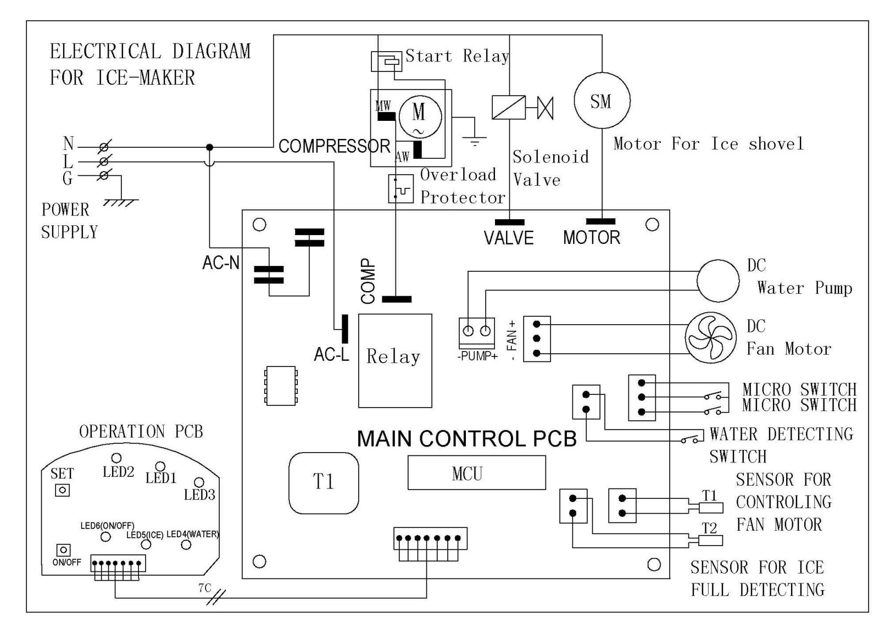

**PLEASE AFFIX YOUR PROOF OF PURCHASE/RECEIPT HERE**

**IN THE EVENT OF A CLAIM UNDER WARRANTY THIS RECEIPT MUST BE PRODUCED.**

**W A R R A N T Y**

1. Home of Living Brands (Pty) Limited warrants to the original purchaser of this product (“the customer”) that this product will be free of defects in quality and workmanship which under normal personal, family or household use and purpose may manifest within a period of 1 (one) year from the date of purchase (“warranty period”).
2. Where the customer has purchased a product and it breaks, is defective or does not work properly for the intended purpose, the customer must notify the supplier from whom the customer bought the product (“the supplier”) thereof within the warranty period. Any claim in terms of this warranty must be supported by a proof of purchase. If proof of purchase is not available, then repair, and/or service charges may be payable by the customer to the supplier.
3. The faulty product must be taken to the supplier's service centre to exercise the warranty.
4. The supplier will refund, repair or exchange the product in terms of this warranty subject to legislative requirements. This warranty shall be valid only where the customer has not broken the product himself, or used the product for something that it is not supposed to be used for. The warranty does not include and will not be construed to cover products damaged as a result of disaster, misuse, tamper, abuse or any unauthorised modification or repair of the product.
5. This warranty will extend only to the product provided at the date of the purchase and not to any expendables attached or installed by the customer.
6. If the customer requests that the supplier repairs the product and the product breaks or fails to work properly within 3 (three) months of the repair and not as a result of misuse, tampering or modification by or on behalf of the customer, then the supplier may replace the product or pay a refund to the customer.
7. The customer may be responsible for certain costs where products returned are not in the original packaging, or if the packaging is damaged. This will be deducted from any refund paid to the customer.

**HOME OF LIVING BRANDS (PTY) LTD**

JOHANNESBURG TEL NO. (011) 490-9600

CAPE TOWN TEL NO. (021) 552-5161

DURBAN TEL NO. (031) 792-6000

www.homeoflivingbrands.co.za

www.russellhobbs.co.za

www.facebook.com/RussellHobbsSA