

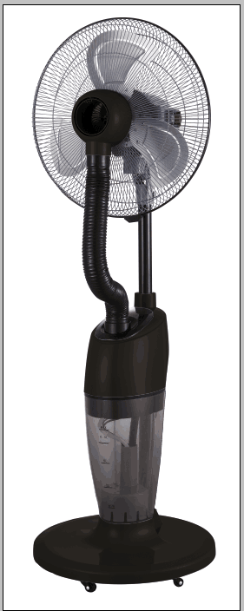 **INSTRUCTIONS & WARRANTY**

**MODEL NO: RHOMF8**

**RUSSEL HOBBS OUTDOOR MIST FAN**

Congratulations on purchasing our Russell Hobbs Outdoor Mist Fan. Each unit is manufactured to ensure safety and reliability. Before using this appliance for the first time, please read the instruction manual carefully and keep it for future reference.

**FEATURES OF RUSSELL HOBBS OUTDOOR MIST FAN**

1. 18’’ Outdoor mist fan
2. Suitable for commercial use
3. Humidifier with 7L water tank
4. Generates mist for up to 5,5 hours
5. 4 Speed settings
6. Oscillating function
7. Castors for ease of movement
8. 3 Large industrial blades
9. Overheat protection
10. 230W

**IMPORTANT SAFEGUARDS**

When using any electrical appliance, basic safety precautions should always be followed including the following:

1. Please read the instructions carefully before using any appliance.
2. Use the fan only for purposes described in the instruction manual.
3. Always ensure that the voltage on the rating label corresponds to the mains voltage in your home.
4. Incorrect operation and improper use can damage the appliance and cause injury to the user.
5. This appliance is not intended for use by persons (including children) with reduced physical, sensory or mental capabilities, or lack of experience and knowledge, unless they have been given supervision or instruction concerning use of the appliance by a person responsible for their safety.
6. Avoid any contact with moving parts.
7. To reduce the risk of fire or electric shock, do not use this fan with any solid-state speed control device.
8. To protect against electrical shock, do not immerse the fan, plug or cord in water or any other liquid or spray with liquids.
9. Children should be supervised to ensure that they do not play with the appliance
10. Close supervision is required when any appliance is used near or by children, pets and invalids.
11. Check the power cord and plug regularly for any damage. If the cord or the plug is damaged, it must be replaced by the manufacturer or a qualified person in order to avoid an electrical hazard.
12. Do not operate the fan in the presence of explosive and/or flammable fumes.
13. Do not use the appliance if it has been dropped or damaged in any way. In case of damage, take the unit in for examination and/or repair by an authorised service agent
14. Place the fan on a dry level surface
15. Do not hang or mount fan on a wall or ceiling
16. Remove the plug from the socket by gripping the plug. Do not pull on the cord to disconnect the appliance from the mains. Always unplug the fan when not in use, before cleaning or when adding or removing parts.
17. The use of accessory attachments that are not recommended or supplied by the manufacturer may result in injuries, fire or electric shock.
18. A short cord is provided to reduce the hazards resulting from becoming entangled in or tripping over a longer cord.
19. Do not allow the cord to touch hot surfaces and do not place on or near a hot gas or electric burner or in a heated oven.
20. Use of an extension cord with this appliance is not recommended. However, if it is necessary to use an extension lead, ensure that the lead is suited to the power consumption of the appliance to avoid overheating of the extension cord, appliance or plug point. Do not place the extension cord in a position where it can be pulled on by children or animals or tripped over.
21. This appliance is not suitable for outdoor use. Do not use this appliance for anything other than its intended use.
22. Do not carry the appliance by the power cord.
23. Do not leave this appliance unattended during use. Always unplug the unit when not in use or before cleaning.
24. Always operate the appliance on a smooth, even, stable surface. Do not place the unit on a hot surface.
25. Ensure that the switch is in “Off” position after each use.
26. The manufacturer does not accept responsibility for any damage or injury caused by improper or incorrect use, or for repairs carried out by unauthorised personnel.
27. In case of technical problems, switch off the appliance and do not attempt to repair it yourself. Return the appliance to an authorised service facility for examination, adjustment or repair. Always insist on the use of original spare parts. Failure to comply with the above mentioned pre-cautions and instructions, could affect the safe operation of this appliance.
28. Do not touch/ pull out/ put back the water tank when the unit is plugged into the power source. Make sure it is physically disconnected from the mains before you do anything with the water tank.
29. When the water level is too low, the safety switch will stop the operation of the mist function, unplug the unit and refill the water tank for further operation.
30. Do not let dust or other substances collect on the mist plate – if the outlet is blocked, the mist function will fail to function normally.
31. Before cleaning the unit, make sure that it is completely disconnected from the plug. Make sure your hands are not wet when unplugging the unit.
32. Do not use hot water in the water tank.
33. Do not add any chemicals, oils or other additives to the water tank.

**PARTS DIAGRAM**

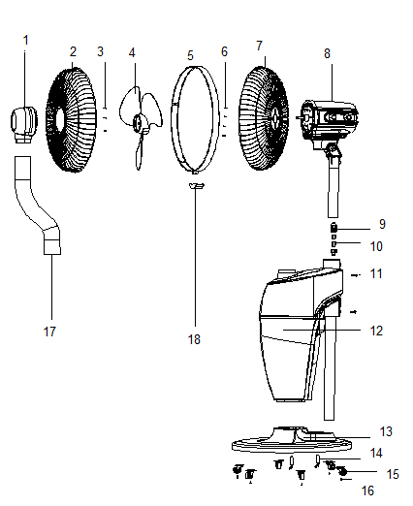

19

20

1. Mist outlet
2. 18 inch front fan guard
3. Screw
4. 18 inch AL blades
5. Iron belt
6. M6 screw
7. 18 inch rear fan guard
8. Motor
9. Wire box
10. Wire
11. M5 screw
12. Fan body
13. Base
14. M8 screw
15. Wheel
16. Screw
17. Hose
18. Buckle
19. Screw
20. Tube

## ASSEMBLY INSTRUCTIONS

1. Assemble the wheel (15) to the base (13) with the screw.
2. Assemble the fan body (12) and fit it to the base (13) with a screw (14).
3. Connect the internal wires (10) to motor assembly (8). Connect the wire box (9) to the fan body (12) and then assemble the motor (8) to the fan body (12) with the screws (11).
4. Assemble the rear fan guard (7) to the motor (8).
5. Assemble the blades (4) onto the motor (8).
6. Fasten the mist outlet (1) on the front fan guard (2) and then fasten the fan guard (2) and (7) with the iron belt (5) and buckle (18).
7. Insert the hose (17) into the mist outlet (1) and insert the other side to the fan body (12).
8. Fasten the tube (20) to the body with the screw (19).”

## BEFORE FIRST USE

1. First ensure that the body is attached to the base.
2. The fan head must be fixed to the main part of the structure pole.
3. Install the back fan guard to the motor housing, slide on aluminum blades and ensure the screw is tightened.

**OPERATING INSTRUCTIONS**

Place the water tank on a flat surface and fill with water as per below steps：

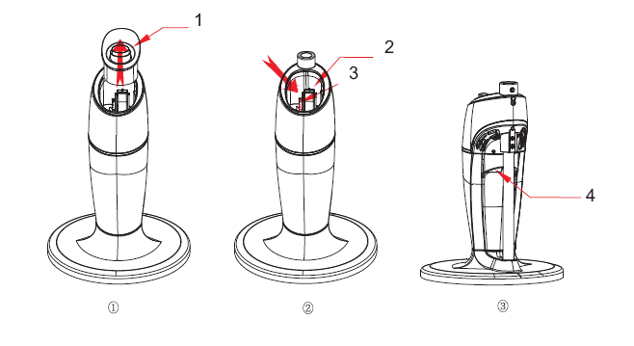

1. Remove the mist tank on upper side , the mist function will be cut off automatically when the water tank is removed from the body
2. Pour the water into the water tank.
3. Ensure that the water level does not reach be beyond the max indication.
4. After filling the water, close the mist cask and connect the mist tube.

Attention: Please check carefully to ensure the tank is not overfilled and there is no water running down the back side of the tank.

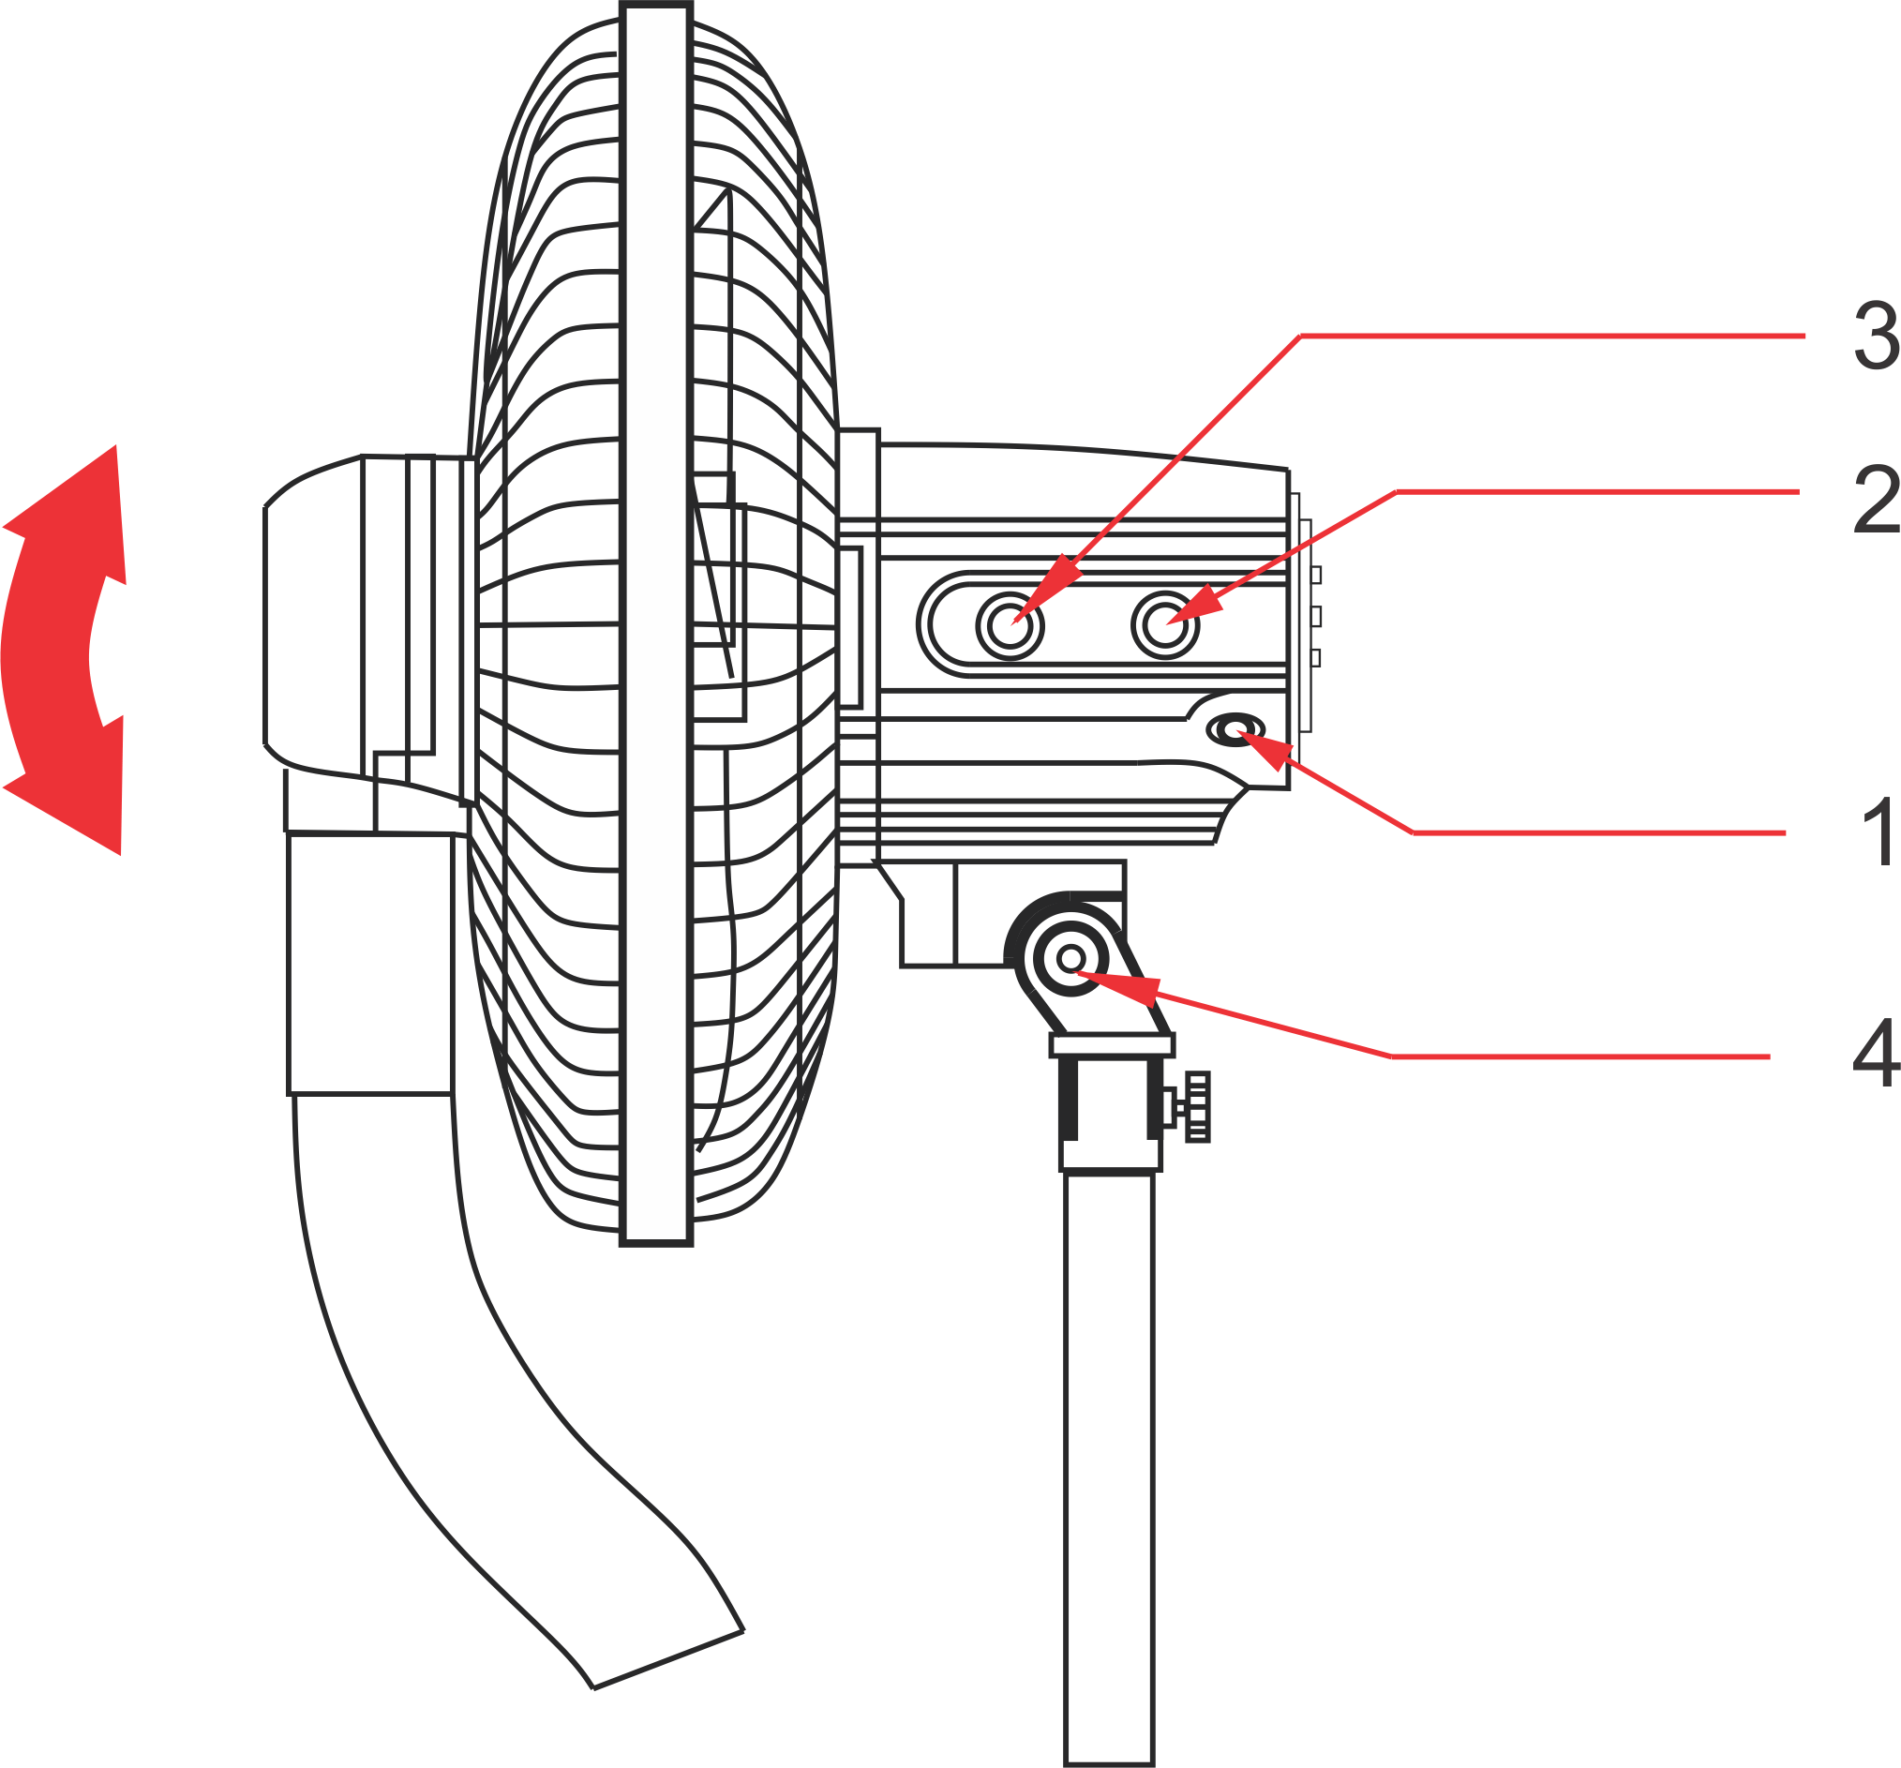

1. Oscillation switch
2. Mist button
3. Speed button
4. Angle adjustment lock nut
5. Insert the plug into the socket and turn on the fan, choose the function button to select the fan speed accordingly.
6. Speed button (3)：Operate this button and choose the fan speed level 1,2,3,4
7. Turn on mist switch (2); the mist will spray out from the mist outlet, “the mist” function can be used separately or in conjunction with the fan. If the mist function is used separately, it will increase the humidity in the air.
8. Switch on the oscillation switch (1), to change the wind direction. Switch off again to stop oscillation.
9. Angle adjustment: Adjust the fan guard direction to move the wind angle of the fan. If necessary slacken the lock nut (4) with a spanner, change the angle and then tighten the nut again

**CLEANING AND MAINTENANCE**

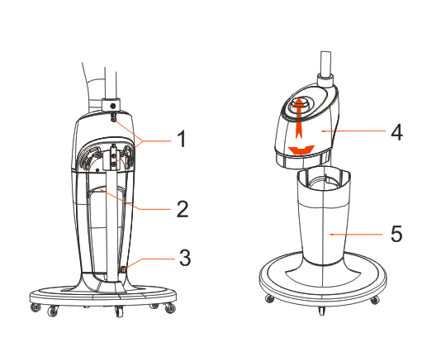

1. Screw
2. Overflow gap
3. Water release hole
4. Shell
5. Water tank
6. Mist tank
7. Upper water outlet
8. Lower water outlet
9. 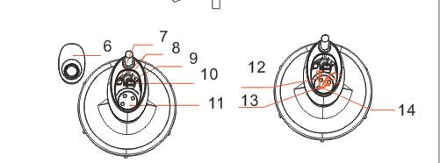Max water level
10. Wind outlet
11. Mist maker
12. Cleanser
13. Mist disk
14. Brush

Before cleaning, turn the unit off, unplug from the power supply and wait for the unit to cool down.

1. To clean the unit use a soft cloth to wipe off any dust.
2. Clean the water tank every two or three weeks, and clean the flume every week.
3. Remove the plastic tube from mist tank and remove the water tank to clean it.
4. Open the tank cover, use dry cloth to clean the mist tank or use mild detergent to clean the mist tank if it has mineral water residue.
5. Please add a few drops of lubricant to the motor shaft after cleaning it to extend motor life.

Keep the unit in a cool and dry place when not to be used for a long time.

**CAUTION:** Unplug fan from the electrical supply source before cleaning. After servicing, any safety device (including grilles and blades) it must be reinstalled or remounted as previously installed. Use soft damp cloth then wipe with dry cloth. Do not use harmful detergents. Do not bend the blades.

**STORING THE APPLIANCE**

* Unplug the unit from the wall outlet and clean all the parts as instructed above. Ensure that all parts are dry before storing.
* Store the appliance in its box or in a clean, dry place.
* Never store the appliance while it is still wet or dirty.

**SERVICING THE APPLIANCE**

There are no user serviceable parts in this appliance. If the unit is not operating correctly, please check the following:

• You have followed the instructions correctly

• That the unit has been wired correctly and that the wall socket is switched on.

• That the mains power supply is ON.

• That the plug is firmly in the mains socket.

If the appliance still does not work after checking the above:

- Consult the retailer for possible repair or replacement. If the retailer fails to resolve the problem and you need to return the appliance, make sure that:

• The unit is packed carefully back into its original packaging.

• Proof of purchase is attached.

• A reason is provided for why it is being returned.

If the supply cord is damaged, it must be replaced by the manufacturer or an authorised service agent, in order to avoid any hazard. If service becomes necessary within the warranty period, the appliance should be returned to an approved Home Of Living Brands (Pty) Limited service centre. Servicing outside the warranty period is still available, but will, however, be chargeable.

**CHANGING THE PLUG**

Should the need arise to change the fitted plug, follow the instructions below.

**This unit is designed to operate on the stated current only. Connecting to other power sources may damage the appliance. Connect a three-pin plug as follows:**

The wires in this mains lead are coloured in accordance with the following code:

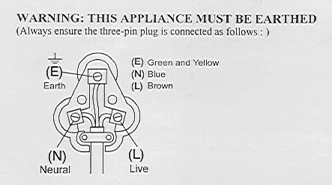

Green/Yellow = Earth

Blue = Neutral

Brown = Live

**PLEASE AFFIX YOUR PROOF OF PURCHASE/RECEIPT HERE**

**IN THE EVENT OF A CLAIM UNDER WARRANTY THIS RECEIPT MUST BE PRODUCED.**

***2 YEAR WARRANTY***

*1 year retail* ⵏ *1 year extended warranty upon registration\**

*visit www.russellhobbs.co.za*

*W A R R A N T Y AND EXTENDED WARRANTY*

1. Home of Living Brands (Pty) Limited ("Home of Living Brands") warrants to the original purchaser of this product ("the customer") that this product will be free of defects in quality and workmanship which under normal personal, family or household use and purpose may manifest within a period of 1 (one) year from the date of purchase ("warranty period").
2. Home of Living Brands shall extend the warranty period for a further period of 1(one) year (“extended warranty period*”), on condition that the purchaser registers the product on the website, within 12 months from the date of purchase of the product. The website address for registration is as follows: http://russellhobbs.co.za/info-pages/warranty-info.aspx. The extended warranty period only applies to products purchased on or after 1 October 2017.
3. Where the customer has purchased a product and it breaks, is defective or does not work properly for the intended purpose, the customer must notify the supplier from whom the customer bought the product ("the supplier") thereof within the warranty period or if applicable, the extended warranty period. Any claim in terms of this warranty must be supported by a proof of purchase. If proof of purchase is not available, then repair, and/or service charges may be payable by the customer to the supplier.
4. The faulty product must be taken to the supplier's service centre to exercise the warranty.
5. The supplier will refund, repair or exchange the product in terms of this warranty subject to legislative requirements. This warranty shall be valid only where (a) the customer is not the cause of the product breaking, and (b) the product has been used for the intended purpose stipulated in the product manual. The warranty does not include and will not be construed to cover products damaged as a result of disaster, misuse, tamper, abuse or any unauthorised modification or repair of the product.
6. This warranty will extend only to the product provided at the date of the purchase and not to any expendables attached or installed by the customer. In this regard any accessories supplied with the product by the supplier, may be excluded in this warranty or extended warranty (see Exclusions to Warranty and Extended Warranty document).
7. If the customer requests that the supplier repairs the product and the product breaks or fails to work properly within 3 (three) months of the repair and not as a result of misuse, tampering or modification by or on behalf of the customer, then the supplier may replace the product or pay a refund to the customer, subject to the supplier’s discretion.
8. The customer may be responsible for certain costs where products returned are not in the original packaging, or if the packaging is damaged. This will be deducted from any refund paid to the customer.

**HOME OF LIVING BRANDS (PTY) LTD (JOHANNESBURG)**

JOHANNESBURG TEL NO. (011) 490-9600

CAPE TOWN TEL NO. (021) 552-5161

DURBAN TEL NO. (031) 303-1163

www.homeoflivingbrands.com

www.russellhobbs.co.za

[www.facebook.com/RussellHobbsSA](http://www.facebook.com/RussellHobbsSA)

*EXCLUSIONS TO W A R R A N T Y AND EXTENDED WARRANTY*

1. Any accessories supplied with the product, including but not limited to, bowls, jugs, mills or carafes made either of glass or plastic and supplied with this appliance (hereinafter referred to as “the accessory or accessories”), is warranted to be free from material and workmanship defects for the duration of the appliance warranty.
2. The accessories should give trouble free service when used in accordance with the directions described in the instruction manual. However, the accessories will be damaged if subjected to impact, and this damage is not covered by the warranty. Such impact damage can occur either from the outside (if for example it is dropped or knocked against a hard surface), or from within (if for example foreign objects are placed within the accessories and the power is switched on).
3. Should you need to replace an accessory during the warranty period; a claim for a free replacement will only be considered if the item (including all shards and broken parts) is returned to the nearest HOLB service centre for examination.
4. The remains of the accessory will be carefully examined by the relevant professionals and if it is determined (at the sole discretion of HOLB) that the damage was caused by impact, then the claim will be refused and will not be covered by the warranty or any extended warranty.
5. Any replacement part provided in terms of clause 4 above will become a chargeable item payable by the customer.