INSTRUCTIONS OF USE

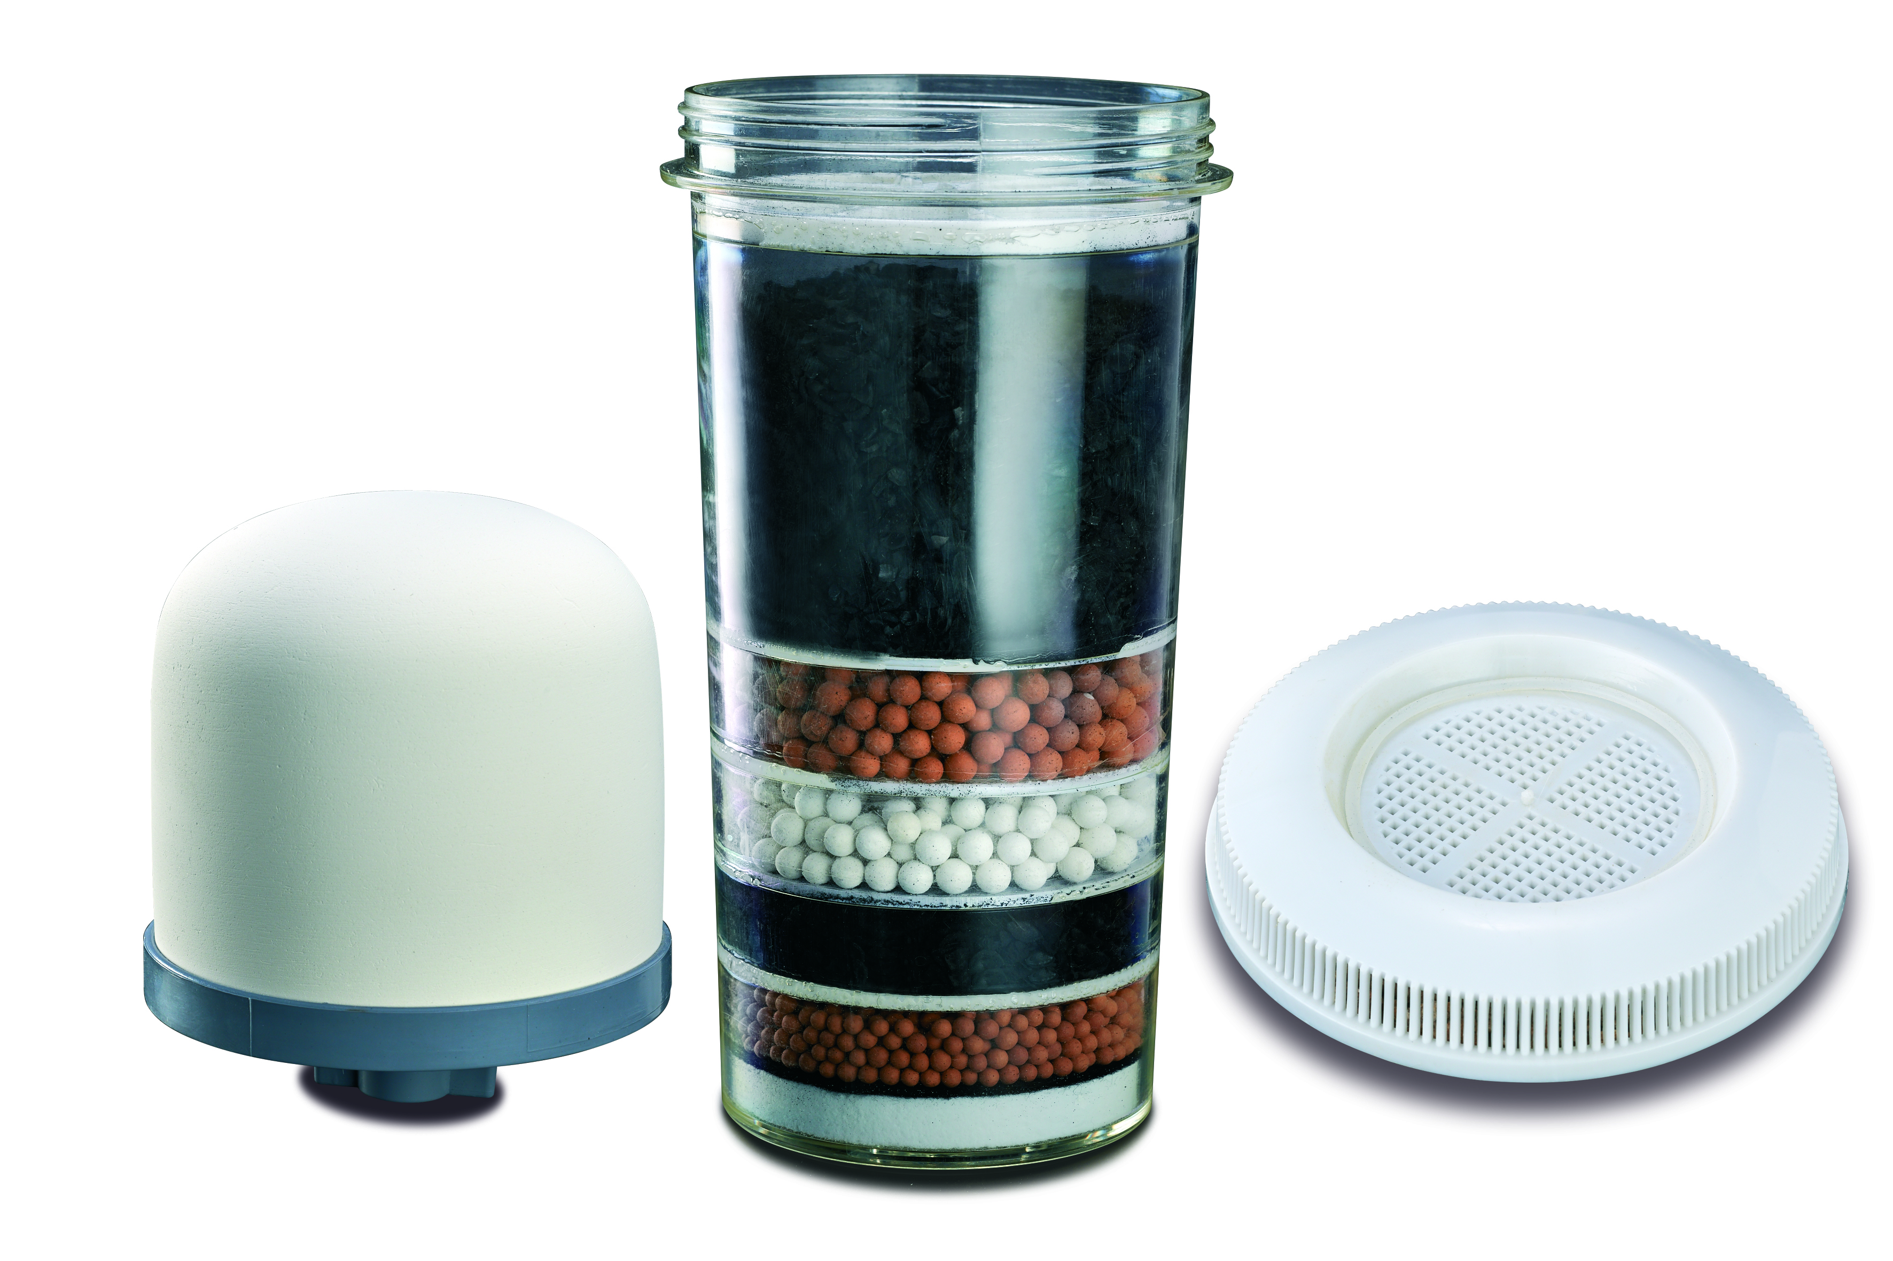

MODEL NO.: RHRWF3
Russell Hobbs Replacement Water Filter

Congratulations on purchasing our Russell Hobbs Replacement Water Filters. Each unit is manufactured to ensure safety and reliability. Before using this appliance for the first time, please read the instruction manual carefully and keep it for future reference.
FEATURES OF THE RUSSELL HOBBS REPLACEMENT WATER FILTERS:
- Ceramic Dome – the ceramic dome removes rust and sediment particles of 0.3 microns and larger.
- Carbon Filter - Activated carbon removes chlorine, trihalomethanes (as a result of chlorination), organic chemicals, unpleasant tastes and odours, creating fresh and clean purified water.
- Mineral Stones - contains germanium which is known for improving health and aiding towards cancer prevention. This stage adds minerals back into the water that may have been lost in stages 1 and 2.

BENEFITS OF THE RUSSELL HOBBS REPLACEMENT WATER FILTERS:
- Harmful bacteria is removed from the water and re-mineralized with ionised minerals.
- Filters up to 99% of all harmful bacteria and chlorine, improving taste and odour of the water.
- Provides, healthier, cleaner, safer drinking water.
- Filters are generally replaced every 3-6 months depending on the calcium content/ quality of water in your area.

PREPARATION
- Opening the packing box and check that the all parts are in accordance with the above illustration.
- Take the ceramic dome, active carbon and mineral stones out of the packaging and wash these parts gently under running water before first time use.
- Pre-soak the ceramic dome for 1-2 hrs before first time of use.
IMPORTANT NOTES:
- Allow the system to filter 3 times before first use to remove any residue, impurities and odors in the water.
- Ensure to change your filter every 3 to 8 months (depending on the condition of the water in your area)

HOME OF LIVING BRANDS (PTY) LTD (JOHANNESBURG)
JOHANNESBURG TEL NO. (011) 490-9600
CAPE TOWN TEL NO. (021) 552-5161
DURBAN TEL NO. (031) 303-1163
www.homeoflivingbrands.com
www.russellhobbs.co.za
www.facebook.com/RussellHobbsSA

