INSTRUCTIONS AND WARRANTY

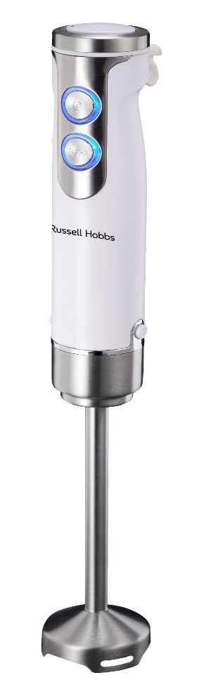

MODEL NO. RHSB018

RUSSELL HOBBS INFINITY 400W STICK BLENDER

Thank you for purchasing the Russell Hobbs Infinity 400W Stick Blender. Each unit has been manufactured to ensure safety, reliability and ease of use. Before use, please read the instructions carefully and keep it for future reference. Should you pass the unit on, please ensure that you also pass the instruction manual.

FEATURES OF THE RUSSELL HOBBS INFINITY 400W STICK BLENDER

- Bringing versatility, efficiency and effortless food preparation to your kitchen
- 400W of power for even smoother results
- Six speed settings
- Mixing cup included
- Durable stainless-steel blades
- Anti-splash blade guard
- Detachable stainless-steel mixing stick for quick and easy cleaning
- Multipurpose: Blends, mixes soups, mayonnaise, milkshakes and smoothies
- For domestic use only
- 2 year warranty (1 year retail • 1 year extended upon online registration of product • visit www.russellhobbs.co.za)

NOTE: USE EXTREME CARE WHEN HANDLING THE BLADES. DO NOT TOUCH THE BLADES WITH YOUR FINGERS. THE BLADES ARE SHARP AND CAN CAUSE INJURY.

IMPORTANT SAFEGUARDS

- Please read the instructions carefully before using the appliance.
- Always ensure that the voltage on the rating label corresponds to the mains voltage in your home.
- Incorrect operation and improper use can damage the appliance and cause injury to the user.
- The appliance is intended for household use only. Commercial use invalidates the warranty and the supplier cannot be held responsible for injury or damage caused when using the appliance for any other purpose than that intended.
- Always disconnect the appliance from the power supply if it is left unattended and before assembling, disassembling or cleaning.
- Avoid any contact with moving parts. Never touch the rotating tools while still in motion - always wait for them to come to a complete stop.
- Close supervision is required when any appliance is used near or by children.
- Check the power cord and plug regularly for any damage. If the cord or the plug is damaged, it must be replaced by the manufacturer or a qualified person in order to avoid an electrical hazard.
- Do not use the appliance if it has been dropped or damaged in any way. In a case where it has been damaged, take the unit in for examination and/or repair by an authorised service agent.
- To reduce the risk of electric shock, do not immerse or expose the motor assembly, plug or the power cord to water or any other liquid. Do not use it with wet hands.
- Never immerse the motor unit in water or any other liquid for cleaning purposes.
- Remove the plug from the socket by gripping the plug. Do not pull on the cord to disconnect the appliance from the mains. Always unplug the unit when not in use, before cleaning or when adding or removing parts.
- Insert only original parts. The use of accessory attachments that are not recommended or supplied by the manufacturer may result in injuries, fire or electric shock.
- A short cord is provided to reduce hazards resulting from becoming entangled in or tripping over a longer cord.
- Do not let the cord hang over the edge of a table or counter. Ensure that the cord is not in a position where it can be pulled on inadvertently.
- Do not allow the cord to touch hot surfaces and do not place on or near a hot gas or electric burner or in a heated oven.
- Do not use the appliance on a gas or electric cooking top or over or near an open flame.
- Keep the appliance and cord away from direct radiant heat from the sun, damp areas, sharp edges and other dangers.
- Use of an extension cord with this appliance is not recommended. However, if it is necessary to use an extension cord, ensure that the cord is suited to the power consumption of the appliance to avoid overheating the appliance or plug point. Do not place the extension cord in a position where it can be pulled on by children or animals or tripped over.
- This appliance is not suitable for outdoor use. Do not use this appliance for anything other than its intended use.
- DO NOT carry the appliance by the power cord.
- Do not leave this appliance unattended during use. Always unplug the unit when not in use or before cleaning.
- Always operate the appliance on a smooth, even, stable surface. Do not place the unit on a hot surface.
- Do not operate this appliance by means of an external timer or remote control system.
- Never use this appliance to mix, blend or stir anything other than foods.
- Do not use during cooking processes or with boiling liquids.
- The blades are very sharp. Be cautious when handling the sharp blades, emptying the bowl and during cleaning.
- Ensure that after each cycle the stick blender is switched off by pressing the power button on the blender.
- The manufacturer does not accept responsibility for any damage or injury caused by improper or incorrect use, or for repairs carried out by unauthorised personnel.
- In case of technical problems, switch off the blender and do not attempt to repair it yourself. Return the appliance to an authorised service facility for examination, adjustment or repair. Always insist on the use of original spare parts. Failure to comply with the above mentioned pre-cautions and instructions, could affect the safe operation of this unit.
- This appliance is not intended for use by persons (including children) with reduced physical, sensory or mental capabilities, or lack of experience and knowledge, unless they are under supervision or instruction concerning use of the appliance by a person responsible for their safety. Children should be supervised to ensure that they do not play with the appliance.

CAUTION: This appliance is not for professional use. It has a powerful motor which yields highly efficient results. There should be no need to run the motor for longer than the advisory cycle times below.

PLEASE FOLLOW THESE CYCLE TIMES TO HELP PROLONG THE LIFE OF YOUR APPLIANCE:
- If blending solid, hard or sticky ingredients, please use your blender for no longer than 15 seconds at a time. After blending for 15 seconds, let the blender cool down for a minute. This is one cycle. The blender can only be used for 3 consecutive cycles and must then be left to cool down for 30 minutes before using it again.
- If blending liquid or softer ingredients, please use your blender for no longer than 1 minute at a time. After using it for 1 minute, let it cool down for another minute. This is one cycle. The blender can only be used for 3 consecutive cycles and must then be left to cool down for 30 minutes before using it again.

PARTS DIAGRAM

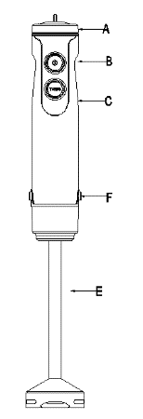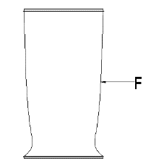
- Speed selector
- Power switch
- Turbo switch
- Motor unit
- Stainless steel blending leg
- Mixing cup
D

BEFORE FIRST USE

Before using your appliance for the first time, remove the appliance from the box and take off any protective wrappings.
REMEMBER: DO NOT LEAVE PROTECTIVE PACKAGING LYING AROUND, AS IT COULD BE DANGEROUS AROUND INFANTS.
Wash the blending leg and mixing cup in warm soapy water, rinse well and dry. Wipe the main motor unit with a slightly dampened cloth.

OPERATING INSTRUCTIONS

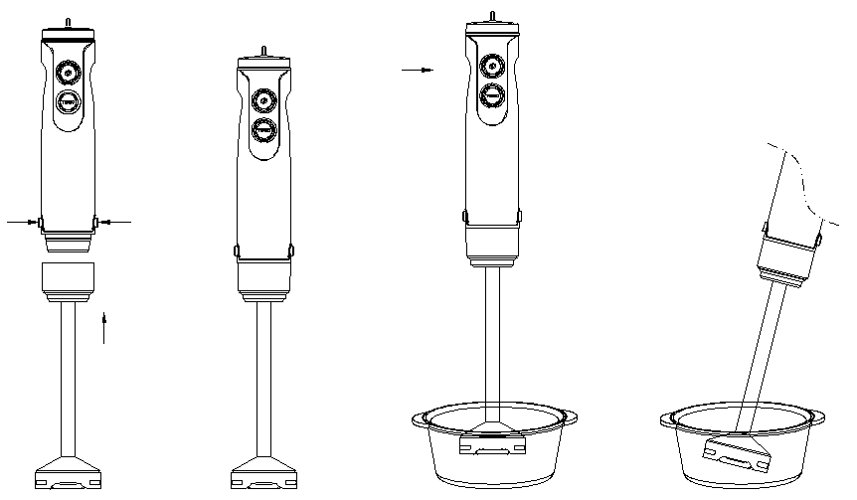

- Ensure that the stick blender is switched off at the power outlet and that the speed control is set to the ‘1’ speed position.
- Insert the blending leg attachment into the motor unit until it securely clicks into place.
- Place required ingredients into the mixing cup, a mixing bowl, beaker or any other durable bowl which is sufficiently tall and wide enough to avoid splashing.
- Immerse the blending leg into the ingredients as seen in the image above.
NOTE: Ensure the blending leg is not immersed beyond the point where the blending leg joins with the motor unit.
- Switch the unit on at the main power supply. Then press the power switch on to operate the unit.
NOTE: The unit will turn on immediately if the power switch is pressed even if the speed control is set on the ‘1’ speed setting– please be cautious.
- Use the speed selector to adjust the speed accordingly.
- Switch off the unit by pressing the power switch and unplugging it from the power outlet.

NEVER USE THIS APPLIANCE IN A BOWL OR SAUCEPAN WHILE COOKING.

SUGGESTIONS FOR USE
- Move the blending leg and blade gently around the mixture to ensure uniform results.
- If you want to scrape the ingredients off the sides and base of the mixing cup, beaker or container with a hand-held utensil, switch the stick blender off by pressing the power switch first. Under no cicumstances should other utenils be used while the stick blender is operating.
- To avoid unnecessary splashing, immerse the blending leg and blade into the mixture before switching the appliance on.
- The speed can be adjusted at any time. Use the lower speed setting to attain a thicker consistency. Use the higher speed setting to attain a finer consistency.

CLEANING AND MAINTENANCE

NOTE: Use extreme care when handling the blades at the bottom of the blending leg. Do not touch the blades with your fingers. The blades are very sharp and can cause injury.

- Make sure the unit is switched off and unplugged from the main power supply.
- Disconnect the blending leg attachment from the motor unit.
- It is much easier to clean the accessories directly after use.
- Clean the motor unit with a damp cloth only and dry thoroughly.
- Clean the blending leg attachment in warm soapy water, rinse and dry thoroughly.
- To remove stubborn spots, wipe the surface with a piece of cloth slightly dampened in soapy water. Follow with a clean, damp cloth.
- When processing foods with colour (e.g. carrots), parts of the appliance may become discoloured. Wipe these parts with vegetable oil before washing them.
- Do not use any abrasive cleaning material to clean any part of the stick blender, as it will harm the exterior.

CAUTION: The stick blender motor should never be submerged in water or held under running tap water. To clean, simply wipe with a damp cloth and dry thoroughly.

STORING THE APPLIANCE

- Unplug the unit from the wall outlet and clean all the parts as instructed above. Ensure that all parts are dry before storing.
- Store the appliance in its box or in a clean, dry place.
- Never store the appliance while it is still wet or dirty.

SERVICING THE APPLIANCE

There are no user serviceable parts in this appliance. If the unit is not operating correctly, please check the following:
- You have followed the instructions correctly
- That the unit has been wired correctly and that the wall socket is switched on.
- That the mains power supply is ON.
- That the plug is firmly in the mains socket.

If the appliance still does not work after checking the above:
- Consult the retailer for possible repair or replacement. If the retailer fails to resolve the problem and you need to return the appliance, make sure that:
- The unit is packed carefully back into its original packaging.
- Proof of purchase is attached.
- A reason is provided for why it is being returned.

If the supply cord is damaged, it must be replaced by the manufacturer or an authorised service agent, in order to avoid any hazard. If service becomes necessary within the warranty period, the appliance should be returned to an approved Home Of Living Brands (Pty) Limited service centre. Servicing outside the warranty period is still available, but will, however, be chargeable.

CHANGING THE PLUG

Should the need arise to change the fitted plug, follow the instructions below.
This unit is designed to operate on the stated current only. Connecting to other power sources may damage the appliance.

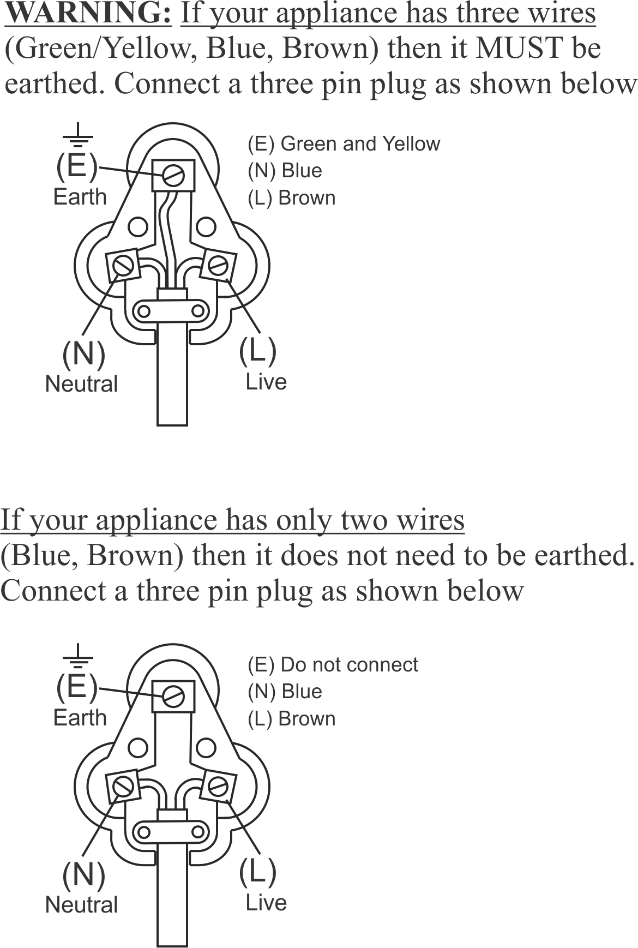

PLEASE AFFIX YOUR PROOF OF PURCHASE/RECEIPT HERE
IN THE EVENT OF A CLAIM UNDER WARRANTY THIS RECEIPT MUST BE PRODUCED.

2 YEAR WARRANTY
1 year retail ⵏ 1 year extended warranty upon registration*
visit www.russellhobbs.co.za

W A R R A N T Y AND EXTENDED WARRANTY

- Home of Living Brands (Pty) Limited ("Home of Living Brands") warrants to the original purchaser of this product ("the customer") that this product will be free of defects in quality and workmanship which under normal personal, family or household use and purpose may manifest within a period of 1 (one) year from the date of purchase ("warranty period").
- Home of Living Brands shall extend the warranty period for a further period of 1(one) year (“extended warranty period*”), on condition that the purchaser registers the product on the website, within 12 months from the date of purchase of the product. The website address for registration is as follows: http://russellhobbs.co.za/info-pages/warranty-info.aspx. The extended warranty period only applies to products purchased on or after 1 October 2017.
- Where the customer has purchased a product and it breaks, is defective or does not work properly for the intended purpose, the customer must notify the supplier from whom the customer bought the product ("the supplier") thereof within the warranty period or if applicable, the extended warranty period. Any claim in terms of this warranty must be supported by a proof of purchase. If proof of purchase is not available, then repair, and/or service charges may be payable by the customer to the supplier.
- The faulty product must be taken to the supplier's service centre to exercise the warranty.
- The supplier will refund, repair or exchange the product in terms of this warranty subject to legislative requirements. This warranty shall be valid only where (a) the customer is not the cause of the product breaking, and (b) the product has been used for the intended purpose stipulated in the product manual. The warranty does not include and will not be construed to cover products damaged as a result of disaster, misuse, tamper, abuse or any unauthorised modification or repair of the product.
- This warranty will extend only to the product provided at the date of the purchase and not to any expendables attached or installed by the customer. In this regard any accessories supplied with the product by the supplier, may be excluded in this warranty or extended warranty (see Exclusions to Warranty and Extended Warranty document).
- If the customer requests that the supplier repairs the product and the product breaks or fails to work properly within 3 (three) months of the repair and not as a result of misuse, tampering or modification by or on behalf of the customer, then the supplier may replace the product or pay a refund to the customer, subject to the supplier’s discretion.
- The customer may be responsible for certain costs where products returned are not in the original packaging, or if the packaging is damaged. This will be deducted from any refund paid to the customer.

HOME OF LIVING BRANDS (PTY) LTD (JOHANNESBURG)

JOHANNESBURG TEL NO. (011) 490-9600
CAPE TOWN TEL NO. (021) 552-5161
DURBAN TEL NO. (031) 303-1163

www.homeoflivingbrands.com
www.russellhobbs.co.za
www.facebook.com/RussellHobbsSA

EXCLUSIONS TO W A R R A N T Y AND EXTENDED WARRANTY

- Any accessories supplied with the product, including but not limited to, bowls, jugs, mills or carafes made either of glass or plastic and supplied with this appliance (hereinafter referred to as “the accessory or accessories”), is warranted to be free from material and workmanship defects for the duration of the appliance warranty.
- The accessories should give trouble free service when used in accordance with the directions described in the instruction manual. However, the accessories will be damaged if subjected to impact, and this damage is not covered by the warranty. Such impact damage can occur either from the outside (if for example it is dropped or knocked against a hard surface), or from within (if for example foreign objects are placed within the accessories and the power is switched on).
- Should you need to replace an accessory during the warranty period; a claim for a free replacement will only be considered if the item (including all shards and broken parts) is returned to the nearest HOLB service centre for examination.
- The remains of the accessory will be carefully examined by the relevant professionals and if it is determined (at the sole discretion of HOLB) that the damage was caused by impact, then the claim will be refused and will not be covered by the warranty or any extended warranty.
- Any replacement part provided in terms of clause 4 above will become a chargeable item payable by the customer.

