

INSTRUCTIONS AND WARRANTY

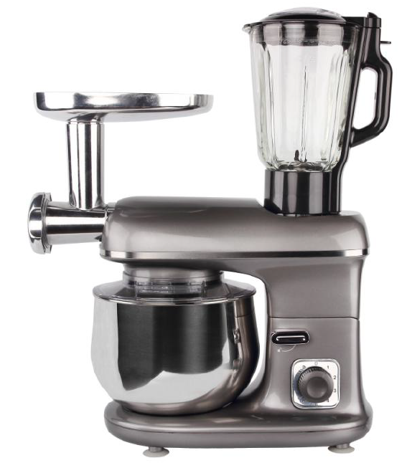

RHSB350

RUSSELL HOBBS
MULTI-PRO KITCHEN MACHINE

Congratulations on purchasing your Russell Hobbs Multi-Pro Kitchen Machine. Each unit is manufactured to ensure safety and reliability. Before using this appliance for the first time, please read the instruction manual carefully and keep it for future reference.

FEATURES OF THE RUSSELL HOBBS MULTI-PRO KITCHEN MACHINE

- Powerful 1100W motor
- Classic Titanium finish
- Oversized 5L stainless steel bowl with transparent splash guard
- 10 speed control plus pulse
- One system for mixing, kneading, blending, chopping, mincing and much more!
- The kitchen machine includes the following accessories:
- 0.5L Plastic food processor bowl with chopping blade, slicer, shredder and chip slicing discs
- 1.5L Glass blending jug
- Dough hook
- Balloon whisk
- Cream beater
- Citrus juicer with 2 x cones
- Mincer attachment with 3 different mincing grades
- Non-slip rubber feet for stability
- For domestic use only
- 2 year warranty (1 year retail • 1 year extended upon online registration of product • visit www.russellhobbs.co.za)

IMPORTANT SAFEGUARDS

When using any electrical appliance, basic safety precautions should always be followed including the following:

- Please read the instructions carefully before using any appliance.
- Always ensure that the voltage on the rating label corresponds to the mains voltage in your home.
- Incorrect operation and improper use can damage the appliance and cause injury to the user.
- The appliance is intended for household use only. Commercial use invalidates the warranty and the supplier cannot be held responsible for injury or damage caused when using the appliance for any other purpose than that intended.
- Avoid any contact with moving parts. Always use the safety pusher when utilizing the food processing attachment.
- This appliance is not intended for use by persons (including children) with reduced physical, sensory or mental capabilities, or lack of experience and knowledge, unless they are under supervision or given instructions concerning use of the appliance by a person responsible for their safety.
- Children should be supervised to ensure that they do not play with the appliance.
- Check the power cord and plug regularly for any damage. If the cord or the plug is damaged, it must be replaced by the manufacturer or a qualified person in order to avoid an electrical hazard.
- Do not use the appliance if it has been dropped or damaged in any way. In case of damage, take the unit in for examination and/or repair by an authorised service agent.
- To reduce the risk of electric shock, do not immerse or expose the motor assembly, plug or the power cord to water or any other liquid.
- Never immerse the unit in water or any other liquid for cleaning purposes.
- Remove the plug from the socket by gripping the plug. Do not pull on the cord to disconnect the appliance from the mains. Always unplug the unit when not in use, before cleaning or when adding or removing parts.
- The use of accessories that are not recommended or supplied by the manufacturer may result in injuries, fire or electric shock.
- A short cord is provided to reduce the hazards resulting from becoming entangled in or tripping over a longer cord.
- Do not let the cord hang over the edge of a table or counter. Ensure that the cord is not in a position where it can be pulled on accidently.
- Do not allow the cord to touch hot surfaces and do not place on or near a hot gas or electric burner.
- Do not use the appliance on a gas or electric cooking top or over or near an open flame.
- Use of an extension cord with this appliance is not recommended. However, if it is necessary to use an extension lead, ensure that the lead is suited to the power consumption of the appliance to avoid overheating of the extension cord, appliance or plug point. Do not place the extension cord in a position where it can be pulled on by children or animals or tripped over.
- This appliance is not suitable for outdoor use. Do not use this appliance for anything other than its intended use.
- DO NOT carry the appliance by the power cord.
- Take care when lifting this appliance as it is heavy. Ensure that the head is locked and that the bowl, accessories, cover plate and cord are secure before lifting.
- Do not leave this appliance unattended during use. Always unplug the unit when not in use or before cleaning.
- Always operate the appliance on a smooth, even and stable surface. Do not place the unit on a hot surface.
- Ensure that the switch is in the “0” position after each use.
- Do not use this appliance to process any substance(s) not intended for processing e.g. paint, metals, etc.
- Do not use the jug blender accessory and other accessories at the same time.
- Please note when the blender, food processor or mincer attachment are not in use, the cover plates should be in place otherwise the unit will not work.
- Do not operate this appliance by means of an external timer or separate remote control system.
- The manufacturer does not accept responsibility for any damage or injury caused by improper or incorrect use, or for repairs carried out by unauthorised personnel.
- In case of technical problems, switch off the machine and do not attempt to repair it yourself. Return the appliance to an authorised service facility for examination, adjustment or repair.
- Always insist on the use of original spare parts. Failure to comply with the above mentioned precautions and instructions, could affect the safe operation of this machine.

THIS APPLIANCE IS FOR HOUSEHOLD USE ONLY

PARTS DIAGRAM
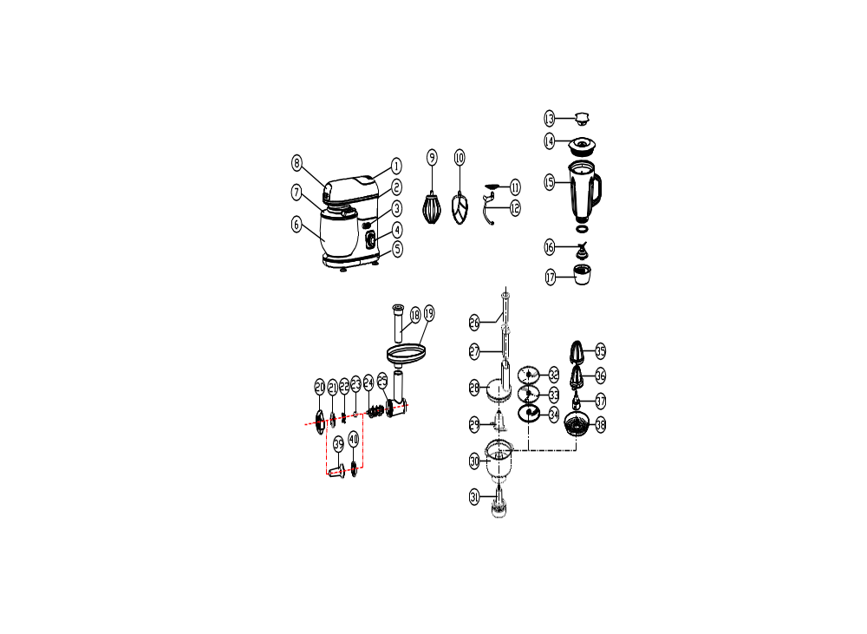

1. | Blender cover plate | 2 | Mixer head
3. | Release switch | 4. | Speed control knob
5. | Motor base | 6. | Mixing bowl
7. | Lid | 8. | Mincing cover plate
9. | Whisk | 10. | Flat beater
11. | Splash guard | 12. | Kneading hook
13. | Removeable filter cap | 14. | Blender lid
15. | Glass jug | 16. | Jug blades
17. | Blade Assembly Base | 18. | Mincer safety pusher
19. | Meat tray | 20. | Ring nut
21. | Mincing disk | 22. | Mincer blade
23. | Silicon coupling | 24. | Mincer scroll
25. | Meat grinder body | 26 | Food processor small pusher
27. | Food processor large pusher | 28 | Food processor bowl cover
29. | Stainless steel chopping blade | 30. | Food processor bowl
31. | Food processor connector | 32. | Thin slicer/shredder disc
33. | Thick slicer/shredder disc | 34. | Stainless steel chip slicing disc
35. | Large juicer cone | 36. | Small juicer cone
37. | Citrus juicer connector | 38. | Citrus pulp strainer

OPERATING INSTRUCTIONS

BEFORE FIRST USE

Before using this appliance for the first time, unpack the appliance and remove all protective packaging and wrappings.

Please ensure to discard or store the protective packaging and wrappings immediately. It is important to keep these away from babies, infants and children for safety purposes.

All parts of the kitchen machine need to be thoroughly cleaned before being used for the first time. (See “Cleaning and maintenance” section).

NOTE: When the food processor, blender or meat grinder is not attached to the kitchen machine or when not in use, ensure the cover plates are placed securely on the machine otherwise the machine will not operate. (Refer to image below)

Ensure the cover plate is on when not in use/when blender or food processor is not attached.
Ensure the cover plate is on when not in use/when the meat grinder is not attached.
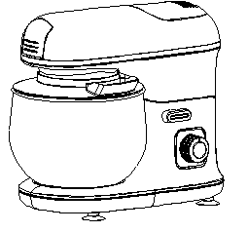

RAISING THE HEAD

Note: Accessories such as the blender should not be attached when raising the
head.

- Ensure that the kitchen machine is switched off and unplugged.
- Turn the release switch clockwise to unlock, as marked on the appliance.
- The head will lift, with your assistance, allowing removal/replacement of the stainless-steel bowl and/or mixing accessories. In its uppermost position the head will lock into place and the release switch will return to the lock position.

LOWERING THE HEAD

Caution: Keep hands and items clear of the head’s pivoting area to avoid injury or damage to the appliance.

- Ensure that the required mixing accessory is correctly fitted and the mixing bowl is in position.
- Turn the release switch clockwise to the unlock position.
- Gently lower the head by pressing down on the top of the kitchen machine until it locks into position.
- The release switch will return to the lock position.

SPLASH GUARD

The mixing bowl can be used with or without the splash guard. It is recommended to use the mixing bowl with the splash guard and chute cover fitted to avoid spatter.

- Ensure that the kitchen machine is switched off and unplugged.
- Raise the head (see “Raising the head” section).
- Remove any mixing accessories from the mixing accessory drive.
- The splash guard fits onto the underside of the head, above the mixing accessory drive.

FITTING THE SPLASH GUARD

- Hold the splash guard by the feeding chute.
- Fit the first latch on the splash guard (the latch nearest to the feeding chute) over the notch on the head.
- Push the opposite side of the splash guard upwards until the second latch clicks into place onto the notch at the rear of the head.

REMOVING THE SPLASH GUARD

- Carefully pull down the rear of the splash guard to release the rear latch from the notch on the rear of the head.
- With the rear latch now disengaged, the splash guard can be lowered and removed from the head.

CHUTE COVER

Caution: Do not insert fingers or utensils into the feeding chute at any time.

- To avoid spatter, ensure the chute cover is fitted when the kitchen machine is in use.
- The chute cover sits on top of the feeding chute on the splash guard.
- Lift the chute cover off to add ingredients.

MIXING BOWL

Caution: Only use the bowl supplied - do NOT attempt to use any other bowl.
The head must be raised to allow for fitting or removing of the bowl (see “Raising the Head” Section).
Note: It is much easier to fit and remove the bowl without the mixing accessories
fitted.

FITTING THE BOWL

- Fit the bowl in the space provided in the kitchen machine base.
- Turn the bowl anti-clockwise to lock it in place.

REMOVING THE BOWL

- Turn the bowl clockwise to release it from its fittings.
- Lift it out of the kitchen machine base.

MIXING ACCESSORIES

Caution: Fit and remove the mixing accessories with the kitchen machine head
raised and ensure that the unit is switched off and unplugged.

FITTING ACCESSORIES

- Ensure that the kitchen machine is switched off and unplugged.
- Raise the head (see “Raising the Head” section)
- Select the appropriate accessory:
  - Creamer-Beater: For making cakes, biscuits, pastry, icing, fillings, éclairs and mashed potato.
  - Balloon Whisk: For eggs, cream, batters, fatless sponges, meringues, cheesecakes, mousses, soufflés. Do not use the whisk for heavy mixtures (e.g. creaming fat and sugar), you could damage it.
  - Dough Hook: For yeast mixtures.
- Turn the release switch clockwise to lift the machine head and insert the creamer-beater, dough hook or whisk.
- Push the top of the accessory into the mixing accessories drive and turn it anti-clockwise to lock it into place.
- Now lower the head of the appliance by turning the release switch clockwise and lower it down until you hear a clicking sound. This means that the machine head has safely returned to the correct position.

REMOVING ACCESORIES

- Press the accessory up into the mixing accessory drive and turn it clockwise.
- Pull it down and out of the mixing accessory drive.

POWER UP

Caution: - If the speed control is not set to ‘0' (off position), the kitchen machine will start when the power supply is connected. Please fit accessories correctly to avoid damaging the machine.
- Check that the speed control is set to "0".
- Put the plug into the wall power outlet and switch it on.

SPEED CONTROL

- Turn the speed control clockwise to the speed you want.
- Turn the speed control back to "0" to turn the motor off.
- Pressing the “P” on the speed control dial will give you a pulse at a high speed.

Caution: Do not run the motor continuously for more than 10 minutes, it may overheat. After 10 minutes, switch off for at least 30 minutes to let the motor cool.

PULSE FUNCTION ("P")

- Press the “P” on the speed control dial which will give you a short burst at a high speed.
- Use "P" as a "pulse" function, for greater control over the mixing process.

Caution: do not use "P’"pulse function with the dough hook accessory, you may overload the motor.

Note: the contents of the bowl will rise when you start the motor – the higher the speed, the more they will rise. It is recommended to fill the bowl to no more than half of its capacity.

HOT LIQUIDS

Caution: Take extreme care if mixing hot liquids. The mixing accessories may splash liquids creating a scalding hazard. Ideally, you should not try mixing liquids that are hotter than you can comfortably handle i.e. temperatures below 40°C. If your recipe calls for mixing liquids hotter than 40°C, ensure you take steps to prevent scalding from possible splatter.

POWER DOWN

Turn the speed control to the ‘0’ (off position) and wait until the mixing accessory stops moving before placing hands or utensils in the bowl or raising the head.

JUG BLENDER

Use the blender jug for blending room temperature soups, sauces, smoothies and cocktails, making mayonnaise, hollandaise, breadcrumbs and pesto.

BEFORE USE

All parts of the kitchen machine including the blender jug need to be thoroughly cleaned before being used for the first time (see the “Cleaning and Maintenance” section).

POSITIONING
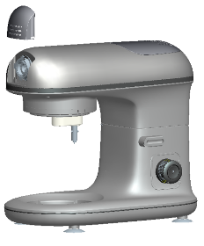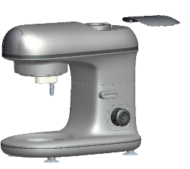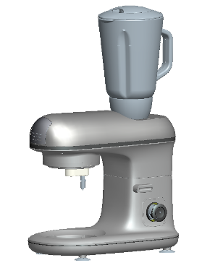

- Place the Multi-Pro kitchen machine on a firm, stable, level surface.
- Position the power cord away from the edge of tables or countertops so it cannot be tripped over or caught.

Caution: Do not operate the blender accessory empty for more than 1 (one) minute. Never fill the glass jug with boiling liquid. Allow liquids to cool down to ambient room temperature. By not following this caution, the appliance could overheat and the glass of the jug could crack.

USING THE JUG

Caution: The blades are very sharp. Handle the blender with extreme care and caution.
- Slide the blender drive cover to open the cover and expose the drive for the jug.
- Lower the jug onto the drive.
- Push the handle towards the rear of the kitchen machine to turn the jug anti-clockwise and lock it into place.

FILLING THE JUG

Caution: Do not use the jug without fitting the lid.

- Place the ingredients into the jug.
- Do not fill past the MAX mark as the contents may force their way past the lid when you start the motor.
- Fit the lid on the jug and press it down fully to secure it.

POWER UP

Caution: - If the speed control is not set to the ‘0’ (off position) the kitchen machine will start when the power supply is connected. If accessories are not fitted correctly you may damage the machine.

- Check that the speed control is set to “0”.
- Put the plug into the wall power outlet and switch it on.

SPEED CONTROL

- Turn the speed control clockwise to the speed you want.
- Press the "P" for "pulse" function which will give you a pulse at a high speed.
- Turn the speed control back to “0” to turn the motor off.

CAUTION: Do not run the motor continuously for more than 10 minutes, it may overheat. After 10 minutes, switch off for at least 30 minutes to let the motor cool.
PULSE FUNCTION (‘P’)

- Turning the speed control anti-clockwise to ‘P’ will give you a short burst at high speed.
- Use ‘P’ as a “pulse” function, for greater control over the mixing process.

ADDING INGREDIENTS

Ensure that larger pieces of food are cut into small pieces before blending. Their approximate size should be 2cm × 2cm × 2cm.

If you need to add solid ingredients after you have started blending:
- Turn the speed control to “0” (off position)
- Wait until the blades stop moving.
- Remove the lid.
- Add the ingredients.
- Replace the lid.
- Start the motor.

You may add liquid ingredients (such as oil, cream, water, etc.) to the food while blending. To do so, use the removeable filter cap located on top of the blender jug lid. Ensure to replace the removeable filter cap after adding additional ingredients.

Caution: Check that the added ingredients do not push the volume over the MAX mark.

POWER DOWN

- Turn the speed control to the ‘0’ (off position) and wait until the blades stop moving before removing the lid from the jug or removing the jug from the motor unit.
- Turn the jug clockwise to remove it.
- Lift the jug off the drive.
THE BLADE UNIT

REMOVING THE BLADE UNIT

- Remove the lid and turn the jug upside down.
- Use the grips to turn the blade unit anti-clockwise to release the latches on the blade unit from the tabs on the inside of the jug.
- Lift the blade unit out of the jug.

Caution: The blades are very sharp. Handle with extreme care and caution, using only the plastic parts.

FITTING THE BLADE UNIT

- Lower the blade unit into the upturned jug.
- Use the grips to turn the blade unit clockwise to engage the latches on the blade unit with the tabs on the inside of the jug.

USING THE MINCER ACCESSORY

The mincer accessory is intended to be used to process all types of meat. It also includes discs with different mincing grades to suit each preference.

- Trim the meat, removing excess fat, gristle and sinew. Place the meat you plan to mince in the freezer for at least 24 hours. This will allow it to chill, keeping the mincer from gumming up during the mincing process.
- Wash and dry the blades and inside shoot of the mincer. Choose the disc and set up the grinder as per below.
- Cut the meat into 3cm cubes.
- Feed the cubes into the mincer until the feed shoot is full.
- Place a bowl beneath the exit shoot of the mincer.
- Turn the power ON. Press the meat into the body of the mincer using the safety pusher that came with the machine.
- Continue to feed the mincer, pushing down with the pusher, until all the meat is ground.
1.  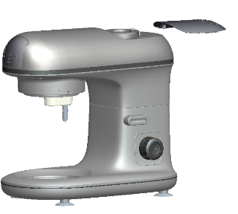  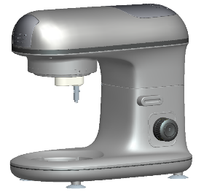 | 1.Place the appliance on a flat surface, e.g. a kitchen counter, and make sure it is standing firmly.  2.Place the blender cover plate onto the mixer head.
2.  2.1  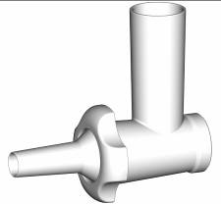  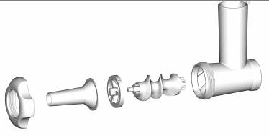 | 1. Fit the mincer scroll (24) in the meat grinder body (25) with the thin metal connection outwards, then press it firmly into place.
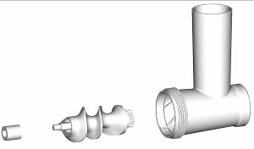  2.2    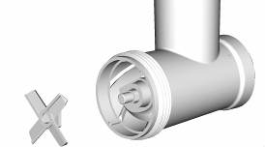    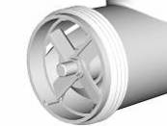  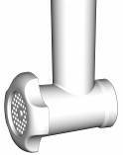  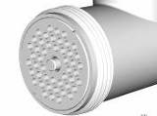  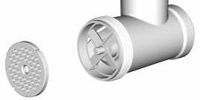  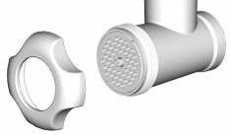 | 1. Fit the mincer scroll (24) in the meat grinder body (25) with the thin metal connection outwards then press firmly into place.  2. Fit the silicon coupling (23) onto the scroll connection  3. Fit the cutter (22) onto the scroll connection. The sharp edges of the cutter should point towards the mincing disk.  4. Fit the mincing disk (21) on top of the cutter. Turn the mincing disk so the two indentations are aligned with the pins on the meat grinder body. Select the mincing disk for the required consistency: choose between fine, medium and coarse.  5. Fit the ring nut (20) over the mincing disk on the meat grinder body. Turn clockwise to lock. The ring nut must hold the mincing disk securely in place. But do not over tighten.
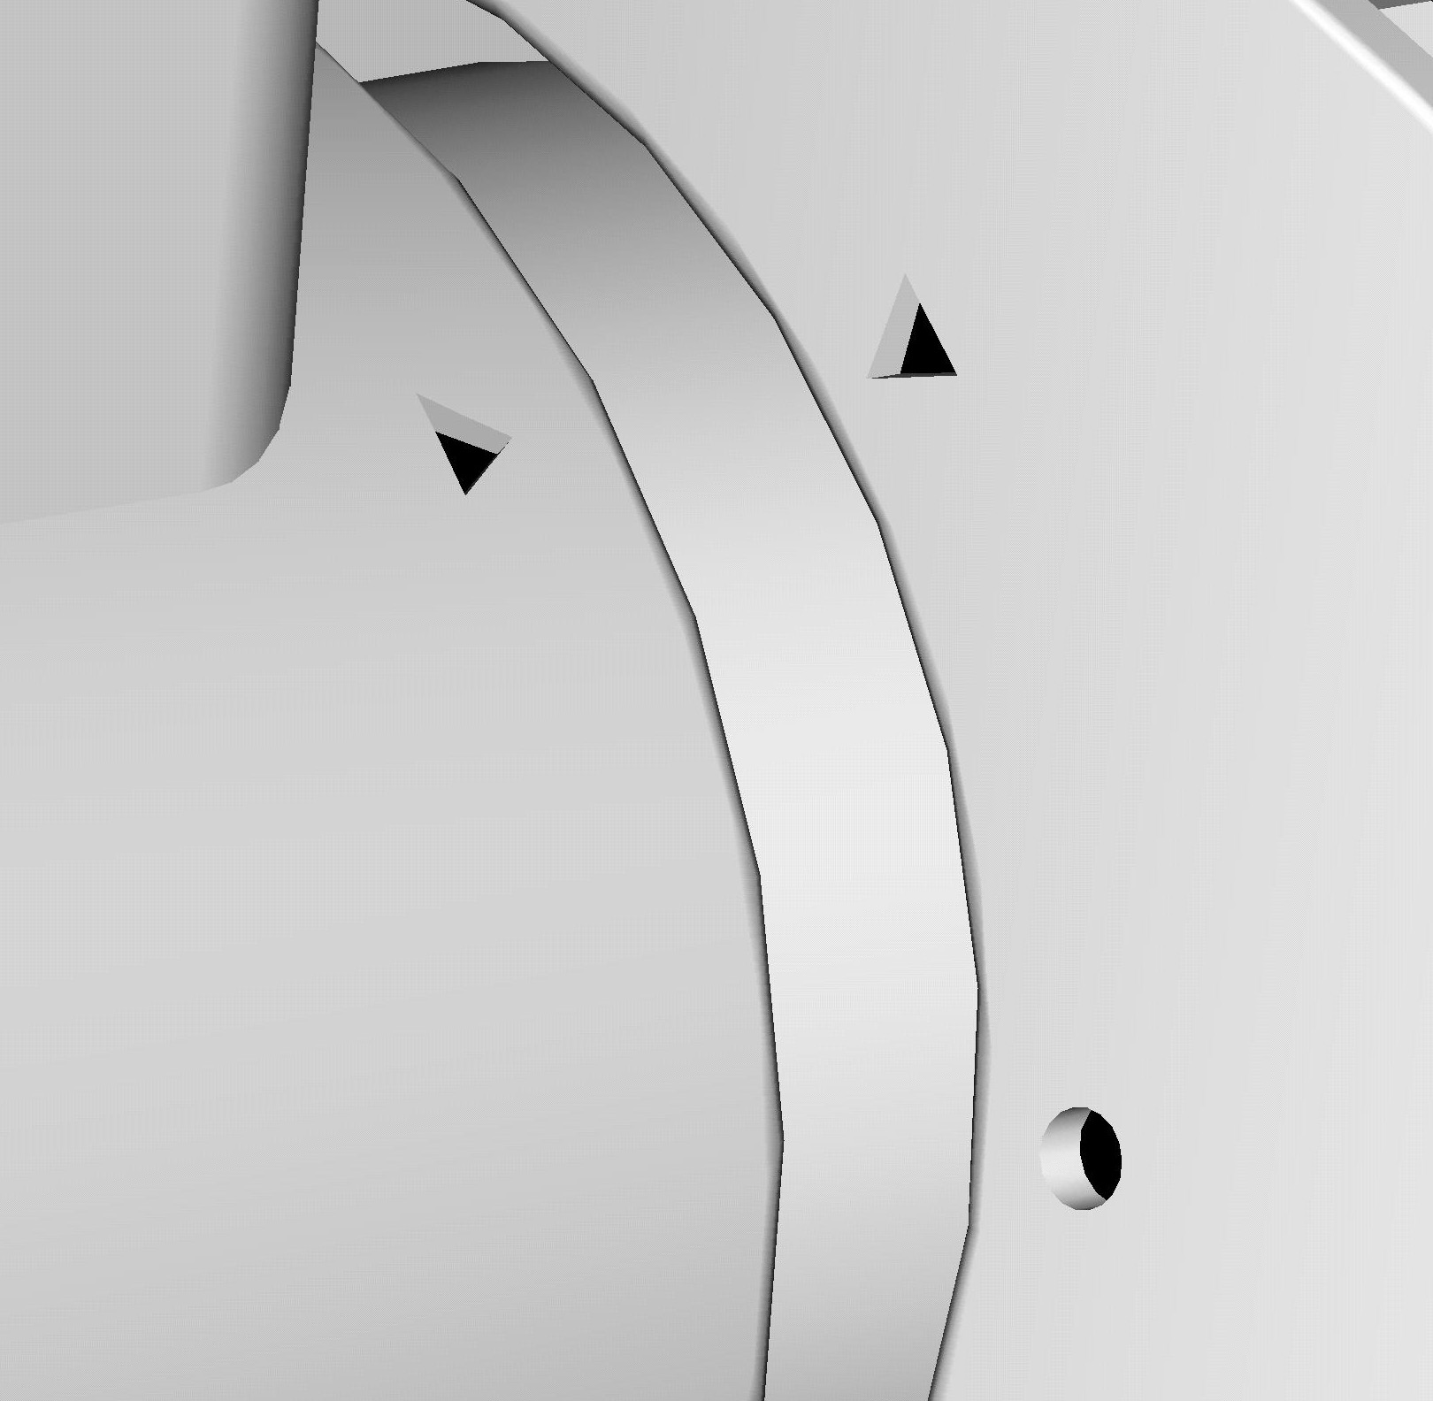      3.  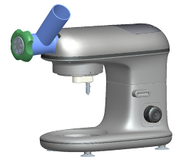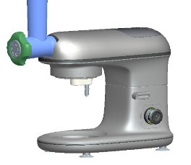 | 1. Fit the meat grinder body (25) in the mixer head (2) socket, ensuring that the arrow is aligned with the circle. Turn it in an anti-clockwise direction so that both arrows are aligned with the arrow.
4.  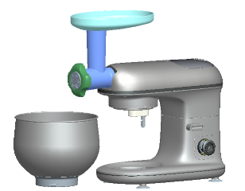 | 1. Fit the meat tray (19) onto the meat grinder body (25) so that the wide part is positioned over the motor house of the appliance.  2. Place the mixing bowl (6) or a similar bowl under the meat grinder body opening.  3. The appliance is now ready for use.
5.  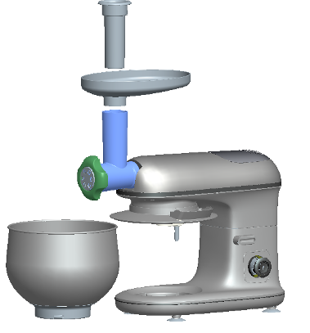 | 1. Plug the power cord into main power outlet and switch to desired speed control.  2.Cut your meat into smaller pieces, so the pieces fit into the feeding tube. Dice or cut into strips with a width of approximately 2.5 cm. Place the pieces onto the meat tray (19).  3. Select the speed you want using the speed dial.  4.The meat pieces travel down the feeding tube. Push down carefully with the meat safety pusher (18). Do not press too hard, otherwise you may damage the appliance.
6.  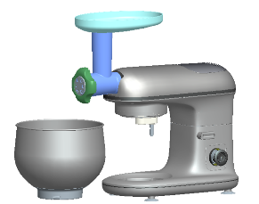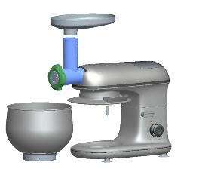 | 1.Switch off the appliance once you have finished grinding the meat. Unplug it before you change the accessories, or before you take the appliance apart or when not in use.  2.Remove mincer safety pusher and meat tray.
7.  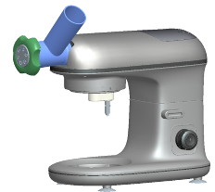 | 1. To detach the meat grinder, turn the body clockwise so the arrow is aligned with the circle and then remove it.
8.  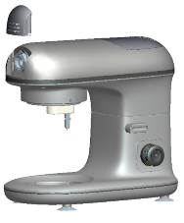 | 1. Fit the cover plate over the accessory socket again.

BEFORE USE

All parts of the kitchen machine need to be thoroughly cleaned before being used for the first time (see the “Cleaning and Maintenance” section).

FOOD PROCESSOR

A Food Processor allows you to chop, grate and slice, particularly in large quantities which will save you time. Vegetables, fruits and nuts are easy as pie. It is ideal if you want to make a stuffing. It can also evenly chop meat much more efficiently.

It is also good at slicing whatever you need, such as cucumbers; apples, cabbages and potatoes, ensuring it slices the ingredients evenly and precisely.

Why not try a whole-egg mayonnaise, for example. It can then be made into a chunky tartar sauce, with capers, cornichons (baby gherkins) and parsley chopped in at the end.
With a little crème fraiche and some butter, a processor will make a lovely smooth, velvety parsnip purée.

Grating large quantities can be hard work by hand. Make light work of something hard, such as fresh coconut, and if you need a large amount of freshly grated Parmesan, it is all speedily and easily done.

Caution: Do not use the food processor to mash potatoes or to process hard spices such as nutmeg.

POSITIONING

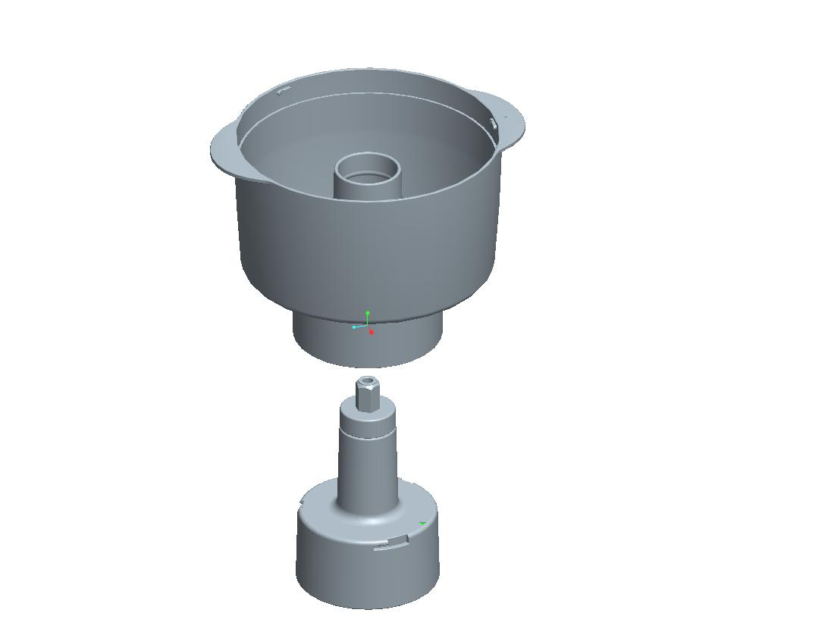
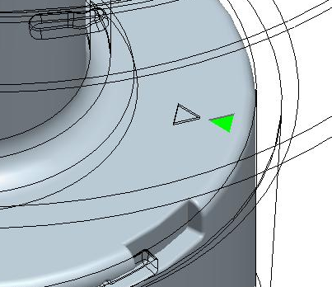

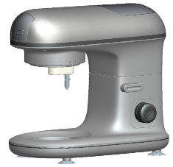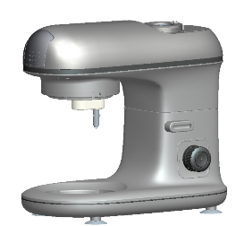
1
2

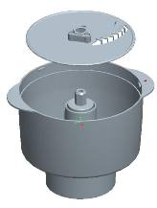
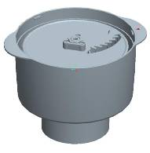
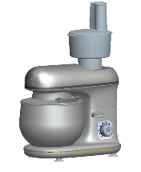
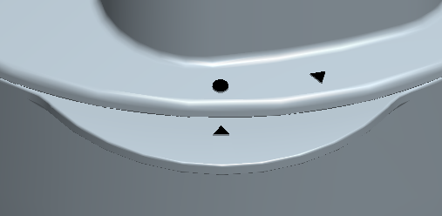
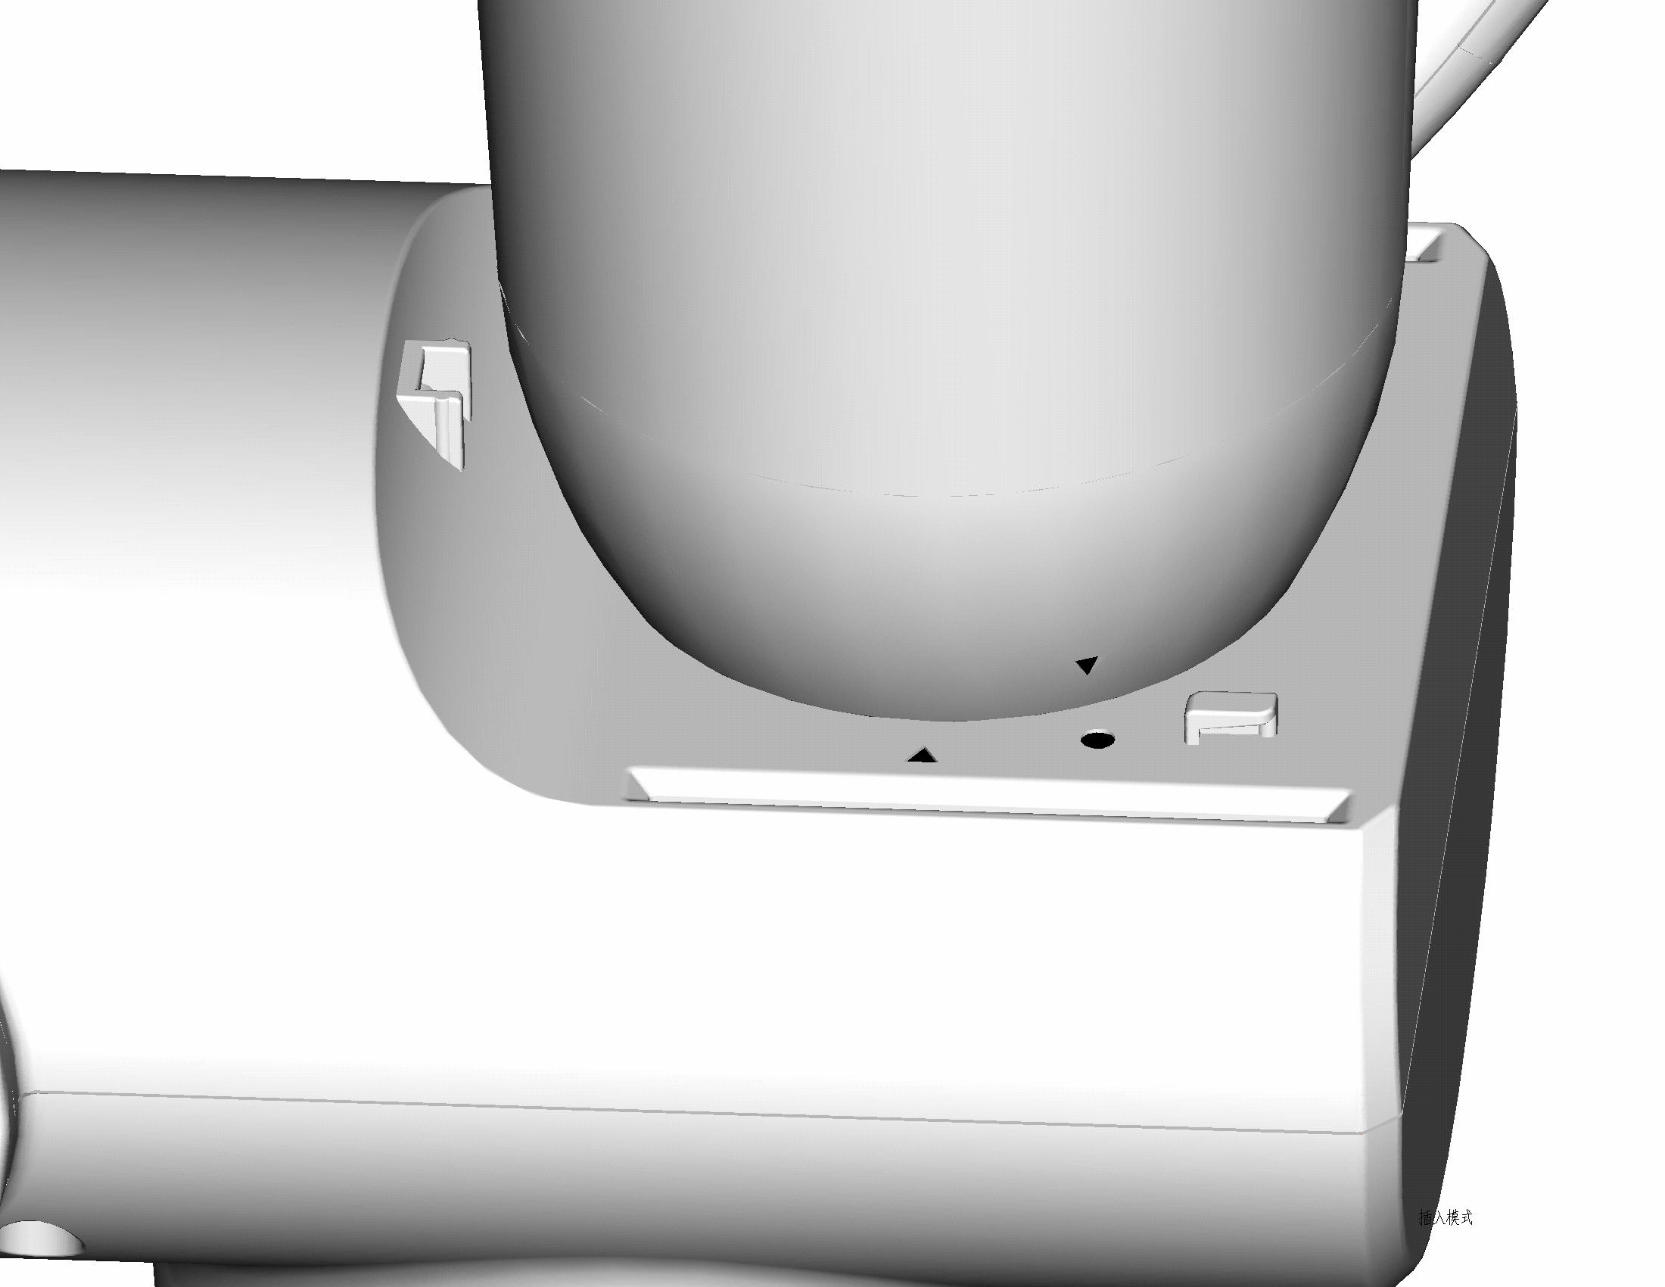
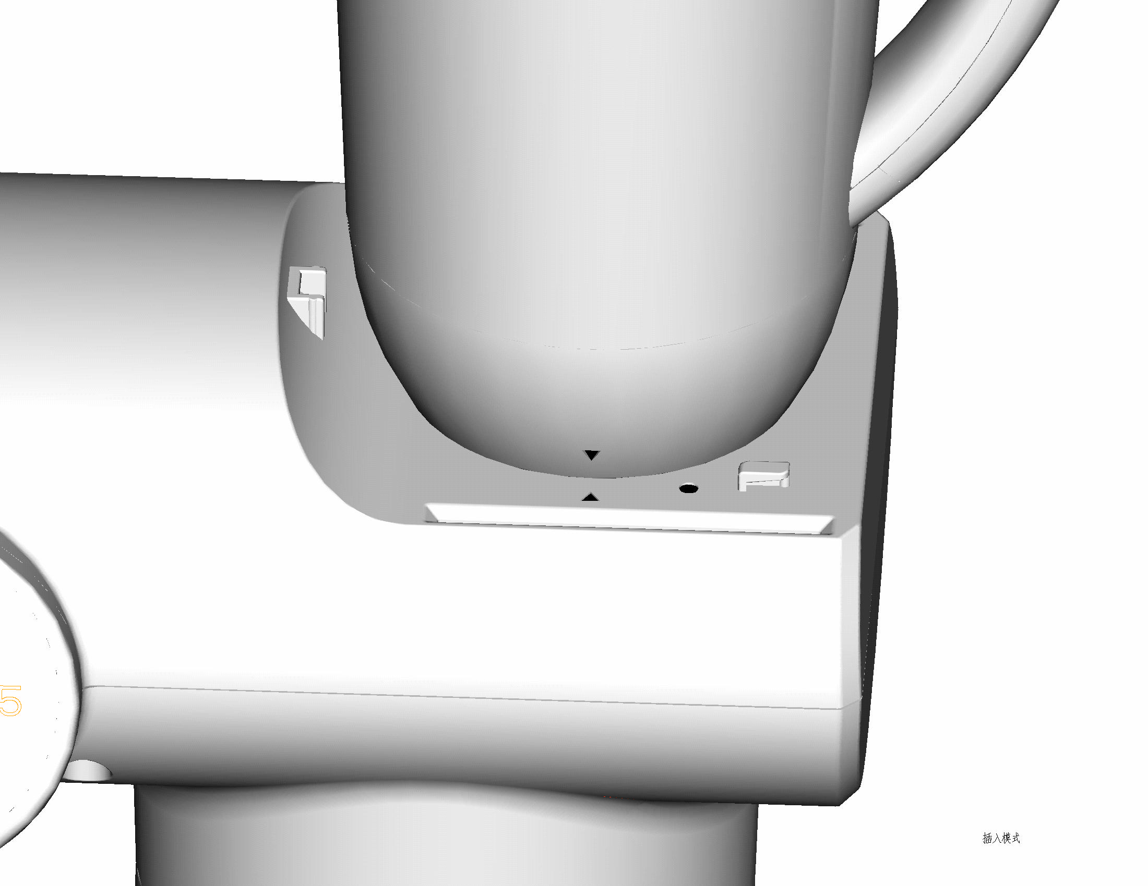
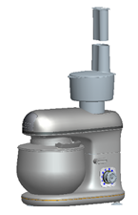
3
4
5

- Place the Multi-Pro kitchen machine on a firm, stable, level surface.
- Position the power cord away from the edge of tables or countertops so it cannot be tripped over or caught.
- Fit the bowl and splash guard cover to the kitchen machine. The kitchen machine’s drive operates when the motor is running.

Caution: Do not operate the food processor accessory empty for more than 1 (one) minute. Never fill it with boiling liquid. Allow ingredients to cool down to ambient room temperature. By not following this caution, the appliance could overheat and the food processor bowl could crack.

USING THE FOOD PROCESSING BOWL

Caution: The blades are very sharp, hold only the plastic part. Handle them with extreme care and caution.

- Put the turn axis onto the power outlet.
- Put the plastic bowl onto the turn axis, onto the power outlet and turn the handle in a clockwise direction.
- Put the blade support on the axis in the middle of the bowl and press it to the bottom.
- Now fit the chopping blade to the blade support. Warning: The blades are sharp. Please only hold the plastic part while using.
- Put the ingredients into the bowl.
- Put the cover on the bowl and turn it until you hear the lid fitting correctly into place.

Slicing & Shredding

- Put the slicing or shredding disc into the disc support in the middle of the bowl.
- Put the turn axis onto the drive outlet tightly.
- Put the bowl onto the turn axis and on to the driver outlet. Turn the bowl in a clockwise direction, until you hear it lock into place.
- Put the disc support on to the turn axis in the middle of the bowl.
- Put the cover on the bowl and turn it until it locks into place.

FILLING THE FOOD PROCESSOR BOWL

Caution: Do not use the bowl without fitting the lid.
- Place the ingredients into the bowl.
- Do not fill past the MAX mark as the contents may force their way past the lid when you start the motor. Larger ingredients need to be cut into smaller pieces, for example at approximately 2cm × 2cm × 2cm.
- Fit the lid on the bowl as instructed above.

POWER UP

Caution: - If the speed control is not set to the ‘0’ (off position) the kitchen machine will start when the power supply is connected. If accessories are not fitted correctly you may damage the machine.

- Check that the speed control is set to “0”.
- Put the plug into the wall power outlet and switch it on.

SPEED CONTROL

- Turn the speed control clockwise to the speed you want.
- Turning the speed control anti-clockwise to ‘P’ will give you a pulse at high speed.
- Turn the speed control back to “0” to turn the motor off.

CAUTION: Do not run the motor continuously for more than 10 minutes, it may overheat. After 10 minutes, switch off for at least 10 minutes to let the motor cool.

PULSE FUNCTION (‘P’)

- Press the pulse function ‘P’ which will give you a short burst at high speed.
- Use ‘P’ as a “pulse” function, for greater control over the mixing process.

ADDING INGREDIENTS

Always ensure that you are using the safety pusher when adding ingredients to the food processor bowl during processing. Ensure that the safety pusher remains fitted to the bowl once you have finished adding ingredients.

Caution: Check that the added ingredients do not push the volume over the MAX mark.

POWER DOWN

Turn the speed control to the ‘0’ (off position) and wait until the blades stop moving before removing the lid from the bowl or removing the bowl from the drive outlet.

HOT LIQUIDS

Caution: Pouring hot liquids into the processor bowl could cause the bowl to break.
Before pouring into the bowl, let the liquid cool down to a temperature you can comfortably handle – i.e. keep the liquid temperature below 40°C.

CITRUS JUICER
- Make sure the control dial is turned to the OFF (O) position and the unit is unplugged.
- Attach the motor shaft attachment to the blending base.
- Lock the food processor bowl onto the base.
- Place citrus press plastic strainer on the removable drive attachment, then place the citrus press juicing cone on the removable drive attachment on top of the citrus press plastic strainer.
- The large cone is suitable for juicing large citrus fruit, such as grapefruit, oranges etc. The small cone is suitable for juicing small citrus fruit, such as lemons and limes etc.
- Cut a citrus fruit in half and press the cut end of one fruit half onto the cone. Turn on the machine and choose the desired speed. Please select a low speed before juicing and gradually increase it throughout the juicing process.
- The cone scrapes the pulp out and squeezes the juice from the fruit.
- To maximize the quantity of juice extracted from a fruit, press a fruit onto the cone several times.
1. | 1. Place the machine on a flat surface, e.g. a kitchen counter, and make sure it is standing firmly.  2. Ensure that the mincing cover plate (8) is fitted onto the Mixer head (2) socket.  3. Remove the blender cover plate (1) from the mixer head (see illustration).
2. | 1. Remove the food processor bowl cover (28) from the food processor bowl (30) by rotating it anti-clockwise.  2. Place the food processor bowl onto the food processor connector (31) ensuring that the arrow on the bowl is aligned with the arrow on the connector, hold the bowl and turn the connector clockwise until it locks into position.
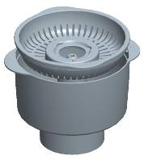  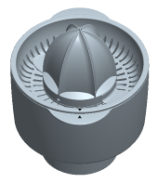  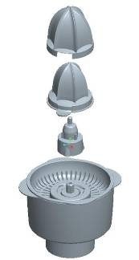  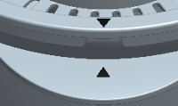  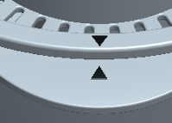  3. | 1. Place the sieve (38) in the bowl. Ensuring the arrow on the bowl is aligned with the arrow on the sieve.  2. Place the citrus juicer connector (37) onto the sieve.  3. Fit the small squeezer (36) or alternatively the large squeezer (35).  Note: The small squeezer is for squeezing lemons and fruits similar in size. The large squeezer is for squeezing oranges and fruits similar in size.
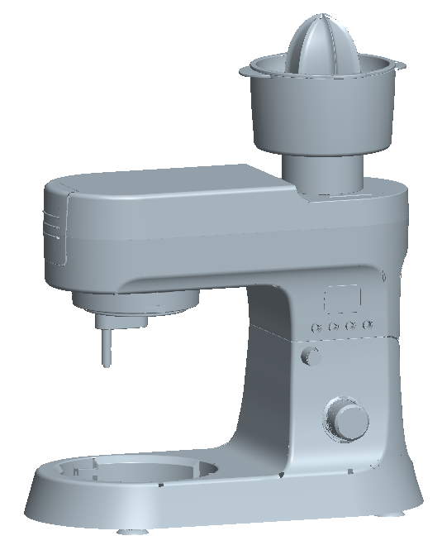  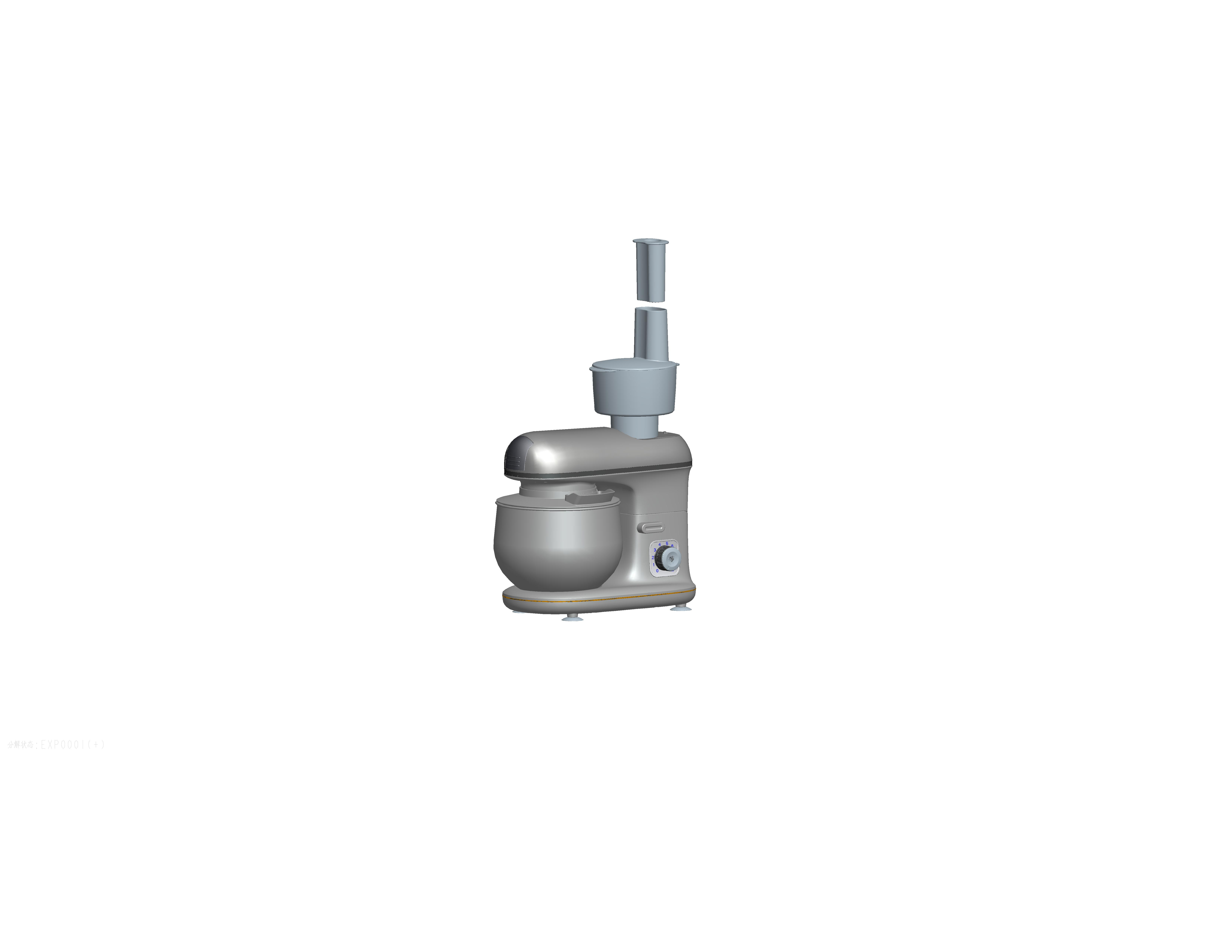  4. | 1. Place the citrus juicer assembly in the motor house, so that the arrow is aligned with the circle. Turn it clockwise, so that both arrows end up aligned.  2. The appliance is now ready for use.  3. Connect the plug to the power supply. Turn the speed control button (4) to the desired setting and the juicer will start.
5. | 1. Cut the fruit in half. Press and hold down the fruit onto the squeezer.
6. | 1. Stop the juicer by returning the speed control button to the off “0” position when you have finished juicing your fruits. Unplug it from the mains electrical supply before you change the accessories, or before you take the appliance apart or when not in use.  2.To detach the juicer assembly, turn the bowl anti-clockwise so the arrow is aligned with the circle and then remove.
8.  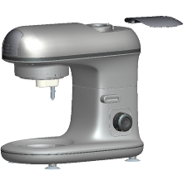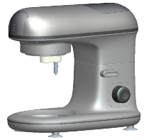 | 1.Place the blender cover plate into the mixer head (see illustration).

PROCESSING GUIDE

General

- Switch the kitchen machine off and scrape the bowl with the spatula frequently.
- Use cold ingredients for pastry unless your recipe says otherwise.
- Tips for bread making:
  - Never exceed the maximum capacities; otherwise you will overload the appliance.
  - If you hear the appliance motor is taking strain/labouring - switch the kitchen machine off, remove half the dough and do each half separately.
  - The ingredients mix best if you put the liquid in first.

Hints for beating egg whites:

- Before whisking egg whites, make sure that there’s no grease or egg yolk on the whisk or bowl.
- Be sure that the bowl and mixing accessories are clean.
- Be sure that there is no egg yolk in the egg white.
- Egg whites should be at room temperature for maximum volume.
- Use a high setting.
- Beating time will vary according to the freshness of the eggs.

Hints for whipping cream:

- Use a heavy cream.
- Chill the cream before whipping.
- For best results, chill both beaters and bowl.
- Start beating at a low speed to prevent spatter, increase to high as the cream thickens.
- Beating time will vary according to the fat content, age and temperature of the cream.

Important: Guidelines given in the processing guide and recipes are approximate. Due to personal differences in taste, some foods may be desired processed/ crisped/ cooked, etc. Therefore, duration may be increased, decreased or varied in any way to suit individual preference.

Mixing Bowl
Item | Max quantities | Comments | Accessory
Stiff yeast dough | 1600g | Flour and water at a ratio of 5:3  Pre-treatment of dough:  From speed 1 for 180 seconds  Operation period:  Speed 2 for 10 seconds | 
Soft yeast dough | 2000g | Flour and water at a ratio of 1:1  Pre-treatment of dough:  From speed 1 for 90 seconds  Operation period:  Speed 2 for 10 seconds
Whipped cream | 300ml fresh cream | From speed 1 to 4 for about 5 minutes. | 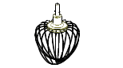
Shakes,  cocktails or other liquids | 1L | Beating eggs into creamed mixtures.  From speed 1 for about 4 minutes. | 

Food Processor

FUNCTION | INGREDIENT | MAX QUANTITIES | MAXIMUM TIMES (s)
FUNCTION | INGREDIENT | MAX QUANTITIES | SLICING | SHREDDING
SLICING & SHREDDING
SLICING & SHREDDING | MELON | 400g | 50s | 30s
SLICING & SHREDDING | CARROT | 400g | 50s | 30s
CHOPPING | MEAT | 300g (about 10g per piece) | 30s
CHOPPING | HAM | 300g (about 15g per piece) | 30s
CHOPPING | ONIONS | 400g (about 20g per piece) | 30s
CHOPPING | STRAWBERRY | 200g | 25s
CHOPPING | CHEESE | 100g | 20s
CHOPPING | ALMONDS | 100g | 20s
CHOPPING | HAZELNUTS | 100g | 20s
CHOPPING | WALNUTS | 100g | 20s

CLEANING AND MAINTENANCE

General

- Ensure that the kitchen machine is switched off and unplugged before cleaning. Give it a few minutes to cool down.
- Clean the kitchen machine as soon after use as possible to prevent residues setting.
- Wash the bowl and accessories in warm soapy water, rinse well.
- Leave them to drain and air dry.
- Please DO NOT put any of the kitchen machine accessories in the dishwasher.
- Wipe the external surfaces of the kitchen machine with a clean damp cloth and immediately buff with a soft dry cloth.
- Do not immerse the motor unit in water or any other liquid.
- Do not use harsh or abrasive cleaning agents or solvents.

Blender

- Wash the jug and lid in warm soapy water and rinse well. Leave them to drain and air dry.
- Do not put the jug, blade unit or lid in a dishwasher.
- Remove the blade unit, (See “Removing the blade unit” section) and wash it in warm soapy water using a nylon brush to clean the blades.

STORING THE APPLIANCE

- Complete cleaning and maintenance as instructed above.
- Ensure that all parts are dry before storing.
- Store the appliance in its box or in a clean, dry place.
- Never store the appliance while it is still wet or dirty.
- Never wrap the power cord around the appliance.

SERVICING THE APPLIANCE

There are no user serviceable parts in this appliance. If the unit is not operating correctly, please check the following:
- You have followed the instructions correctly.
- That the unit has been wired correctly and that the wall socket is switched on.
- That the mains power supply is ON.
- That the plug is firmly in the mains socket.

If the appliance still does not work after checking the above:
- Consult the retailer for possible repair or replacement. If the retailer fails to resolve the problem and you need to return the appliance, make sure that:
- The unit is packed carefully back into its original packaging.
- Proof of purchase is attached.
- A reason is provided for why it is being returned.

If the supply cord is damaged, it must be replaced by the manufacturer or an authorised service agent, in order to avoid any hazard. If service becomes necessary within the warranty period, the appliance should be returned to an approved Home of Living Brands (Pty) Limited service centre. Servicing outside the warranty period is still available, but will, however, be chargeable.

CHANGING THE PLUG
Should the need arise to change the fitted plug, follow the instructions below.
This unit is designed to operate on the stated current only. Connecting to other power sources may damage the appliance.

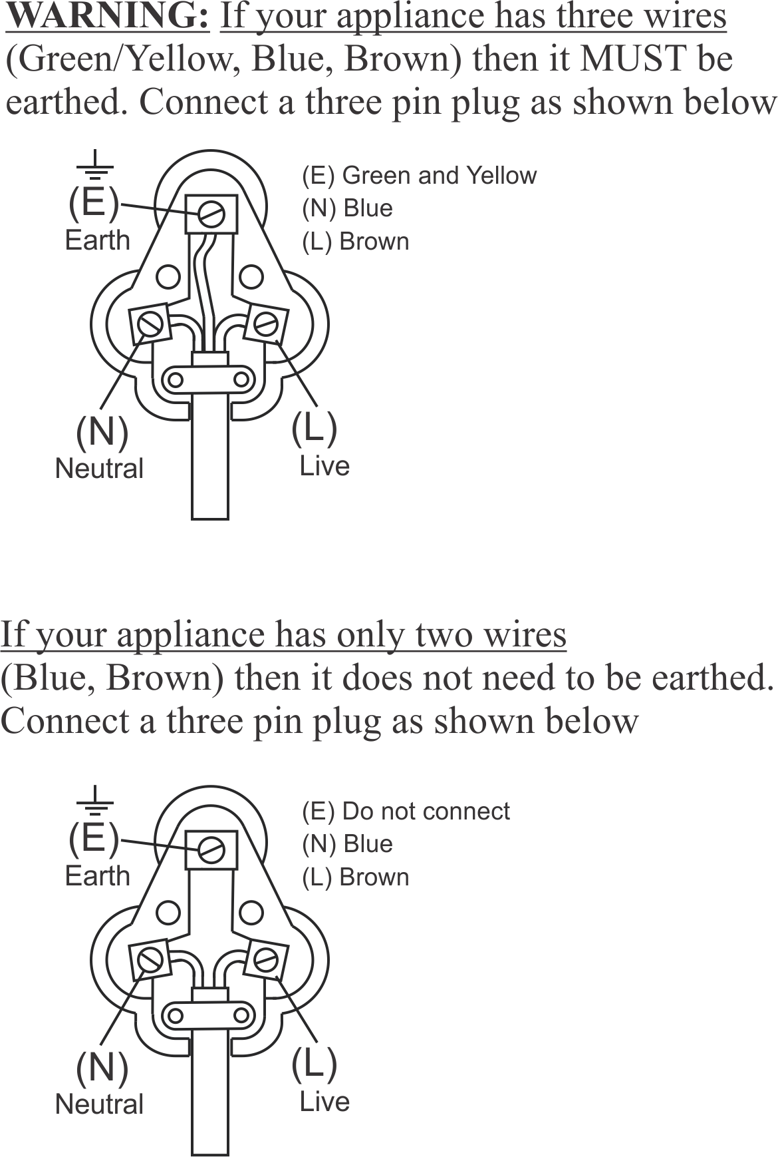

RECIPES TO GET YOU STARTED

SHREDDED APPLE AND CARROT SALAD
Prep Time: 20 min
Cooking Time: 11 min
Serves: 6
INGREDIENTS:
2 Tbsp sesame seeds
2 cups of shredded carrots (3 medium carrots)
1 granny smith apple cored and shredded
½ cup fresh, chopped parsley
¼ cup lemon juice
2 Tbsp apple cider vinegar
1 Tbsp white sugar (optional)
1 garlic clove, minced
1 tsp salt
2 Tbsp olive oil

METHODS:
- Heat a skillet over medium heat; pour sesame seeds into the hot skillet. Cook, stirring often, for 3 to 5 minutes until sesame seeds are lightly browned and fragrant. Remove from heat.
- With a shredder; shred the peeled carrots and apple and mix in a bowl.
- Mix carrots, apple, toasted sesame seeds, and parsley together in a bowl.
- Blend lemon juice, vinegar, sugar, garlic, salt, and pepper together in a separate bowl; slowly drizzle olive oil into lemon juice
- Pour dressing over carrot mixture; toss to coat.

BROTH SMOOTHIE
Prep Time: 30 min
Cooking Time: 10 min
Serves: 6

INGREDIENTS:
1 medium carrot, roughly chopped
1 small orange, peeled
1 Tbsp fresh, grated turmeric
½ a mango or ½ a pawpaw
½ a banana, chopped
1 Tbsp fresh, grated ginger
1 Tbsp flaxseed oil
2 Tbsp coconut oil
200ml chicken stock

METHOD:
- Add all ingredients to a blender and blend until smooth.

CLASSIC POTATO LATKES
Prep Time: 10 min
Cooking Time: 4 min 30 sec
Serves: 4

INGREDIENTS:
70g potatoes
1 large onion, shredded
3/4 cup breadcrumbs
2 large eggs, beaten
1 Tbsp potato starch, or more if needed
1 1/4 tsp salt, or more to taste
1/2 tsp pepper
Oil for frying (about 1 1/2 cups - choose an oil with a high
smoke point)

METHOD:
- Before you begin making the latkes, place your wire cooling rack close to the area where you will be frying the latkes. Place a layer of paper towels below the cooling rack to catch excess oil.
- Cut the potatoes into large chunks and shred using a hand grater or food processor shredding attachment with large holes (large shreds).
- Use the food processor attachment to shred your onion.
- Mix all the ingredients together in a bowl and create a patty like shape and deep fry until cooked and golden brown.

HAMBURGER
Prep Time: 20 minutes
Cooking Time: 8 min
Serves: 6
INGREDIENTS:
227g chuck, trimmed and cubed
227g sirloin, trimmed and cubed
½ tsp salt
¾ cup breadcrumbs
1 egg, beaten
1 tsp cayenne pepper
2 cloves garlic, minced
METHOD:
- Separate the batches, pulse the chuck and sirloin in a grinder 5 times
- Combine the chuck, sirloin and the salt in a large bowl
- Form the meat into 144g patties
- Heat up a skillet or griddle over medium - high heat for 3 minutes
- Place the hamburger patty in the pan, cook for 4 minutes each side.

FALAFEL MEATBALLS
Prep Time: 12 hours for Dry chickpeas
Cooking Time: 40 minutes
Serves: 5

INGREDIENTS:
3 cans 400g drained chickpeas (canned), Note: If using dried chickpeas, use 1 Cup and cover with water and let sit overnight
4 cloves of garlic
1 small onion, coarsely chopped
1/4 cup fresh, chopped parsley, 6 sprigs
1/4 cup fresh, chopped coriander, 8 sprigs
1 1/2 tsp salt
1 tsp cumin
1/4 tsp chili powder
Sprinkle black pepper
1 tsp baking powder (optional), helps to achieve a lighter texture
1/3 cup (40g) plain flour

METHODS:
- Pour contents of canned chickpeas into a sieve, rinse with cold water under the tap, shake off excess water and set aside for later. If using dried chickpeas you must soak these overnight in enough cold water to cover.
- Combine chopped onion, garlic cloves, parsley, coriander, cumin, salt, pepper and chili powder into a food processor. Process all ingredients together until you get a rough mixture. When complete, transfer the mixture into a medium-sized mixing bowl.
- Next, transfer the washed chickpeas into the food processor and coarsely process. Like in the previous step, ensure you scrape down the sides of the processor periodically and do not make a puree. Transfer this coarsely blended mixture to the mixing bowl containing the previously prepared ingredients.
- If you over process, your final mixture will be too heavy and the falafels may not cook properly in the center. For best results, process the chickpeas in 2 or 3 batches. If you overload your food processor, you may end up with under-processed chickpeas on top and a pureed mixture at the bottom.
- Using your hands, thoroughly mix the ingredients until you get an evenly distributed mixture.
- Sprinkle the flour and baking powder (optional) evenly over the surface of the mixture. Incorporate this into the falafel mixture using your hands. Wash your hands before next step.
- Between the palms of you hands, roll small portions of the falafel mixture to form falafel balls (you should have enough for 20 balls)
- Heat cooking oil to 190°C and fry falafels in batches until golden brown. It is always good to fry a tester falafel first, just to ensure your oil is hot enough. If the oil is below the temperature specified, your falafels will literally break up into a coarse mess within your fryer. Baked falafels are also quite popular.
- When cooked, transfer your falafels to paper towels to absorb the oil. Let cool before serving.

ITALIAN MERINGUE BUTTERCREAM
Prep Time: 25 min
Total Time: 25 min
Serves: 1 dessert

INGREDIENTS:
- 4 egg whites, large
- 1 1/3 cups (267g) granulated sugar
- Pinch salt optional
- 454g unsalted butter, room temperature cut into ½ cm pieces
- 1 tsp pure vanilla extract optional
- 1/4 tsp cream of tartar
- 1/3 cup water

METHOD:
- Beat the egg whites, salt and cream of tartar, slowly add in 1/3 cup of sugar and continue beating until soft peaks form.
- In a medium saucepan add the remaining sugar and 1/3 cup water then place on medium-low heat.
- Stir until sugar melts and becomes clear.
- Maintain at medium-high heat until temperature reads 130-133°C.
- Drizzle the sugar into the mixer immediately.
- Run mixer until meringue is cool/tepid.
- Switch to a paddle attachment. Add room temperature butter into running mixer one tablespoon piece at a time.
- Add the salt and vanilla if using
- Beat until butter is combined and mixture has reached a silky consistency.

OLIVE BREAD
Prep Time: 1h30min
Cooking Time: 35min
Serves: 8

INGREDIENTS:
11/2 (7ml) tsp instant yeast
2 ¾ cup all-purpose flour
½ tsp salt
1 cup lukewarm water
½ tsp garlic powder
2 tsp olive oil
½ cup pitted, chopped kalamata olives

METHOD:
- Combine the first six ingredients in the bowl of a stand mixer. Use a spatula to roughly combine the ingredients. Let it rest for 15 minutes to activate the yeast.
- Fold in the olives. Attach the dough hook and knead on medium for 5 minutes. Sprinkle in a bit more flour as needed if the dough won’t release from the sides of the bowl.
- Transfer the kneaded dough to an oiled bowl, cover, and allow to rise for 60 minutes in a warm place.
- Punch the dough down, then transfer to a parchment-lined baking sheet. Use your hands to shape it into a loaf. Allow to rise for another 60 minutes.
- Pre-heat your oven to 205°C and place a second baking sheet on the bottom rack. Dust the loaf with flour and use a serrated knife to make three shallow cuts across the top.
- Place the baking sheet containing the dough on the middle rack of the preheated oven. Put a steel bowl of water in the oven to create moisture and a beautiful crust. Bake for 30 minutes.
- Let it cool completely on a wire rack before slicing.

ROSEMARY MAYONNAISE
Prep Time: 10 min
Total Time: 10 min
Serves: ¾ Cup

INGREDIENTS:
2 egg yolks
1 tablespoon fresh lemon juice
1/4 teaspoon mustard (or dried mustard powder)
1/4 teaspoon sea salt
3/4 cup extra virgin olive oil
2 Tbsp freshly chopped rosemary

METHOD:
- Infuse the rosemary in olive oil 2 days before you start making the mayonnaise
- In the jug blender, blend the yolks, lemon juice, mustard, rosemary and salt for a few seconds until combined. With the jug blender running, gradually add oil in a slow steady stream until the mixture begins to thicken, for at least 10 minutes.

SESAME AND GARLIC DRESSING
Prep Time: 10 min
Total Time: 10 min
Serves: 1 cup
INGREDIENTS:
1/3 cup canola oil
3 cloves garlic, peeled
3 tablespoons low sodium soy sauce
2 tablespoons water
2 tablespoons white distilled vinegar
2 tablespoons honey
1 tablespoon sesame oil
1 tablespoon lemongrass paste (ginger would also work)
a squeeze of lime juice

METHOD:
- Puree all the dressing ingredients in a food processor until smooth. Taste and adjust to fit your preferences. Transfer to a dressing jar and rinse the food processor out for use later.

YOUTHFUL GREEN SMOOTHIE
Prep Time: 10 min
Total Time: 10 min
Serves: 4
INGREDIENTS:
2 cups kale
2 cups spinach
2 green apples
½ cucumber
1 lemon, squeezed
1 banana
1 tsp fresh grated ginger
Ice

METHOD:
- Add ingredients into a blender and blend until smooth and creamy. Add ice depending on temperature preference.
- Frozen bananas work best in smoothies. Peel, slice in half, and place in a large Ziploc bag in the freezer overnight.
- Add more spinach and kale to increase nutritional benefit

SPONGE CAKE
Prep Time: 15 min
Baking Time: 30 min
Serves: 15
INGREDIENTS:
225g softened butter
225g castor sugar
4 large eggs
½ lemon, zested
1 tsp vanilla extract
225g self-rising flour
Splash of milk
Optional fillings of lemon curd and lightly whipped cream
Icing sugar for dusting

METHOD:
- Heat oven to 180°C/160°C fan/gas, butter and line the base of two 20cm spring-form cake tins with baking parchment.
- Using an electric whisk beat the butter and sugar together until pale and fluffy. Crack the eggs in one at a time and whisk well, scraping down the sides of the bowl after each addition. Add the lemon zest, vanilla, flour, milk and a pinch of salt. Whisk until just combined then divide the mixture between the two tins.
- Bake in the centre of the oven for 25-30 mins until a skewer inserted into the middle of each cake comes out clean. After 10 mins remove the cakes from their tins and leave to cool completely on a wire rack. Fill how you like. Our personal favorite is a good dollop of lemon curd and some fresh cream, then dust the top with icing sugar. Consume in 3 days.

BASIC PASTA DOUGH
Prep Time:15 min
Serves:2
INGREDIENTS:
1 egg, beaten
½ tsp salt
1 cup all-purpose flour
2 Tbsp water
1 L of hot water for cooking the pasta

METHOD:
- In a medium sized bowl, combine flour and salt. Make a well in the flour, add the slightly beaten egg, and mix. Mixture should form a stiff dough. If needed, stir in 1 to 2 tablespoons water.
- On a lightly floured surface, knead dough for about 3 to 4 minutes. With a pasta machine or by hand roll dough out to desired thinness. Use machine or knife to cut into strips of desired width.

PLEASE AFFIX YOUR PROOF OF PURCHASE/RECEIPT HERE
IN THE EVENT OF A CLAIM UNDER WARRANTY THIS RECEIPT MUST BE PRODUCED.

2 YEAR WARRANTY
1 year retail ⵏ 1 year extended warranty upon registration*
visit www.russellhobbs.co.za

W A R R A N T Y AND EXTENDED WARRANTY

- Home of Living Brands (Pty) Limited ("Home of Living Brands") warrants to the original purchaser of this product ("the customer") that this product will be free of defects in quality and workmanship which under normal personal, family or household use and purpose may manifest within a period of 1 (one) year from the date of purchase ("warranty period").
- Home of Living Brands shall extend the warranty period for a further period of 1(one) year (“extended warranty period*”), on condition that the purchaser registers the product on the website, within 12 months from the date of purchase of the product. The website address for registration is as follows: http://russellhobbs.co.za/info-pages/warranty-info.aspx. The extended warranty period only applies to products purchased on or after 1 October 2017.
- Where the customer has purchased a product and it breaks, is defective or does not work properly for the intended purpose, the customer must notify the supplier from whom the customer bought the product ("the supplier") thereof within the warranty period or if applicable, the extended warranty period. Any claim in terms of this warranty must be supported by a proof of purchase. If proof of purchase is not available, then repair, and/or service charges may be payable by the customer to the supplier.
- The faulty product must be taken to the supplier's service centre to exercise the warranty.
- The supplier will refund, repair or exchange the product in terms of this warranty subject to legislative requirements. This warranty shall be valid only where (a) the customer is not the cause of the product breaking, and (b) the product has been used for the intended purpose stipulated in the product manual. The warranty does not include and will not be construed to cover products damaged as a result of disaster, misuse, tamper, abuse or any unauthorised modification or repair of the product.
- This warranty will extend only to the product provided at the date of the purchase and not to any expendables attached or installed by the customer. In this regard any accessories supplied with the product by the supplier, may be excluded in this warranty or extended warranty (see Exclusions to Warranty and Extended Warranty document).
- If the customer requests that the supplier repairs the product and the product breaks or fails to work properly within 3 (three) months of the repair and not as a result of misuse, tampering or modification by or on behalf of the customer, then the supplier may replace the product or pay a refund to the customer, subject to the supplier’s discretion.
- The customer may be responsible for certain costs where products returned are not in the original packaging, or if the packaging is damaged. This will be deducted from any refund paid to the customer.

HOME OF LIVING BRANDS (PTY) LTD (JOHANNESBURG)

JOHANNESBURG TEL NO. (011) 490-9600
CAPE TOWN TEL NO. (021) 552-5161
DURBAN TEL NO. (031) 303-1163
www.homeoflivingbrands.com
www.russellhobbs.co.za
www.facebook.com/RussellHobbsSA

EXCLUSIONS TO W A R R A N T Y AND EXTENDED WARRANTY

- Any accessories supplied with the product, including but not limited to, bowls, jugs, mills or carafes made either of glass or plastic and supplied with this appliance (hereinafter referred to as “the accessory or accessories”), is warranted to be free from material and workmanship defects for the duration of the appliance warranty.
- The accessories should give trouble free service when used in accordance with the directions described in the instruction manual. However, the accessories will be damaged if subjected to impact, and this damage is not covered by the warranty. Such impact damage can occur either from the outside (if for example it is dropped or knocked against a hard surface), or from within (if for example foreign objects are placed within the accessories and the power is switched on).
- Should you need to replace an accessory during the warranty period; a claim for a free replacement will only be considered if the item (including all shards and broken parts) is returned to the nearest HOLB service centre for examination.
- The remains of the accessory will be carefully examined by the relevant professionals and if it is determined (at the sole discretion of HOLB) that the damage was caused by impact, then the claim will be refused and will not be covered by the warranty or any extended warranty.
- Any replacement part provided in terms of clause 4 above will become a chargeable item payable by the customer.

