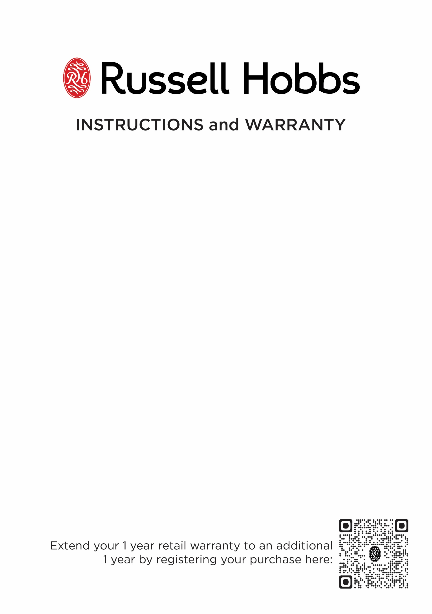

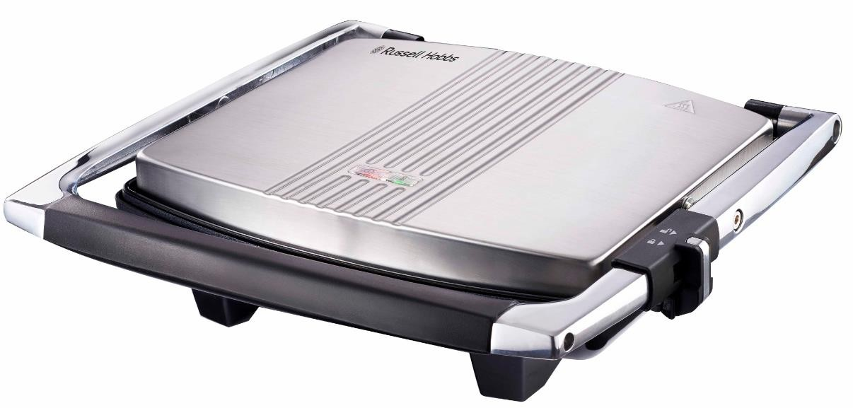

MODEL No. RHSP015
Russell Hobbs Gourmet Sandwich Press
Congratulations on purchasing your Russell Hobbs Gourmet Sandwich Press. Each unit is manufactured to ensure safety and reliability. Before using this hand mixer for the first time, please read the instruction manual carefully and keep it for future reference.

FEATURES OF THE RUSSELL HOBBS GOURMET SANDWICH PRESS
- 2000W
- Contact Griller
- Brushed chrome plated housing
- Ready light indicator
- Fits 4 sandwiches comfortably
- Non-stick coated cooking plates for easy cleaning
- Bakelite heat resistant handle
- Carry safe lid lock
- High wattage for fast cooking
- Convenient and removable drip tray
- Easy cord storage
- For domestic use only
- 1 year standard warranty. Warranty will be extended for another year if you register your product online within 12 months of purchase (visit https://russellhobbswarranty.co.za/)

IMPORTANT SAFEGUARDS

  - When using any electrical appliance, basic safety precautions should always be followed including the following:
  - Please read the instructions carefully before using any appliance.
  - Always ensure that the voltage on the rating label corresponds to the mains voltage in your home.
  - Incorrect operation and improper use can damage the appliance and cause injury to the user.
  - The appliance is intended for household use only. Commercial use invalids the warranty and the supplier cannot be held responsible for injury or damage caused when using the appliance for any other purpose than that intended.
  - Avoid any contact with moving parts.
  - This appliance is not intended for use by persons (including children) with reduced physical, sensory or mental capabilities, or lack of experience and knowledge, unless they have been given supervision or instruction concerning use of the appliance by a person responsible for their safety
  - Close supervision is required when any appliance is used near or by children or invalids.
  - Check the power cord and plug regularly for any damage. If the cord or the plug is damaged, it must be replaced by the manufacturer or a qualified person in order to avoid an electrical hazard.
  - Do not use the appliance if it has been dropped or damaged in any way. In case of damage, take the unit in for examination and/or repair by an authorised service agent
  - To reduce the risk of electric shock, do not immerse or expose the motor assembly, plug or the power cord to water or any other liquid.
  - Never immerse the unit in water or any other liquid for cleaning purposes.

  - Remove the plug from the socket by gripping the plug. Do not pull on the cord to disconnect the appliance from the mains. Always unplug the unit when not in use, before cleaning or when adding or removing parts.
  - The use of accessory attachments that are not recommended or supplied by the manufacturer may result in injuries, fire or electric shock.
  - A short cord is provided to reduce the hazards resulting from becoming entangled in or tripping over a longer cord.
  - Do not let the cord hang over the edge of a table or counter. Ensure that the cord is not in a position where it can be pulled on inadvertently.
  - Do not allow the cord to touch hot surfaces and do not place on or near a hot gas or electric burner or in a heated oven.
  - Do not use the appliance on a gas or electric cooking top or over or near an open flame.
  - Use of an extension cord with this appliance is not recommended. However, if it is necessary to use an extension lead, ensure that the lead is suited to the power consumption of the appliance to avoid overheating of the extension cord, appliance or plug point. Do not place the extension cord in a position where it can be pulled on by children or animals or tripped over.
  - This appliance is not suitable for outdoor use. Do not use this appliance for anything other than its intended use.
  - DO NOT carry the appliance by the power cord.
  - Do not leave this appliance unattended during use. Always unplug the unit when not in use or before cleaning.
  - Always operate the appliance on a smooth, even, stable surface. Do not place the unit on a hot surface.
  - The manufacturer does not accept responsibility for any damage or injury caused by improper or incorrect use, or for repairs carried out by unauthorised personnel

  - The grill must only be used by or under the supervision of a responsible adult. Use and store the grill out of reach of children.
  - Don’t put the grill in liquid, don’t use it in a bathroom, near water, or outdoors.
  - Some parts aren’t as hot as others, but they’re all hot. Don’t touch – use oven gloves or a folded towel.
  - Bread, oil, and other foods may burn. Don’t use the appliance near or below curtains or other combustible materials, and watch it while in use.
  - Sit the grill on a stable, level, heat-resistant surface, near a power socket.
  - Route the cable so it doesn’t overhang, and can’t be tripped over or caught.
  - This appliance must not be operated by an external timer or remote control system.
  - Don’t wrap food in plastic film, polythene bags, or metal foil. You’ll damage the grill and you may cause a fire hazard.
  - Cook meat, poultry, and derivatives mince, burgers, etc.) till the juices run clear. Cook fish till the flesh is opaque throughout.
  - Don’t use tools that might damage the non-stick surfaces.
  - Keep the grill and the cable away from hotplates, hobs or burners
  - Unplug the grill after use, before moving and before cleaning.
  - Don’t use the grill for any purpose other than cooking food.
  - Don’t use the grill if it’s damaged or malfunctions.
  - If the cable is damaged, you must return the grill, in order to avoid hazard

PARTS DIAGRAM

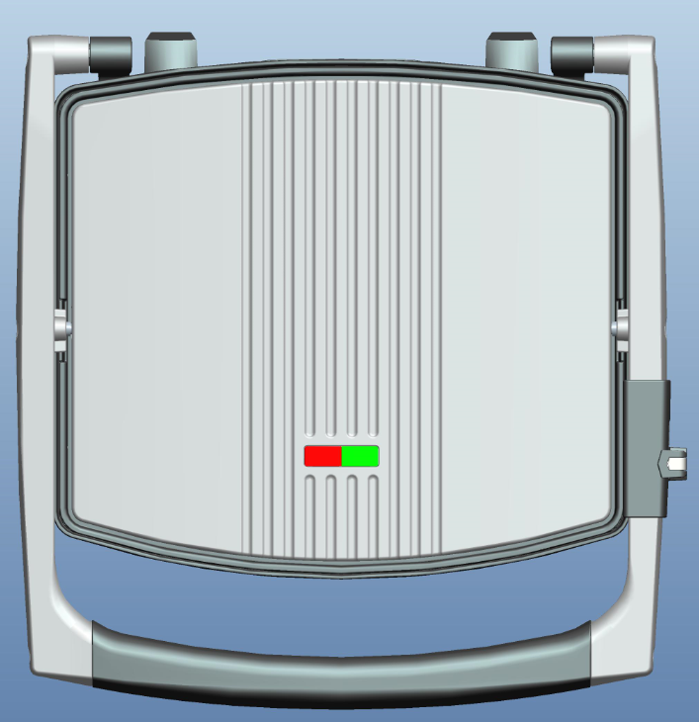
Power Indicator Light

Ready Indicator Light

Lock Clip
Carry Handle

BEFORE USING FOR THE FIRST TIME
1. Do not use this product to cook or defrost frozen food. All food must be completely defrosted before cooking it with this product.

NOTE: During the initial use of this product, it may produce some smoke. This is normal and will subside with further use.

PREPARATION

- Before using this product for the first time, clean it as described in the “Care and Maintenance” section.
- Press in the end of the Locking Latch nearest the Handle to unlock the product.
- Open the unit by pulling the Carry Handle up.
- Close the Plates and turn the unit on by plugging it into a standard electrical outlet. Ensure that the Power Indicator Light illuminates in orange.

WARNING: The Cooking Plates and metal surfaces of the unit will become extremely hot when in use. To avoid a burn hazard, wear heat resistant mitts or gloves and touch only the black portion of the Handle.

- After the unit preheats for approximately five minutes, the Ready Indicator Light will illuminate in green, indicating the product is ready for use.
- Use the Handle to lift the Upper Plate. Place food on the Lower Plate using wooden or plastic heat- resistant utensils.

CAUTION: Do not use metal utensils on this product, as they will scratch and damage the Plates’ non-stick coating.

- Use the Handle to lower and rest the Upper Plate on top of the food.

NOTE: The cooking time may differ depending on the type and thickness of the foods. Ensure that foods are thoroughly cooked before consumption.

- When the food is cooked as desired, lift the Handle to open the Plates, then remove the food using the utensils. If more cooking is required, ensure to close the Plates to conserve the heat.
- Repeat Steps 6-8 until all cooking is complete, reapply cooking oil as necessary.
- Turn off the product by unplugging the Power Cord from the electrical outlet.
- When the unit has completely cooled, clean and dry it.
- Lock the unit in its closed position by pressing in the end of the Locking Latch farthest from the Handle.

CARE AND MAINTENANCE

- Unplug the grill and let it cool before cleaning and storing away.
- Wipe all surfaces with a damp cloth or sponge. Use a paper towel with a dab of cooking oil to remove stubborn stains.
- Wash the drip tray in warm soapy water, or in the top rack of the dishwasher.
- Take extra care with the non-stick cooking surfaces.
- Don’t put the grill in water or any other liquid.
- Don’t use harsh or abrasive cleaners, solvents, scourers, wire wool, or soap pad

STORING THE APPLIANCE

- Unplug the unit from the wall outlet and clean all the parts as instructed above. Ensure that all parts are dry before storing.
- Store the appliance in its box or in a clean, dry place.
- Never store the appliance while it is still wet or dirty.
- Never wrap the power cord around the appliance.

SERVICING THE APPLIANCE

There are no user serviceable parts in this appliance. If the unit is not operating correctly, please check the following:
  - You have followed the instructions correctly
  - That the unit has been wired correctly and that the wall socket is switched on.
  - That the mains power supply is ON.
  - That the plug is firmly in the mains socket.

If the appliance still does not work after checking the above:
- Consult the retailer for possible repair or replacement. If the retailer fails to resolve the problem and you need to return the appliance, make sure that:
  - The unit is packed carefully back into its original packaging.
  - Proof of purchase is attached.
  - A reason is provided for why it is being returned.

If the supply cord is damaged, it must be replaced by the manufacturer or an authorised service agent, in order to avoid any hazard. If service becomes necessary within the warranty period, the appliance should be returned to an approved Amalgamated Appliance (Pty) Ltd service centre. Servicing outside the warranty period is still available, but will, however, be chargeable.

CHANGING THE PLUG

Should the need arise to change the fitted plug, follow the instructions below.
This unit is designed to operate on the stated current only. Connecting to other power sources may damage the appliance.

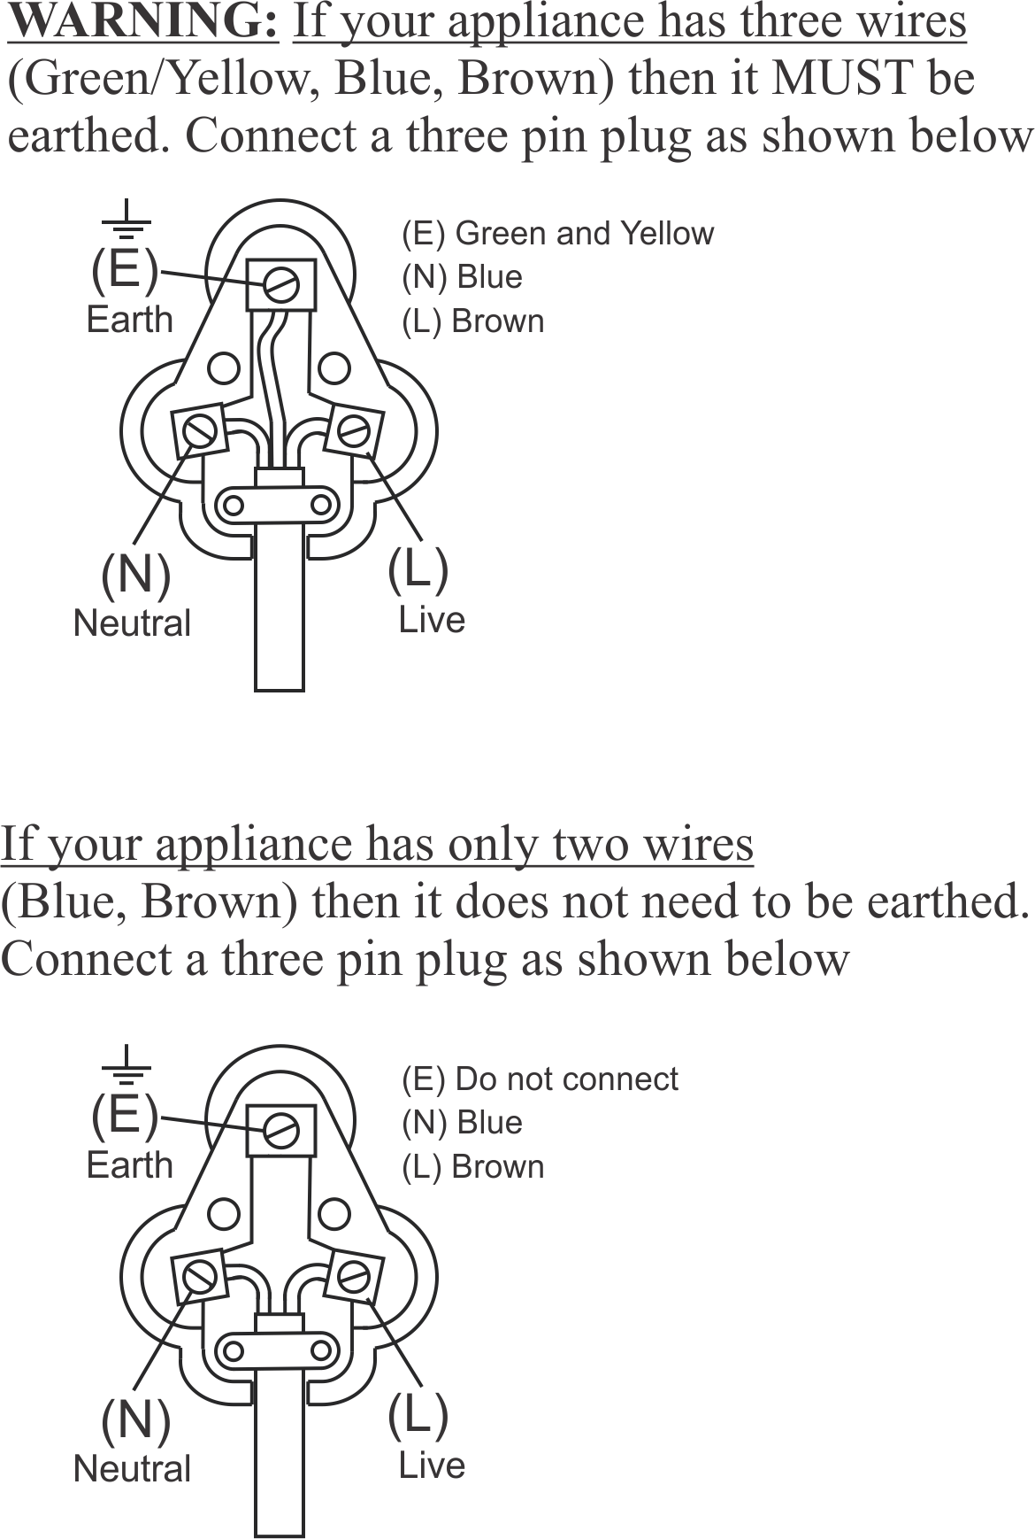
PLEASE AFFIX YOUR PROOF OF PURCHASE/RECEIPT HERE
IN THE EVENT OF A CLAIM UNDER WARRANTY THIS RECEIPT MUST BE PRODUCED.

1 YEAR STANDARD WARRANTY
Warranty will be extended for another year if you register your product online within 12 months of purchase (visit https://russellhobbswarranty.co.za/ )

W A R R A N T Y AND EXTENDED WARRANTY

- Home of Living Brands (Pty) Limited ("Home of Living Brands") warrants to the original purchaser of this product ("the customer") that this product will be free of defects in quality and workmanship which under normal personal, family or household use and purpose may manifest within a period of 1 (one) year from the date of purchase ("warranty period").
- Home of Living Brands shall extend the warranty period for a further period of 1(one) year (“extended warranty period*”), on condition that the purchaser registers the product on the website, within 12 months from the date of purchase of the product. The website address for registration is as follows: https://russellhobbswarranty.co.za/.
- Where the customer has purchased a product and it breaks, is defective or does not work properly for the intended purpose, the customer must notify the supplier from whom the customer bought the product ("the supplier") thereof within the warranty period or if applicable, the extended warranty period. Any claim in terms of this warranty must be supported by a proof of purchase. If proof of purchase is not available, then repair, and/or service charges may be payable by the customer to the supplier.
- The faulty product must be taken to the supplier's service centre to exercise the warranty.
- The supplier will refund, repair or exchange the product in terms of this warranty subject to legislative requirements. This warranty shall be valid only where (a) the customer is not the cause of the product breaking, and (b) the product has been used for the intended purpose stipulated in the product manual. The warranty does not include and will not be construed to cover products damaged as a result of disaster, misuse, tamper, abuse or any unauthorised modification or repair of the product.
- This warranty will extend only to the product provided at the date of the purchase and not to any expendables attached or installed by the customer. In this regard any accessories supplied with the product by the supplier, may be excluded in this warranty or extended warranty (see Exclusions to Warranty and Extended Warranty document).
- If the customer requests that the supplier repairs the product and the product breaks or fails to work properly within 3 (three) months of the repair and not as a result of misuse, tampering or modification by or on behalf of the customer, then the supplier may replace the product or pay a refund to the customer, subject to the supplier’s discretion.
- The customer may be responsible for certain costs where products returned are not in the original packaging, or if the packaging is damaged. This will be deducted from any refund paid to the customer.
HOME OF LIVING BRANDS (PTY) LTD (JOHANNESBURG)
JOHANNESBURG TEL NO. (011) 490-9600
CAPE TOWN TEL NO. (021) 552-5161
DURBAN TEL NO. (031) 303-1163
www.homeoflivingbrands.com
www.russellhobbs.co.za
www.facebook.com/RussellHobbsSA

EXCLUSIONS TO W A R R A N T Y AND EXTENDED WARRANTY
- Any accessories supplied with the product, including but not limited to, bowls, jugs, mills or carafes made either of glass or plastic and supplied with this appliance (hereinafter referred to as “the accessory or accessories”), is warranted to be free from material and workmanship defects for the duration of the appliance warranty.
- The accessories should give trouble free service when used in accordance with the directions described in the instruction manual. However, the accessories will be damaged if subjected to impact, and this damage is not covered by the warranty. Such impact damage can occur either from the outside (if for example it is dropped or knocked against a hard surface), or from within (if for example foreign objects are placed within the accessories and the power is switched on).
- Should you need to replace an accessory during the warranty period; a claim for a free replacement will only be considered if the item (including all shards and broken parts) is returned to the nearest HOLB service centre for examination.
- The remains of the accessory will be carefully examined by the relevant professionals and if it is determined (at the sole discretion of HOLB) that the damage was caused by impact, then the claim will be refused and will not be covered by the warranty or any extended warranty.
- Any replacement part provided in terms of clause 4 above will become a chargeable item payable by the customer.

