INSTRUCTIONS & WARRANTY
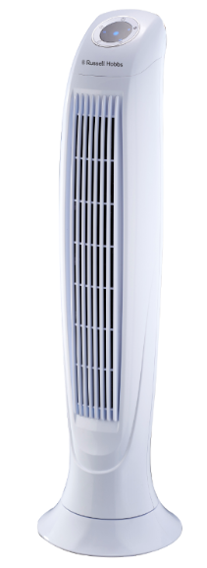

MODEL NO: RHTF37

RUSSELL HOBBS TOWER FAN

Congratulations on purchasing our Russell Hobbs Tower Fan. Each unit is manufactured to ensure safety and reliability. Before using this appliance for the first time, please read the instruction manual carefully and keep it for future reference.

FEATURES OF THE RUSSELL HOBBS TOWER FAN
- 34 Inch tower fan
- Classic and elegant white finish
- Quiet operation
- Remote control
- 3 Speed settings
- 3 Modes: normal/natural/sleep
- Oscillation function
- Digital display
- 7.5 hour timer
- 60W

IMPORTANT SAFEGUARDS
When using any electrical appliance, basic safety precautions should always be followed including the following:
- When using any electrical appliance, basic safety precautions should always be followed including the following:
- Please read the instructions carefully before using any appliance.
- Always ensure that the voltage on the rating label corresponds to the mains voltage in your home.
- Incorrect operation and improper use can damage the appliance and cause injury to the user.
- The appliance is intended for household use only. Commercial use invalidates the warranty and the supplier cannot be held responsible for injury or damage caused when using the appliance for any other purpose than that intended.
- Avoid any contact with moving parts.
- This appliance is not intended for use by persons (including children) with reduced physical, sensory or mental capabilities, or lack of experience and knowledge, unless they have been given supervision or instruction concerning use of the appliance by a person responsible for their safety.
- Children should be supervised to ensure that they do not play with the appliance.
- Check the power cord and plug regularly for any damage. If the cord or the plug is damaged, it must be replaced by the manufacturer or a qualified person in order to avoid an electrical hazard.
- Do not use the appliance if it has been dropped or damaged in any way. In case of damage, take the unit in for examination and/or repair by an authorised service agent.
- To reduce the risk of electric shock, do not immerse or expose the motor assembly, plug or the power cord to water or any other liquid.
- Never immerse the full unit in water or any other liquid for cleaning purposes.
- Remove the plug from the socket by gripping the plug. Do not pull on the cord to disconnect the appliance from the mains. Always unplug the unit when not in use, before cleaning or when adding or removing parts.
- The use of accessory attachments that are not recommended or supplied by the manufacturer may result in injuries, fire or electric shock.
- A short cord is provided to reduce the hazards resulting from becoming entangled in or tripping over a longer cord.
- Do not let the cord hang over the edge of a table or counter. Ensure that the cord is not in a position where it can be pulled on inadvertently.
- Do not allow the cord to touch hot surfaces and do not place on or near a hot gas or electric burner or in a heated oven.
- Do not use the appliance on a gas or electric cooking top or over or near an open flame.
- Use of an extension cord with this appliance is not recommended. However, if it is necessary to use an extension lead, ensure that the lead is suited to the power consumption of the appliance to avoid overheating of the extension cord, appliance or plug point. Do not place the extension cord in a position where it can be pulled on by children or animals or tripped over.
- This appliance is not suitable for outdoor use. Do not use this appliance for anything other than its intended use.
- Do not carry the appliance by the power cord.
- Do not leave this appliance unattended during use. Always unplug the unit when not in use or before cleaning.
- Always operate the appliance on a smooth, even, stable surface. Do not place the unit on a hot surface.
- Ensure that the switch is in the “Off” position after each use.
- The manufacturer does not accept responsibility for any damage or injury caused by improper or incorrect use, or for repairs carried out by unauthorised personnel.
- In case of technical problems, switch off the machine and do not attempt to repair it yourself. Return the appliance to an authorised service facility for examination, adjustment or repair. Always insist on the use of original spare parts. Failure to comply with the above mentioned pre-cautions and instructions, could affect the safe operation of this machine.
- Unplug the fan when not in use, before moving it between locations and before cleaning.
- Once the fan is assembled the guards/grids should not be disassembled for any reason or for cleaning purposes.
- Do not expose this unit to rain or moisture or operate it near a window or veranda where the unit could possibly be exposed to these elements.
- Do not spray liquids into or near the fan.
- Do not operate this unit in presence of explosive and /or flammable fumes.
- Do not insert any object into the fan guards whether the fan is running or not.
- Warning: Do NOT use this fan with any solid state voltage regulator or speed control.
- Always use on a dry, level and stable surface when operating to avoid overturning.
- Do not hang or mount the fan on a wall or ceiling.
- Do not mount this fan on a table or elevated stand.
- Never use the fan without the guards fitted.

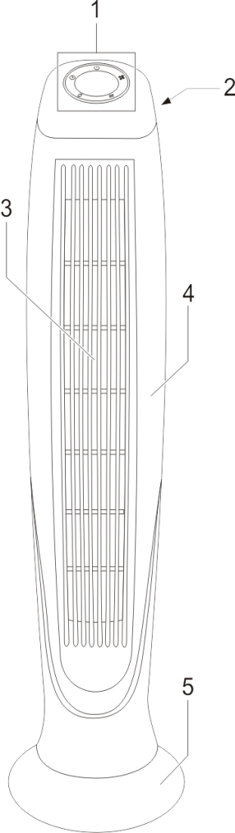
PARTS DIAGRAM
Fully assembled unit
1. Control panel
2. Handle/remote control holder (behind unit)
3. Air outlet and fan guard
4. Fan body
5. Fan stand

Control panel
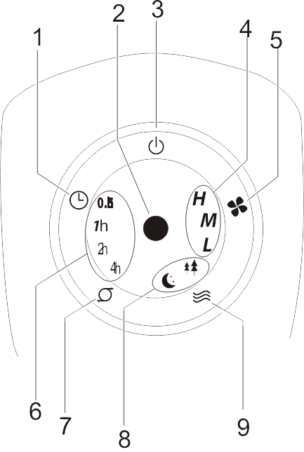
1. Timer switch
2. Power indicator
3. Power switch
4. Speed indicators
5. Speed switch
6. Timer indicator
7. Oscillation switch
8. Mode indicator
9. Mode switch

ASSEMBLY INSTRUCTIONS
- Clip the two halves of the stand together as shown below.
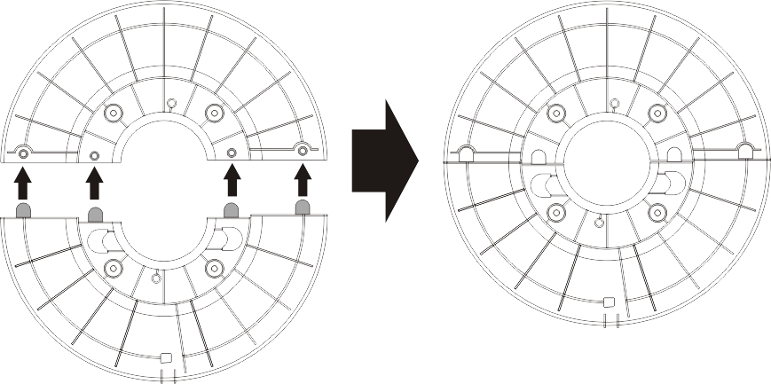

- Pass the power cable through the hole in the assembled stand and position the stand on the base of the fan.
NOTE: Ensure the cable guide is positioned at the back of the fan. Screw the stand to the fan base with the four screws supplied (refer to arrows).
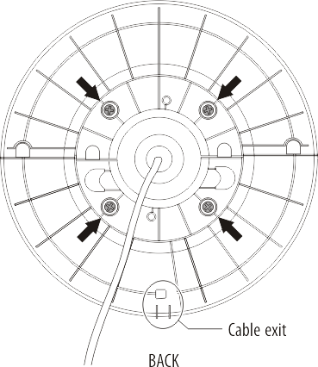
Cable guide

- Tuck the power cable into the cable guide as shown.
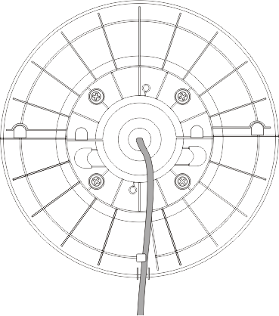

- The fan is now assembled and ready for use.

OPERATING INSTRUCTIONS

Place the fan on a level floor close to a mains power point and in a location where it cannot be knocked over.

The fan can be operated either from the control panel or from the remote handset.

Plug the power cord into the mains supply and switch on the mains power.

The fan will beep to show it is in Standby mode.

Power Button

To switch the fan on press the Power (Standby) switch. The fan will commence operation.

Speed Control

Press the switch repeatedly to select the desired speed: L (Low), M (Medium), H (High).

The relevant indicator on the front panel will light up to display the selected fan speed.

Oscillation

Press the Oscillation switch .

The fan will slowly revolve back and forth along its vertical axis.

Press the button again to cancel oscillation.

The fan will become stationary in the position it was last in. Using this control you can adjust the fan at an angle of your choice.

Timer Control

Press the Timer switch to preset the number of hours of operation from 30 minutes to 7.5 hours.

The front panel indicator shows the set time as the sum of the indicated times displayed.

For example, if 1h, 2h and 0.5h are displayed, the set time is 3.5h.

When no timer indicators are displayed the fan is set for continuous operation.

Modes

Press the MODE button repeatedly to select a mode.

Normal (no mode indicator): The fan operates at a speed set with the speed control.

Nature: The speed cycles up and down to simulate a natural breeze. The change in intensity of the breeze depends on the speed setting.

Sleep: This mode is a variant of the Nature mode.

If the fan has been set to high speed on sleep mode the unit will operate at the high speed nature setting for half an hour, then change to medium speed on the nature setting for half an hour after which time it will then change to the low speed nature setting.

If the fan has been set to low speed on sleep mode, the unit will remain on the low speed nature setting until the fan is switched off or switches off after the preset time.

Remote control

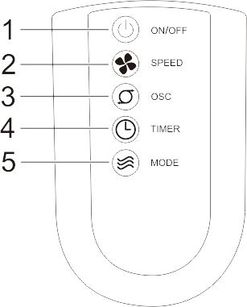
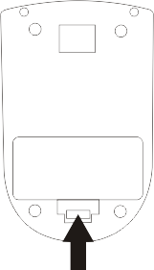
On/Off button

Speed button

Oscillation button

Timer button

Mode button

The remote control is stored in the back of the fan below the handle.
Remove the battery compartment lid of the remote control and insert 2 “AAA” batteries according to the polarity; then replace the lid.
The remote control’s buttons duplicate the functionality on the fan’s control panel.

CLEANING AND MAINTANANCE
WARNING: To avoid the risk of electrical shock, always ensure the product is unplugged from the electrical outlet before relocating or cleaning it.
- Switch off and unplug from the power supply before assembling or disassembling and cleaning.
- Keep the air vents free from dust or fluff - use a vacuum cleaner to remove these when necessary. Do not probe any openings to remove build up.
- Clean using mild soap and a damp cloth or sponge. Ensure soap is thoroughly removed.
- Do not allow any water or other liquid to enter the motor housing and do not immerse the unit in water or other liquids.
- Never use polish or any corrosive or abrasive liquids or substances that will damage the surface.

STORING THE APPLIANCE

- Unplug the unit from the wall outlet and clean all the parts as instructed above. Ensure that all parts are dry before storing.
- Store the appliance in its box or in a clean, dry place.
- Never store the appliance while it is still wet or dirty.

SERVICING THE APPLIANCE

There are no user serviceable parts in this appliance. If the unit is not operating correctly, please check the following:
- You have followed the instructions correctly
- That the unit has been wired correctly and that the wall socket is switched on.
- That the mains power supply is ON.
- That the plug is firmly in the mains socket.

If the appliance still does not work after checking the above:
- Consult the retailer for possible repair or replacement. If the retailer fails to resolve the problem and you need to return the appliance, make sure that:
- The unit is packed carefully back into its original packaging.
- Proof of purchase is attached.
- A reason is provided for why it is being returned.

If the supply cord is damaged, it must be replaced by the manufacturer or an authorised service agent, in order to avoid any hazard. If service becomes necessary within the warranty period, the appliance should be returned to an approved Home Of Living Brands (Pty) Limited service centre. Servicing outside the warranty period is still available, but will, however, be chargeable.

CHANGING THE PLUG
Should the need arise to change the fitted plug, follow the instructions below.
This unit is designed to operate on the stated current only. Connecting to other power sources may damage the appliance. Connect a three-pin plug as follows:
The wires in this mains lead are coloured in accordance with the following code:

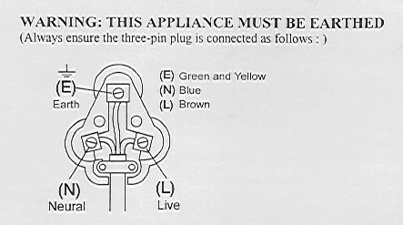
Green/Yellow = Earth
Blue = Neutral
Brown = Live

PLEASE AFFIX YOUR PROOF OF PURCHASE/RECEIPT HERE
IN THE EVENT OF A CLAIM UNDER WARRANTY THIS RECEIPT MUST BE PRODUCED.

2 YEAR WARRANTY
1 year retail ⵏ 1 year extended warranty upon registration*
visit www.russellhobbs.co.za

W A R R A N T Y AND EXTENDED WARRANTY

- Home of Living Brands (Pty) Limited ("Home of Living Brands") warrants to the original purchaser of this product ("the customer") that this product will be free of defects in quality and workmanship which under normal personal, family or household use and purpose may manifest within a period of 1 (one) year from the date of purchase ("warranty period").
- Home of Living Brands shall extend the warranty period for a further period of 1(one) year (“extended warranty period*”), on condition that the purchaser registers the product on the website, within 12 months from the date of purchase of the product. The website address for registration is as follows: http://russellhobbs.co.za/info-pages/warranty-info.aspx. The extended warranty period only applies to products purchased on or after 1 October 2017.
- Where the customer has purchased a product and it breaks, is defective or does not work properly for the intended purpose, the customer must notify the supplier from whom the customer bought the product ("the supplier") thereof within the warranty period or if applicable, the extended warranty period. Any claim in terms of this warranty must be supported by a proof of purchase. If proof of purchase is not available, then repair, and/or service charges may be payable by the customer to the supplier.
- The faulty product must be taken to the supplier's service centre to exercise the warranty.
- The supplier will refund, repair or exchange the product in terms of this warranty subject to legislative requirements. This warranty shall be valid only where the customer has not broken the product themselves, or used the product for something that it is not supposed to be used for. The warranty does not include and will not be construed to cover products damaged as a result of disaster, misuse, tamper, abuse or any unauthorised modification or repair of the product.
- This warranty will extend only to the product provided at the date of the purchase and not to any expendables attached or installed by the customer.
- If the customer requests that the supplier repairs the product and the product breaks or fails to work properly within 3 (three) months of the repair and not as a result of misuse, tampering or modification by or on behalf of the customer, then the supplier may replace the product or pay a refund to the customer, subject to the supplier’s discretion.
- The customer may be responsible for certain costs where products returned are not in the original packaging, or if the packaging is damaged. This will be deducted from any refund paid to the customer.

HOME OF LIVING BRANDS (PTY) LTD (JOHANNESBURG)
JOHANNESBURG TEL NO. (011) 490-9600
CAPE TOWN TEL NO. (021) 552-5161
DURBAN TEL NO. (031) 303-1163

www.homeoflivingbrands.com
www.russellhobbs.co.za
www.facebook.com/RussellHobbsSA

