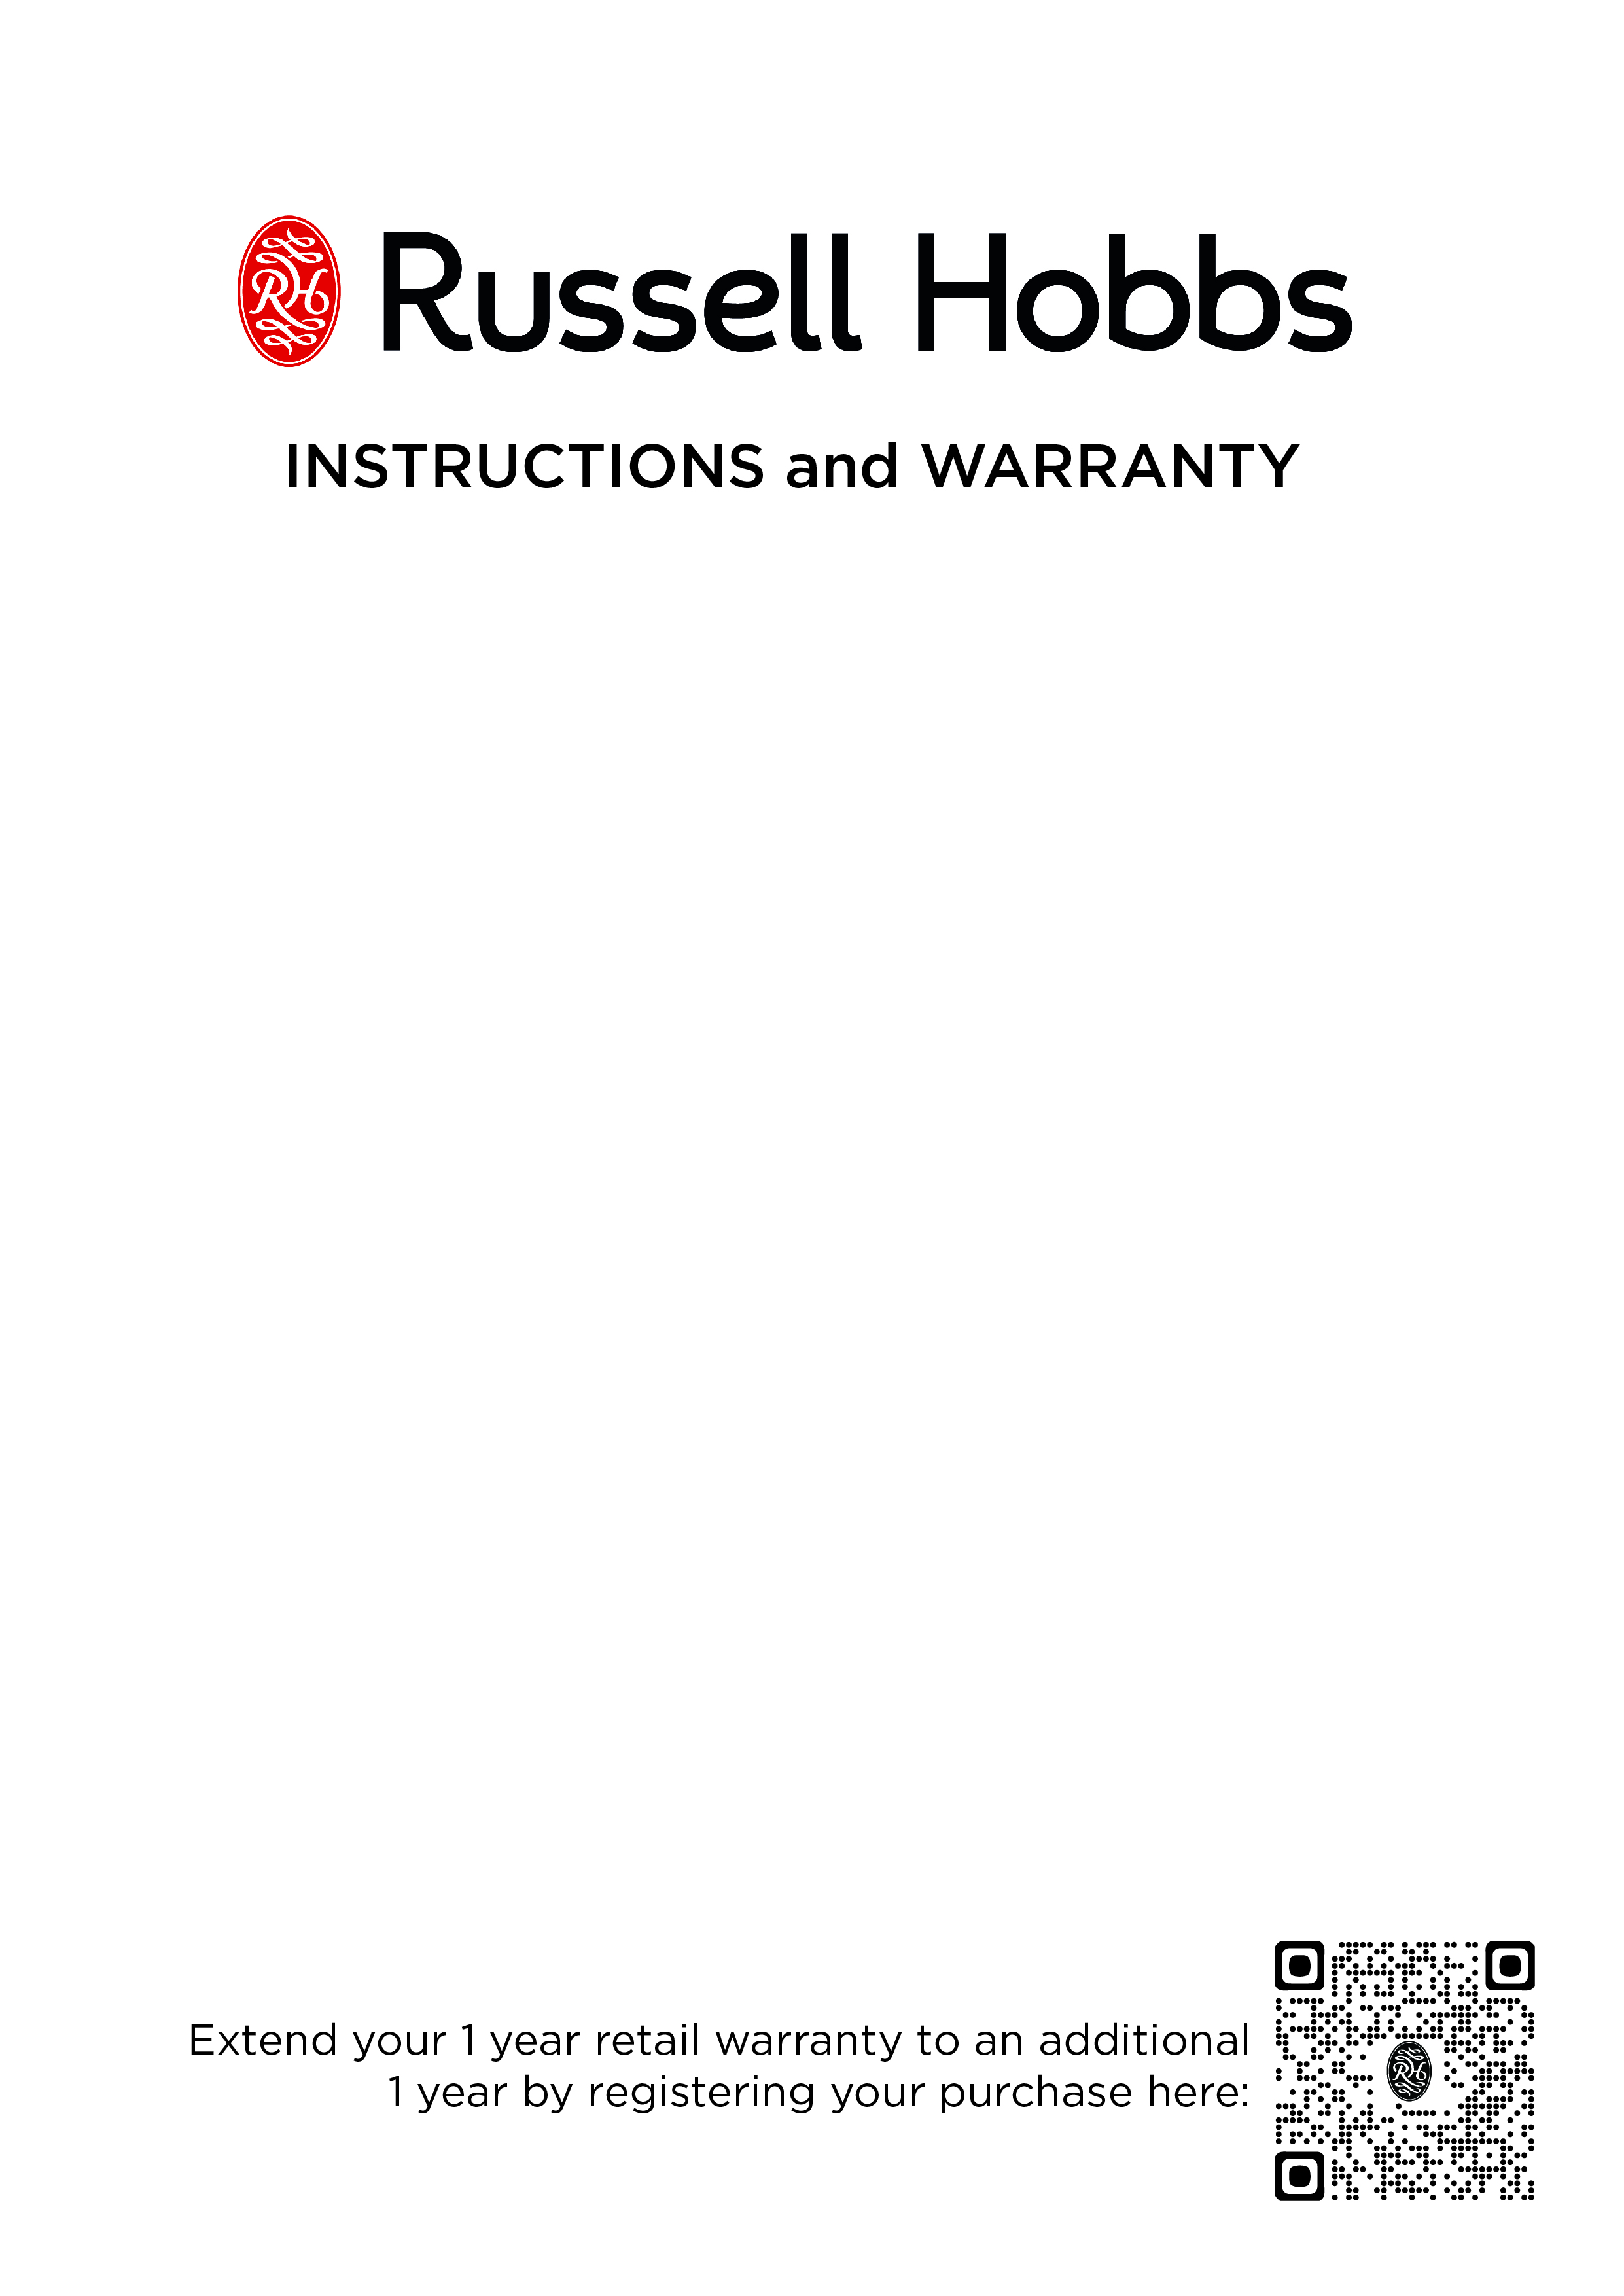

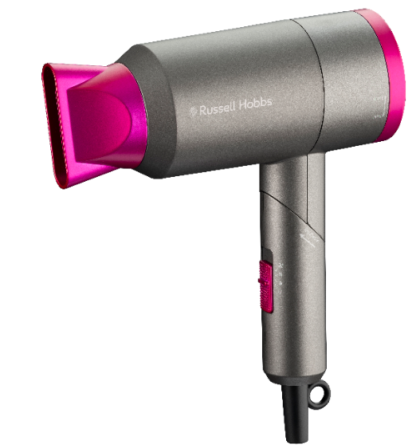

MODEL No. RHTH88
Russell Hobbs travel hair dryer

Congratulations on purchasing your Russell Hobbs travel hair dryer. Each unit is manufactured to ensure safety and reliability. Before using this appliance for the first time, please read the instruction manual carefully and keep it for future reference.

FEATURES OF THE RUSSELL HOBBS TRAVEL HAIR DRYER
- 1400-1800W
- DC motor
- 2 speed settings
- Swivel foldable handle
- Concentrator & hang up hook
- 1.8m Power cord
- For domestic use only
- 1 year standard warranty. Warranty will be extended for another year if you register your product online within 12 months of purchase (visit https://russellhobbswarranty.co.za/)

IMPORTANT SAFEGUARDS
When using any electrical appliance, basic safety precautions should always be followed including the following:
- Please read the instructions carefully before using any appliance.
- Always ensure that the voltage on the rating label corresponds to the mains voltage in your home.
- Incorrect operation and improper use can damage the appliance and cause injury to the user.
- The appliance is intended for household use only. Commercial use invalidates the warranty and the supplier cannot be held responsible for injury or damage caused when using the appliance for any other purpose than that intended.
- Avoid any contact with moving parts.
- This appliance is not intended for use by persons (including children) with reduced physical, sensory or mental capabilities, or lack of experience and knowledge, unless they have been given supervision or instruction concerning use of the appliance by a person responsible for their safety.
- Children should be supervised to ensure that they do not play with the appliance.
- Check the power cord and plug regularly for any damage. If the cord or the plug is damaged, it must be replaced by the manufacturer or a qualified person to avoid an electrical hazard.
- Do not use the appliance if it has been dropped or damaged in any way. In case of damage, take the unit in for examination and/or repair by an authorized service agent
- To reduce the risk of electric shock, do not immerse or expose the motor assembly, plug or the power cord to water or any other liquid.
- Never immerse the unit in water or any other liquid for cleaning purposes.
- Remove the plug from the socket by gripping the plug. Do not pull on the cord to disconnect the appliance from the mains. Always unplug the unit when not in use, before cleaning or when adding or removing parts.
- The use of accessory attachments that are not recommended or supplied by the manufacturer may result in injuries, fire or electric shock.
- Do not let the cord hang over the edge of a table or counter. Ensure that the cord is not in a position where it can be pulled on inadvertently.
- Do not allow the cord to touch hot surfaces and do not place on or near a hot gas or electric burner.
- Use of an extension cord with this appliance is not recommended. However, if it is necessary to use an extension cord, ensure that the cord is suited to the power consumption of the appliance to avoid overheating of the extension cord, appliance or plug point. Do not place the extension cord in a position where it can be pulled on by children or animals or tripped over.
- This appliance is not suitable for outdoor use. Do not use this appliance for anything other than its intended use.
- DO NOT carry the appliance by the power cord.
- Do not leave this appliance unattended during use. Always unplug the unit when not in use or before cleaning.
- Ensure that the switch is in the “0” position after each use.
- The manufacturer does not accept responsibility for any damage or injury caused by improper or incorrect use, or for repairs carried out by unauthorised personnel.
- In case of technical problems, switch off the machine and do not attempt to repair it yourself. Return the appliance to an authorised service facility for examination, adjustment or repair. Always insist on the use of original spare parts. Failure to comply with the above mentioned pre-cautions and instructions, could affect the safe operation of this machine.

ADDITIONAL SAFEGUARDS
- Ensure the hair dryer is only used on real human hair. The hair dryer is not intended for use on synthetic hair.
- Ensure the hair dryer is protected from dripping or splashing water.
- For additional protection, the installation of a residual current devise (RCD) having a rated residual operating current not exceeding 30 mA is advisable in the electrical circuit supplying the bathroom. Ask your installer for advice.
- WARNING: Do not use this appliance near bathtubs, showers, basins or other vessels containing water. Should the hair dryer be used in a bathroom, unplug it after use since the proximity of water presents a hazard even when the hair dryer is switched off. However, it is not recommended to be used in a bathroom.
- If the supply cord is damaged, it must be replaced by the manufacturer, its service agent or similarly qualified persons in order to avoid a hazard.
- Never put the hair dryer down on soft furnishings, bedding or any other flammable surface.
- Never cover the hair dryer.
- Always keep the rear grille and filter dust and fluff free.
- Do not block the air inlet or outlet.
- Always ensure hands are dry and hair is free from excess water before handling the plug or switching on the appliance.
- Allow the hair dryer to cool before cleaning and storing away.
- Do not use the appliance outdoors.
- Do not wrap the mains lead around the dryer and avoid twisting or kinking it. If this were to happen, please ensure that the cord is untwisted before use.
- Never carry or suspend the appliance by the mains lead.
- Do not use the appliance for any purpose other than those described in these instructions.
- Do not place or store appliance where it can fall or be pulled into a tub or sink.
- If an appliance falls into water, unplug it immediately. Do not reach into the water. Have a specialist inspect the unit before operating it again.
- Do not direct hot air toward eyes or other heat sensitive areas.
- Attachments may be hot during use. Allow them to cool down before handling.
- While using the appliance, keep your hair away from the air inlets.
- Do not operate the appliance with a voltage converter.
- This device has an overheating protection system. In the event of overheating, (if the air inlet or air outlet is covered) the device will automatically switch off. If this occurs, set the on/off switch to 0 (off), pull out the plug from the mains socket, and allow the device to cool down adequately. Before switching it back on, ensure that there are no hairs or foreign bodies blocking the air inlet.
- Do not switch on the device at the same time as another device with high power consumption plugged into the same socket.
- Do not expose the device to temperatures below –10 °C or above 40 °C.

For domestic use only.
PARTS DIAGRAM
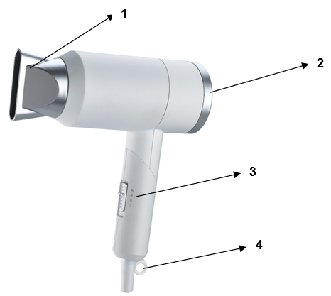

- Styling concentrator (rotatable and removable)
- Removable rear grille
- Heat/speed settings with cool shot option
- Hanging loop

OPERATING INSTRUCTIONS

NOTE: Before using for the first time, switch the device on for a few minutes and allow it to run at the highest speed and temperature settings. As a result of the manufacturing process, a slight odour may be produced. This is not harmful and only occurs during initial use. Ensure that the room has good ventilation. Please read these instructions before operating and retain for future reference.
- Remove all packaging and keep it somewhere safe until you are satisfied that your hair dryer is operating correctly.
- Do not plug it in, until ready to use.
- Wash and condition your hair as you normally would.
- Ensure your hands are dry and your hair is towel dried before use, to remove any excess moisture.
- Plug the unit into a suitable mains supply and switch it on.
- Selecting temperature:
The switch for the hot air settings allows you to select the desired temperature for the air flow:
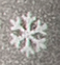 = cooling function
 = low temperature
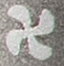 = high temperature
- Cooling function:
After styling your hair with the higher temperature of the unit, the cool shot function can be used to improve the durability of the style created. Swipe up the controller to the first option ensuring that the cooling function has been selected during the drying process in order to obtain cool air flow independently of the temperature setting. When you no longer require the cool airflow, swipe the controller down.
- Styling concentrator:
The styling concentrator makes it possible to target the air flow at specific sections of hair.
Attach the styling concentrator to the front of the hair dryer so that it clicks into place.
The styling concentrator can be rotated into any desired position.
Remove the concentrator only once it has cooled down.
- After using the dryer, set the on/off switch to 0 (off) and pull out the mains plug.

HINTS AND TIPS
- As a general guide use higher heat / speed settings for initial drying, rough drying as well as for thicker, heavier hair. Use lower settings for finer hair, to complete your style and for more precise control.
- Use the concentrator to help direct airflow.

CLEANING AND MAINTENANCE
- This appliance is for household use only and is not user-serviceable.
- Do not open or change any parts by yourself. Please refer to a qualified electrical service department or return to the supplier if servicing is necessary.
- Always remember to unplug the unit from the electrical outlet when not in use and before cleaning. Ensure that the speed control is set to “0”.
- The concentrator can be removed and washed in warm soapy water.
- The body of the appliance and the stand should be cleaned with a damp cloth. Do not let water enter the appliance or the stand.
- Do not use bleach or other abrasive substance or solvents to clean your appliance as it can be damaging to the finish.
- Do not immerse the appliance in water or any other liquid, or hold it under a running tap to clean.
- To remove stubborn spots/marks, wipe the surfaces with a cloth slightly dampened in soapy water or mild non-abrasive cleaner.
- Ensure all parts are dried thoroughly with a soft towel before reusing. Rinse and dry with a clean, dry, soft cloth.
- Clean the appliance regularly.
- Be particularly sure to check that the air inlet and outlet are free from dust, hairs and fluff.
- Remove the styling concentrator from the hair dryer. Hold the hair dryer with the air outlet facing downwards. Clean the safety fins with a brush.
- Slightly press the removable rear grille on the sides then twist the rear grille as per the arrow direction on the appliance to either open or close it. Hold the hair dryer with the air inlet facing downwards. Clean the inside and outside of the removable grille with a brush.
- If you have long hair or use high amounts of styling products, clean the filter regularly at least once a month.

STORING THE APPLIANCE
- Unplug the unit from the wall outlet and clean all the parts as instructed above.
- After use, let the appliance cool off before storing.
- Ensure that all parts are dry before storing.
- Store the appliance in its box or in a clean, dry place away from children.
- Never store the appliance while it is still wet or dirty.
- Never wrap the power cord around the appliance.

SERVICING THE APPLIANCE

There are no user serviceable parts in this appliance. If the unit is not operating correctly, please check the following:
You have followed the instructions correctly
- That the unit has been wired correctly and that the wall socket is switched on.
- That the mains power supply is ON.
- That the plug is firmly in the mains socket.
- Ensure the overheating protection didn’t switch off the device. Set the on / off switch to 0 (off), pull out the plug from the mains socket, and allow the device to cool adequately. Before switching it back on, ensure that there are no hairs or foreign bodies blocking the air inlet.
If the appliance still does not work after checking the above:
- Consult the retailer for possible repair or replacement. If the retailer fails to resolve the problem and you need to return the appliance, make sure that:
- The unit is packed carefully back into its original packaging.
- Proof of purchase is attached.
- A reason is provided for why it is being returned.
If the supply cord is damaged, it must be replaced by the manufacturer or an authorised service agent, in order to avoid any hazard. If service becomes necessary within the warranty period, the appliance should be returned to an approved Home of Living Brands (Pty) Limited service centre. Servicing outside the warranty period is still available, but will, however, be chargeable.

CHANGING THE PLUG

Should the need arise to change the fitted plug, follow the instructions below.
This unit is designed to operate on the stated current only. Connecting to other power sources may damage the appliance.

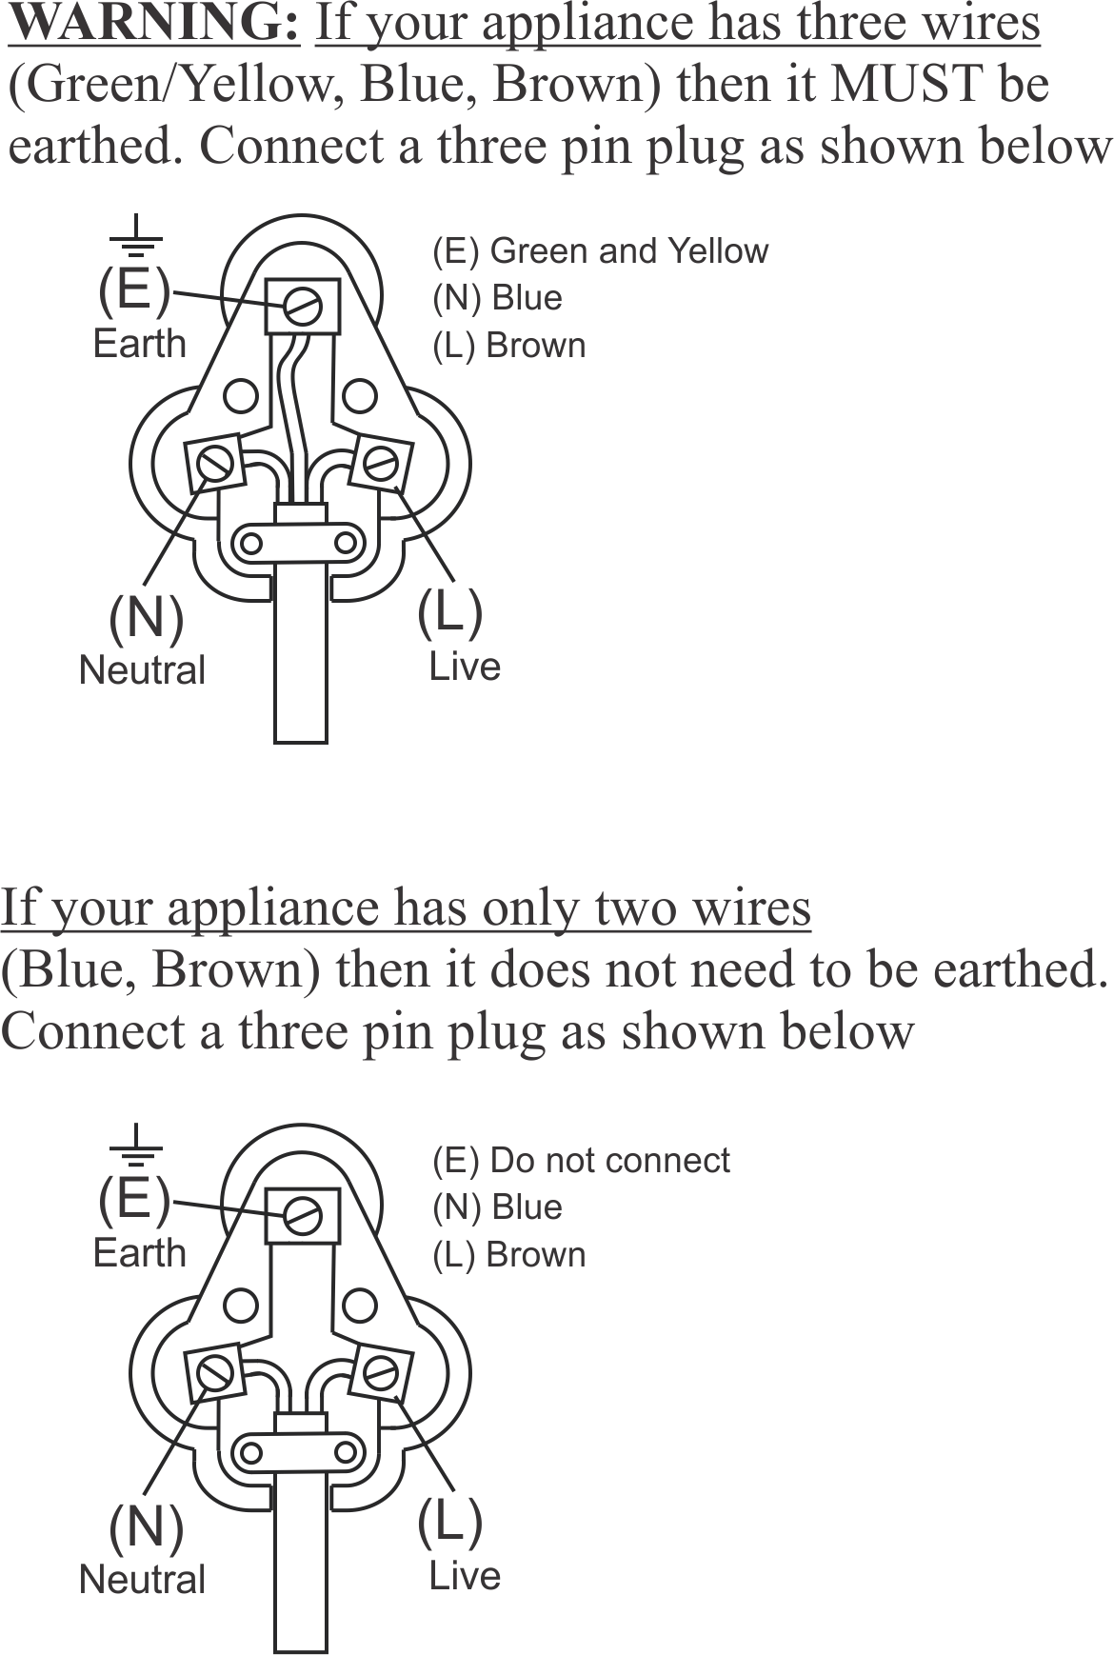

PLEASE AFFIX YOUR PROOF OF PURCHASE/RECEIPT HERE
IN THE EVENT OF A CLAIM UNDER WARRANTY THIS RECEIPT MUST BE PRODUCED.

1 YEAR STANDARD WARRANTY
Warranty will be extended for another year if you register your product online within 12 months of purchase (visit https://russellhobbswarranty.co.za/ )

W A R R A N T Y AND EXTENDED WARRANTY

- Home of Living Brands (Pty) Limited ("Home of Living Brands") warrants to the original purchaser of this product ("the customer") that this product will be free of defects in quality and workmanship which under normal personal, family or household use and purpose may manifest within a period of 1 (one) year from the date of purchase ("warranty period").
- Home of Living Brands shall extend the warranty period for a further period of 1(one) year (“extended warranty period*”), on condition that the purchaser registers the product on the website, within 12 months from the date of purchase of the product. The website address for registration is as follows: https://russellhobbswarranty.co.za/.
- Where the customer has purchased a product and it breaks, is defective or does not work properly for the intended purpose, the customer must notify the supplier from whom the customer bought the product ("the supplier") thereof within the warranty period or if applicable, the extended warranty period. Any claim in terms of this warranty must be supported by a proof of purchase. If proof of purchase is not available, then repair, and/or service charges may be payable by the customer to the supplier.
- The faulty product must be taken to the supplier's service centre to exercise the warranty.
- The supplier will refund, repair or exchange the product in terms of this warranty subject to legislative requirements. This warranty shall be valid only where (a) the customer is not the cause of the product breaking, and (b) the product has been used for the intended purpose stipulated in the product manual. The warranty does not include and will not be construed to cover products damaged as a result of disaster, misuse, tamper, abuse or any unauthorised modification or repair of the product.
- This warranty will extend only to the product provided at the date of the purchase and not to any expendables attached or installed by the customer. In this regard any accessories supplied with the product by the supplier, may be excluded in this warranty or extended warranty (see Exclusions to Warranty and Extended Warranty document).
- If the customer requests that the supplier repairs the product and the product breaks or fails to work properly within 3 (three) months of the repair and not as a result of misuse, tampering or modification by or on behalf of the customer, then the supplier may replace the product or pay a refund to the customer, subject to the supplier’s discretion.
- The customer may be responsible for certain costs where products returned are not in the original packaging, or if the packaging is damaged. This will be deducted from any refund paid to the customer.
HOME OF LIVING BRANDS (PTY) LTD (JOHANNESBURG)
JOHANNESBURG TEL NO. (011) 490-9600
CAPE TOWN TEL NO. (021) 552-5161
DURBAN TEL NO. (031) 303-1163
www.homeoflivingbrands.com
www.russellhobbs.co.za
www.facebook.com/RussellHobbsSA

EXCLUSIONS TO W A R R A N T Y AND EXTENDED WARRANTY
- Any accessories supplied with the product, including but not limited to, bowls, jugs, mills or carafes made either of glass or plastic and supplied with this appliance (hereinafter referred to as “the accessory or accessories”), is warranted to be free from material and workmanship defects for the duration of the appliance warranty.
- The accessories should give trouble free service when used in accordance with the directions described in the instruction manual. However, the accessories will be damaged if subjected to impact, and this damage is not covered by the warranty. Such impact damage can occur either from the outside (if for example it is dropped or knocked against a hard surface), or from within (if for example foreign objects are placed within the accessories and the power is switched on).
- Should you need to replace an accessory during the warranty period; a claim for a free replacement will only be considered if the item (including all shards and broken parts) is returned to the nearest HOLB service centre for examination.
- The remains of the accessory will be carefully examined by the relevant professionals and if it is determined (at the sole discretion of HOLB) that the damage was caused by impact, then the claim will be refused and will not be covered by the warranty or any extended warranty.
- Any replacement part provided in terms of clause 4 above will become a chargeable item payable by the customer.

