

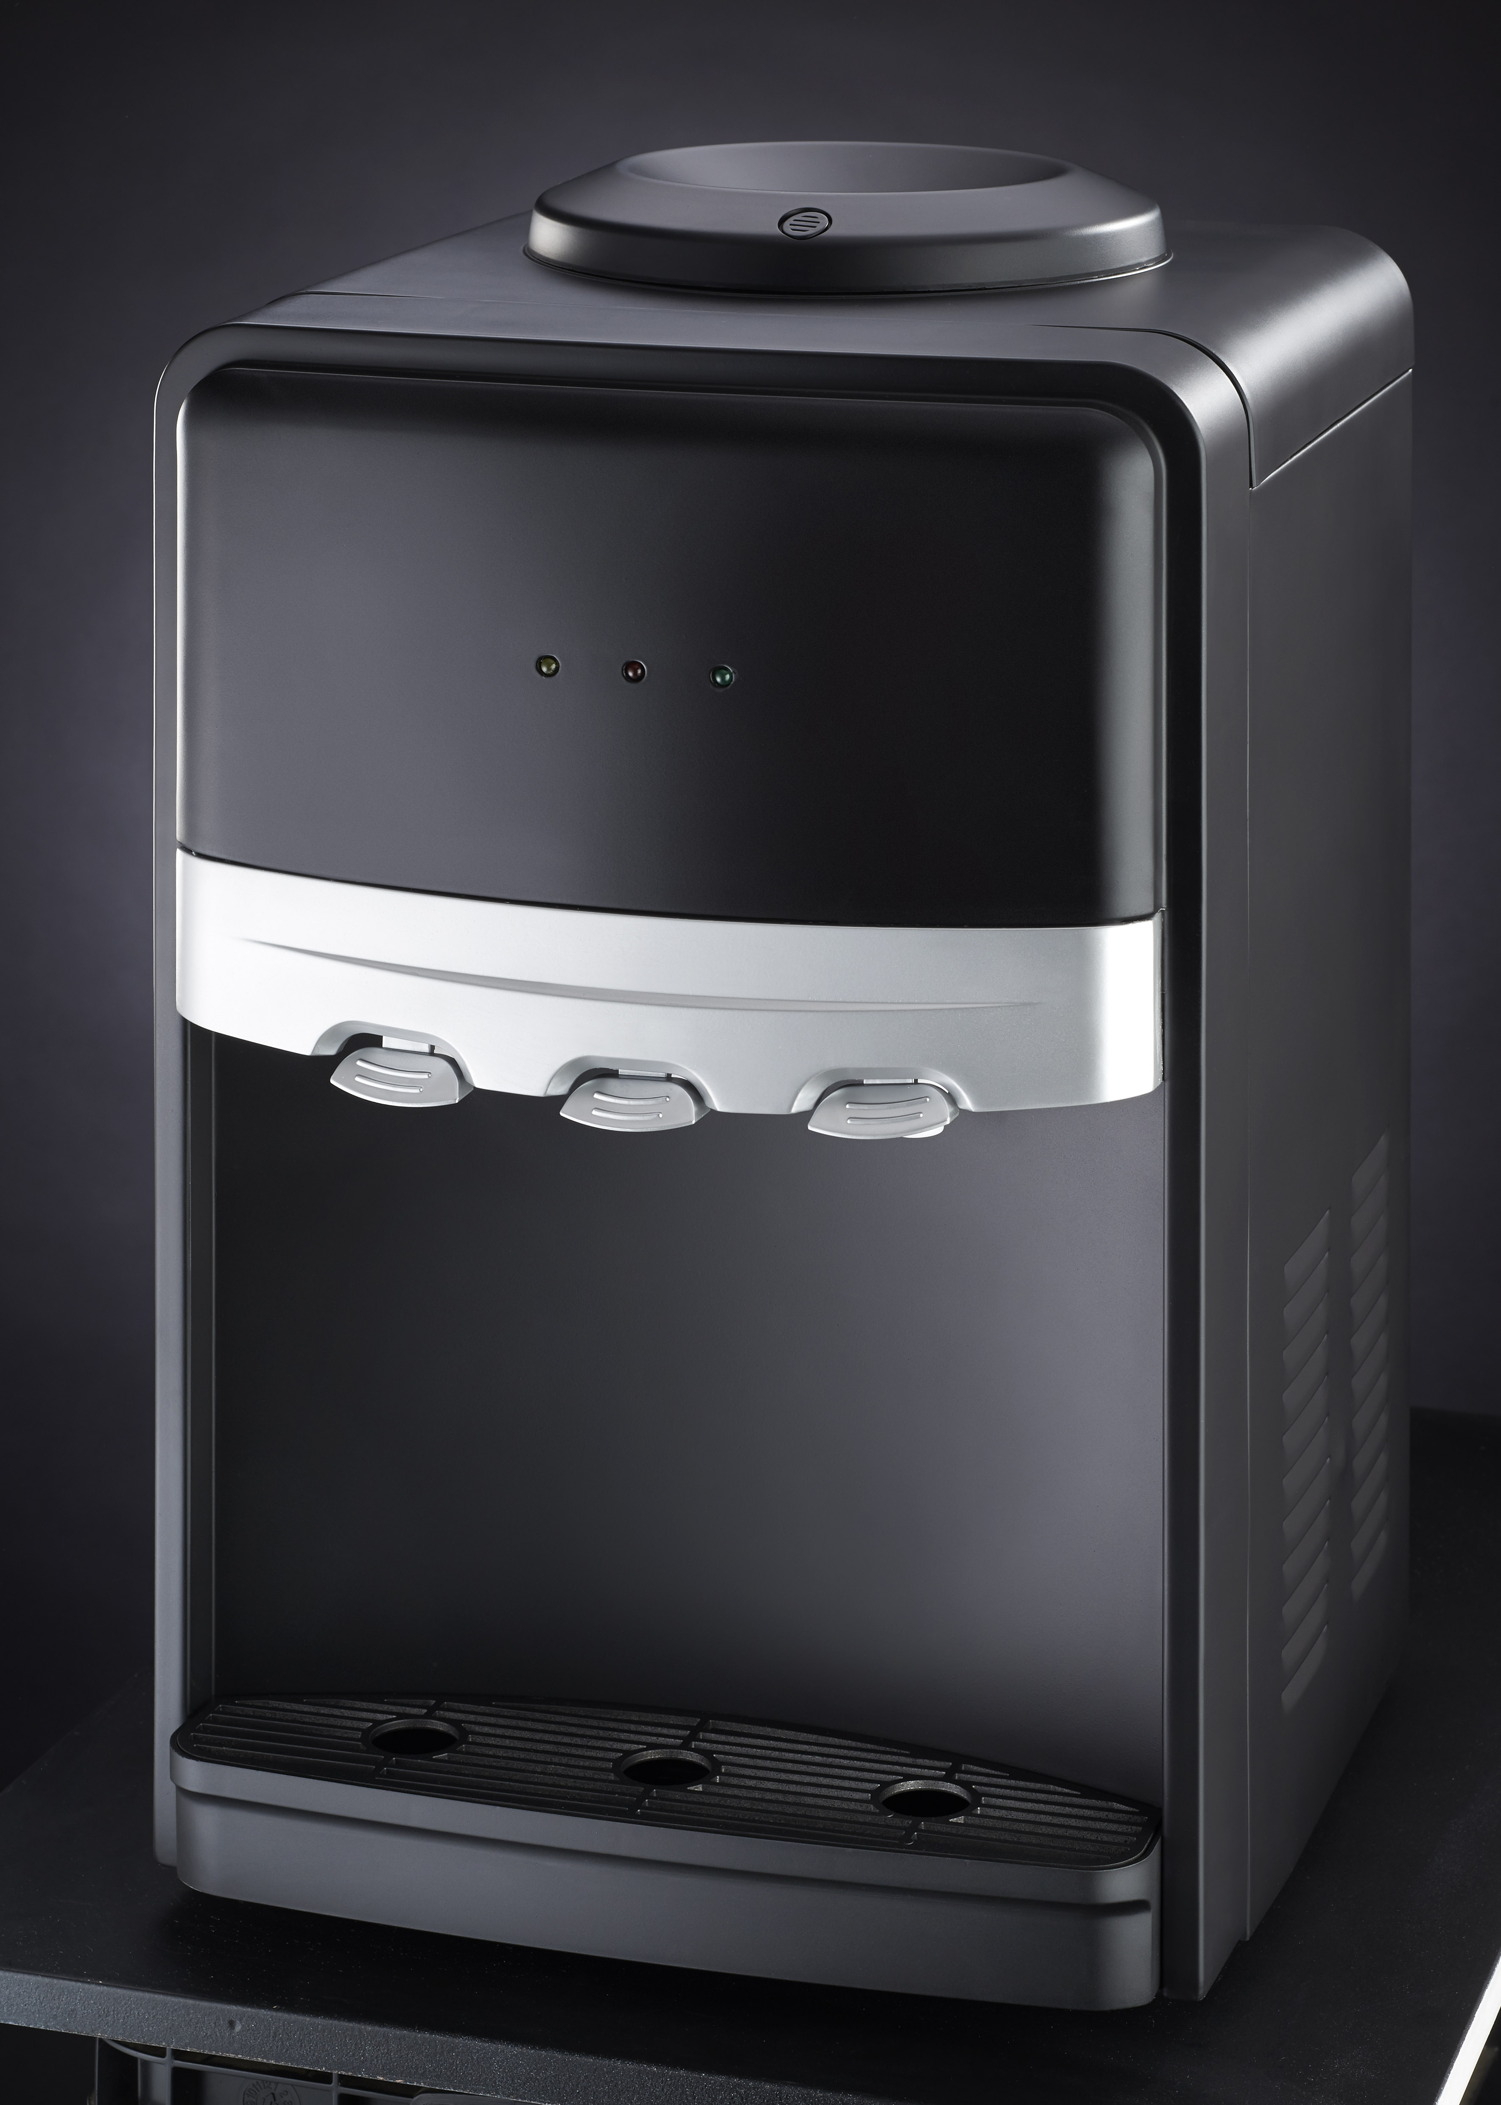

RHTWD3

Russell Hobbs Table Top Water Dispenser

WATER DISPENSER

1-Top cover
2-Power indicator
3-Heating indicator light
4-Cooling indicator light
5-Heating switch
6-Cooling switch
7-Cold thermostat
8-Cold water taps
9-Hot water taps
10-Cold water tank
11-Hot water tank
12-Compressor
13-Drip box
14-Fuse
15-Condenser
16-Door
17-Cabinet
18-Drain valve
19-Power wire
20-Fixing stands

Thank you for having selected the water dispenser. This product is also one of the products which we have provided for you like other products in order to make life easier.

Please read CAREFULLY this user’s manual in order to get the best performance from your product, and keep it for your further reference.

IMPORTANT SAFEGUARDS
* Make sure that the voltage indicated on Water Dispenser corresponds with the voltage in your home. Our company shall not be held liable for any failures owing to any discrepancy and such failures shall not be covered by the guarantee.
* Your appliance has been designed for household and workplace use only.
* Your close supervision is necessary when the appliance is used by children, people having insufficient experience and knowledge, physically (audio, visual) or mentally handicapped people. Make sure that children do not play with the appliance.
* To prevent harming your appliance, do not use extension cords that supply insufficient current.
* Your water dispenser should be at least 30 cm away from heat sources such as furnace, oven, heater core, stove and electric oven, and should not be kept under direct sunlight.
* For efficient operation of your water dispenser, ambient temperature should be minimum 6°C and maximum 30°C.
* Safe operating temperature of the appliance is 45°C.
* Leave back of water dispenser with sufficient openness (10-20cm) for good ventilation.
* If two water dispensers are placed side by side, at least 2 cm space should be left between them.
* Your water dispenser should operate and stop smoothly. Ensure that your water dispenser stands balanced on the horizontal and solid ground. This process should be made before water bottle (dispenser size bottle) is placed.
* Select the connecting cable to which you have connected the appliance and electrical outlet well, ALWAYS make grounding.
Do not allow for overheating of the power outlet by checking it for a certain period after operation.
* Before starting to use your water dispenser against probable dusting during the transportation, discharge water from the taps until one dispenser size bottled water finishes and then, discharge completely by opening the water discharge stopper on the back side.
* When there is no water in the hot water tank, never bring the heating button to the open position.

* After the system is washed by discharging the water in 2-3 dispenser size bottled water for cleaning purpose in your product, the water which you will receive will have the desired odor and taste.
* While using the product, do not put a new dispenser size bottle before water in the dispenser size bottle finishes completely. It is required for not spoiling the water level inside this product.
* Repairs of electrical appliances are made only for qualified persons. Repairs made unconsciously can be dangerous for the user.
* In case of any mistake or while making maintenance and cleaning, disconnect power of your appliance by closing the fuse or by pulling the plug. Pay attention not to pull the cables while removing the plug.
* Electrical safety of your appliance is guaranteed in case the grounding system at your home complies with the standards.
* The product which you have purchased has been designed only for using with “Water dispenser bottle”.
* If there is no function apparatus on the cover of water dispenser size bottle, open notches with a sharp tool (knife etc.) on the center of cover of water dispenser size bottle in order to ensure easy receipt of water into the tanks.
* Keep your water dispenser away from electronic and valuable materials such as TV, CD player or stereo system, and place it into shadowed locations.
* Do not use any place of the product as support or stair instrument.
* Do not operate damaged water dispenser. In case of indecision, consult with your service.
* Do not damage back parts where cooling gas circulation is made in your water dispenser by using cutting and drilling tools. In case condenser gas channels or pipe extensions are punctured, cooling gas to be sprayed may cause skin irritations and eye injuries.
* Do not cover top of your product and do not close it with any object.
* Pay attention that the children do not play with the appliance. For example; keep out of reach of children in order not to be damaged by opening the hot water tap.
* This product has been produced only for water heating and cooling purpose. Do not use it for cooling buttermilk drink, lemonade or drinks with high percentage of alcohol.
* Never keep products containing flammable gas (e.g. spray) and explosive materials near your appliance.
* Do not tilt your appliance more than 45° during transportation or relocation.
* Do not use water dispenser size bottles leaking water due to cracks, holes etc.
* To prevent damage to the heating system, never operate the heating function before water comes from hot water tap.
* Never operate the heating function while water dispenser size bottle is not available on the appliance.
* If water trap fills during the daily use, please discharge accumulated water.
* Do not change the cooling function between open and closed positions within a shorter period than 3 minutes. (It is important for extending the useful life by protecting the compressor.)
* Do not make any intervention to your appliance other than cleaning and maintenance. If the cord or plug of your appliance is out of order, it was damaged because of being dropped or for another reason, do not use it. Do not attempt to repair it by yourself.
. Pay attention to use only original spare parts in your appliance.

Pay attention to the following points in the first operation of the water dispenser;
* In order to prevent any damage to the heating system; do not make connection of power plug before water comes from the hot water tap.
* Your appliance should never be exposed to any power failure.
* Cooling button should not be brought to closed position for the first six hours.
* If power failure has occurred within the first six hours; pay attention to the warnings under the title of “

DURING THE TRANSPORTATION

* Original packages and foams may be required for re-transportation or transportation of your appliance.
Points to consider during re-transportation of the product;
- Your water dispenser should be discharged and cleaned before the transportation.
- Accessories of your water dispenser should be taped and then, strengthened against the shake.
- Condenser pipes on the back side should be protected against impacts, perforations before the packaging.
- Package should be fixed with thick tapes or strong ropes and should comply with the package absolutely.
- Your appliance should not be transported horizontally more than 45° during the transportation. When this situation occurs, the appliance should be caused to be waited vertically for 6 hours before reoperation.

NECESSARY ACTIONS FOR ENERGY SAVING
* Do not put hot water into the water dispenser.
* Do not place your water dispenser near the heat emitting appliances such as oven, dishwasher, and heater or so as to take direct sunlight.
* If you will not use your water dispenser for long period or when it will not be used at nights, turn off (power) appliance.

NOTE: If you will not use your water dispenser for long period, discharge the water inside it completely. In order to discharge the water inside it completely, open the drain valve behind your appliance after water coming from taps finishes, and wait for finishing the water completely. The water, which waits inside the appliance for long period, may cause odor and if it remains in the cold ambient, it may cause deformation of water tanks by freezing.

OPERATION OF WATER DISPENSER

Preparation for operation of the water dispenser;
* Tear the hygienic label on the water bottle (water dispenser size bottle). Place the bottle reversely into the water protector on the top part of the water dispenser.
* Internal center of the water protector opens and clogs the valve automatically. As the bottle moves in this time, it will automatically turn off in order to prevent probable water leakage on the valve.
* Push the hot water tap, bubbles which indicate that water in the bottle flows into hot and cold water tanks will occur. Continue pressing the hot water tap until water flow terminates.

CAUTION: Never make power connection of your appliance until water comes from hot water tap.

* When water starts to flow from hot water tap, you can make the power connection.
* Turn “on” (red) hot water power switch and hot water indicator light will be lit (red) and heating system will start to operate. If you do not want to use hot water, turn “off” hot water power switch and the water will be at normal temperature.
* When red indicator light turns off automatically, water temperature will come to 85-95°C ideal hot water temperature. When water temperature reduces to 80°C, red indicator light will be lit automatically and water temperature will increase again.
* Turn “on” (blue) cold water power switch, cold water indicator light will be lit (green), and cooling system will start to operate.
* When red indicator light turns off automatically, water coldness will come to 8°C ideal cold water temperature.
* Your water dispenser has two taps as hot water and cold water.
* Hot water tap is on the left, cold water tap is on the right.

PREPARATION

Push the hot water tap. Bubbles flowing in the bottle will indicate that water in the bottle is flowing into the hot water tank. Continue pressing the hot water tap until water in the hot water tank stops.

INSTALLATION

- Your water dispenser has three taps namely, hot, cold and ambient water.
- Turn on the ‘red’ hot water power switch found at the back of your unit.
- The cold water indicator light will illuminate ‘green’, the power indicator light will illuminate ‘yellow’ and the hot water indicator light will be illuminate ‘red’. The heating system will start to operate.
- When the ‘red’ indicator light turns off automatically, the water temperature will have reached the ideal temperature of 85-95°C. When the water temperature reduces to 80°C, the ‘red’ indicator light will illuminate automatically and the water temperature will increase again.
- If you do not want to use hot water, turn off the hot water power switch at the back of your unit and the water will be at normal temperature.

CLEANING AND CARE

* Before cleaning, disconnect the power of your appliance by pulling the plug or turning off the fuse.
* Never use vapor or steam cleaning materials for cleaning purpose, do not spray water directly. In such a case, vapor or water droplets contact with the zones having electric current on your appliance and then, they may cause short circuit or electric shocks.
* Clean the outer surfaces of your appliance with a soft cloth or sponge wetted with warm water to which carbonate (baking soda) was added. Use cloth or sponge after squeezing them properly. Never use scratching and abrasive (thinner, bleach, detergent powder etc.) materials.
* Remove dusts between your appliance through a brush or vacuum cleaner once a year. If dust or other foreign matters have covered on the condenser, clean with a soft cloth wetted on the water.
* Dry the appliance completely after cleaning.

CAUTION: In case of sudden power failure or removal and insertion of the plug, as the pressure of gas in the cooling system of your appliance has not been balanced yet, compressor protector’s thermal blows.

In case of any power failure;
* If it occurs within the first six hours during the first operation of your appliance, pull the plug, wait for one hour and then, reinsert it.
* If it occurs after the first six hours, there is no need to pull the plug. Your appliance will start to operate automatically after 10 minutes.
* If your appliance has not started to cool at the end of these periods, call the Authorized Service.

TROUBLESHOOTING

Trouble | Probable Cause
Water dispenser does not operate | It is not plugged in.  Fuse has blown or failed.
Water which comes from cold water tap is not cold sufficiently | Ensure that cold water button on the back is open.  Water dispenser has not been placed on the distance sufficiently far from the wall.
Water dispenser does not heat the water sufficiently | Ensure that hot water button on the back is open.  Surface of the heater in the hot water tank may have been deposited (calcified). Read and apply the text of cleaning the water dispenser.
Compressor is operating and stopping frequently | Room temperature is over the normal.  Water dispenser has not been placed on the distance sufficiently far from the wall.
It makes vibration | Ensure that the water dispenser is located in balanced manner.
Water dispenser is operating very noisily. | Noise may be caused from flow of cooling agent, this is normal.  You can hear a flow sound at the end of each circulation.  Clinking sounds may occur as a result of contradiction and expansion because of heating and cooling of water tanks.  Ensure that the water dispenser is located in balanced manner.

SERVICING THE APPLIANCE
There are no user serviceable parts in this appliance. If the unit is not operating correctly, please check the following:
- You have followed the instructions correctly
- That the unit has been wired correctly and that the wall socket is switched on.
- That the mains power supply is ON.
- That the plug is firmly in the mains socket.

If the appliance still does not work after checking the above:
- Consult the retailer for possible repair or replacement. If the retailer fails to resolve the problem and you need to return the appliance, make sure that:
- The unit is packed carefully back into its original packaging.
-Proof of purchase is attached.
-A reason is provided for why it is being returned.

If the supply cord is damaged, it must be replaced by the manufacturer or an authorised service agent, in order to avoid any hazard. If service becomes necessary within the warranty period, the appliance should be returned to an approved Home of Living Brands(Pty) Ltd service centre. Servicing outside the warranty period is still available, but will, however, be chargeable.

CHANGING THE PLUG
Should the need arise to change the fitted plug, follow the instructions below.
Connecting to other power sources may damage the appliance. Connect a three-pin plug as follows: The wires in this mains lead are coloured in accordance with the following code:
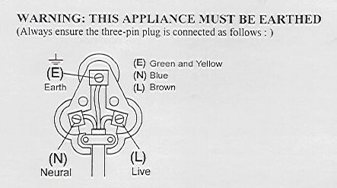
Green/Yellow = Earth
Blue = Neutral
Brown = Live

PLEASE AFFIX YOUR PROOF OF PURCHASE/RECEIPT HERE
IN THE EVENT OF A CLAIM UNDER WARRANTY THIS RECEIPT MUST BE PRODUCED.

W A R R A N T Y

- Home of Living Brands (Pty) Limited warrants to the original purchaser of this product (“the customer”) that this product will be free of defects in quality and workmanship which under normal personal, family or household use and purpose may manifest within a period of 1 (one) year from the date of purchase (“warranty period”).
- Where the customer has purchased a product and it breaks, is defective or does not work properly for the intended purpose, the customer must notify the supplier from whom the customer bought the product (“the supplier”) thereof within the warranty period. Any claim in terms of this warranty must be supported by a proof of purchase. If proof of purchase is not available, then repair, and/or service charges may be payable by the customer to the supplier.
- The faulty product must be taken to the supplier's service centre to exercise the warranty.
- The supplier will refund, repair or exchange the product in terms of this warranty subject to legislative requirements. This warranty shall be valid only where the customer has not broken the product himself, or used the product for something that it is not supposed to be used for. The warranty does not include and will not be construed to cover products damaged as a result of disaster, misuse, tamper, abuse or any unauthorised modification or repair of the product.
- This warranty will extend only to the product provided at the date of the purchase and not to any expendables attached or installed by the customer.
- If the customer requests that the supplier repairs the product and the product breaks or fails to work properly within 3 (three) months of the repair and not as a result of misuse, tampering or modification by or on behalf of the customer, then the supplier may replace the product or pay a refund to the customer.
- The customer may be responsible for certain costs where products returned are not in the original packaging, or if the packaging is damaged. This will be deducted from any refund paid to the customer.

HOME OF LIVING BRANDS (PTY) LTD
JOHANNESBURG TEL NO. (011) 490-9600
CAPE TOWN TEL NO. (021) 552-5161
DURBAN TEL NO. (031) 792-6000
www.homeoflivingbrands.co.za
www.russellhobbs.co.za
www.facebook.com/RussellHobbsSA

