INSTRUCTIONS AND WARRANTY

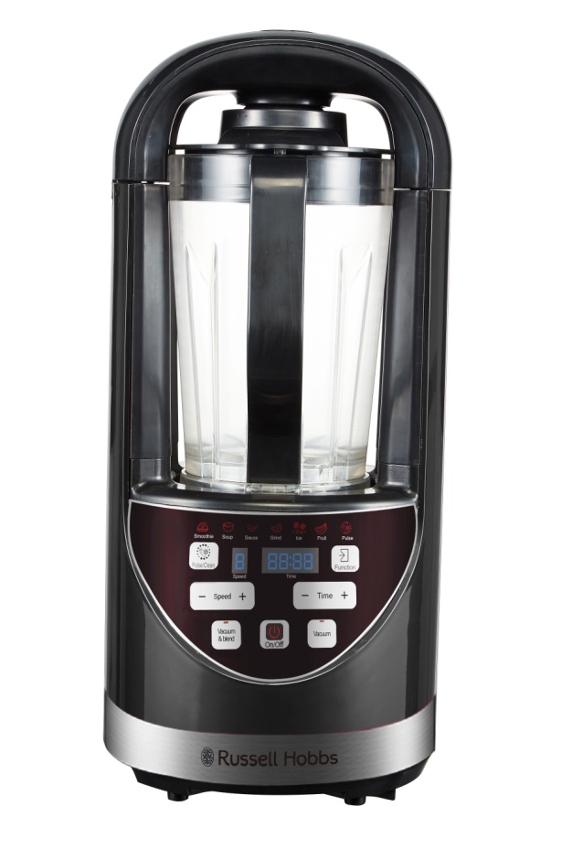

MODEL NO. RHVB09

RUSSELL HOBBS NUTRIMASTER

Congratulations on purchasing our Russell Hobbs Nutrimaster. Each unit is manufactured to ensure safety and reliability. Before using this appliance for the first time, please read the instruction manual carefully and keep it for future reference.

FEATURES OF THE RUSSELL HOBBS NUTRIMASTER

- High speed vacuum blender
- Advanced anti-oxidisation technology
- Removes oxygen in blending process which preserves ingredients and retains more nutrients and flavour
- Results in brighter colour and even smoother consistency in blended ingredients
- Retains the freshness and original taste of ingredients for longer
- Powerful 1500W motor
- LED display panel
- Maximum speed of 25 000 RPM
- Powerful stainless-steel blades break down ingredients more effectively
- 1.8L BPA free jug
- Simplified blending function options with variable speed settings
- For domestic use only
- 2-year warranty (1-year retail • 1 year extended upon online registration of product • visit www.russellhobbs.co.za)

IMPORTANT SAFEGUARDS

When using any electrical appliance, basic safety precautions should always be followed including the following:

- Please read the instructions carefully before using the appliance.
- Always ensure that the voltage on the rating label corresponds to the mains voltage in your home.
- Incorrect operation and improper use can damage the appliance and cause injury to the user.
- The appliance is intended for household use only. Commercial use invalidates the warranty and the supplier cannot be held responsible for injury or damage caused when using the appliance for any other purpose than that intended.
- Always disconnect the appliance from the power supply if it is left unattended and before assembling, disassembling or cleaning.
- Avoid any contact with moving parts. Never touch the rotating tools while still in motion - always wait for them to come to a complete stop.
- Close supervision is required when any appliance is used near or by children.
- Check the power cord and plug regularly for any damage. If the cord or the plug is damaged, it must be replaced by the manufacturer or a qualified person in order to avoid an electrical hazard.
- Do not use the appliance if it has been dropped or damaged in any way. In case of damage, take the unit in for examination and/or repair by an authorized service agent.
- To reduce the risk of electric shock, do not immerse or expose the motor assembly, plug or the power cord to water or any other liquid. Do not use it with wet hands.
- Never immerse the unit in water or any other liquid for cleaning purposes.
- Remove the plug from the socket by gripping the plug. Do not pull on the cord to disconnect the appliance from the mains. Always unplug the unit when not in use, before cleaning or when adding or removing parts.
- Insert only original parts. The use of accessory attachments that are not recommended or supplied by the manufacturer may result in injuries, fire or electric shock.
- A short cord is provided to reduce the hazards resulting from becoming entangled in or tripping over a longer cord.
- Do not let the cord hang over the edge of a table or counter. Ensure that the cord is not in a position where it can be pulled on inadvertently.
- Do not allow the cord to touch hot surfaces and do not place on or near a hot gas or electric burner or in a heated oven.
- Do not use the appliance on a gas or electric cooking top or over or near an open flame.
- Keep the appliance and cord away from direct radiant heat from the sun, damp areas, sharp edges and other dangers.
- Do not put the motor unit in water or any other liquid; do not use it in a bathroom or near any source of water.
- Never immerse the plug and the power cord in water or other fluids. Never clean the plug with a wet cloth. Never insert or pull out the plug with wet hands.
- When the blending jug is on the base, do not put your hands or any other objects like metal into the jug. This is to avoid injury or damage to both the person handling the product and the appliance.
- Never switch the appliance on without any ingredients in it.
- When using this product, make sure that water or any other liquids don’t exceed the maximum capacity.
- Do not use the appliance if the blades are bent or damaged.
- Use of an extension cord with this appliance is not recommended. However, if it is necessary to use an extension cord, ensure that the cord is suited to the power consumption of the appliance to avoid overheating of the extension cord, appliance or plug point. Do not place the extension cord in a position where it can be pulled on by children or animals or tripped over.
- This appliance is not suitable for outdoor use. Do not use this appliance for anything other than its intended use.
- Do not carry the appliance by the power cord.
- Do not leave this appliance unattended during use. Always unplug the unit when not in use or before cleaning.
- Always operate the appliance on a smooth, even, stable surface. Do not place the unit on a hot surface.
- Do not operate this appliance by means of an external timer or remote-control system.
- Never use this appliance to blend anything other than foods.
- Do not use during cooking processes or with boiling liquids.
- Do not operate the appliance with no ingredients and do not remove the jug lid when the blades have not come to a complete stop.
- Always turn the blender power off at the power outlet before you remove the plug.
- The manufacturer does not accept responsibility for any damage or injury caused by improper or incorrect use, or for repairs carried out by unauthorized personnel.
- In case of technical problems, switch off the blender and do not attempt to repair it yourself. Return the appliance to an authorized service facility for examination, adjustment or repair. Always insist on the use of original spare parts. Failure to comply with the above-mentioned pre-cautions and instructions, could affect the safe operation of this machine.
- This appliance is not intended for use by persons (including children) with reduced physical, sensory or mental capabilities, or lack of experience and knowledge, unless they have been given supervision or instruction concerning use of the appliance by a person responsible for their safety.
- Store the blender away from direct sunlight and fluorescent light where possible.
- Children should be supervised to ensure that they do not play with the appliance.
- Do not use the blender for any purpose other than those described in these instructions.
- When the motor is overloaded, it will turn off automatically. It is only a safety protection. Switch off the appliance and let the machine totally cool down. You can use the appliance again after 45 minutes.
- This appliance is designed for processing household quantities; it is not suitable for commercial purposes. Use the appliance only for the purpose it was designed for.
- Do not use this appliance if it or parts of it show visible damage or if the appliance has been dropped.
- Do not attempt to make any modifications to this appliance.
- To avoid any risk and to remain within warranty, repairs to this appliance must be carried out by an authorised service agent only.
- If the supply cord is damaged, it must be replaced by the manufacturer, its authorised service agent or similarly qualified persons in order to avoid any hazard.
- Do not use outdoors.

PARTS DIAGRAM

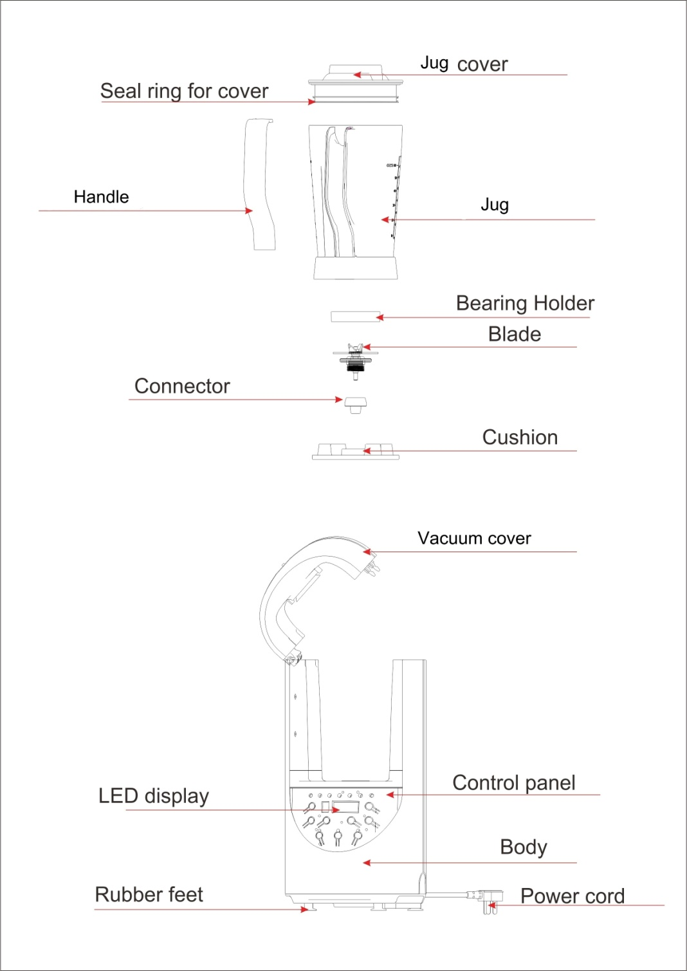

OPERATING INSTRUCTIONS

- Ensure the control panel is facing forward then proceed by lifting the Vacuum cover up on the right hand side of the unit where the “Lift to Open” wording is clearly indicated.
- When placing the jug on the base, please ensure it’s locked in properly whereby the handle is on the other side of the LED display panel and that the vacuum cover is tightly closed.
- Once the vacuum blender has been connected to a power source the LED timer will display four zeros ”00:00“, the LED speed indicator will display “0” and the “On/off” button will light up.
- The blender would then be on standby whereby you can choose your desired function.
- Only Smoothies, Soups, Sauces and Fruit selections can be used for the vacuum option.
- Grinding and Ice functions cannot be used in conjunction with the vacuum function.
- The “Vacuum” function only serves the sole purpose of vacuuming the ingredients, the “On/Off” option is only for blending and the “Vacuum & blend” option is for vacuuming and blending.

NUTRIMASTER FUNCTIONS

Note: Once the vacuum function has been used in certain functions and the blending process has been completed the rubber seal on the vacuum cover must be pulled to release any pressure. To ensure the jug opens properly after the vacuum blending process also pull on the rubber seal on the jug lid.

- Smoothie:
- Select the smoothie button to enable the smoothie function.
- Select Vacuum & blend function then press the “On/Off” button.
- The appliance will start vacuuming and the vacuum time will depend on the liquid capacity.
- The more liquid you put into the blender, the shorter the time period it will take to vacuum.
- The maximum vacuuming time is 2 minutes.
- When it has finished vacuuming, it will start to blend. The LED timer will display 03:00 (meaning 3 minutes) and the LED speed indicator will display “1”.
- The timer will start counting down from 03:00 to 02:56 with the speeds increasing from “1” to “4”.
- It will remain on the “4” speed setting until the timer indicates 02:31.
- Once it hits 02:30 then the speed will change to “6” until the timer displays 02:00 whereby the speed will change to “8” until blending process is complete.

Note: The smoothie function has a preset time that is set for 3 minutes. If you want to adjust the speed or time, after choosing the “Smoothie” function, press “+” or “-“ to set your preferred settings. Thereafter press the “Vacuum & blend” button and the “On/Off” button then the appliance will work according to your settings.

- Soup:
Note: This blender does not have a heating function; the soup function is a recommended setting to blend ingredients in or for soups.
Do not use boiling liquids.
- Select the soup button for the soup function.
- Select Vacuum & blend function then press the “On/Off” button.
- The appliance will start vacuuming and the vacuum time will depend on the liquid capacity.
- The more liquid you put into the blender, the shorter the time period it will take to vacuum.
- The maximum vacuuming time is 2 minutes.
- When it has finished vacuuming, it will start to blend. The LED timer will display 06:00 (meaning 6 minutes) and the LED speed indicator will display “1”.
- The timer will start counting down from 06:00 to 05:52. The speed will remain at “8” until the blending process is complete.

Note: The soup function has a preset time that is set for 6 minutes. If you want to adjust the speed or time, after choosing the “Soup” function, press “+” or “-“ to set your preferred settings. Thereafter press the “Vacuum & blend” button and the “On/Off” button then the appliance will work according to your settings.

- Sauce:
- Select the sauce button for sauce function.
- Select Vacuum & blend function then press the “On/Off” button.
- The appliance will start vacuuming and the vacuum time will depend on the liquid capacity.
- The more liquid you put into the blender, the shorter the time period it will take to vacuum.
- The max vacuuming time is 2 minutes.
- When it has finished vacuuming, it will start to blend. The LED timer will display 04:00 (meaning 4 minutes) and the LED speed indicator will display “3”.
- The timer will start counting down from 04:00 to 03:54 with the speeds increasing from “3” to “8”. The speed will remain at “8” until the blending process is complete.

Note: The sauce function has a preset time that is set for 4 minutes. If you want to adjust the speed or time, after choosing the “Sauce” function, press “+” or “-“ to set your preferred settings. Thereafter press the “Vacuum & blend” button and the “On/Off” button then the appliance will work according to your settings.

- Grinding:
- Select the grinding button for grinding function.
- Then press the “On/Off” button.
- It will start to blend as this function does not have a vacuum option.
- The LED of timer will display 01:00 (meaning 1 minute) and the LED speed indicator will display “1”.
- The timer will start counting down from 01:00 with the speed increasing from “1” to “8”.
- The speed will remain at “8” until the blending process is complete.

Note: The grinding function does not have a vacuum option but if you want to adjust the speed or time, after choosing the “Grinding” function, press “+” or “-“ on the speed and time buttons to set your preferred settings. Thereafter press the “On/Off” button. It will then work according to your settings.

- Ice:
- Add 200ml of water (so that the ice does not stick together) and ensure the ice does not exceed the 750ml mark per cycle.
- It’s advisable to stop mid operation and mix the ice manually using a spatula (not with your fingers) to ensure the ice gets evenly crushed.
- Select the Ice button for the ice function.
- Then press the “On/Off” button.
- It will start to blend as this function does not have a vacuum option.
- The LED timer on the panel will display 00:48 (meaning 48 seconds) and the LED speed indicator will display “8”.
- The timer will start counting down from 00:48 but please note the blender will operate for 4 seconds and stop for another 4 seconds, this process will occur 6 times then completely stop.
- The speed will remain at “8” until the blending process is complete.
Note: The ice function does not have a vacuum option but if you want to adjust the speed or time, after choosing the “Ice” function, press “+” or “-“ on the speed and time buttons to set your preferred settings. Thereafter press the “On/Off” button. It will then work according to your settings.

- Fruit:
- Select the fruit button for fruit function.
- Select Vacuum & blend function then press “On/Off” button.
- The appliance will start vacuuming and the vacuum time will depend on the liquid capacity.
- The more ingredients you put into the blender, the shorter the time period it will take to vacuum.
- The maximum vacuuming time is 2 minutes.
- When it has finished vacuuming, it will start to blend. The LED timer will display 00:40 (meaning 40 seconds) and the LED speed indicator will display “1”.
- The timer will start counting down from 00:40 to 00:32 with the speeds increasing from “1” to “8”. When the timer displays 00:32 and the speed at “8”, the vacuuming process is complete and the blending process will begin.

Note: The fruit function has a preset time that is set for 40 seconds. If you want to adjust the speed or time, after choosing the “Fruit” function, press “+” or “-“ to set your preferred settings. Thereafter press the “Vacuum & blend” button then press the “On/off” button and the appliance will work according to your settings.

- Pulse:
- Select the Pulse(clean) function, the indicated light will then switch on.
- If you remove your finger from the button, it will stop working.
- The set speed for this function is “8”.

Note: Do not use the Vacuum function directly after using the above Pulse function as this will damage the vacuum motor.

- Vacuum:
- Press the Vacuum button.
- The appliance will start vacuuming and the vacuum time will depend on the liquid capacity.
- The more liquid / ingredients you put into the blender, the shorter the time period it will take to vacuum.
- The maximum vacuum time is 2 minutes.
- To ensure the jug doesn’t lift (after any vacuum related function) when trying to open the vacuum cover, pull on the black rubber seal and proceed with opening the cover.

Note: This function is only for vacuuming.
PLEASE NOTE: USER CAN OPT TO STOP OPERATION WHENEVER THEY SEE THAT THE INGREDIENTS HAVE BLENDED SUFFICIENTLY BEFORE THE BLENDING SESSION ENDS.

CAUTION

- If the ingredients are too thick or blend under a low speed for long period of time, it may cause the product to stop working as the motor would get too hot.
- Therefore, it’s recommended to use high speeds if the ingredients are too dense.
- If the motor is too hot, it will stop working. Please remove the plug from the socket and let the product cool down for 45 minutes then continue using the product thereafter.
- Please ensure the jug cover and the vacuum cover are closed properly to avoid ingredients from spilling out.
- When selecting the grinding function, please do not fill the jug over the 500ml point and ensure the blending time does not exceed 3 minutes.
- Do not use the appliance for over 10 minutes per cycle.

Nutrimaster checklist

Can it blend/grind the below?
Apples (peeled/unpeeled/both?) | Both but with liquid must be cored
Beetroot (peeled/unpeeled/both?) | Peeled, cooked
Oranges (peeled/unpeeled/both?) | Peeled
Carrots (peeled/unpeeled/both?) | Both, cooked or raw
Celery | Yes
Spinach | Only with liquid or if cooked
Pears (peeled/unpeeled/both?) | Yes, must be cored
Frozen fruit (if yes, which ones?) | Frozen berries
Dried fruit | Yes
Seeds (chai/sesame/pumpkin/pomegranate/sunflower/flux/hemp) | No
Cucumber | Yes, with liquid
Ginger | Yes, with liquid
Berries | Yes
Pineapples | Yes
Green pepper | Yes
Nuts (specify) | Yes, mixed nuts
Biltong (specify which and the qty?) | Yes 500g
Coffee beans | No
Oat meal | Yes
Egg plant | Yes, if cooked
Coconut | No
Butternut (cooked?) | Yes
Pomegranate | no
Passion fruit | No
Melons (specify) | Yes, green melon
Tomatoes | Yes
Peas | No
Asparagus | Yes, cooked
Legumes (specify) | No
Broccoli (cooked/uncooked?) | Both, with liquid
Herbs (specify) | Yes. Parsley, basil, chives with liquid

Nutrimaster recipes

Power green Juice
Ingredients:
4 apples
1kg spinach roughly torn
10 g fresh ginger
500ml water, cold
Method:
- Core and quarter the apples then place into the jug
- Add spinach, ginger and water
- Vacuum blend on smoothie function
- Serve immediately or lock in the nutrition by storing the actual jug in the refrigerator and serve later

Apple Sauce
Ingredients:
6 apples cored and quartered
3 tbsp. sugar
1 tbsp. lemon zest
250ml water
½ tsp cinnamon
30 ml orange juice
Method:
- Add all ingredients into the jug
- Set on sauce function and allow to puree until smooth
- Remove from the Nutrimaster into a saucepan and allow to cook for 15-20 minutes on medium heat

Beetroot and goats cheese salad

Ingredients:
700g beetroot, peeled and cooked
250g goats cheese, crumbed
80g walnuts roughly chopped
2 cups of rocket leaves
Salt and pepper
Olive oil and Balsamic for dressing
Method:
- Add the beetroot into the Nutrimaster jug and pulse until roughly chopped
- Remove and add the beetroot into a bowl, top with goat’s cheese, nuts and rocket leaves
- Season with salt and pepper
- Drizzle olive oil and balsamic over

Gazpacho Soup

Ingredients:

2 tbsp. basil
400g tomatoes, blanched and peeled
80g white onion
1 whole cucumber
2 gloves garlic
1 jalapeno whole
½ red pepper
1 tsp cumin
Salt and pepper
Method:
- Add all the ingredients into the Nutrimaster jug
- Set on soup function and vacuum blend until smooth
- Serve soup cold with crusty bread

Piquante Pepper dip

Ingredients:
150g peppadew piquante pepper diced
200g goats cheese
200g mascarpone
200g cream cheese
3 basil leaves
2 gloves garlic
Salt and pepper
Method:
- Add all ingredients into the Nutrimaster jug
- Set on smoothie function
- Once it has vacuum blended, remove and serve with crackers or fresh baby vegetables

Baba Ganoosh
Ingredients:
6 medium eggplants roughly chopped
1 tsp salt
3 garlic cloves
4 tbsp. olive oil
3 tbsp. tahini paste (sesame paste)
1 tsp cumin
½ tsp cayenne pepper
Method:
- On a roasting pan add eggplants, salt, garlic cloves and olive oil
- Roast at 180c for 30 minutes
- Once cooked, remove and allow to cool
- Add the cooked eggplants, tahini paste, cumin and cayenne pepper into the Nutrimaster jug
- Set on smoothie function and vacuum blend until smooth. You may add more olive oil to smoothen the consistency.
- Serve as a dip
Fruit and nut crumble topping
Ingredients:
250g mixed dried fruit
100g mixed nuts
1 tbsp. sunflower seeds
1 tbsp. pumpkin seeds
80g butter
80g rolled oats
Method:
- Add all ingredients into the Nutrimaster jug
- Set on grind function and allow mixture to blend well
- Remove from jug, place on a baking tray and bake for 10-15 mins at 180’c
- Serve over yoghurt for breakfast or ice cream as a dessert

Super green smoothie
Ingredients:
1 cup kale
1 pear, cored
1 carrot whole
1 cup fresh orange juice
1 cup fresh berries
1 cup ice
Method:
- Add all ingredients into the Nutrimaster jug
- Set on smoothie function till well combined

Pancake batter

Ingredients:
1 egg
120g flour
300ml milk
Pinch salt
1 tbsp. oil
Method:
- Add all ingredients into the Nutrimaster jug
- Set on soup function and allow to vacuum blend well
- Set aside until needed
** Add 1 tbsp. baking powder to make a flapjack batter

Mango Lassi

Ingredients:
2 cups mango
1tbsp honey
2 tsp lemon juice
1 cup yoghurt
3 cups ice
Method:
- Add all ingredients into the Nutrimaster jug
- Set on smoothie function
- Serve with mint or mango piece as garnish

CLEANING AND MAINTENANCE

- This appliance is for household use only and is not user-serviceable.
- Do not open or change any parts by yourself. Please refer to an authorized electrical service department or return to the supplier if servicing is necessary.
- Always remember to unplug the unit from the electrical outlet when not in use and before cleaning.
- Do not use bleach or other abrasive substance or solvents to clean your appliance as it can be damaging to the finish.
- Do not immerse the whole unit (base) in water or any other liquid or hold it under a running tap to clean.
- Unplug the blender from the mains before cleaning and storing away.
- Clean after use to prevent residues settling inside the bottle(s) or container.
- Remove the jug from the motor unit. Wash the jug in warm soapy water, rinse well, then turn it upside down to drain and dry.
- You can use water to clean the jug directly. Or you can fill in 2 cups of water and use “Pulse/Clean” function to clean it. After that, use a soft cloth to dry it.
- Keep hands out of the jug – BLADES ARE VERY SHARP.
- If the jug is left for too long without cleaning and bits have glued themselves to the inside of the jug, use a nylon brush to remove.
- Wipe the outside of the motor unit with a clean damp cloth.
- Do not put the motor unit in water or any other liquid.

STORING THE APPLIANCE
- Unplug the unit from the wall outlet and clean all the parts as instructed above. Ensure that all parts are dry before storing.
- Store the appliance in its box or in a clean, dry place.
- Never store the appliance while it is still wet or dirty.
- Never wrap the power cord around the appliance.

SERVICING THE APPLIANCE
There are no user serviceable parts in this appliance. If the unit is not operating correctly, please check the following:
- You have followed the instructions correctly
- That the unit has been wired correctly and that the wall socket is switched on.
- That the mains power supply is ON.
- That the plug is firmly in the mains socket.

If the appliance still does not work after checking the above:
- Consult the retailer for possible repair or replacement. If the retailer fails to resolve the problem and you need to return the appliance, make sure that:
- The unit is packed carefully back into its original packaging.
- Proof of purchase is attached.
- A reason is provided for why it is being returned.

If the supply cord is damaged, it must be replaced by the manufacturer or an authorised service agent, in order to avoid any hazard. If service becomes necessary within the warranty period, the appliance should be returned to an approved Home of Living Brands (Pty) Limited service centre. Servicing outside the warranty period is still available, but will, however, be chargeable.

CHANGING THE PLUG
Should the need arise to change the fitted plug, follow the instructions below.
This unit is designed to operate on the stated current only. Connecting to other power sources may damage the appliance.

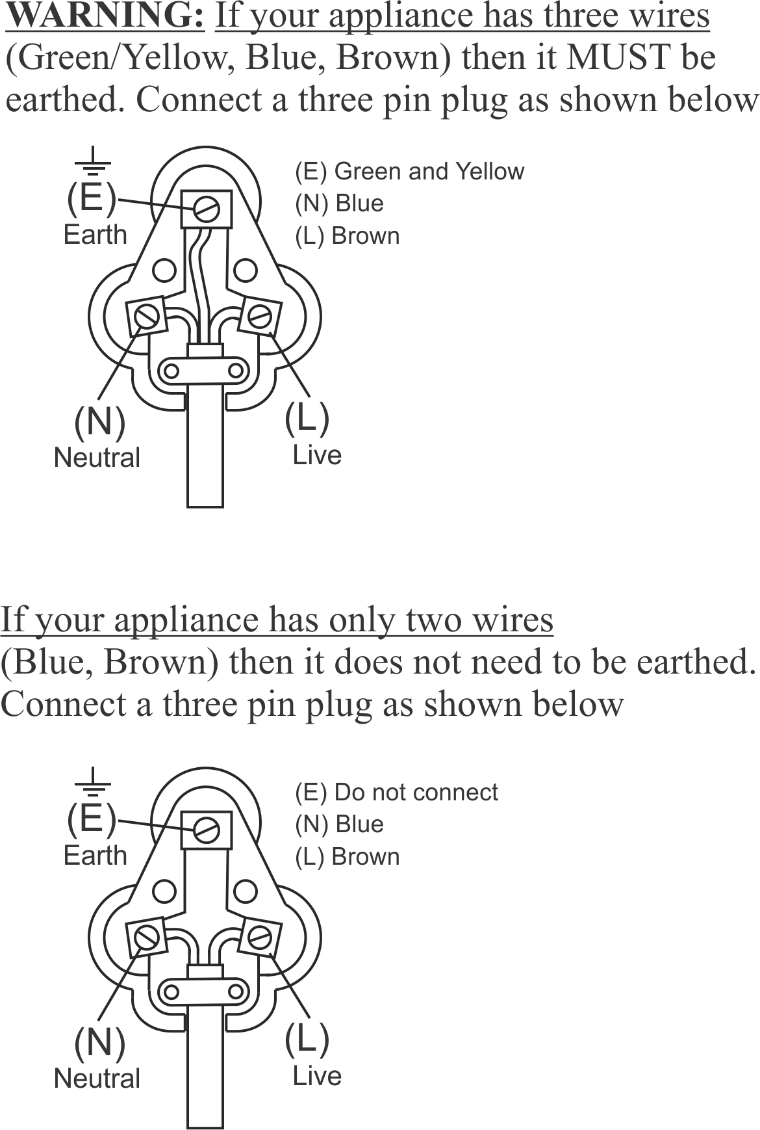

PLEASE AFFIX YOUR PROOF OF PURCHASE/RECEIPT HERE
IN THE EVENT OF A CLAIM UNDER WARRANTY THIS RECEIPT MUST BE PRODUCED.

2 YEAR WARRANTY
1 year retail ⵏ 1 year extended warranty upon registration*
visit www.russellhobbs.co.za

W A R R A N T Y AND EXTENDED WARRANTY

- Home of Living Brands (Pty) Limited ("Home of Living Brands") warrants to the original purchaser of this product ("the customer") that this product will be free of defects in quality and workmanship which under normal personal, family or household use and purpose may manifest within a period of 1 (one) year from the date of purchase ("warranty period").
- Home of Living Brands shall extend the warranty period for a further period of 1(one) year (“extended warranty period*”), on condition that the purchaser registers the product on the website, within 12 months from the date of purchase of the product. The website address for registration is as follows: http://russellhobbs.co.za/info-pages/warranty-info.aspx. The extended warranty period only applies to products purchased on or after 1 October 2017.
- Where the customer has purchased a product and it breaks, is defective or does not work properly for the intended purpose, the customer must notify the supplier from whom the customer bought the product ("the supplier") thereof within the warranty period or if applicable, the extended warranty period. Any claim in terms of this warranty must be supported by a proof of purchase. If proof of purchase is not available, then repair, and/or service charges may be payable by the customer to the supplier.
- The faulty product must be taken to the supplier's service centre to exercise the warranty.
- The supplier will refund, repair or exchange the product in terms of this warranty subject to legislative requirements. This warranty shall be valid only where (a) the customer is not the cause of the product breaking, and (b) the product has been used for the intended purpose stipulated in the product manual. The warranty does not include and will not be construed to cover products damaged as a result of disaster, misuse, tamper, abuse or any unauthorised modification or repair of the product.
- This warranty will extend only to the product provided at the date of the purchase and not to any expendables attached or installed by the customer. In this regard any accessories supplied with the product by the supplier, may be excluded in this warranty or extended warranty (see Exclusions to Warranty and Extended Warranty document).
- If the customer requests that the supplier repairs the product and the product breaks or fails to work properly within 3 (three) months of the repair and not as a result of misuse, tampering or modification by or on behalf of the customer, then the supplier may replace the product or pay a refund to the customer, subject to the supplier’s discretion.
- The customer may be responsible for certain costs where products returned are not in the original packaging, or if the packaging is damaged. This will be deducted from any refund paid to the customer.

HOME OF LIVING BRANDS (PTY) LTD (JOHANNESBURG)

JOHANNESBURG TEL NO. (011) 490-9600
CAPE TOWN TEL NO. (021) 552-5161
DURBAN TEL NO. (031) 303-1163
www.homeoflivingbrands.com
www.russellhobbs.co.za
www.facebook.com/RussellHobbsSA

EXCLUSIONS TO W A R R A N T Y AND EXTENDED WARRANTY

- Any accessories supplied with the product, including but not limited to, bowls, jugs, mills or carafes made either of glass or plastic and supplied with this appliance (hereinafter referred to as “the accessory or accessories”), is warranted to be free from material and workmanship defects for the duration of the appliance warranty.
- The accessories should give trouble free service when used in accordance with the directions described in the instruction manual. However, the accessories will be damaged if subjected to impact, and this damage is not covered by the warranty. Such impact damage can occur either from the outside (if for example it is dropped or knocked against a hard surface), or from within (if for example foreign objects are placed within the accessories and the power is switched on).
- Should you need to replace an accessory during the warranty period; a claim for a free replacement will only be considered if the item (including all shards and broken parts) is returned to the nearest HOLB service centre for examination.
- The remains of the accessory will be carefully examined by the relevant professionals and if it is determined (at the sole discretion of HOLB) that the damage was caused by impact, then the claim will be refused and will not be covered by the warranty or any extended warranty.
- Any replacement part provided in terms of clause 4 above will become a chargeable item payable by the customer.

